Model selection

Jake Cavaiani

1/28/2022

The purpose of this script is to model HI/FI against fixed and random effects and perform model selection techniques to see which model is best fit

Input: 2019_2020 HI for each catchment that is will be from Output_from_analysis->07_Models Step 1) import HI.dat file which is HI for individual storms in 2018-2021 across DoD sites Step 2) standardize and center the data Step 3) add fixed (storm total, intensity, week precip, month precip, 3month precip and doy) and random effects (catchments) Output: linear model plot

# Read in data #   
antecedent_HI_FI_1_0 <- read_csv("~/Documents/Storms/Output_from_analysis/06_HI_fire_permafrost_script/antecedent_HI_FI_1.0.csv") # read in data

## Warning: Missing column names filled in: 'X1' [1]

##   
## ── Column specification ────────────────────────────────────────────────────────  
## cols(  
## .default = col_double(),  
## site.ID = col_character(),  
## storm.ID = col_character(),  
## response_var = col_character(),  
## burn = col_character(),  
## pf = col_character(),  
## date = col_date(format = "")  
## )  
## ℹ Use `spec()` for the full column specifications.

antecedent_HI_FI_1_0 <- antecedent_HI_FI_1_0[,-c(1:2,14:15,17,19)] # cleaning up columns that are unnecessary   
  
colNames <- c("Hyst_index", "HI_ymin", "HI_ymax", "site.ID", "storm.ID", "month", "day", "response_var", "Flush_index", "FI_ymin", "FI_ymax", "year", "beta", "StormPrecip", "StormTemp", "PrecipWeek", "PrecipMonth", "ThreeMonth", "TempWeek", "Duration", "Intensity", "doy", "burn", "pf", "date", "TimeSinceChena")  
  
names(antecedent_HI_FI_1_0)<- colNames # renaming columns   
  
# filling in holes that the automated script did not do correctly   
antecedent_HI_FI_1_0[c(306:310), 20] <- 68.75  
antecedent_HI_FI_1_0[c(306:310), 21] <- 0.01454545  
  
antecedent_HI_FI_1_0[c(313:315), 20] <- 68.75  
antecedent_HI_FI_1_0[c(313:315), 21] <- 0.01454545  
  
antecedent_HI_FI_1_0[c(327:330), 20] <- 61.25  
antecedent_HI_FI_1_0[c(327:330), 21] <- 0.07183673  
  
antecedent_HI_FI_1_0[c(628:631), 20] <- 21.25  
antecedent_HI_FI_1_0[c(628:631), 21] <- 0.09411765  
  
antecedent_HI_FI_1_0[c(650:652), 20] <- 30.25  
antecedent_HI_FI_1_0[c(650:652), 21] <- 0.2181818  
  
antecedent_HI_FI_1_0[c(656:657), 20] <- 23.5  
antecedent_HI_FI_1_0[c(656:657), 21] <- 0.03404255  
  
antecedent_HI_FI_1_0[c(810:813), 20] <- 30.5  
antecedent_HI_FI_1_0[c(810:813), 21] <- 0.1901639  
  
antecedent_HI_FI_1_0[c(848:850), 20] <- 58.5  
antecedent_HI_FI_1_0[c(848:850), 21] <- 0.1628205  
  
antecedent_HI_FI_1_0[c(885:888), 20] <- 31.5  
antecedent_HI_FI_1_0[c(885:888), 21] <- 0.1777778  
  
antecedent_HI_FI_1_0[c(86), 14] <- 6.604  
antecedent_HI_FI_1_0[c(86), 15] <- 13.560411  
antecedent_HI_FI_1_0[c(86), 16] <- 9.779  
antecedent_HI_FI_1_0[c(86), 17] <- 79.756  
antecedent_HI_FI_1_0[c(86), 18] <- 79.756  
antecedent_HI_FI_1_0[c(86), 19] <- 6.389494  
antecedent_HI_FI_1_0[c(86), 20] <- 32.46667  
antecedent_HI_FI_1_0[c(86), 21] <- 0.203408624  
antecedent_HI_FI_1_0[c(86), 22] <- 179.2299  
antecedent_HI_FI_1_0[c(86), 23] <- "burned"  
antecedent_HI_FI_1_0[c(86), 24] <- "medium"  
  
antecedent_HI_FI_1_0[c(86), 26] <- 38.22986  
  
antecedent_HI_FI_1_0[c(110), 14] <- 2.667  
antecedent_HI_FI_1_0[c(110), 15] <- 7.809827  
antecedent_HI_FI_1_0[c(110), 16] <- 8.255  
antecedent_HI_FI_1_0[c(110), 17] <- 109.474000  
antecedent_HI_FI_1_0[c(110), 18] <- 175.641000  
antecedent_HI_FI_1_0[c(110), 19] <- 9.680474  
antecedent_HI_FI_1_0[c(110), 20] <- 47.96667  
antecedent_HI_FI_1_0[c(110), 21] <- 0.055601112  
antecedent_HI_FI_1_0[c(110), 22] <- 235.4590  
antecedent_HI_FI_1_0[c(110), 23] <- "burned"  
antecedent_HI_FI_1_0[c(110), 24] <- "medium"  
#antecedent_HI_FI_1_0[c(110), 25] <- "2018-06-29"  
antecedent_HI_FI_1_0[c(110), 26] <- 94.45903  
  
antecedent_HI_FI_1_0[c(126:127), 14] <- 40.640  
antecedent_HI_FI_1_0[c(126:127), 15] <- 4.928689  
antecedent_HI_FI_1_0[c(126:127), 16] <- 21.082  
antecedent_HI_FI_1_0[c(126:127), 17] <- 26.543  
antecedent_HI_FI_1_0[c(126:127), 18] <- 26.543  
antecedent_HI_FI_1_0[c(126:127), 19] <- 5.977116  
antecedent_HI_FI_1_0[c(126:127), 20] <- 104.96667  
antecedent_HI_FI_1_0[c(126:127), 21] <- 0.387170530  
antecedent_HI_FI_1_0[c(126:127), 22] <- 262.9174  
antecedent_HI_FI_1_0[c(126:127), 23] <- "burned"  
antecedent_HI_FI_1_0[c(126:127), 24] <- "medium"  
#antecedent_HI_FI_1_0[c(126:127), 25] <- "2018-06-29"  
antecedent_HI_FI_1_0[c(126:127), 26] <- 121.91736  
  
antecedent_HI_FI_1_0[c(130), 14] <- 4.572  
antecedent_HI_FI_1_0[c(130), 15] <- 4.103419  
antecedent_HI_FI_1_0[c(130), 16] <- 48.133  
antecedent_HI_FI_1_0[c(130), 17] <- 67.183  
antecedent_HI_FI_1_0[c(130), 18] <- 67.183  
antecedent_HI_FI_1_0[c(130), 19] <- 5.676306  
antecedent_HI_FI_1_0[c(130), 20] <- 130.96667  
antecedent_HI_FI_1_0[c(130), 21] <- 0.034909646  
antecedent_HI_FI_1_0[c(130), 22] <- 267.3340  
antecedent_HI_FI_1_0[c(130), 23] <- "burned"  
antecedent_HI_FI_1_0[c(130), 24] <- "medium"  
#antecedent_HI_FI_1_0[c(130), 25] <- "2018-06-29"  
antecedent_HI_FI_1_0[c(130), 26] <- 126.33403  
  
antecedent_HI_FI_1_0[c(313), 14] <- 37.600  
antecedent_HI_FI_1_0[c(313), 15] <- 12.7643333  
antecedent_HI_FI_1_0[c(313), 16] <- 54.800  
antecedent_HI_FI_1_0[c(313), 17] <- 106.600  
antecedent_HI_FI_1_0[c(313), 18] <- 229.000  
antecedent_HI_FI_1_0[c(313), 19] <- 12.263147  
antecedent_HI_FI_1_0[c(313), 20] <- 68.75  
antecedent_HI_FI_1_0[c(313), 21] <- 0.014545450  
antecedent_HI_FI_1_0[c(313), 22] <- 216.6042  
antecedent_HI_FI_1_0[c(313), 23] <- "burned"  
antecedent_HI_FI_1_0[c(313), 24] <- "high"  
#antecedent_HI_FI_1_0[c(313), 25] <- "2018-06-29"  
#antecedent_HI_FI_1_0[c(313), 26] <- 79.60417  
antecedent_HI_FI_1_0 <- antecedent_HI_FI_1_0[-658,]  
  
which(antecedent_HI_FI_1_0$site.ID == "MOOS")

## [1] 38 39 40 41 42 43 44 45 46 47 48 49 50 51 52 53 54 55  
## [19] 56 57 58 59 60 61 62 63 64 65 66 67 68 69 70 71 72 73  
## [37] 74 75 76 77 78 79 80 81 216 217 218 219 220 221 222 223 224 225  
## [55] 226 227 228 229 230 231 232 233 234 235 236 237 238 239 240 241 242 243  
## [73] 244 245 246 247 248 249 250 251 252 253 254 255 256 257 258 259 260 261  
## [91] 262 263 264 503 504 505 506 507 508 509 510 511 512 513 514 515 516 517  
## [109] 518 519 520 521 522 523 524 525 526 527 528 529 530 531 532 817 818 819  
## [127] 820 821 822 823 824 825 826 827 828 829 830 831 832 833 834 835 836 837  
## [145] 838 839 840 841 842 843 844 845 846

# i have a discrepency with is MOOS is burned or not....2018/2019 are listed as burned and 2020/2021 are listed as unburned....MOOS is catergorized as BURNED  
  
antecedent_HI_FI_1_0[c(503:532, 817:846), 23] <- "burned"  
  
##subsetting by solute   
# NO3 #  
HI_FI_NO3 = subset(antecedent_HI_FI_1_0, response_var == "NO3")  
# fDOM #  
HI_FI_fDOM = subset(antecedent_HI_FI_1_0, response_var == "fDOM")  
# SPC #  
HI_FI_SPC = subset(antecedent_HI_FI_1_0, response_var == "SPC")  
# turb #  
HI_FI_turb = subset(antecedent_HI_FI_1_0, response_var == "turb")

HI vs. FI

HI_FI_NO3$site.ID <- factor(HI_FI_NO3$site.ID, levels = c('FRCH','MOOS','CARI','POKE','STRT', 'VAUL'))  
  
HI_FI_NO3.p =   
 ggplot(HI_FI_NO3, aes(Flush_index, Hyst_index)) + geom_point(aes(colour=factor(site.ID), shape = pf), size = 4)+  
 geom_errorbar(aes(ymin=HI_ymin, ymax=HI_ymax), colour="black", alpha=0.5, size=.5, width = 0.1)+   
 geom_hline(yintercept = 0) + geom_vline(xintercept = 0)+  
 geom_errorbarh(aes(xmin=FI_ymin, xmax=FI_ymax), colour="black", alpha=0.5, size=.5, height = 0.1) +  
 scale_color_manual(values = c("orange red", viridis::viridis(6)), "Catchment")+theme_bw() +  
 ylim(-1.5, 1.5) + xlim(-1.5, 1.5)+  
 ggtitle("a) NO3-")+   
 theme(panel.border = element_blank(), panel.grid.major = element_blank(),panel.grid.minor = element_blank(), axis.line = element_line(colour = "black"), text = element_text(size = 20))   
HI_FI_NO3.p

## Warning: Removed 86 rows containing missing values (geom_point).

## Warning: Removed 92 rows containing missing values (geom_errorbarh).

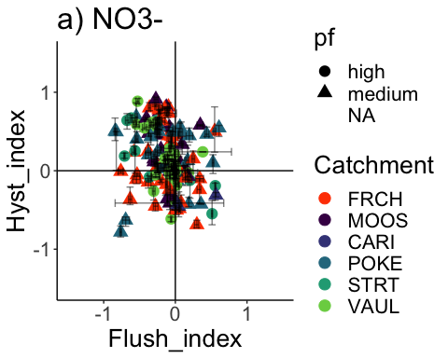 Doesnt look like there is too much of a pattern here….slightly more (+) HI and slightly more (-) FI

### HI vs. FI ### PF

HI_FI_fDOM$site.ID <- factor(HI_FI_fDOM$site.ID, levels = c('FRCH','MOOS','CARI','POKE','STRT', 'VAUL'))  
  
HI_FI_fDOM.p =   
 ggplot(HI_FI_fDOM, aes(Flush_index, Hyst_index)) + geom_point(aes(colour=factor(site.ID), shape = pf), size = 4)+  
 geom_errorbar(aes(ymin=HI_ymin, ymax=HI_ymax), colour="black", alpha=0.5, size=.5, width = 0.1)+   
 geom_hline(yintercept = 0) + geom_vline(xintercept = 0)+  
 geom_errorbarh(aes(xmin=FI_ymin, xmax=FI_ymax), colour="black", alpha=0.5, size=.5, height = 0.1) +  
 scale_color_manual(values = c("orange red", viridis::viridis(6)), "Catchment")+theme_bw() +  
 ylim(-1.5, 1.5) + xlim(-1.5, 1.5)+  
 ggtitle("b) fDOM")+   
 theme(panel.border = element_blank(), panel.grid.major = element_blank(),panel.grid.minor = element_blank(), axis.line = element_line(colour = "black"), text = element_text(size = 20))   
HI_FI_fDOM.p

## Warning: Removed 69 rows containing missing values (geom_point).

## Warning: Removed 97 rows containing missing values (geom_errorbarh).

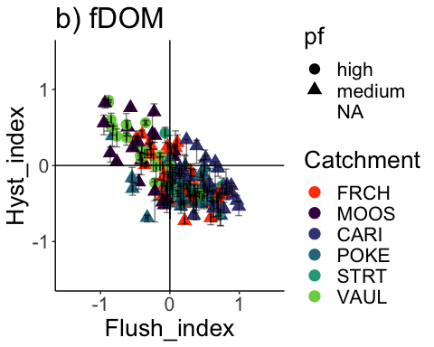 Looks like there is a clear pattern with VAUL and MOOS as it usually dilutes during a storm meanwhile CARI and the other sites flush more frequently

### HI vs. FI

HI_FI_SPC$site.ID <- factor(HI_FI_SPC$site.ID, levels = c('FRCH','MOOS','CARI','POKE','STRT', 'VAUL'))  
  
HI_FI_SPC.p =   
 ggplot(HI_FI_SPC, aes(Flush_index, Hyst_index)) + geom_point(aes(colour=factor(site.ID), shape = pf), size = 4)+  
 geom_errorbar(aes(ymin=HI_ymin, ymax=HI_ymax), colour="black", alpha=0.5, size=.5, width = 0.1)+   
 geom_hline(yintercept = 0) + geom_vline(xintercept = 0)+  
 geom_errorbarh(aes(xmin=FI_ymin, xmax=FI_ymax), colour="black", alpha=0.5, size=.5, height = 0.1) +  
 scale_color_manual(values = c("orange red", viridis::viridis(6)), "Catchment")+theme_bw() +  
 ylim(-1.5, 1.5) + xlim(-1.5, 1.5)+  
 ggtitle("c) SPC")+   
 theme(panel.border = element_blank(), panel.grid.major = element_blank(),panel.grid.minor = element_blank(), axis.line = element_line(colour = "black"), text = element_text(size = 20))   
HI_FI_SPC.p

## Warning: Removed 114 rows containing missing values (geom_point).

## Warning: Removed 119 rows containing missing values (geom_errorbarh).

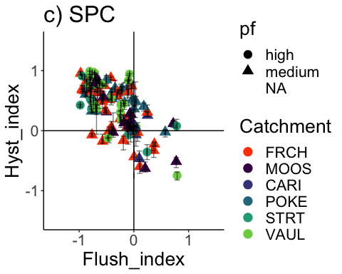 Mostly a dilution and clockwise effect for SPC

### HI vs. FI

HI_FI_turb$site.ID <- factor(HI_FI_turb$site.ID, levels = c('FRCH','MOOS','POKE','STRT','VAUL', 'CARI'))  
  
HI_FI_turb.p =   
 ggplot(HI_FI_turb, aes(Flush_index, Hyst_index)) + geom_point(aes(colour=factor(site.ID), shape = pf), size = 4)+  
 geom_errorbar(aes(ymin=HI_ymin, ymax=HI_ymax), colour="black", alpha=0.5, size=.5, width = 0.1)+   
 geom_hline(yintercept = 0) + geom_vline(xintercept = 0)+  
 geom_errorbarh(aes(xmin=FI_ymin, xmax=FI_ymax), colour="black", alpha=0.5, size=.5, height = 0.1) +  
 scale_color_manual(values = c("orange red", viridis::viridis(6)), "Catchment")+theme_bw() +  
 ylim(-1.5, 1.5) + xlim(-1.5, 1.5)+  
 ggtitle("d) Turb")+   
 theme(panel.border = element_blank(), panel.grid.major = element_blank(),panel.grid.minor = element_blank(), axis.line = element_line(colour = "black"), text = element_text(size = 20))   
HI_FI_turb.p

## Warning: Removed 75 rows containing missing values (geom_point).

## Warning: Removed 111 rows containing missing values (geom_errorbarh).

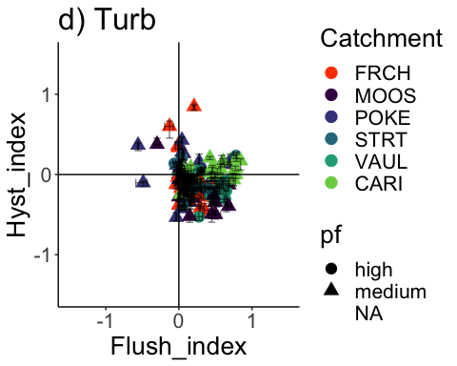 This seems like we would expect…a mostly flushing effect during storms

### HI vs. FI ### FIRE

HI_FI_NO3.p.fire =   
 ggplot(HI_FI_NO3, aes(Flush_index, Hyst_index)) + geom_point(aes(colour=factor(site.ID), shape = burn), size = 4)+  
 geom_errorbar(aes(ymin=HI_ymin, ymax=HI_ymax), colour="black", alpha=0.5, size=.5, width = 0.1)+   
 geom_hline(yintercept = 0) + geom_vline(xintercept = 0)+  
 geom_errorbarh(aes(xmin=FI_ymin, xmax=FI_ymax), colour="black", alpha=0.5, size=.5, height = 0.1) +  
 scale_color_manual(values = c("orange red", viridis::viridis(6)), "Catchment")+theme_bw() +  
 ylim(-1.5, 1.5) + xlim(-1.5, 1.5)+  
 ggtitle("a) NO3-")+   
 theme(panel.border = element_blank(), panel.grid.major = element_blank(),panel.grid.minor = element_blank(), axis.line = element_line(colour = "black"), text = element_text(size = 20))   
HI_FI_NO3.p.fire

## Warning: Removed 86 rows containing missing values (geom_point).

## Warning: Removed 92 rows containing missing values (geom_errorbarh).

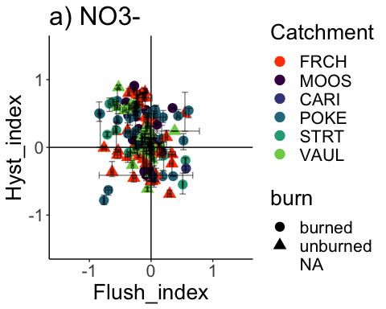

HI_FI_fDOM.p.fire =   
 ggplot(HI_FI_fDOM, aes(Flush_index, Hyst_index)) + geom_point(aes(colour=factor(site.ID), shape = burn), size = 4)+  
 geom_errorbar(aes(ymin=HI_ymin, ymax=HI_ymax), colour="black", alpha=0.5, size=.5, width = 0.1)+   
 geom_hline(yintercept = 0) + geom_vline(xintercept = 0)+  
 geom_errorbarh(aes(xmin=FI_ymin, xmax=FI_ymax), colour="black", alpha=0.5, size=.5, height = 0.1) +  
 scale_color_manual(values = c("orange red", viridis::viridis(6)), "Catchment")+theme_bw() +  
 ylim(-1.5, 1.5) + xlim(-1.5, 1.5)+  
 ggtitle("b) fDOM")+   
 theme(panel.border = element_blank(), panel.grid.major = element_blank(),panel.grid.minor = element_blank(), axis.line = element_line(colour = "black"), text = element_text(size = 20))   
HI_FI_fDOM.p.fire

## Warning: Removed 69 rows containing missing values (geom_point).

## Warning: Removed 97 rows containing missing values (geom_errorbarh).

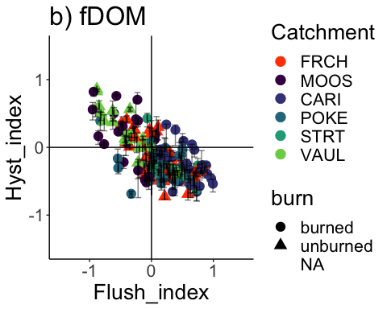

HI_FI_SPC.p.fire =   
 ggplot(HI_FI_SPC, aes(Flush_index, Hyst_index)) + geom_point(aes(colour=factor(site.ID), shape = burn), size = 4)+  
 geom_errorbar(aes(ymin=HI_ymin, ymax=HI_ymax), colour="black", alpha=0.5, size=.5, width = 0.1)+   
 geom_hline(yintercept = 0) + geom_vline(xintercept = 0)+  
 geom_errorbarh(aes(xmin=FI_ymin, xmax=FI_ymax), colour="black", alpha=0.5, size=.5, height = 0.1) +  
 scale_color_manual(values = c("orange red", viridis::viridis(6)), "Catchment")+theme_bw() +  
 ylim(-1.5, 1.5) + xlim(-1.5, 1.5)+  
 ggtitle("c) SPC")+   
 theme(panel.border = element_blank(), panel.grid.major = element_blank(),panel.grid.minor = element_blank(), axis.line = element_line(colour = "black"), text = element_text(size = 20))   
HI_FI_SPC.p.fire

## Warning: Removed 114 rows containing missing values (geom_point).

## Warning: Removed 119 rows containing missing values (geom_errorbarh).

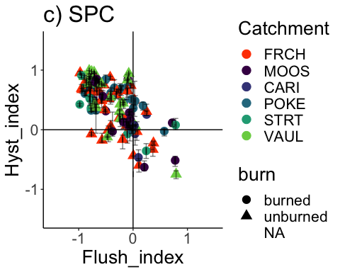

HI_FI_turb.p.fire =   
 ggplot(HI_FI_turb, aes(Flush_index, Hyst_index)) + geom_point(aes(colour=factor(site.ID), shape = burn), size = 4)+  
 geom_errorbar(aes(ymin=HI_ymin, ymax=HI_ymax), colour="black", alpha=0.5, size=.5, width = 0.1)+   
 geom_hline(yintercept = 0) + geom_vline(xintercept = 0)+  
 geom_errorbarh(aes(xmin=FI_ymin, xmax=FI_ymax), colour="black", alpha=0.5, size=.5, height = 0.1) +  
 scale_color_manual(values = c("orange red", viridis::viridis(6)), "Catchment")+theme_bw() +  
 ylim(-1.5, 1.5) + xlim(-1.5, 1.5)+  
 ggtitle("d) Turb")+   
 theme(panel.border = element_blank(), panel.grid.major = element_blank(),panel.grid.minor = element_blank(), axis.line = element_line(colour = "black"), text = element_text(size = 20))   
HI_FI_turb.p.fire

## Warning: Removed 75 rows containing missing values (geom_point).

## Warning: Removed 111 rows containing missing values (geom_errorbarh).

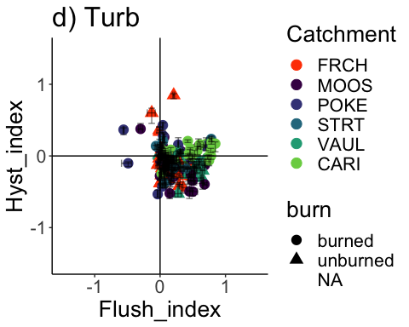

### regression between FI and Beta

# all together  
ggplot(HI_FI_NO3, aes(Flush_index, beta)) + geom_point(aes(colour=factor(site.ID)), size = 4) +  
 ylim(-1.5, 1.5) + xlim(-1.5, 1.5) +  
 geom_smooth(method = "lm", na.rm = TRUE, fullrange = TRUE, aes(group = 1)) +   
 stat_poly_eq(formula = y~x,  
 label.y = "top", label.x = "right",  
 aes(label = paste(..eq.label.., ..rr.label.., sep = "~~~")),   
 parse = TRUE)

## `geom_smooth()` using formula 'y ~ x'

## Warning: Removed 101 rows containing non-finite values (stat_poly_eq).

## Warning: Removed 101 rows containing missing values (geom_point).

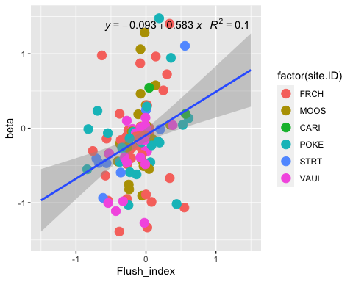

# all together  
ggplot(HI_FI_fDOM, aes(Flush_index, beta)) + geom_point(aes(colour=factor(site.ID)), size = 4) +  
 ylim(-1.5, 1.5) + xlim(-1.5, 1.5) +  
 geom_smooth(method = "lm", na.rm = TRUE, fullrange = TRUE, aes(group = 1)) +   
 stat_poly_eq(formula = y~x,  
 label.y = "top", label.x = "right",  
 aes(label = paste(..eq.label.., ..rr.label.., sep = "~~~")),   
 parse = TRUE)

## `geom_smooth()` using formula 'y ~ x'

## Warning: Removed 92 rows containing non-finite values (stat_poly_eq).

## Warning: Removed 92 rows containing missing values (geom_point).

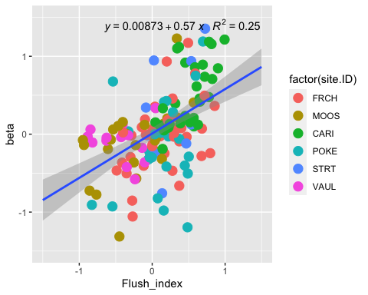

# all together  
ggplot(HI_FI_SPC, aes(Flush_index, beta)) + geom_point(aes(colour=factor(site.ID)), size = 4) +  
 ylim(-1.5, 1.5) + xlim(-1.5, 1.5) +  
 geom_smooth(method = "lm", na.rm = TRUE, fullrange = TRUE, aes(group = 1)) +   
 stat_poly_eq(formula = y~x,  
 label.y = "top", label.x = "right",  
 aes(label = paste(..eq.label.., ..rr.label.., sep = "~~~")),   
 parse = TRUE)

## `geom_smooth()` using formula 'y ~ x'

## Warning: Removed 124 rows containing non-finite values (stat_poly_eq).

## Warning: Removed 124 rows containing missing values (geom_point).

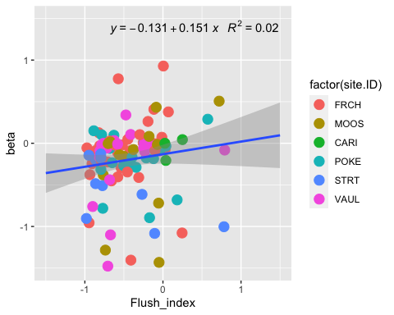

ggplot(HI_FI_turb, aes(Flush_index, beta)) + geom_point(aes(colour=factor(site.ID)), size = 4) +  
 ylim(-1.5, 1.5) + xlim(-1.5, 1.5) +  
 geom_smooth(method = "lm", na.rm = TRUE, fullrange = TRUE, aes(group = 1)) +   
 stat_poly_eq(formula = y~x,  
 label.y = "top", label.x = "right",  
 aes(label = paste(..eq.label.., ..rr.label.., sep = "~~~")),   
 parse = TRUE)

## `geom_smooth()` using formula 'y ~ x'

## Warning: Removed 96 rows containing non-finite values (stat_poly_eq).

## Warning: Removed 96 rows containing missing values (geom_point).

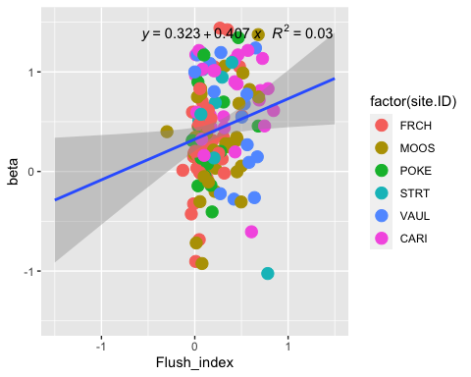

### HI vs. beta ### PF

HI_FI_NO3.p.beta =   
 ggplot(HI_FI_NO3, aes(beta, Hyst_index)) + geom_point(aes(colour=factor(site.ID), shape = pf), size = 4)+  
 geom_errorbar(aes(ymin=HI_ymin, ymax=HI_ymax), colour="black", alpha=0.5, size=.5, width = 0.1)+   
 geom_hline(yintercept = 0) + geom_vline(xintercept = 0)+  
 geom_errorbarh(aes(xmin=FI_ymin, xmax=FI_ymax), colour="black", alpha=0.5, size=.5, height = 0.1) +  
 scale_color_manual(values = c("orange red", viridis::viridis(6)), "Catchment")+theme_bw() +  
 ylim(-1.5, 1.5) + xlim(-1.5, 1.5)+  
 ggtitle("a) NO3-")+   
 theme(panel.border = element_blank(), panel.grid.major = element_blank(),panel.grid.minor = element_blank(), axis.line = element_line(colour = "black"), text = element_text(size = 20))   
HI_FI_NO3.p.beta

## Warning: Removed 31 rows containing missing values (geom_point).

## Warning: Removed 92 rows containing missing values (geom_errorbarh).

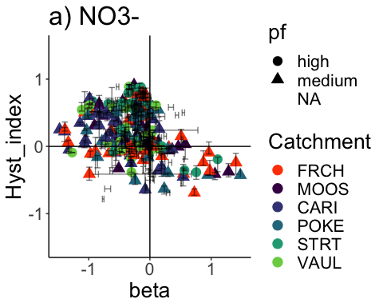

HI_FI_fDOM.p.beta =   
 ggplot(HI_FI_fDOM, aes(beta, Hyst_index)) + geom_point(aes(colour=factor(site.ID), shape = pf), size = 4)+  
 geom_errorbar(aes(ymin=HI_ymin, ymax=HI_ymax), colour="black", alpha=0.5, size=.5, width = 0.1)+   
 geom_hline(yintercept = 0) + geom_vline(xintercept = 0)+  
 geom_errorbarh(aes(xmin=FI_ymin, xmax=FI_ymax), colour="black", alpha=0.5, size=.5, height = 0.1) +  
 scale_color_manual(values = c("orange red", viridis::viridis(6)), "Catchment")+theme_bw() +  
 ylim(-1.5, 1.5) + xlim(-1.5, 1.5)+  
 ggtitle("b) fDOM")+   
 theme(panel.border = element_blank(), panel.grid.major = element_blank(),panel.grid.minor = element_blank(), axis.line = element_line(colour = "black"), text = element_text(size = 20))   
HI_FI_fDOM.p.beta

## Warning: Removed 35 rows containing missing values (geom_point).

## Warning: Removed 97 rows containing missing values (geom_errorbarh).

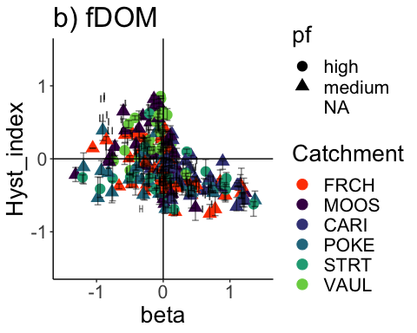

HI_FI_SPC.p.beta =   
 ggplot(HI_FI_SPC, aes(beta, Hyst_index)) + geom_point(aes(colour=factor(site.ID), shape = pf), size = 4)+  
 geom_errorbar(aes(ymin=HI_ymin, ymax=HI_ymax), colour="black", alpha=0.5, size=.5, width = 0.1)+   
 geom_hline(yintercept = 0) + geom_vline(xintercept = 0)+  
 geom_errorbarh(aes(xmin=FI_ymin, xmax=FI_ymax), colour="black", alpha=0.5, size=.5, height = 0.1) +  
 scale_color_manual(values = c("orange red", viridis::viridis(6)), "Catchment")+theme_bw() +  
 ylim(-1.5, 1.5) + xlim(-1.5, 1.5)+  
 ggtitle("c) SPC")+   
 theme(panel.border = element_blank(), panel.grid.major = element_blank(),panel.grid.minor = element_blank(), axis.line = element_line(colour = "black"), text = element_text(size = 20))   
HI_FI_SPC.p.beta

## Warning: Removed 20 rows containing missing values (geom_point).

## Warning: Removed 119 rows containing missing values (geom_errorbarh).

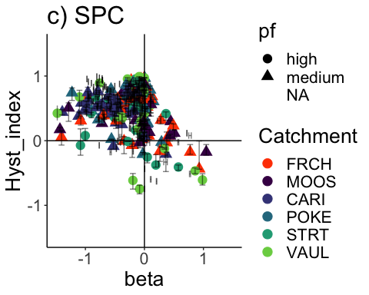

HI_FI_turb.p.beta =   
 ggplot(HI_FI_turb, aes(beta, Hyst_index)) + geom_point(aes(colour=factor(site.ID), shape = pf), size = 4)+  
 geom_errorbar(aes(ymin=HI_ymin, ymax=HI_ymax), colour="black", alpha=0.5, size=.5, width = 0.1)+   
 geom_hline(yintercept = 0) + geom_vline(xintercept = 0)+  
 geom_errorbarh(aes(xmin=FI_ymin, xmax=FI_ymax), colour="black", alpha=0.5, size=.5, height = 0.1) +  
 scale_color_manual(values = c("orange red", viridis::viridis(6)), "Catchment")+theme_bw() +  
 ylim(-1.5, 1.5) + xlim(-1.5, 1.5)+  
 ggtitle("d) Turb")+   
 theme(panel.border = element_blank(), panel.grid.major = element_blank(),panel.grid.minor = element_blank(), axis.line = element_line(colour = "black"), text = element_text(size = 20))   
HI_FI_turb.p.beta

## Warning: Removed 30 rows containing missing values (geom_point).

## Warning: Removed 111 rows containing missing values (geom_errorbarh).

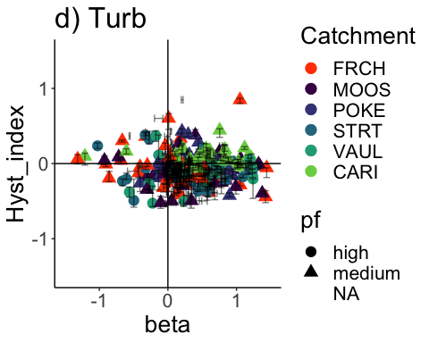

ggplot(antecedent_HI_FI_1_0, aes(doy, TimeSinceChena)) +  
 geom_point() +  
 geom_smooth(method = "lm", na.rm = TRUE, fullrange = TRUE, aes(group = 1)) +   
 stat_poly_eq(formula = y~x,  
 label.y = "top", label.x = "right",  
 aes(label = paste(..eq.label.., ..rr.label.., sep = "~~~")),   
 parse = TRUE) +   
 facet_grid(rows = vars(year))

## `geom_smooth()` using formula 'y ~ x'

## Warning: Removed 9 rows containing non-finite values (stat_poly_eq).

## Warning: Removed 9 rows containing missing values (geom_point).

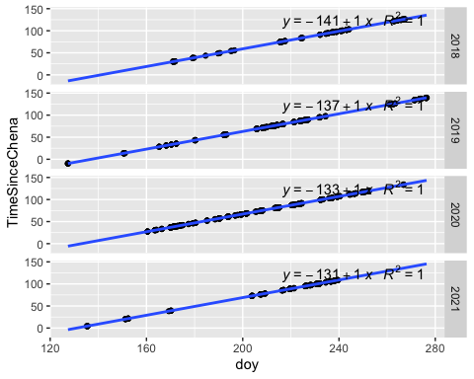

#### Data visualization

ggplot(antecedent_HI_FI_1_0, aes(doy, Hyst_index)) +  
 geom_hline(yintercept = 0, linetype = "dotted", size = 1) +  
 geom_errorbar(aes(ymin=HI_ymin, ymax=HI_ymax), colour="black", alpha=0.5, size=.5, width = 0.1) +   
 geom_point(aes(color = site.ID)) +  
 scale_color_manual(values = c("orange red", viridis::viridis(6)), "Catchment")+theme_bw() +  
 geom_smooth(method = "lm", na.rm = TRUE, fullrange = TRUE, aes(group = 1)) +   
 stat_poly_eq(formula = y~x,  
 label.y = "top", label.x = "right",  
 aes(label = paste(..eq.label.., ..rr.label.., sep = "~~~")),   
 parse = TRUE) +   
 ylab("Hysteresis Index") +  
 ggtitle("HI") +  
 facet_grid(rows=vars(year), cols = vars(response_var))

## `geom_smooth()` using formula 'y ~ x'

## Warning: Removed 8 rows containing non-finite values (stat_poly_eq).

## Warning: Removed 8 rows containing missing values (geom_point).

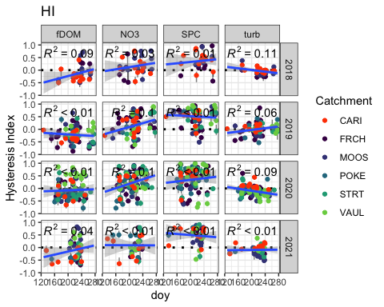

### Checking for outliers

HI_FI_NO3.pl <- HI_FI_NO3 %>% filter(year == "2018") %>%  
 ggplot(aes(x = doy, y = Hyst_index)) +   
 geom_hline(yintercept = 0, linetype = "dotted", size = 1) +  
 geom_errorbar(aes(ymin=HI_ymin, ymax=HI_ymax), colour="black", alpha=0.5, size=.5, width = 0.1)+   
 geom_point(aes(color = site.ID), size = 2) +  
 scale_color_manual(values = c("orange red", viridis::viridis(3)), "Catchment")+  
 ylab("Hysteresis Index") +  
 ggtitle("a) 2018 NO3-")  
  
HI_FI_NO3.pl

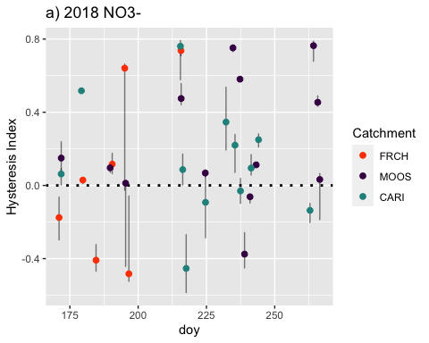 So when I look here I see early storms in French but I don’t see corresponding storms in Moose or Caribou…why might this happen?

1. There could be missing data for the duration of that storm due to instrument malfunction/servicing/user error
2. Streams may respond differently to a rain event due to physical attributes within the catchment… lets look at the discharge record to compare Q response look at the discharge record to see if we are missing a storm…If you are going to do this go back to the first script and run the discharge and chem script to get the file loaded in so you can check the alarm bells and the Q response:’
3. Storms alarms may trigger in one catchment and not in another due to the location of the precipitation event!
4. A storm may have been delineated from the triage of storm or not and then when it was time to run in through the HI function it came back with an error code that would potentially occur due to missing data points/jumps in datetime (requires a full continuous record) or the format of the data was not correct (as.posixct, as.numeric)…(this one does happen but probably the least out of the options listed above when it comes to HI)

DOY 175 is 6/24 DOY 250 is 9/7 1) FRCH storm with such a big CI around day 195 which is mid/end of July, lets look at the jitter plot for HI for that. The range of the 2% discharge increments go from -0.2 all the way up to 0.7 so that explains the big CI. This CQ loop also criss crosses…Do you think that has any influence on the CI? How should we remedy this?

1. MOOS storms in end of season due to more complete chemistry record….FRCH has a big gap throughout beginning of august to end of September

#HI_FI_NO3.2018 <- HI_FI_NO3 %>% filter(year == "2018")  
#plot(POKE.st$inst_rainfall_mm ~ POKE.st$DateTime, type="h",  
# xlim = as.POSIXct(c("2018-05-01 0:00:00","2018-10-15 00:00:00"), tz="America/Anchorage"),  
# ylim = c(10,0),   
## axes=F, xlab="", ylab="")  
#axis(side = 4)  
#mtext(side = 4, line = 3, 'POKE precip. (mm)')  
##abline(v = as.POSIXct(poke.five.fourty.eight$DateTime), col="yellow", lwd = 0.1)  
#abline(v = as.POSIXct(poke.five.twenty.four$DateTime), col = "green", lwd = 0.1)  
#par(new = T)  
#plot(MOOS$MeanDischarge ~ MOOS$DateTime, type = "l", xlab = "", ylab = "Q (L/sec)", col = "purple", ylim = c(0,4000)) +  
 # lines(FRCH$MeanDischarge ~ FRCH$DateTime, type = "l", col = "red")

As can be seen here it does appear that we can have a storm in one catchment vs another catchment (look at end of June for an example of Moose having a response in Q and FRCH not)

HI_FI_NO3.2019.pl <- HI_FI_NO3 %>% filter(year == "2019") %>%  
 ggplot(aes(x = doy, y = Hyst_index)) +   
 geom_hline(yintercept = 0, linetype = "dotted", size = 1) +  
 geom_errorbar(aes(ymin=HI_ymin, ymax=HI_ymax), colour="black", alpha=0.5, size=.5, width = 0.1)+   
 geom_point(aes(color = site.ID), size = 2) +  
 scale_color_manual(values = c("orange red", viridis::viridis(6)), "Catchment")+  
 ylab("Hysteresis Index") +  
 ggtitle("b) 2019 NO3-")  
   
HI_FI_NO3.2019.pl

## Warning: Removed 2 rows containing missing values (geom_point).

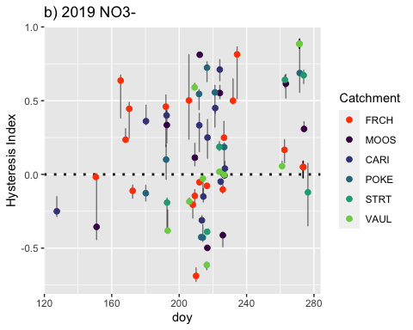 This is showing a lot of early 2019 storms for FRCH when MOOS does not have a storm….let us check the Q record as we did for 2018 to make sure that we are correct in that here:

1. Our Q record shows us that some of our streams respond differently to some of our rain events…FRCH indicates a storm by MOOS does not.
2. CARI has a storm earlier than every other site due to longer record.

#plot(FRCH.st$inst_rainfall_mm ~ FRCH.st$DateTime, type="h",  
# xlim = as.POSIXct(c("2019-05-01 0:00:00","2019-10-15 00:00:00"), tz="America/Anchorage"),  
# ylim = c(10,0),   
# axes=F, xlab="", ylab="")  
#axis(side = 4)  
#mtext(side = 4, line = 3, 'POKE precip. (mm)')  
##abline(v = as.POSIXct(frch.five.fourty.eight$DateTime), col="yellow", lwd = 0.1)  
#abline(v = as.POSIXct(frch.five.twenty.four$DateTime), col = "green", lwd = 0.1)  
#par(new = T)  
#plot(MOOS$Q ~ MOOS$DateTime, type = "l", xlab = "", ylab = "Q (L/sec)", col = "purple", ylim = c(0,7000)) +  
# lines(FRCH$Q ~ FRCH$DateTime, type = "l", col = "red") +  
# lines(VAUL$Q ~ VAUL$DateTime, type = "l", col = "blue") +  
# lines(POKE$Q ~ POKE$DateTime, type = "l", col = "black") +  
# lines(STRT$Q ~ STRT$DateTime, type = "l", col = "orange")

HI_FI_NO3.2020.pl <- HI_FI_NO3 %>% filter(year == "2020") %>%  
 ggplot(aes(x = doy, y = Hyst_index)) +   
 geom_hline(yintercept = 0, linetype = "dotted", size = 1) +  
 geom_errorbar(aes(ymin=HI_ymin, ymax=HI_ymax), colour="black", alpha=0.5, size=.5, width = 0.1)+   
 geom_point(aes(color = site.ID), size = 2) +  
 scale_color_manual(values = c("orange red", viridis::viridis(6)), "Catchment")+  
 ylab("Hysteresis Index") +  
 ggtitle("c) 2020 NO3-")  
   
HI_FI_NO3.2020.pl

## Warning: Removed 1 rows containing missing values (geom_point).

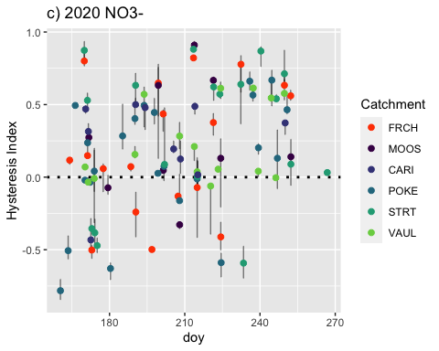 This appears to be consistent:

1. Storms line up across catchments

#plot(FRCH.st$inst_rainfall_mm ~ FRCH.st$DateTime, type="h",  
# xlim = as.POSIXct(c("2020-05-01 0:00:00","2020-10-15 00:00:00"), tz="America/Anchorage"),  
# ylim = c(10,0),   
# axes=F, xlab="", ylab="")  
#axis(side = 4)  
#mtext(side = 4, line = 3, 'POKE precip. (mm)')  
#abline(v = as.POSIXct(frch.five.fourty.eight$DateTime), col="yellow", lwd = 0.1)  
#abline(v = as.POSIXct(frch.five.twenty.four$DateTime), col = "green", lwd = 0.1)  
#par(new = T)  
#plot(MOOS$Q ~ MOOS$DateTime, type = "l", xlab = "", ylab = "Q (L/sec)", col = "purple", ylim = c(0,7000)) +  
# lines(FRCH$Q ~ FRCH$DateTime, type = "l", col = "red") +  
 # lines(VAUL$Q ~ VAUL$DateTime, type = "l", col = "blue") +  
 #lines(POKE$Q ~ POKE$DateTime, type = "l", col = "black") +  
# lines(STRT$Q ~ STRT$DateTime, type = "l", col = "orange")

HI_FI_NO3.2021.pl <- HI_FI_NO3 %>% filter(year == "2021") %>%  
 ggplot(aes(x = doy, y = Hyst_index)) +   
 geom_hline(yintercept = 0, linetype = "dotted", size = 1) +  
 geom_errorbar(aes(ymin=HI_ymin, ymax=HI_ymax), colour="black", alpha=0.5, size=.5, width = 0.1)+   
 geom_point(aes(color = site.ID), size = 2) +  
 scale_color_manual(values = c("orange red", viridis::viridis(6)), "Catchment")+  
 ylab("Hysteresis Index") +  
 ggtitle("d) 2021 NO3-")  
   
HI_FI_NO3.2021.pl

## Warning: Removed 2 rows containing missing values (geom_point).

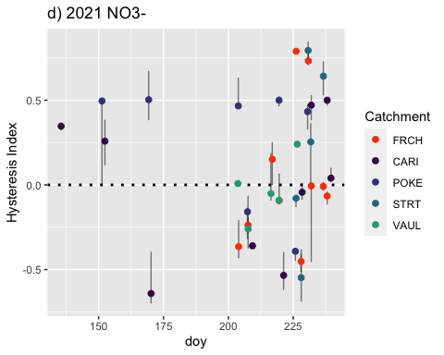 Unfortunately we have some missing records for 2021:

1. FRCH/MOOS/VAUL Q record doesnt start until 6/30
2. Beaver dams at STRT and POKE throughout the year took away accurate Q measurements for multiple precip events that would have been a storm
3. MOOS SUNA was out of commission for the entire year
4. Records that overlap appear to look alright

HI_FI_fDOM.2018.pl <- HI_FI_fDOM %>% filter(year == "2018") %>%  
 ggplot(aes(x = doy, y = Hyst_index)) +   
 geom_hline(yintercept = 0, linetype = "dotted", size = 1) +  
 geom_errorbar(aes(ymin=HI_ymin, ymax=HI_ymax), colour="black", alpha=0.5, size=.5, width = 0.1)+   
 geom_point(aes(color = site.ID), size = 2) +  
 scale_color_manual(values = c("orange red", viridis::viridis(6)), "Catchment")+  
 ylab("Hysteresis Index") +  
 ggtitle("a) 2018 fDOM")  
   
HI_FI_fDOM.2018.pl

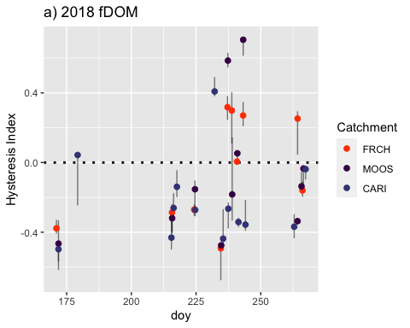 Nothing looks too out of the ordinary for this

HI_FI_fDOM.2019.pl <- HI_FI_fDOM %>% filter(year == "2019") %>%  
 ggplot(aes(x = doy, y = Hyst_index)) +   
 geom_hline(yintercept = 0, linetype = "dotted", size = 1) +  
 geom_errorbar(aes(ymin=HI_ymin, ymax=HI_ymax), colour="black", alpha=0.5, size=.5, width = 0.1)+   
 geom_point(aes(color = site.ID), size = 2) +  
 scale_color_manual(values = c("orange red", viridis::viridis(6)), "Catchment")+  
 ylab("Hysteresis Index") +  
 ggtitle("b) 2019 fDOM")  
   
HI_FI_fDOM.2019.pl

## Warning: Removed 1 rows containing missing values (geom_point).

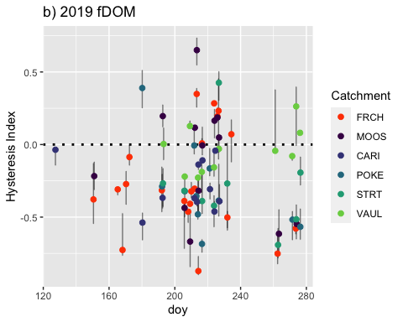 From DOY 160-180 there are only storms for FRCH….is this true?

1. Looking at my storm events it is true that I only have FRCH storms for this early year.
2. When we look at the rest of the record it looks pretty normal.

HI_FI_fDOM.2020.pl <- HI_FI_fDOM %>% filter(year == "2020") %>%  
 ggplot(aes(x = doy, y = Hyst_index)) +   
 geom_hline(yintercept = 0, linetype = "dotted", size = 1) +  
 geom_errorbar(aes(ymin=HI_ymin, ymax=HI_ymax), colour="black", alpha=0.5, size=.5, width = 0.1)+   
 geom_point(aes(color = site.ID), size = 2) +  
 scale_color_manual(values = c("orange red", viridis::viridis(6)), "Catchment")+  
 ylab("Hysteresis Index") +  
 ggtitle("c) 2020 fDOM")  
   
HI_FI_fDOM.2020.pl

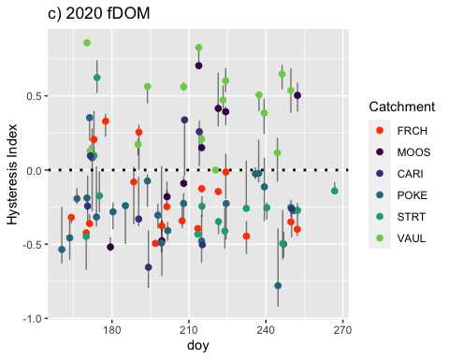 This plot looks pretty normal as most of the time there was a storm in one catchment there were registered storms elsewhere.

HI_FI_fDOM.2021.pl <- HI_FI_fDOM %>% filter(year == "2021") %>%  
 ggplot(aes(x = doy, y = Hyst_index)) +   
 geom_hline(yintercept = 0, linetype = "dotted", size = 1) +  
 geom_errorbar(aes(ymin=HI_ymin, ymax=HI_ymax), colour="black", alpha=0.5, size=.5, width = 0.1)+   
 geom_point(aes(color = site.ID), size = 2) +  
 scale_color_manual(values = c("orange red", viridis::viridis(6)), "Catchment")+  
 ylab("Hysteresis Index") +  
 ggtitle("d) 2021 fDOM")  
   
HI_FI_fDOM.2021.pl

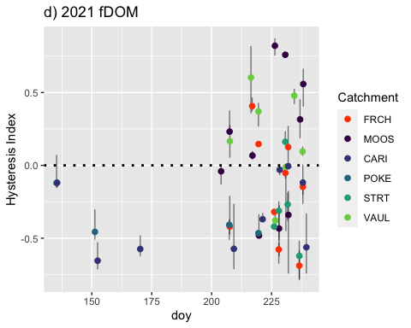 Unfortunately we have some missing records for 2021:

1. FRCH/MOOS/VAUL Q record doesnt start until 6/30
2. Beaver dams at STRT and POKE throughout the year took away accurate Q measurements for multiple precip events that would have been a storm
3. Records that overlap appear to look alright

grid.arrange(HI_FI_fDOM.2018.pl, HI_FI_fDOM.2019.pl,  
 HI_FI_fDOM.2020.pl, HI_FI_fDOM.2021.pl)

## Warning: Removed 1 rows containing missing values (geom_point).

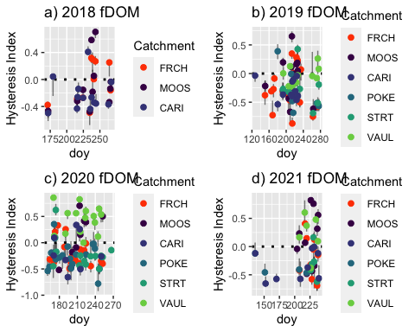 2020 shows some clear patterns between catchment as VAUL maintains positive HI indicating proximal stores and or insufficient sources to maintain throughout entire storm

HI_FI_SPC.2018.pl <- HI_FI_SPC %>% filter(year == "2018") %>%  
 ggplot(aes(x = doy, y = Hyst_index)) +   
 geom_hline(yintercept = 0, linetype = "dotted", size = 1) +  
 geom_errorbar(aes(ymin=HI_ymin, ymax=HI_ymax), colour="black", alpha=0.5, size=.5, width = 0.1)+   
 geom_point(aes(color = site.ID), size = 2) +  
 scale_color_manual(values = c("orange red", viridis::viridis(6)), "Catchment")+  
 ylab("Hysteresis Index") +  
 ggtitle("a) 2018 SPC")  
   
HI_FI_SPC.2018.pl

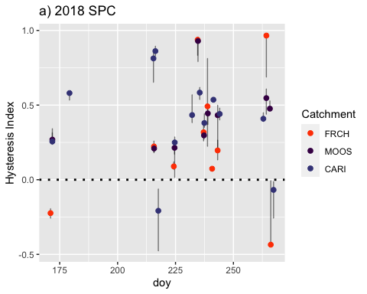 This looks pretty consistent as when one storm occurs it appears that most if not all catchments register a storm as well.

HI_FI_SPC.2019.pl <- HI_FI_SPC %>% filter(year == "2019") %>%  
 ggplot(aes(x = doy, y = Hyst_index)) +   
 geom_hline(yintercept = 0, linetype = "dotted", size = 1) +  
 geom_errorbar(aes(ymin=HI_ymin, ymax=HI_ymax), colour="black", alpha=0.5, size=.5, width = 0.1)+   
 geom_point(aes(color = site.ID), size = 2) +  
 scale_color_manual(values = c("orange red", viridis::viridis(6)), "Catchment")+  
 ylab("Hysteresis Index") +  
 ggtitle("b) 2019 SPC")  
   
HI_FI_SPC.2019.pl

## Warning: Removed 1 rows containing missing values (geom_point).

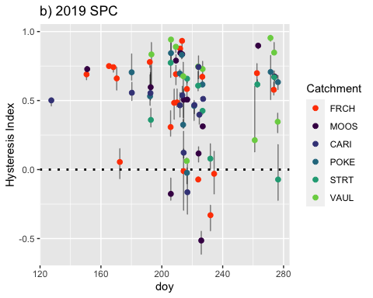 From DOY 160-180 there are only storms for FRCH….is this true?

1. Looking at my storm events/Q record it is true that I only have FRCH storms for this early year.
2. When we look at the rest of the record it looks pretty normal.

HI_FI_SPC.2020.pl <- HI_FI_SPC %>% filter(year == "2020") %>%  
 ggplot(aes(x = doy, y = Hyst_index)) +   
 geom_hline(yintercept = 0, linetype = "dotted", size = 1) +  
 geom_errorbar(aes(ymin=HI_ymin, ymax=HI_ymax), colour="black", alpha=0.5, size=.5, width = 0.1)+   
 geom_point(aes(color = site.ID), size = 2) +  
 scale_color_manual(values = c("orange red", viridis::viridis(6)), "Catchment")+  
 ylab("Hysteresis Index") +  
 ggtitle("c) 2020 SPC")  
   
HI_FI_SPC.2020.pl

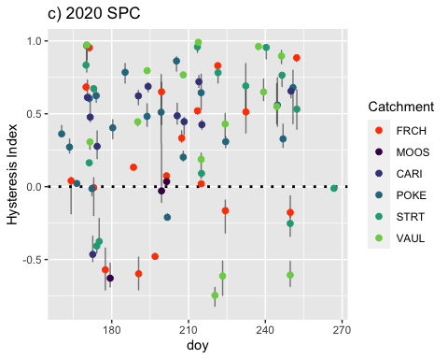 Some pretty big shifts in HI from caribou but it only occurs in consecutive storms

HI_FI_SPC.2021.pl <- HI_FI_SPC %>% filter(year == "2021") %>%  
 ggplot(aes(x = doy, y = Hyst_index)) +   
 geom_hline(yintercept = 0, linetype = "dotted", size = 1) +  
 geom_errorbar(aes(ymin=HI_ymin, ymax=HI_ymax), colour="black", alpha=0.5, size=.5, width = 0.1)+   
 geom_point(aes(color = site.ID), size = 2) +  
 scale_color_manual(values = c("orange red", viridis::viridis(6)), "Catchment")+  
 ylab("Hysteresis Index") +  
 ggtitle("d) 2021 SPC")  
   
HI_FI_SPC.2021.pl

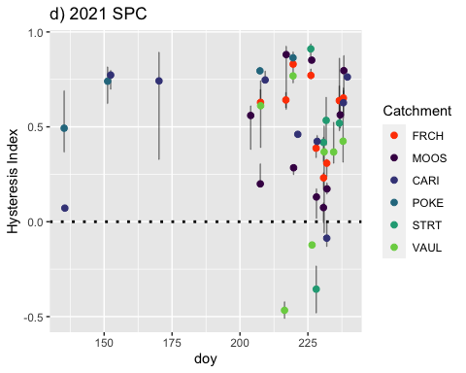 Unfortunately we have some missing records for 2021:

1. FRCH/MOOS/VAUL Q record doesnt start until 6/30
2. Beaver dams at STRT and POKE throughout the year took away accurate Q measurements for multiple precip events that would have been a storm
3. Records that overlap appear to look alright

grid.arrange(HI_FI_SPC.2018.pl, HI_FI_SPC.2019.pl,  
 HI_FI_SPC.2020.pl, HI_FI_SPC.2021.pl)

## Warning: Removed 1 rows containing missing values (geom_point).

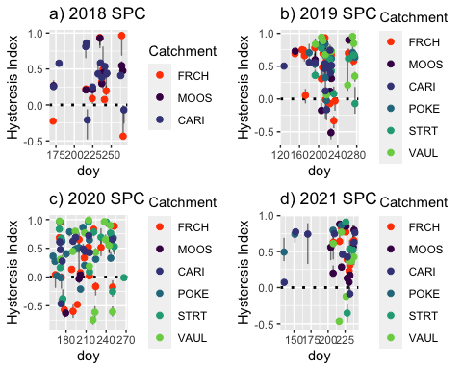

HI_FI_turb.2018.pl <- HI_FI_turb %>% filter(year == "2018") %>%  
 ggplot(aes(x = doy, y = Hyst_index)) +   
 geom_hline(yintercept = 0, linetype = "dotted", size = 1) +  
 geom_errorbar(aes(ymin=HI_ymin, ymax=HI_ymax), colour="black", alpha=0.5, size=.5, width = 0.1)+   
 geom_point(aes(color = site.ID), size = 2) +  
 scale_color_manual(values = c("orange red", viridis::viridis(6)), "Catchment")+  
 ylab("Hysteresis Index") +  
 ggtitle("a) 2018 turb")  
   
HI_FI_turb.2018.pl

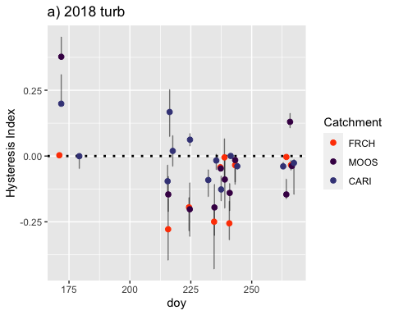 Doesn’t look like anything is too out of the ordinary

HI_FI_turb.2019.pl <- HI_FI_turb %>% filter(year == "2019") %>%  
 ggplot(aes(x = doy, y = Hyst_index)) +   
 geom_hline(yintercept = 0, linetype = "dotted", size = 1) +  
 geom_errorbar(aes(ymin=HI_ymin, ymax=HI_ymax), colour="black", alpha=0.5, size=.5, width = 0.1)+   
 geom_point(aes(color = site.ID), size = 2) +  
 scale_color_manual(values = c("orange red", viridis::viridis(6)), "Catchment")+  
 ylab("Hysteresis Index") +  
 ggtitle("b) 2019 turb")  
   
HI_FI_turb.2019.pl

## Warning: Removed 1 rows containing missing values (geom_point).

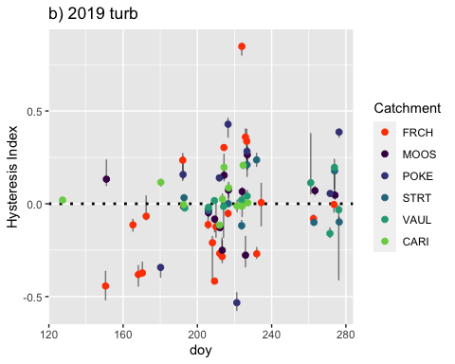 From DOY 160-180 there are only storms for FRCH….is this true?

1. Looking at my storm events/Q record it is true that I only have FRCH storms for this early year.
2. When we look at the rest of the record it looks pretty normal.

HI_FI_turb.2020.pl <- HI_FI_turb %>% filter(year == "2020") %>%  
 ggplot(aes(x = doy, y = Hyst_index)) +   
 geom_hline(yintercept = 0, linetype = "dotted", size = 1) +  
 geom_errorbar(aes(ymin=HI_ymin, ymax=HI_ymax), colour="black", alpha=0.5, size=.5, width = 0.1)+   
 geom_point(aes(color = site.ID), size = 2) +  
 scale_color_manual(values = c("orange red", viridis::viridis(6)), "Catchment")+  
 ylab("Hysteresis Index") +  
 ggtitle("c) 2020 turb")  
   
HI_FI_turb.2020.pl

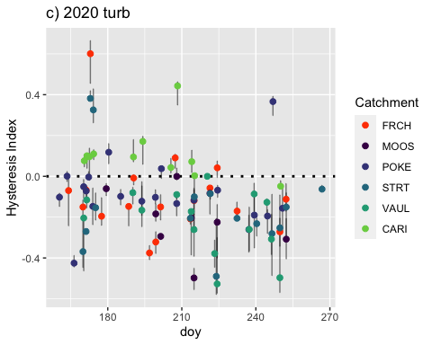 Nothing looks too out of the ordinary

HI_FI_turb.2021.pl <- HI_FI_turb %>% filter(year == "2021") %>%  
 ggplot(aes(x = doy, y = Hyst_index)) +   
 geom_hline(yintercept = 0, linetype = "dotted", size = 1) +  
 geom_errorbar(aes(ymin=HI_ymin, ymax=HI_ymax), colour="black", alpha=0.5, size=.5, width = 0.1)+   
 geom_point(aes(color = site.ID), size = 2) +  
 scale_color_manual(values = c("orange red", viridis::viridis(6)), "Catchment")+  
 ylab("Hysteresis Index") +  
 ggtitle("d) 2021 turb")  
   
HI_FI_turb.2021.pl

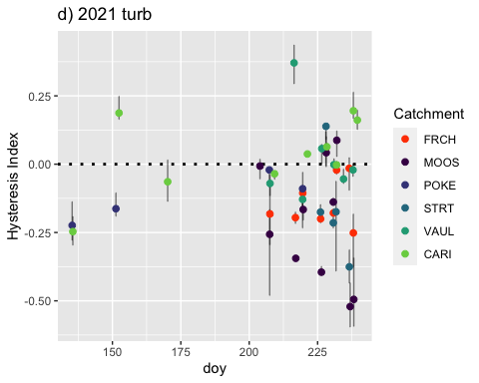 Unfortunately we have some missing records for 2021:

1. FRCH/MOOS/VAUL Q record doesnt start until 6/30
2. Beaver dams at STRT and POKE throughout the year took away accurate Q measurements for multiple precip events that would have been a storm
3. Records that overlap appear to look alright

grid.arrange(HI_FI_turb.2018.pl, HI_FI_turb.2019.pl,  
 HI_FI_turb.2020.pl, HI_FI_turb.2021.pl)

## Warning: Removed 1 rows containing missing values (geom_point).

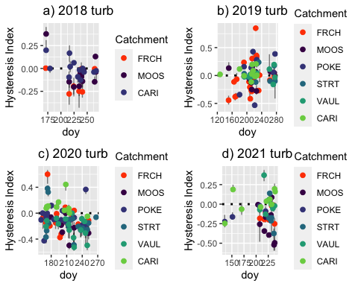 Doesn’t look like anything is too out of the ordinary

Make scatterplot matrix for each predictor on HI – color site ## Assessing model assumptions

Our next problem that we seem to have is that I say that the total precip totals for POKE seem to be higher than the rest of our gauges…..let us investigate that claim here:

#FRCH_RainGauge_2019.url <- "https://docs.google.com/spreadsheets/d/e/2PACX-1vRClQEChvrubY0D1iWXnZ8QQKY1NexCzcKHEC3XsnAmn4IlP2O2wUUOBoF9A1dOd-Fl5AeuPsUInZ12/pub?output=csv"  
#POKE_RainGauge_2019.url <- "https://docs.google.com/spreadsheets/d/e/2PACX-1vRClQEChvrubY0D1iWXnZ8QQKY1NexCzcKHEC3XsnAmn4IlP2O2wUUOBoF9A1dOd-Fl5AeuPsUInZ12/pub?output=csv"  
#VAUL_RainGauge_2019.url <- "https://docs.google.com/spreadsheets/d/e/2PACX-1vRKbGuJu7VV9oVxTC96mhlmV-VNiHmmSSEbrPaZEEbX7RJy3yHu8HO5ifx6VLLsLOr-qCPny5FjW3bU/pub?output=csv"  
  
#VAUL_RainGauge_2019 <- read.csv(url(VAUL_RainGauge_2019.url), skip = 1)  
#VAUL_RainGauge_2019 <- VAUL_RainGauge_2019[,-c(4:7)]  
  
#FRCH_RainGauge_2019 <- read.csv(url(FRCH_RainGauge_2019.url), skip = 1)  
#FRCH_RainGauge_2019 <- FRCH_RainGauge_2019[,-c(4:7)]  
  
#names(VAUL_RainGauge_2019) <- c("Site", "DateTimeGMT", "Precip")  
#VAUL_RainGauge_2019$Site <- "VAUL" # adding a site column  
#names(FRCH_RainGauge_2019) <- c("Site", "DateTimeGMT", "Precip")  
#FRCH_RainGauge_2019$Site <- "FRCH" # adding a site column  
  
  
#VAUL_RainGauge_2019$DateTime <- mdy_hms(VAUL_RainGauge_2019$DateTimeGMT, tz = "GMT")  
#attributes(VAUL_RainGauge_2019$DateTime)$tzone <- 'America/Anchorage'  
  
#FRCH_RainGauge_2019$DateTime <- mdy_hms(FRCH_RainGauge_2019$DateTimeGMT, tz = "GMT")  
#attributes(FRCH_RainGauge_2019$DateTime)$tzone <- 'America/Anchorage'  
  
#ggplot(VAUL_RainGauge_2019) +  
 # geom_line(aes(x = DateTime, y = Precip)) +  
# xlab("Date") +  
# ylab("Cumulative Precipitation (mm)") +  
# ggtitle("VAUL 2019 Rain Gauge")  
  
#ggplot(FRCH_RainGauge_2019) +  
# geom_line(aes(x = DateTime, y = Precip)) +  
# xlab("Date") +  
# ylab("Cumulative Precipitation (mm)") +  
# ggtitle("FRCH 2019 Rain Gauge")  
  
#rain.gauge.2019 <- bind_rows(VAUL_RainGauge_2019, FRCH_RainGauge_2019)  
  
  
  
#total.precip.2019 <- ggplot(rain.gauge.2019) +  
# geom_line(aes(x = DateTime, y = Precip, color = Site)) +  
# xlab("Date") +   
# ylab("Cumulative Precipitation in cm") +  
# ggtitle("STRT FRCH VAUL Rain Gauge")  
#total.precip.2019  
  
  
#range(FRCH_RainGauge_2019$Datetime)  
#range(POKE_RainGauge_2019$DateTime)  
#range(VAUL_RainGauge_2019$DateTime)  
  
#sum(FRCH_RainGauge_2019$inst_rainfall_mm)  
#sum(POKE_RainGauge_2019$inst_rainfall_mm)  
#sum(VAUL_RainGauge_2019$inst_rainfall_mm)

This is showing that we may have a pretty sizeable difference in precip totals across site

### This script reads in and plots Rain Gauge data at FRCH, STRT, VAUL, CARI, CRREL sites for 2020 from our HOBOs and POKE from LTER data ###  
  
#Step 1: Import raw data from HOBOware # File path directory DoD Project->2020 AK Sensors-> Rain Gauge-> "site"  
#Step 2: Plot data # HOBOware data comes in the form of cumulative precip....you have to put it in instanteous 15 minute intervals  
#Step 3: output csv with Site, DateTime, and Precip  
  
### Import Data from our sites ###  
### This script reads in and plots Rain Gauge data at FRCH, STRT, VAUL, CARI, CRREL sites for 2020 from our HOBOs and POKE from LTER data ###  
  
#Step 1: Import raw data from HOBOware # File path directory DoD Project->2020 AK Sensors-> Rain Gauge-> "site"  
#Step 2: Plot data # HOBOware data comes in the form of cumulative precip....you have to put it in instanteous 15 minute intervals  
#Step 3: output csv with Site, DateTime, and Precip  
  
### Import Data from our sites ###  
#strt.2020.url <- "https://docs.google.com/spreadsheets/d/e/2PACX-1vT05dgyg07MOSVdaEFFywTuktj7TTY0ukYjp5ZckRTP5BJ9dFaq5fT0MppdTchBJseTlLSzoyuLbWNS/pub?output=csv"  
#frch.2020.url <- "https://docs.google.com/spreadsheets/d/e/2PACX-1vSXjY8hE7y3xpQs42ce8tTuqxadD-9GSLdlzmlzapcdxZoYwZ0M3GOjrQfKshj5Cw1XlPMICGK2v51L/pub?output=csv"  
#vaul.2020.url <- "https://docs.google.com/spreadsheets/d/e/2PACX-1vTd-IH6XcwWpzDQav6eQO5NBzV2XB3XzCwJdxHarSiOniu57EoqegV8vU4eF8bo_8REcr8SxsXaDMpR/pub?output=csv"  
### from CPCRW Caribou Peak Met Station ###  
#caribou.2020.url <- "https://docs.google.com/spreadsheets/d/e/2PACX-1vSYvitZk-JWF9bNRKvg2EWyAzt3YPPnWm3UioUEEyoMXaUkZSJRov-R0bk9nMOoXP1CcyyBtELi1_ZF/pub?output=csv"  
### from CPCRW CRREL Main Met Station ###  
#crrel.2020.url <- "https://docs.google.com/spreadsheets/d/e/2PACX-1vTNOk0Gqqc-CqnXO220DIWIeGP9RQLMNEC54QAn-civk5a6Fb_Y3Z3oBNpJNAni46foqRkyytes9GT8/pub?output=csv"  
  
# read in data #   
#strt.2020.gauge <- read.csv(url(strt.2020.url), skip = 1)  
#frch.2020.gauge <- read.csv(url(frch.2020.url), skip = 1)   
#vaul.2020.gauge <- read.csv(url(vaul.2020.url), skip = 1)  
#caribou.2020.gauge <- read.csv(url(caribou.2020.url), skip = 4)  
#crrel.2020.gauge <- read.csv(url(crrel.2020.url), skip = 4)  
  
#caribou.2020.gauge$Site <- "CARI" # adding a site column  
#crrel.2020.gauge$Site <- "CRREL" # adding a site column  
### Rename columns ###  
#names(strt.2020.gauge) <- c("Site", "DateTimeGMT", "Precip")  
#names(frch.2020.gauge) <- c("Site", "DateTimeGMT", "Precip")  
#names(vaul.2020.gauge) <- c("Site", "DateTimeGMT", "Precip")  
#names(caribou.2020.gauge) <- c("DateTimeGMT", "Precip", "Site")  
#names(crrel.2020.gauge) <- c("DateTimeGMT", "Precip", "Site")  
  
#strt.2020.gauge$Site <- "STRT" # adding a site column  
#frch.2020.gauge$Site <- "FRCH" # adding a site column  
#vaul.2020.gauge$Site <- "VAUL" # adding a site column  
  
# Input NA for missing time #  
#strt.2020.gauge$DateTimeGMT[strt.2020.gauge$DateTimeGMT == ""] <- NA  
#frch.2020.gauge$DateTimeGMT[frch.2020.gauge$DateTimeGMT == ""] <- NA  
#vaul.2020.gauge$DateTimeGMT[vaul.2020.gauge$DateTimeGMT == ""] <- NA  
#caribou.2020.gauge$DateTimeGMT[caribou.2020.gauge$DateTimeGMT == ""] <- NA  
#crrel.2020.gauge$DateTimeGMT[crrel.2020.gauge$DateTimeGMT == ""] <- NA  
  
  
# Convert time and put in AK time #  
#strt.2020.gauge$DateTime <- mdy_hms(strt.2020.gauge$DateTimeGMT, tz = "GMT")  
#attributes(strt.2020.gauge$DateTime)$tzone <- 'America/Anchorage'  
  
#frch.2020.gauge$DateTime <- mdy_hms(frch.2020.gauge$DateTimeGMT, tz = "GMT")  
#attributes(frch.2020.gauge$DateTime)$tzone <- 'America/Anchorage'  
  
#vaul.2020.gauge$DateTime <- mdy_hms(vaul.2020.gauge$DateTimeGMT, tz = "GMT")  
#attributes(vaul.2020.gauge$DateTime)$tzone <- 'America/Anchorage'  
  
#caribou.2020.gauge$DateTime = as.POSIXct(caribou.2020.gauge$DateTimeGMT, "%m/%d/%y %H:%M", tz="America/Anchorage")  
#crrel.2020.gauge$DateTime = as.POSIXct(crrel.2020.gauge$DateTimeGMT, "%m/%d/%y %H:%M", tz="America/Anchorage")  
  
# Plot data #  
#STRT.2020.RAIN <- ggplot(strt.2020.gauge) +  
 # geom_line(aes(x = DateTime, y = Precip)) +  
 #xlab("Date") +  
 #ylab("Cumulative Precipitation (mm)") +  
 #ggtitle("Stuart 2020 Rain Gauge")  
  
#STRT.2020.RAIN  
  
#FRCH.2020.RAIN <- ggplot(frch.2020.gauge) +   
 # geom_line(aes(x = DateTime, y = Precip)) +  
 #xlab("Date") +  
#ylab("Cumulative Precipitation (mm)") +  
 # ggtitle("French 2020 Rain Gauge")  
#FRCH.2020.RAIN  
  
#VAUL.2020.RAIN <- ggplot(vaul.2020.gauge) +  
# geom_line(aes(x = DateTime, y = Precip)) +  
# xlab("Date") +  
# ylab("Cumulative Precipitation (mm)") +  
# ggtitle("Vault 2020 Rain Gauge")  
#VAUL.2020.RAIN  
  
#CARI.2020.RAIN <- ggplot(caribou.2020.gauge) +  
# geom_line(aes(x = DateTime, y = Precip)) +  
# xlab("Date") +  
# ylab("Instanteous Precipitation (mm)") +  
# ggtitle("CPCRW CARI 2020 Rain Gauge")  
#CARI.2020.RAIN  
  
#CRREL.2020.RAIN <- ggplot(crrel.2020.gauge) +  
# geom_line(aes(x = DateTime, y = Precip)) +  
# xlab("Date") +  
# ylab("Instanteous Precipitation (mm)") +  
# ggtitle("CPCRW CRREL 2020 Rain Gauge")  
#CRREL.2020.RAIN  
  
# Bind Together # Poker is going to be the average between these two rain gauges  
#poke.2020.gauge <- data.frame(caribou.2020.gauge$DateTime, crrel.2020.gauge$Precip, #caribou.2020.gauge$Precip)  
#poke.2020.gauge$MeanPrecip <- rowMeans(poke.2020.gauge[,c('crrel.2020.gauge.Precip', 'caribou.2020.gauge.Precip')], na.rm = TRUE)  
#poke.2020.gauge$Site <- "POKE"  
#names(poke.2020.gauge) <- c("DateTime", "CRREL_Precip", "CARI_Precip", "inst_rainfall_mm", "Site")  
  
## STRT ## turn into instantaneous precip  
#strt.2020.gauge$inst_rainfall_mm = 0.2  
  
## FRCH ##  
#frch.2020.gauge$inst_rainfall_mm = 0.2  
  
## VAUL ##  
#vaul.2020.gauge$inst_rainfall_mm = 0.2  
  
  
#### compile into per 15 min rainfall ###  
  
## FRCH ##  
#min<-cut(frch.2020.gauge$DateTime, breaks="15 min")  
#FRCH.2020.st <- as.data.frame(aggregate(inst_rainfall_mm ~ min, data = frch.2020.gauge, FUN=function(x)   
# sum=sum(x)))  
#FRCH.2020.st$DateTime<-as.POSIXct(FRCH.2020.st$min, "%Y-%m-%d %H:%M:%S", tz="America/Anchorage")  
  
## STRT ## adding FRCH data to data frame because STRT didnt have a rain gauge there until the 7/29/20  
#min<-cut(strt.2020.gauge$DateTime, breaks="15 min")  
#STRT.2020.st <- as.data.frame(aggregate(inst_rainfall_mm ~ min, data = strt.2020.gauge, FUN=function(x)   
# sum=sum(x)))  
#STRT.2020.st$DateTime <-as.POSIXct(STRT.2020.st$min, "%Y-%m-%d %H:%M:%S", tz="America/Anchorage")  
  
#STRT.FRCH <- FRCH.2020.st[-c(438:677), ] #clipping off 7/29-on   
  
#STRT.2020.st <- full_join(STRT.FRCH, STRT.2020.st, by = c("DateTime")) #merging FRCH and STRT  
#STRT.2020.st$inst_rainfall_mm <- rowMeans(STRT.2020.st[,c(2,5)], na.rm = TRUE)   
  
## VAUL ##  
#min<-cut(vaul.2020.gauge$DateTime, breaks="15 min")  
#VAUL.2020.st <- as.data.frame(aggregate(inst_rainfall_mm ~ min, data=vaul.2020.gauge, FUN=function(x)   
# sum=sum(x)))  
#VAUL.2020.st$DateTime<-as.POSIXct(VAUL.2020.st$min, "%Y-%m-%d %H:%M:%S", tz="America/Anchorage")#  
  
#VAUL.FRCH <- FRCH.2020.st[-c(175:677)] #clipping off 6-22 on  
  
#VAUL.2020.st <- full_join(VAUL.FRCH, VAUL.2020.st) #merging FRCH and VAUL  
  
  
#### round time to nearest 15 min ####  
#STRT.2020.st$DateTime = lubridate::round_date(STRT.2020.st$DateTime, "15 minutes")  
#FRCH.2020.st$DateTime = lubridate::round_date(FRCH.2020.st$DateTime, "15 minutes")  
#VAUL.2020.st$DateTime = lubridate::round_date(VAUL.2020.st$DateTime, "15 minutes")  
  
### Remove columns that are not needed ###  
#STRT.2020.st <- STRT.2020.st[,-c(1,2,4,5)]  
#FRCH.2020.st <- FRCH.2020.st[,-c(1)]  
#VAUL.2020.st <- VAUL.2020.st[,-c(1)]  
#poke.2020.gauge <- poke.2020.gauge[,-c(2,3)]  
#STRT.2020.st$Site <- "STRT"  
#FRCH.2020.st$Site <- "FRCH"  
#VAUL.2020.st$Site <- "VAUL"  
#### plot to check ####  
#plot(STRT.2020.st$inst_rainfall_mm ~ STRT.2020.st$DateTime, type="h",   
# xlim=c(as.POSIXct("2020-06-05 00:00:00"), as.POSIXct("2020-10-21 00:00:00")),  
# ylim=c(0,13))  
  
#plot(FRCH.2020.st$inst_rainfall_mm ~ FRCH.2020.st$DateTime, type="h",   
# xlim=c(as.POSIXct("2020-06-05 00:00:00"), as.POSIXct("2020-10-21 00:00:00")),  
# ylim=c(0,13))  
  
#plot(VAUL.2020.st$inst_rainfall_mm ~ VAUL.2020.st$DateTime, type="h",   
# xlim=c(as.POSIXct("2020-06-05 00:00:00"), as.POSIXct("2020-10-21 00:00:00")),  
# ylim=c(0,13))  
  
  
  
#rain.gauge.2020 <- bind_rows(strt.2020.gauge, frch.2020.gauge, vaul.2020.gauge, poke.2020.gauge)#  
  
#sum(frch.2020.gauge$inst_rainfall_mm)  
#sum(poke.2020.gauge$inst_rainfall_mm)  
  
#total.precip.2020 <- ggplot(rain.gauge.2020) +  
## geom_line(aes(x = DateTime, y = Precip, color = Site)) +  
# xlab("Date") +   
# ylab("Cumulative Precipitation in cm") +  
# ggtitle("STRT FRCH VAUL Rain Gauge")  
#total.precip.2020

Summing the total precip for FRCH and POKE and Poker (CRREL and CARI combined and averaged) has almost 40 mm more of rain in 2020 then FRCH. Does this mean that our rain guages are less sensitive or does this fall in the range of rainfall across space?

#### Scatter plot matrix

ADD IN R^2 value to see if you can get any sense of this!

NO3_data.1 <- HI_FI_NO3[,c("Hyst_index","StormPrecip")]  
  
pairs(NO3_data.1)

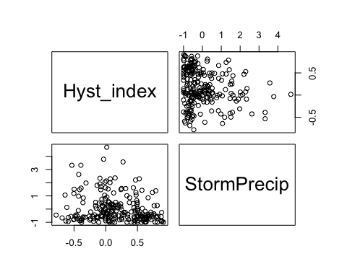

HI_FI_NO3 %>% ggplot(aes(x = StormPrecip, y = Hyst_index)) +   
 geom_hline(yintercept = 0, linetype = "dotted", size = 1) +  
 geom_errorbar(aes(ymin=HI_ymin, ymax=HI_ymax), colour="black", alpha=0.5, size=.5, width = 0.1)+   
 geom_point(aes(color = site.ID), size = 2) +  
 scale_color_manual(values = c("orange red", viridis::viridis(6)), "Catchment")+  
 geom_smooth(method = "lm", na.rm = TRUE, fullrange = TRUE, aes(group = 1)) +   
 stat_poly_eq(formula = y~x,  
 label.y = "top", label.x = "right",  
 aes(label = paste(..eq.label.., ..rr.label.., sep = "~~~")),   
 parse = TRUE) +   
 ylab("Hysteresis Index") +  
 ggtitle("HI vs. StormPrecip")

## `geom_smooth()` using formula 'y ~ x'

## Warning: Removed 5 rows containing non-finite values (stat_poly_eq).

## Warning: Removed 5 rows containing missing values (geom_point).

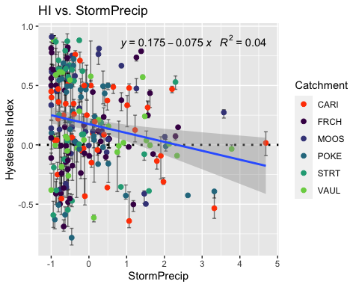

NO3_data.2 <- HI_FI_NO3[,c("Hyst_index","PrecipWeek")]  
  
pairs(NO3_data.2)

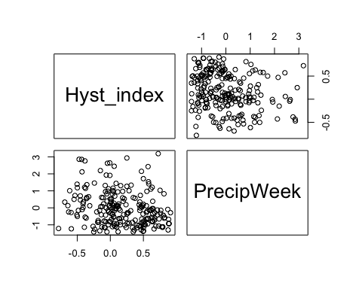

HI_FI_NO3 %>% ggplot(aes(x = PrecipWeek, y = Hyst_index)) +   
 geom_hline(yintercept = 0, linetype = "dotted", size = 1) +  
 geom_errorbar(aes(ymin=HI_ymin, ymax=HI_ymax), colour="black", alpha=0.5, size=.5, width = 0.1)+   
 geom_point(aes(color = site.ID), size = 2) +  
 scale_color_manual(values = c("orange red", viridis::viridis(6)), "Catchment")+  
 geom_smooth(method = "lm", na.rm = TRUE, fullrange = TRUE, aes(group = 1)) +   
 stat_poly_eq(formula = y~x,  
 label.y = "top", label.x = "right",  
 aes(label = paste(..eq.label.., ..rr.label.., sep = "~~~")),   
 parse = TRUE) +   
 ylab("Hysteresis Index") +  
 ggtitle("HI vs. PrecipWeek")

## `geom_smooth()` using formula 'y ~ x'

## Warning: Removed 5 rows containing non-finite values (stat_poly_eq).

## Warning: Removed 5 rows containing missing values (geom_point).

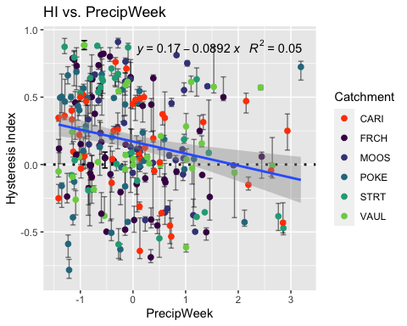

NO3_data.3 <- HI_FI_NO3[,c("Hyst_index","PrecipMonth")]  
  
pairs(NO3_data.3)

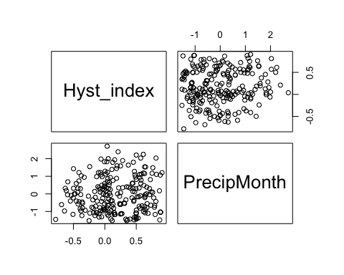

HI_FI_NO3 %>% ggplot(aes(x = PrecipMonth, y = Hyst_index)) +   
 geom_hline(yintercept = 0, linetype = "dotted", size = 1) +  
 geom_errorbar(aes(ymin=HI_ymin, ymax=HI_ymax), colour="black", alpha=0.5, size=.5, width = 0.1)+   
 geom_point(aes(color = site.ID), size = 2) +  
 scale_color_manual(values = c("orange red", viridis::viridis(6)), "Catchment")+  
 geom_smooth(method = "lm", na.rm = TRUE, fullrange = TRUE, aes(group = 1)) +   
 stat_poly_eq(formula = y~x,  
 label.y = "top", label.x = "right",  
 aes(label = paste(..eq.label.., ..rr.label.., sep = "~~~")),   
 parse = TRUE) +   
 ylab("Hysteresis Index") +  
 ggtitle("HI vs. PrecipMonth")

## `geom_smooth()` using formula 'y ~ x'

## Warning: Removed 5 rows containing non-finite values (stat_poly_eq).

## Warning: Removed 5 rows containing missing values (geom_point).

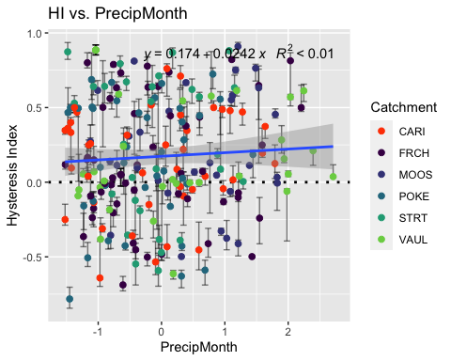

NO3_data.4 <- HI_FI_NO3[,c("Hyst_index","ThreeMonth")]  
  
pairs(NO3_data.4)

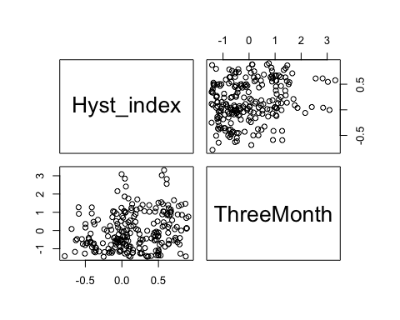

HI_FI_NO3_CARI <- filter(HI_FI_NO3, site.ID == "CARI")  
HI_FI_NO3_FRCH <- filter(HI_FI_NO3, site.ID == "FRCH")  
HI_FI_NO3_MOOS <- filter(HI_FI_NO3, site.ID == "MOOS")  
HI_FI_NO3_POKE <- filter(HI_FI_NO3, site.ID == "POKE")  
HI_FI_NO3_VAUL <- filter(HI_FI_NO3, site.ID == "VAUL")  
HI_FI_NO3_STRT <- filter(HI_FI_NO3, site.ID == "STRT")  
  
HI_FI_NO3_CARI %>% ggplot(aes(x = ThreeMonth, y = Hyst_index)) +  
 geom_hline(yintercept = 0, linetype = "dotted", size = 1) +  
 geom_errorbar(aes(ymin=HI_ymin, ymax=HI_ymax), colour="black", alpha=0.5, size=.5, width = 0.1)+   
 geom_point(aes(color = year), size = 2)

## Warning: Removed 1 rows containing missing values (geom_point).

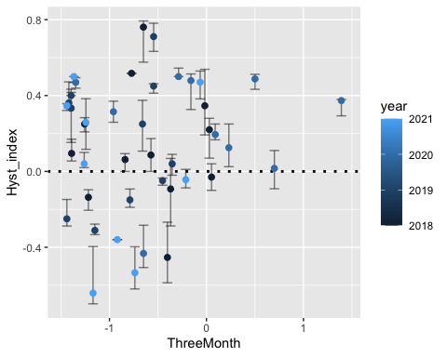

HI_FI_NO3_FRCH %>% ggplot(aes(x = ThreeMonth, y = Hyst_index)) +  
 geom_hline(yintercept = 0, linetype = "dotted", size = 1) +  
 geom_errorbar(aes(ymin=HI_ymin, ymax=HI_ymax), colour="black", alpha=0.5, size=.5, width = 0.1)+   
 geom_point(aes(color = year), size = 2)

## Warning: Removed 2 rows containing missing values (geom_point).

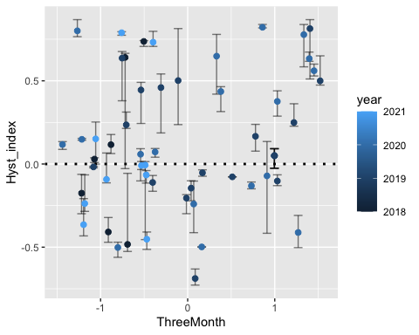

HI_FI_NO3_MOOS %>% ggplot(aes(x = ThreeMonth, y = Hyst_index)) +  
 geom_hline(yintercept = 0, linetype = "dotted", size = 1) +  
 geom_errorbar(aes(ymin=HI_ymin, ymax=HI_ymax), colour="black", alpha=0.5, size=.5, width = 0.1)+   
 geom_point(aes(color = year), size = 2)

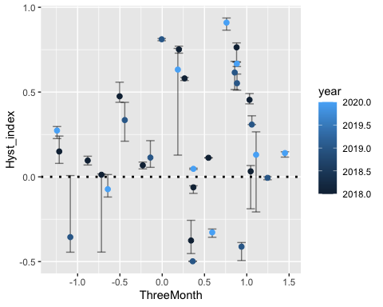

HI_FI_NO3_POKE %>% ggplot(aes(x = ThreeMonth, y = Hyst_index)) +  
 geom_hline(yintercept = 0, linetype = "dotted", size = 1) +  
 geom_errorbar(aes(ymin=HI_ymin, ymax=HI_ymax), colour="black", alpha=0.5, size=.5, width = 0.1)+   
 geom_point(aes(color = year), size = 2)

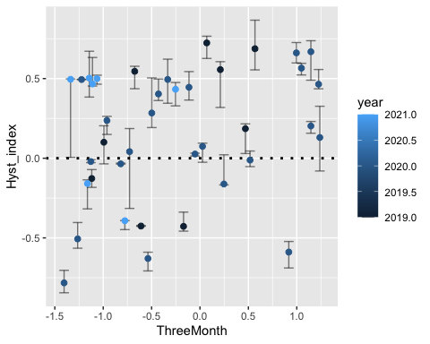

HI_FI_NO3_VAUL %>% ggplot(aes(x = ThreeMonth, y = Hyst_index)) +  
 geom_hline(yintercept = 0, linetype = "dotted", size = 1) +  
 geom_errorbar(aes(ymin=HI_ymin, ymax=HI_ymax), colour="black", alpha=0.5, size=.5, width = 0.1)+   
 geom_point(aes(color = year), size = 2)

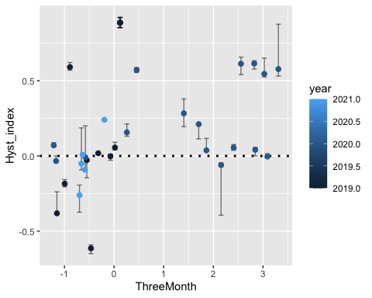

HI_FI_NO3_STRT %>% ggplot(aes(x = ThreeMonth, y = Hyst_index)) +  
 geom_hline(yintercept = 0, linetype = "dotted", size = 1) +  
 geom_errorbar(aes(ymin=HI_ymin, ymax=HI_ymax), colour="black", alpha=0.5, size=.5, width = 0.1)+   
 geom_point(aes(color = year), size = 2)

## Warning: Removed 2 rows containing missing values (geom_point).

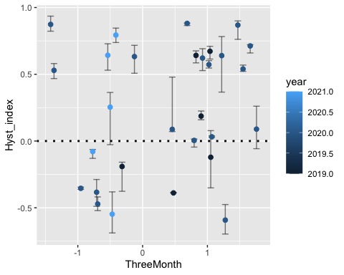

HI_FI_NO3 %>% ggplot(aes(x = ThreeMonth, y = Hyst_index)) +   
 geom_hline(yintercept = 0, linetype = "dotted", size = 1) +  
 geom_errorbar(aes(ymin=HI_ymin, ymax=HI_ymax), colour="black", alpha=0.5, size=.5, width = 0.1)+   
 geom_point(aes(color = site.ID), size = 2) +  
 scale_color_manual(values = c("orange red", viridis::viridis(6)), "Catchment")+  
 geom_smooth(method = "lm", na.rm = TRUE, fullrange = TRUE, aes(group = 1)) +   
 stat_poly_eq(formula = y~x,  
 label.y = "top", label.x = "right",  
 aes(label = paste(..eq.label.., ..rr.label.., sep = "~~~")),   
 parse = TRUE) +   
 ylab("Hysteresis Index") +  
 ggtitle("HI vs. ThreeMonth")

## `geom_smooth()` using formula 'y ~ x'

## Warning: Removed 5 rows containing non-finite values (stat_poly_eq).

## Warning: Removed 5 rows containing missing values (geom_point).

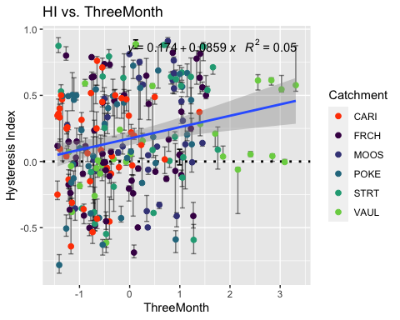 Caribou potentially not right

NO3_data.5 <- HI_FI_NO3[,c("Hyst_index","Intensity")]  
  
HI_FI_NO3 %>% ggplot(aes(x = Intensity, y = Hyst_index)) +   
 geom_hline(yintercept = 0, linetype = "dotted", size = 1) +  
 geom_errorbar(aes(ymin=HI_ymin, ymax=HI_ymax), colour="black", alpha=0.5, size=.5, width = 0.1)+   
 geom_point(aes(color = site.ID), size = 2) +  
 scale_color_manual(values = c("orange red", viridis::viridis(6)), "Catchment")+  
 ylab("Hysteresis Index") +  
 ggtitle("HI vs. Intensity")

## Warning: Removed 11 rows containing missing values (geom_point).

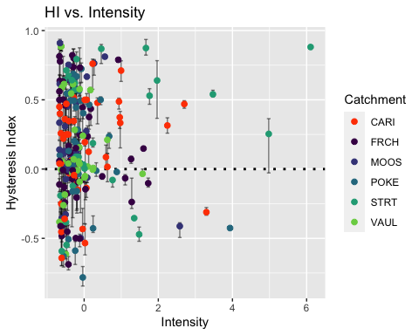

pairs(NO3_data.5)

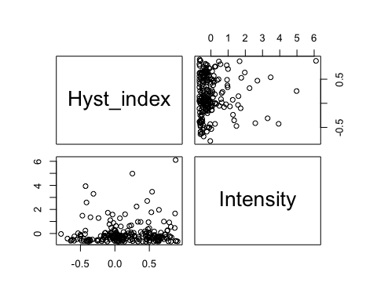

which(HI_FI_NO3$Intensity > 1.5)

## [1] 45 60 67 97 106 154 155 161 165 168 173 188 189 221

HI_FI_NO3.low <- HI_FI_NO3[-c(45,60,67,97,106,154,155,161,165,168,173,188,189,221), ]  
which(HI_FI_NO3.low$Intensity > 1.0)

## [1] 104 149 151 187 195

#HI_FI_NO3.low <- HI_FI_NO3.low[-c(42, 71, 89, 92, 137, 138, 139, 140, 145, 147, 152, 176), ]  
  
NO3_data.5 <- HI_FI_NO3.low[,c("Hyst_index","Intensity")]  
  
pairs(NO3_data.5)

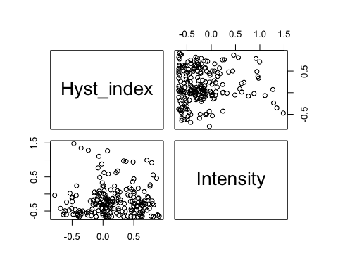 I removed some storms that were way higher in intensity then any other storm

NO3_data.6 <- HI_FI_NO3[,c("Hyst_index","StormTemp")]  
  
pairs(NO3_data.6)

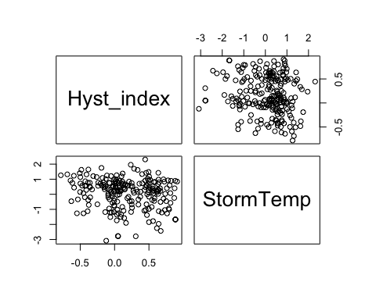

HI_FI_NO3 %>% ggplot(aes(x = StormTemp, y = Hyst_index)) +   
 geom_hline(yintercept = 0, linetype = "dotted", size = 1) +  
 geom_errorbar(aes(ymin=HI_ymin, ymax=HI_ymax), colour="black", alpha=0.5, size=.5, width = 0.1)+   
 geom_point(aes(color = site.ID), size = 2) +  
 scale_color_manual(values = c("orange red", viridis::viridis(6)), "Catchment")+  
 geom_smooth(method = "lm", na.rm = TRUE, fullrange = TRUE, aes(group = 1)) +   
 stat_poly_eq(formula = y~x,  
 label.y = "top", label.x = "right",  
 aes(label = paste(..eq.label.., ..rr.label.., sep = "~~~")),   
 parse = TRUE) +   
 ylab("Hysteresis Index") +  
 ggtitle("HI vs. StormTemp")

## `geom_smooth()` using formula 'y ~ x'

## Warning: Removed 5 rows containing non-finite values (stat_poly_eq).

## Warning: Removed 5 rows containing missing values (geom_point).

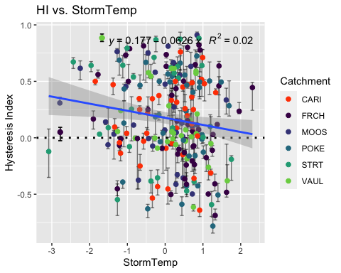

NO3_data.7 <- HI_FI_NO3[,c("Hyst_index","TempWeek")]  
  
pairs(NO3_data.7)

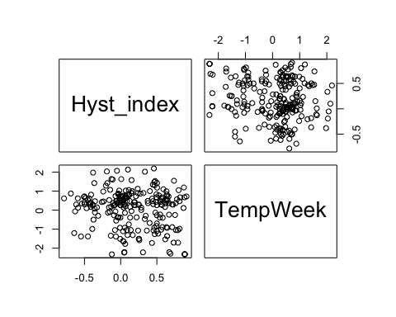

HI_FI_NO3 %>% ggplot(aes(x = TempWeek, y = Hyst_index)) +   
 geom_hline(yintercept = 0, linetype = "dotted", size = 1) +  
 geom_errorbar(aes(ymin=HI_ymin, ymax=HI_ymax), colour="black", alpha=0.5, size=.5, width = 0.1)+   
 geom_point(aes(color = site.ID), size = 2) +  
 scale_color_manual(values = c("orange red", viridis::viridis(6)), "Catchment")+  
 geom_smooth(method = "lm", na.rm = TRUE, fullrange = TRUE, aes(group = 1)) +   
 stat_poly_eq(formula = y~x,  
 label.y = "top", label.x = "right",  
 aes(label = paste(..eq.label.., ..rr.label.., sep = "~~~")),   
 parse = TRUE) +   
 ylab("Hysteresis Index") +  
 ggtitle("HI vs. StormTemp")

## `geom_smooth()` using formula 'y ~ x'

## Warning: Removed 7 rows containing non-finite values (stat_poly_eq).

## Warning: Removed 7 rows containing missing values (geom_point).

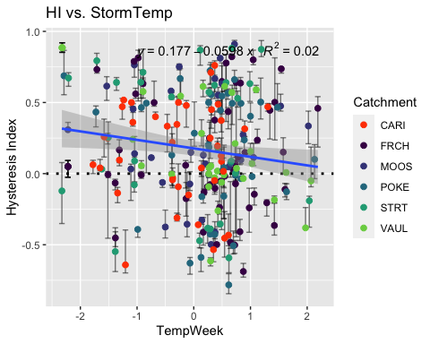

NO3_data.8 <- HI_FI_NO3[,c("Hyst_index","TimeSinceChena")]  
  
pairs(NO3_data.8)

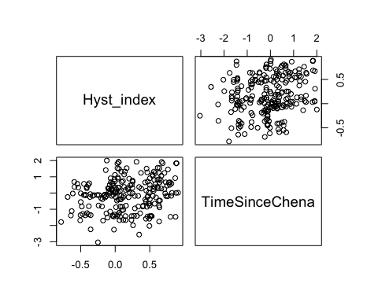

HI_FI_NO3 %>% ggplot(aes(x = TimeSinceChena, y = Hyst_index)) +   
 geom_hline(yintercept = 0, linetype = "dotted", size = 1) +  
 geom_errorbar(aes(ymin=HI_ymin, ymax=HI_ymax), colour="black", alpha = 0.5, size=.5, width = 0.1)+   
 geom_point(aes(color = site.ID, shape = as.factor(year)), size = 2) +  
 scale_color_manual(values = c("orange red", viridis::viridis(6)), "Catchment")+  
 geom_smooth(method = "lm", na.rm = TRUE, fullrange = TRUE, aes(group = 1)) +   
 stat_poly_eq(formula = y~x,  
 label.y = "top", label.x = "right",  
 aes(label = paste(..eq.label.., ..rr.label.., sep = "~~~")),   
 parse = TRUE) +   
 ylab("Hysteresis Index") +  
 ggtitle("HI vs. StormTemp")

## `geom_smooth()` using formula 'y ~ x'

## Warning: Removed 6 rows containing non-finite values (stat_poly_eq).

## Warning: Removed 6 rows containing missing values (geom_point).

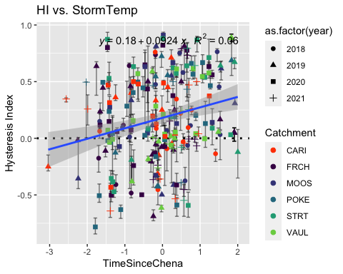

#### Correlation

NO3_data <- HI_FI_NO3[,c("Hyst_index", "site.ID", "StormPrecip", "StormTemp", "PrecipWeek", "PrecipMonth", "ThreeMonth", "TempWeek", "Intensity", "TimeSinceChena", "pf", "burn")]  
NO3_data <- na.omit(NO3_data) # 236 to 223 rows   
cor(NO3_data[,c(1,3:10)])

## Hyst_index StormPrecip StormTemp PrecipWeek PrecipMonth  
## Hyst_index 1.00000000 -0.17847192 -0.16998981 -0.23606673 0.05047384  
## StormPrecip -0.17847192 1.00000000 0.06814589 0.10449381 0.01598572  
## StormTemp -0.16998981 0.06814589 1.00000000 0.04353449 0.11718532  
## PrecipWeek -0.23606673 0.10449381 0.04353449 1.00000000 0.51123221  
## PrecipMonth 0.05047384 0.01598572 0.11718532 0.51123221 1.00000000  
## ThreeMonth 0.22438632 -0.12227358 -0.30044458 0.15172851 0.59092558  
## TempWeek -0.16372058 0.15564183 0.79501278 0.12388460 0.15189251  
## Intensity 0.04473246 0.39214631 0.09708140 -0.05152409 -0.03687383  
## TimeSinceChena 0.25237468 -0.14261959 -0.73673743 -0.12658710 0.11779527  
## ThreeMonth TempWeek Intensity TimeSinceChena  
## Hyst_index 0.2243863 -0.1637206 0.04473246 0.25237468  
## StormPrecip -0.1222736 0.1556418 0.39214631 -0.14261959  
## StormTemp -0.3004446 0.7950128 0.09708140 -0.73673743  
## PrecipWeek 0.1517285 0.1238846 -0.05152409 -0.12658710  
## PrecipMonth 0.5909256 0.1518925 -0.03687383 0.11779527  
## ThreeMonth 1.0000000 -0.2012055 -0.07228910 0.61942410  
## TempWeek -0.2012055 1.0000000 0.10541534 -0.62352435  
## Intensity -0.0722891 0.1054153 1.00000000 -0.07368816  
## TimeSinceChena 0.6194241 -0.6235243 -0.07368816 1.00000000

1. Storm temperature is heavily correlated with temperature a week leading up to a storm (0.794) but storm temperature is slightly more correlated with HI (-0.173 vs. -0.164)
2. Storm temperature is also correlated with time since chena (-0.735) but time since chena is more correlated with HI (0.251 vs. -0.173) so this makes me want to keep Time since Chena and temperature a week before considering that is a more marginal comparison with HI and the temperature predictors.

3)Precip week is correlated with precip month (0.511) but precip week is more correlated with HI than precip month (-0.242 vs. 0.048)

4)Precip month is correlated with three month precip (0.591) but three month precip is more correlated with HI (0.220 vs. 0.048)

1. Three month is correlated with Time since Chena (0.619) but time since chena is more correlated with HI (0.251 vs. 0.220)

* to sum up this makes me want to drop storm temperature and three month precipitation…..but lets run the model with all of the candidate predictors first and go from there

## boundary (singular) fit: see ?isSingular

## Linear mixed model fit by REML ['lmerMod']  
## Formula: Hyst_index ~ StormPrecip + PrecipWeek + PrecipMonth + ThreeMonth +   
## Intensity + StormTemp + TempWeek + TimeSinceChena + (1 | site.ID)  
## Data: NO3_data  
##   
## REML criterion at convergence: 224.5  
##   
## Scaled residuals:   
## Min 1Q Median 3Q Max   
## -2.74443 -0.78353 0.02575 0.78597 2.44148   
##   
## Random effects:  
## Groups Name Variance Std.Dev.  
## site.ID (Intercept) 0.0000 0.0000   
## Residual 0.1362 0.3691   
## Number of obs: 222, groups: site.ID, 6  
##   
## Fixed effects:  
## Estimate Std. Error t value  
## (Intercept) 0.178291 0.024861 7.171  
## StormPrecip -0.067986 0.027522 -2.470  
## PrecipWeek -0.122049 0.031664 -3.854  
## PrecipMonth 0.063442 0.040587 1.563  
## ThreeMonth 0.048222 0.042461 1.136  
## Intensity 0.054413 0.029815 1.825  
## StormTemp -0.052225 0.050106 -1.042  
## TempWeek -0.001190 0.042070 -0.028  
## TimeSinceChena 0.001565 0.049751 0.031  
##   
## Correlation of Fixed Effects:  
## (Intr) StrmPr PrcpWk PrcpMn ThrMnt Intnst StrmTm TempWk  
## StormPrecip -0.027   
## PrecipWeek -0.004 -0.071   
## PrecipMonth 0.032 -0.052 -0.506   
## ThreeMonth -0.042 0.084 0.062 -0.570   
## Intensity 0.021 -0.394 0.065 0.019 0.002   
## StormTemp -0.054 0.142 0.262 -0.226 -0.016 -0.072   
## TempWeek 0.009 -0.145 -0.070 0.010 -0.111 0.002 -0.595   
## TimeSincChn -0.007 0.047 0.250 0.005 -0.543 -0.041 0.494 0.125  
## optimizer (nloptwrap) convergence code: 0 (OK)  
## boundary (singular) fit: see ?isSingular

1. Scaled residulas look pretty good as our median is close to 0 and our quartiles are roughly the same
2. This shows us that the site explains 0 of our variance which doesn’t make complete sence
3. This makes it seem that precip week and storm precip are the most significant in HI which doesnt make sense when we have time since chena as the highest cor factor with HI

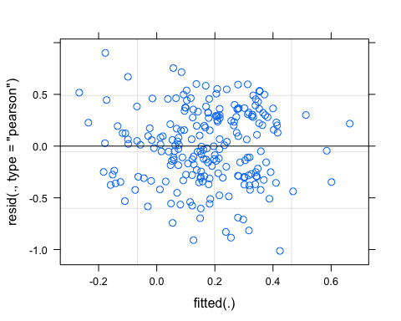 1) Ideally the residual plot will show no fitted pattern. The red line should be horizontal at 0.

This residual are spread equally along the ranges of predictors. It is good to see a horizontal line with equal spread points

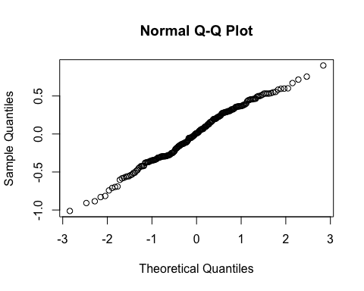 1) Ideally the QQ plot should be a straight line to visually check the normality assumptions. If it is not a straight line we can try log transforming the response variable but this looks pretty good.

vif(M0)

## StormPrecip PrecipWeek PrecipMonth ThreeMonth Intensity   
## 1.258251 1.581980 2.531812 3.019358 1.204633   
## StormTemp TempWeek TimeSinceChena   
## 4.167627 2.903478 4.013561

Anything above a 2 indicates a high correlation and should be removed….lets take StormTemp out and ThreeMonth

f1 <- formula(Hyst_index ~ StormPrecip + PrecipWeek + PrecipMonth + Intensity + TempWeek + TimeSinceChena + (1|site.ID))  
  
M1 <- lmer(f1, data = NO3_data)

## boundary (singular) fit: see ?isSingular

summary(M1)

## Linear mixed model fit by REML ['lmerMod']  
## Formula: Hyst_index ~ StormPrecip + PrecipWeek + PrecipMonth + Intensity +   
## TempWeek + TimeSinceChena + (1 | site.ID)  
## Data: NO3_data  
##   
## REML criterion at convergence: 218.2  
##   
## Scaled residuals:   
## Min 1Q Median 3Q Max   
## -2.74347 -0.72905 0.02232 0.80515 2.26066   
##   
## Random effects:  
## Groups Name Variance Std.Dev.  
## site.ID (Intercept) 0.0000 0.0000   
## Residual 0.1364 0.3693   
## Number of obs: 222, groups: site.ID, 6  
##   
## Fixed effects:  
## Estimate Std. Error t value  
## (Intercept) 0.17807 0.02482 7.174  
## StormPrecip -0.06659 0.02716 -2.452  
## PrecipWeek -0.11574 0.03051 -3.793  
## PrecipMonth 0.07995 0.03198 2.500  
## Intensity 0.05216 0.02976 1.752  
## TempWeek -0.02159 0.03345 -0.645  
## TimeSinceChena 0.05700 0.03410 1.671  
##   
## Correlation of Fixed Effects:  
## (Intr) StrmPr PrcpWk PrcpMn Intnst TempWk  
## StormPrecip -0.016   
## PrecipWeek 0.013 -0.120   
## PrecipMonth -0.006 0.039 -0.540   
## Intensity 0.017 -0.390 0.088 0.004   
## TempWeek -0.037 -0.064 0.122 -0.309 -0.051   
## TimeSincChn -0.005 0.035 0.236 -0.354 -0.008 0.652  
## optimizer (nloptwrap) convergence code: 0 (OK)  
## boundary (singular) fit: see ?isSingular

vif(M1)

## StormPrecip PrecipWeek PrecipMonth Intensity TempWeek   
## 1.223604 1.466787 1.569740 1.198407 1.832572   
## TimeSinceChena   
## 1.882974

1. Our scaled residuals look good
2. Site still not accounting for any variance
3. This makes it seem like precip week leading up to the storm affects HI the most with precip month also significant
4. all VIFs are below 2 which is good!
5. TimeSinceChena and TempWeek are correlated with each other at 0.61 which breaks our rule of not including anything >0.5. Should I keep it as is or get rid of TempWeek

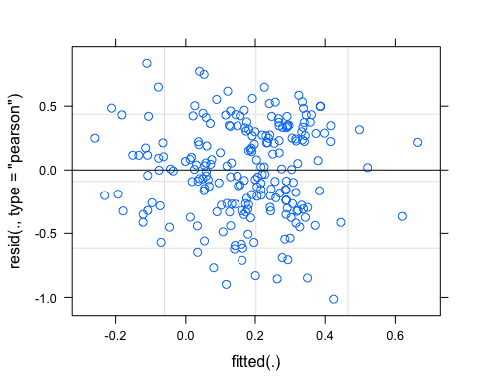

### Partial residuals

Plot partial residual for the interesting predictor – PrecipWeek

pr <- ggpredict(M1, terms = c("PrecipWeek"))  
plot(pr, add.data = TRUE)

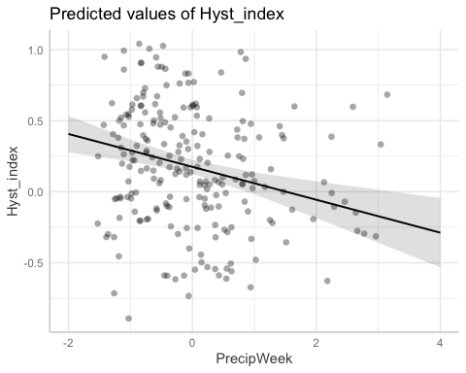 Visually look at the effect of PrecipWeek on HI and we would expect these to look like a nice regression model 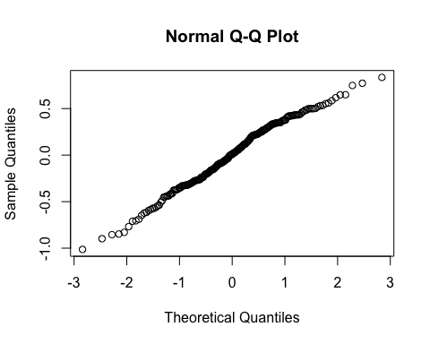

vif(M1)

## StormPrecip PrecipWeek PrecipMonth Intensity TempWeek   
## 1.223604 1.466787 1.569740 1.198407 1.832572   
## TimeSinceChena   
## 1.882974

TimeSinceChena and TempWeek are correlated (0.61) so lets try and remove TempWeek

f2 <- formula(Hyst_index ~ StormPrecip + PrecipWeek + PrecipMonth + Intensity + TimeSinceChena + (1|site.ID))  
  
M2 <- lmer(f2, REML = TRUE, data = NO3_data)

## boundary (singular) fit: see ?isSingular

summary(M2)

## Linear mixed model fit by REML ['lmerMod']  
## Formula: Hyst_index ~ StormPrecip + PrecipWeek + PrecipMonth + Intensity +   
## TimeSinceChena + (1 | site.ID)  
## Data: NO3_data  
##   
## REML criterion at convergence: 213.7  
##   
## Scaled residuals:   
## Min 1Q Median 3Q Max   
## -2.75057 -0.74003 0.04936 0.81316 2.24116   
##   
## Random effects:  
## Groups Name Variance Std.Dev.  
## site.ID (Intercept) 0.000 0.0000   
## Residual 0.136 0.3688   
## Number of obs: 222, groups: site.ID, 6  
##   
## Fixed effects:  
## Estimate Std. Error t value  
## (Intercept) 0.17748 0.02477 7.165  
## StormPrecip -0.06771 0.02707 -2.501  
## PrecipWeek -0.11333 0.03024 -3.747  
## PrecipMonth 0.07356 0.03037 2.422  
## Intensity 0.05118 0.02968 1.724  
## TimeSinceChena 0.07134 0.02583 2.762  
##   
## Correlation of Fixed Effects:  
## (Intr) StrmPr PrcpWk PrcpMn Intnst  
## StormPrecip -0.018   
## PrecipWeek 0.018 -0.113   
## PrecipMonth -0.018 0.020 -0.532   
## Intensity 0.015 -0.394 0.095 -0.013   
## TimeSincChn 0.025 0.101 0.208 -0.211 0.033  
## optimizer (nloptwrap) convergence code: 0 (OK)  
## boundary (singular) fit: see ?isSingular

pr <- ggpredict(M2, terms = c("PrecipWeek"))  
plot(pr, add.data = TRUE)

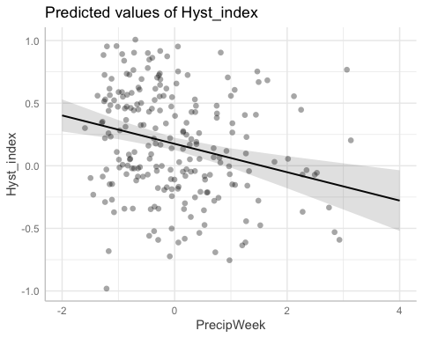

vif(M2)

## StormPrecip PrecipWeek PrecipMonth Intensity TimeSinceChena   
## 1.218626 1.444828 1.419464 1.195294 1.083150

f3 <- formula(Hyst_index ~ StormPrecip + PrecipWeek + PrecipMonth + Intensity + TempWeek + TimeSinceChena + (PrecipWeek|site.ID))  
  
M3 <- lmer(f3, REML = TRUE, data = NO3_data)

## boundary (singular) fit: see ?isSingular

summary(M3)

## Linear mixed model fit by REML ['lmerMod']  
## Formula: Hyst_index ~ StormPrecip + PrecipWeek + PrecipMonth + Intensity +   
## TempWeek + TimeSinceChena + (PrecipWeek | site.ID)  
## Data: NO3_data  
##   
## REML criterion at convergence: 217.9  
##   
## Scaled residuals:   
## Min 1Q Median 3Q Max   
## -2.65165 -0.71497 0.02753 0.84128 2.13414   
##   
## Random effects:  
## Groups Name Variance Std.Dev. Corr  
## site.ID (Intercept) 0.000000 0.00000   
## PrecipWeek 0.001872 0.04327 NaN  
## Residual 0.134980 0.36740   
## Number of obs: 222, groups: site.ID, 6  
##   
## Fixed effects:  
## Estimate Std. Error t value  
## (Intercept) 0.17848 0.02489 7.171  
## StormPrecip -0.06765 0.02704 -2.502  
## PrecipWeek -0.11691 0.03555 -3.289  
## PrecipMonth 0.07819 0.03227 2.423  
## Intensity 0.04932 0.02968 1.662  
## TempWeek -0.02207 0.03347 -0.659  
## TimeSinceChena 0.05497 0.03429 1.603  
##   
## Correlation of Fixed Effects:  
## (Intr) StrmPr PrcpWk PrcpMn Intnst TempWk  
## StormPrecip -0.016   
## PrecipWeek 0.005 -0.104   
## PrecipMonth -0.001 0.041 -0.475   
## Intensity 0.017 -0.388 0.077 0.006   
## TempWeek -0.033 -0.065 0.118 -0.316 -0.049   
## TimeSincChn -0.001 0.033 0.215 -0.362 -0.004 0.654  
## optimizer (nloptwrap) convergence code: 0 (OK)  
## boundary (singular) fit: see ?isSingular

alter structure between random slopes and random intercepts

aictab(list(M0,M1,M2,M3))

## Warning in aictab.AIClmerMod(list(M0, M1, M2, M3)):   
## Model names have been supplied automatically in the table

## Warning in aictab.AIClmerMod(list(M0, M1, M2, M3)):   
## Model selection for fixed effects is only appropriate with ML estimation:  
## REML (default) should only be used to select random effects for a constant set of fixed effects

##   
## Model selection based on AICc:  
##   
## K AICc Delta_AICc AICcWt Cum.Wt Res.LL  
## Mod3 8 230.37 0.00 0.96 0.96 -106.85  
## Mod2 9 237.08 6.71 0.03 1.00 -109.12  
## Mod4 11 241.13 10.76 0.00 1.00 -108.93  
## Mod1 11 247.78 17.41 0.00 1.00 -112.26

Mod3: Model without TempWeek, ThreeMonth, or StormTemp with a random intercept structure structure Mod2: Model without ThreeMonth or StormTemp with a random intercept structure Mod4: Model without ThreeMonth or StormTemp with a random slope structure with (PrecipWeek|site.ID) Mod1: full model with all candidate predictors and random intercept structure

This shows us that the random intercept structure is a better fit model

### Dot and Whisker plot

dwplot(M1, vline = geom_vline(xintercept = 0, colour = "grey50", linetype = 2)) +  
 xlab("Coefficient") +   
 ggtitle("Antecedent Conditions, NO3")

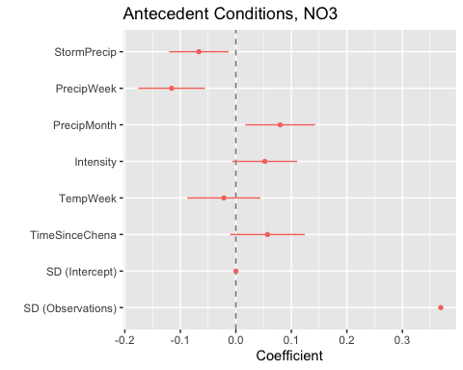 CI overlapping 0 are nonsignificant

summary(M1)

## Linear mixed model fit by REML ['lmerMod']  
## Formula: Hyst_index ~ StormPrecip + PrecipWeek + PrecipMonth + Intensity +   
## TempWeek + TimeSinceChena + (1 | site.ID)  
## Data: NO3_data  
##   
## REML criterion at convergence: 218.2  
##   
## Scaled residuals:   
## Min 1Q Median 3Q Max   
## -2.74347 -0.72905 0.02232 0.80515 2.26066   
##   
## Random effects:  
## Groups Name Variance Std.Dev.  
## site.ID (Intercept) 0.0000 0.0000   
## Residual 0.1364 0.3693   
## Number of obs: 222, groups: site.ID, 6  
##   
## Fixed effects:  
## Estimate Std. Error t value  
## (Intercept) 0.17807 0.02482 7.174  
## StormPrecip -0.06659 0.02716 -2.452  
## PrecipWeek -0.11574 0.03051 -3.793  
## PrecipMonth 0.07995 0.03198 2.500  
## Intensity 0.05216 0.02976 1.752  
## TempWeek -0.02159 0.03345 -0.645  
## TimeSinceChena 0.05700 0.03410 1.671  
##   
## Correlation of Fixed Effects:  
## (Intr) StrmPr PrcpWk PrcpMn Intnst TempWk  
## StormPrecip -0.016   
## PrecipWeek 0.013 -0.120   
## PrecipMonth -0.006 0.039 -0.540   
## Intensity 0.017 -0.390 0.088 0.004   
## TempWeek -0.037 -0.064 0.122 -0.309 -0.051   
## TimeSincChn -0.005 0.035 0.236 -0.354 -0.008 0.652  
## optimizer (nloptwrap) convergence code: 0 (OK)  
## boundary (singular) fit: see ?isSingular

anova(M0, M1, test = "Chi")

## refitting model(s) with ML (instead of REML)

## Data: NO3_data  
## Models:  
## M1: Hyst_index ~ StormPrecip + PrecipWeek + PrecipMonth + Intensity +   
## M1: TempWeek + TimeSinceChena + (1 | site.ID)  
## M0: Hyst_index ~ StormPrecip + PrecipWeek + PrecipMonth + ThreeMonth +   
## M0: Intensity + StormTemp + TempWeek + TimeSinceChena + (1 |   
## M0: site.ID)  
## npar AIC BIC logLik deviance Chisq Df Pr(>Chisq)  
## M1 9 198.66 229.28 -90.330 180.66   
## M0 11 200.24 237.66 -89.118 178.24 2.4244 2 0.2975

plot(M1, site.ID ~ resid(.), abline = 0 ) # generate diagnostic plots

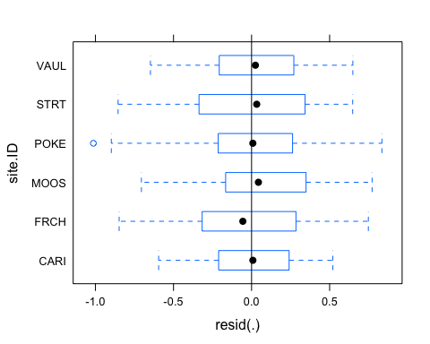 Looking for equal variance -testing assumptions of the model

This plot shows us that there are some outliers in POKE and that the variability within FRCH is greater than in other sites we therefore examine the sites in isolation standardized residuals versus fitted values

plot(M1, resid(., type = "pearson") ~ fitted(.) | site.ID, id = 0.05,   
 adj = -0.3, pch = 20, col = "gray40")

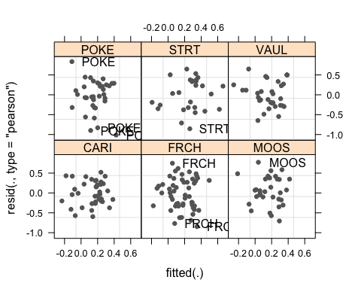 The plot shows the standardized residuals (or Pearson’s residuals) versus fitted values and suggests that there are outliers in the data (the names elements in the plots). To check if these outliers are a cause for concern, we will now use a Levene’s test to check if the variance is distributed homogeneously (homoscedasticity) or whether the assumption of variance homogeneity is violated (due to the outliers).

### Mixed effect model is a pseudo r^2

sjPlot::tab_model(M1)

## Argument 'df_method' is deprecated. Please use 'ci_method' instead.

Hyst_index

Predictors

Estimates

CI

p

(Intercept)

0.18

0.13 – 0.23

<0.001

StormPrecip

-0.07

-0.12 – -0.01

0.015

PrecipWeek

-0.12

-0.18 – -0.06

<0.001

PrecipMonth

0.08

0.02 – 0.14

0.013

Intensity

0.05

-0.01 – 0.11

0.081

TempWeek

-0.02

-0.09 – 0.04

0.519

TimeSinceChena

0.06

-0.01 – 0.12

0.096

Random Effects

σ2

0.14

τ00 site.ID

0.00

N site.ID

6

Observations

222

Marginal R2 / Conditional R2

0.155 / NA

The R2 values of the summary table are incorrect (as indicated by the missing conditional R2 value). The more appropriate conditional and marginal coefficient of determination for generalized mixed-effect models can be extracted using the r.squaredGLMM function from the MuMIn package

The marginal R2 (marginal coefficient of determination) represents the variance explained by the fixed effects while the conditional R2 is interpreted as a variance explained by the entire model, including both fixed and random effects

r.squaredGLMM(M1)

## Warning: 'r.squaredGLMM' now calculates a revised statistic. See the help page.

## R2m R2c  
## [1,] 0.154904 0.154904

random effect isnt explaining only explaining 15 % of the model….maybe dont need a random effect in the model at all if it is 0

sjPlot::plot_model(M1, type = "pred", terms = c("PrecipWeek")) +  
 # show uncentered date rather than centered date  
 scale_x_continuous(name = "PrecipWeek",   
 breaks = seq(-500, 300, 100),   
 labels = seq(1150, 1950, 100))

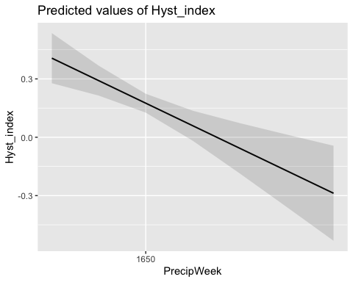 While we have already shown that the effect of PrecipWeek is significant, it is small which means that the HI does not correlate very strongly with PrecipWeek. This suggests that other factors that are not included in the model also influence HI (and probably more meaningfully, too).

Before turning to the diagnostics, we will use the fitted (or predicted) and the observed values with a regression line for the predicted values. This will not only show how good the model fit the data but also the direction and magnitude of the effect.

### Interactions

### Permafrost

f4 <- formula(Hyst_index ~ StormPrecip*pf + PrecipWeek*pf + PrecipMonth*pf + Intensity*pf + TempWeek*pf + TimeSinceChena*pf + (1|site.ID))  
  
M4 <- lmer(f4, data = NO3_data)

## boundary (singular) fit: see ?isSingular

summary(M4)

## Linear mixed model fit by REML ['lmerMod']  
## Formula: Hyst_index ~ StormPrecip * pf + PrecipWeek * pf + PrecipMonth *   
## pf + Intensity * pf + TempWeek * pf + TimeSinceChena * pf +   
## (1 | site.ID)  
## Data: NO3_data  
##   
## REML criterion at convergence: 238.9  
##   
## Scaled residuals:   
## Min 1Q Median 3Q Max   
## -2.70971 -0.67306 -0.03199 0.78034 2.19219   
##   
## Random effects:  
## Groups Name Variance Std.Dev.  
## site.ID (Intercept) 0.0000 0.0000   
## Residual 0.1377 0.3711   
## Number of obs: 222, groups: site.ID, 6  
##   
## Fixed effects:  
## Estimate Std. Error t value  
## (Intercept) 0.201127 0.057028 3.527  
## StormPrecip -0.049152 0.050707 -0.969  
## pfmedium -0.031885 0.064420 -0.495  
## PrecipWeek -0.147696 0.068277 -2.163  
## PrecipMonth 0.106785 0.063650 1.678  
## Intensity 0.060445 0.040381 1.497  
## TempWeek -0.127555 0.077537 -1.645  
## TimeSinceChena -0.002604 0.104184 -0.025  
## StormPrecip:pfmedium -0.012879 0.062221 -0.207  
## pfmedium:PrecipWeek 0.038478 0.077179 0.499  
## pfmedium:PrecipMonth -0.030123 0.074420 -0.405  
## pfmedium:Intensity -0.037397 0.064453 -0.580  
## pfmedium:TempWeek 0.147125 0.087053 1.690  
## pfmedium:TimeSinceChena 0.065089 0.111068 0.586

##   
## Correlation matrix not shown by default, as p = 14 > 12.  
## Use print(x, correlation=TRUE) or  
## vcov(x) if you need it

## optimizer (nloptwrap) convergence code: 0 (OK)  
## boundary (singular) fit: see ?isSingular

This shows us if there is an interaction with any of our candidate predictors and permafrost extent and it doesnt seem like there is any

### burn

f5 <- formula(Hyst_index ~ StormPrecip*burn + PrecipWeek*burn + PrecipMonth*burn + Intensity*burn + TempWeek*burn + TimeSinceChena*pf + (1|site.ID))  
  
M5 <- lmer(f5, data = NO3_data)

## boundary (singular) fit: see ?isSingular

summary(M5)

## Linear mixed model fit by REML ['lmerMod']  
## Formula: Hyst_index ~ StormPrecip * burn + PrecipWeek * burn + PrecipMonth *   
## burn + Intensity * burn + TempWeek * burn + TimeSinceChena *   
## pf + (1 | site.ID)  
## Data: NO3_data  
##   
## REML criterion at convergence: 244.1  
##   
## Scaled residuals:   
## Min 1Q Median 3Q Max   
## -2.73552 -0.69912 -0.01938 0.82479 2.17668   
##   
## Random effects:  
## Groups Name Variance Std.Dev.  
## site.ID (Intercept) 0.0000 0.0000   
## Residual 0.1388 0.3725   
## Number of obs: 222, groups: site.ID, 6  
##   
## Fixed effects:  
## Estimate Std. Error t value  
## (Intercept) 0.1733692 0.0623839 2.779  
## StormPrecip -0.0885608 0.0354080 -2.501  
## burnunburned -0.0368981 0.0564796 -0.653  
## PrecipWeek -0.1127183 0.0369868 -3.048  
## PrecipMonth 0.0681884 0.0445312 1.531  
## Intensity 0.0610243 0.0334200 1.826  
## TempWeek 0.0153301 0.0430131 0.356  
## TimeSinceChena 0.1120201 0.0622388 1.800  
## pfmedium 0.0096364 0.0644319 0.150  
## StormPrecip:burnunburned 0.0863160 0.0636573 1.356  
## burnunburned:PrecipWeek 0.0008008 0.0656377 0.012  
## burnunburned:PrecipMonth 0.0214972 0.0628003 0.342  
## burnunburned:Intensity -0.1081280 0.1042687 -1.037  
## burnunburned:TempWeek -0.0509791 0.0517944 -0.984  
## TimeSinceChena:pfmedium -0.0650635 0.0609738 -1.067

##   
## Correlation matrix not shown by default, as p = 15 > 12.  
## Use print(x, correlation=TRUE) or  
## vcov(x) if you need it

## optimizer (nloptwrap) convergence code: 0 (OK)  
## boundary (singular) fit: see ?isSingular

This shows us if there is an interaction with any of our candidate predictors and burn vs. unburned catchments and it doesnt seem like there are any

fDOM

#### Scatter plot matrix

HI_FI_fDOM_CARI <- filter(HI_FI_fDOM, site.ID == "CARI")  
HI_FI_fDOM_FRCH <- filter(HI_FI_fDOM, site.ID == "FRCH")  
HI_FI_fDOM_MOOS <- filter(HI_FI_fDOM, site.ID == "MOOS")  
HI_FI_fDOM_POKE <- filter(HI_FI_fDOM, site.ID == "POKE")  
HI_FI_fDOM_VAUL <- filter(HI_FI_fDOM, site.ID == "VAUL")  
HI_FI_fDOM_STRT <- filter(HI_FI_fDOM, site.ID == "STRT")  
  
fDOM_data.1 <- HI_FI_fDOM[,c("Hyst_index","StormPrecip")]  
  
pairs(fDOM_data.1)

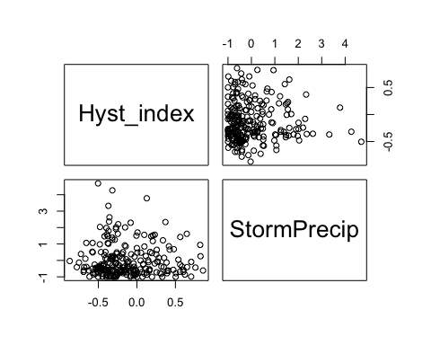

HI_FI_fDOM %>% ggplot(aes(x = StormPrecip, y = Hyst_index)) +   
 geom_hline(yintercept = 0, linetype = "dotted", size = 1) +  
 geom_errorbar(aes(ymin=HI_ymin, ymax=HI_ymax), colour="black", alpha=0.5, size=.5, width = 0.1)+   
 geom_point(aes(color = site.ID), size = 2) +  
 scale_color_manual(values = c("orange red", viridis::viridis(6)), "Catchment")+theme_bw() +  
 geom_smooth(method = "lm", na.rm = TRUE, fullrange = TRUE, aes(group = 1)) +   
 stat_poly_eq(formula = y~x,  
 label.y = "top", label.x = "right",  
 aes(label = paste(..eq.label.., ..rr.label.., sep = "~~~")),   
 parse = TRUE) +   
 ylab("Hysteresis Index") +  
 ggtitle("HI vs. StormPrecip")

## `geom_smooth()` using formula 'y ~ x'

## Warning: Removed 1 rows containing non-finite values (stat_poly_eq).

## Warning: Removed 1 rows containing missing values (geom_point).

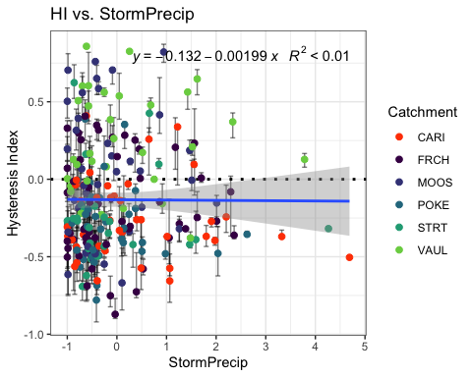 Big storms in FRCH but why not every where else

fDOM_data.2 <- HI_FI_fDOM[,c("Hyst_index","PrecipWeek")]  
  
pairs(fDOM_data.2)

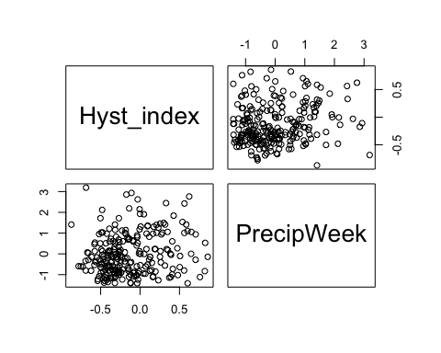

HI_FI_fDOM %>% ggplot(aes(x = PrecipWeek, y = Hyst_index)) +   
 geom_hline(yintercept = 0, linetype = "dotted", size = 1) +  
 geom_errorbar(aes(ymin=HI_ymin, ymax=HI_ymax), colour="black", alpha=0.5, size=.5, width = 0.1)+   
 geom_point(aes(color = site.ID), size = 2) +  
 scale_color_manual(values = c("orange red", viridis::viridis(6)), "Catchment")+theme_bw() +  
 geom_smooth(method = "lm", na.rm = TRUE, fullrange = TRUE, aes(group = 1)) +   
 stat_poly_eq(formula = y~x,  
 label.y = "top", label.x = "right",  
 aes(label = paste(..eq.label.., ..rr.label.., sep = "~~~")),   
 parse = TRUE) +   
 ylab("Hysteresis Index") +  
 ggtitle("HI vs. PrecipWeek")

## `geom_smooth()` using formula 'y ~ x'

## Warning: Removed 1 rows containing non-finite values (stat_poly_eq).

## Warning: Removed 1 rows containing missing values (geom_point).

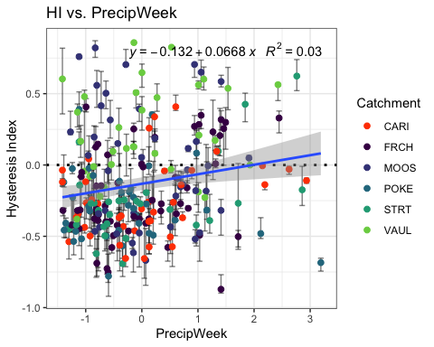

fDOM_data.3 <- HI_FI_fDOM[,c("Hyst_index","PrecipMonth")]  
  
pairs(fDOM_data.3)

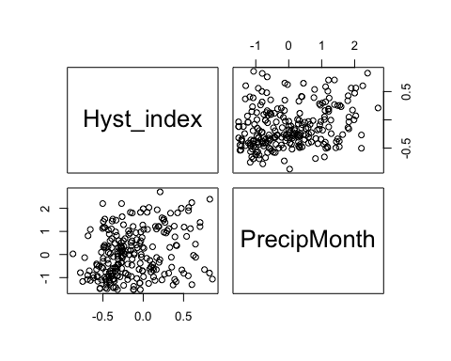

HI_FI_fDOM %>% ggplot(aes(x = PrecipMonth, y = Hyst_index)) +   
 geom_hline(yintercept = 0, linetype = "dotted", size = 1) +  
 geom_errorbar(aes(ymin=HI_ymin, ymax=HI_ymax), colour="black", alpha=0.5, size=.5, width = 0.1)+   
 geom_point(aes(color = site.ID), size = 2) +  
 scale_color_manual(values = c("orange red", viridis::viridis(6)), "Catchment")+theme_bw() +  
 geom_smooth(method = "lm", na.rm = TRUE, fullrange = TRUE, aes(group = 1)) +   
 stat_poly_eq(formula = y~x,  
 label.y = "top", label.x = "right",  
 aes(label = paste(..eq.label.., ..rr.label.., sep = "~~~")),   
 parse = TRUE) +   
 ylab("Hysteresis Index") +  
 ggtitle("HI vs. PrecipMonth")

## `geom_smooth()` using formula 'y ~ x'

## Warning: Removed 1 rows containing non-finite values (stat_poly_eq).

## Warning: Removed 1 rows containing missing values (geom_point).

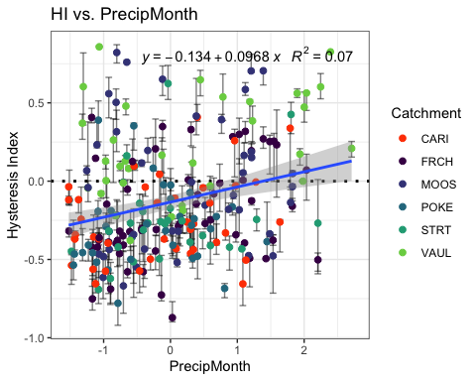

fDOM_data.4 <- HI_FI_fDOM[,c("Hyst_index","ThreeMonth")]  
  
pairs(fDOM_data.4)

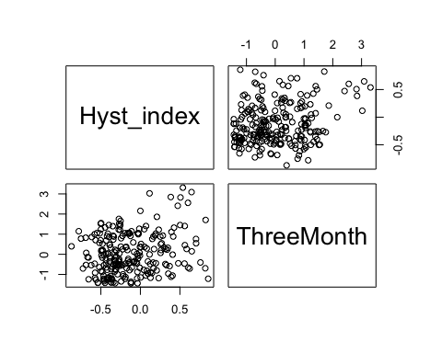

HI_FI_fDOM %>% ggplot(aes(x = ThreeMonth, y = Hyst_index)) +   
 geom_hline(yintercept = 0, linetype = "dotted", size = 1) +  
 geom_errorbar(aes(ymin=HI_ymin, ymax=HI_ymax), colour="black", alpha=0.5, size=.5, width = 0.1)+   
 geom_point(aes(color = site.ID), size = 2) +  
 scale_color_manual(values = c("orange red", viridis::viridis(6)), "Catchment")+theme_bw() +  
 geom_smooth(method = "lm", na.rm = TRUE, fullrange = TRUE, aes(group = 1)) +   
 stat_poly_eq(formula = y~x,  
 label.y = "top", label.x = "right",  
 aes(label = paste(..eq.label.., ..rr.label.., sep = "~~~")),   
 parse = TRUE) +   
 ylab("Hysteresis Index") +  
 ggtitle("HI vs. ThreeMonth")

## `geom_smooth()` using formula 'y ~ x'

## Warning: Removed 1 rows containing non-finite values (stat_poly_eq).

## Warning: Removed 1 rows containing missing values (geom_point).

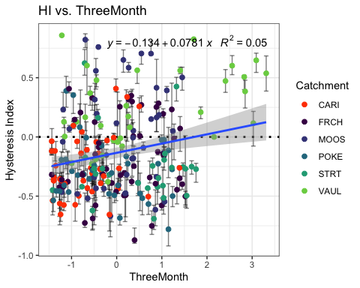

fDOM_data.5 <- HI_FI_fDOM[,c("Hyst_index","Intensity")]  
  
pairs(fDOM_data.5)

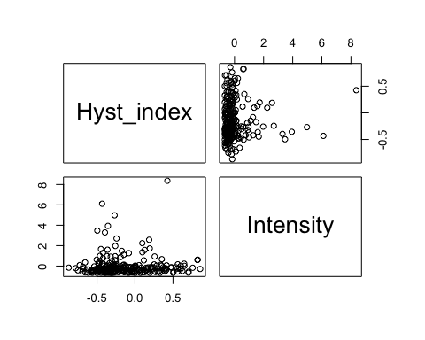

HI_FI_fDOM %>% ggplot(aes(x = Intensity, y = Hyst_index)) +   
 geom_hline(yintercept = 0, linetype = "dotted", size = 1) +  
 geom_errorbar(aes(ymin=HI_ymin, ymax=HI_ymax), colour="black", alpha=0.5, size=.5, width = 0.1)+   
 geom_point(aes(color = site.ID), size = 2) +  
 scale_color_manual(values = c("orange red", viridis::viridis(6)), "Catchment")+theme_bw() +  
 geom_smooth(method = "lm", na.rm = TRUE, fullrange = TRUE, aes(group = 1)) +   
 stat_poly_eq(formula = y~x,  
 label.y = "top", label.x = "right",  
 aes(label = paste(..eq.label.., ..rr.label.., sep = "~~~")),   
 parse = TRUE) +   
 ylab("Hysteresis Index") +  
 ggtitle("HI vs. Intensity")

## `geom_smooth()` using formula 'y ~ x'

## Warning: Removed 2 rows containing non-finite values (stat_poly_eq).

## Warning: Removed 2 rows containing missing values (geom_point).

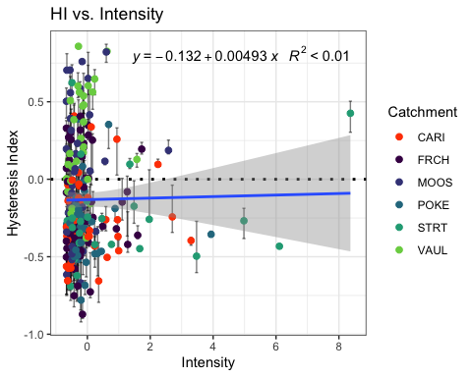

fDOM_data.6 <- HI_FI_fDOM[,c("Hyst_index","StormTemp")]  
  
pairs(fDOM_data.6)

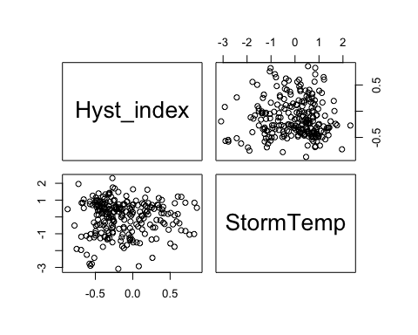

HI_FI_fDOM %>% ggplot(aes(x = StormTemp, y = Hyst_index)) +   
 geom_hline(yintercept = 0, linetype = "dotted", size = 1) +  
 geom_errorbar(aes(ymin=HI_ymin, ymax=HI_ymax), colour="black", alpha=0.5, size=.5, width = 0.1)+   
 geom_point(aes(color = site.ID), size = 2) +  
 scale_color_manual(values = c("orange red", viridis::viridis(6)), "Catchment")+theme_bw() +  
 geom_smooth(method = "lm", na.rm = TRUE, fullrange = TRUE, aes(group = 1)) +   
 stat_poly_eq(formula = y~x,  
 label.y = "top", label.x = "right",  
 aes(label = paste(..eq.label.., ..rr.label.., sep = "~~~")),   
 parse = TRUE) +   
 ylab("Hysteresis Index") +  
 ggtitle("HI vs. StormTemp")

## `geom_smooth()` using formula 'y ~ x'

## Warning: Removed 1 rows containing non-finite values (stat_poly_eq).

## Warning: Removed 1 rows containing missing values (geom_point).

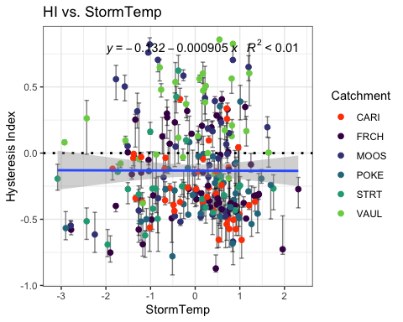

fDOM_data.7 <- HI_FI_fDOM[,c("Hyst_index","TempWeek")]  
  
pairs(fDOM_data.7)

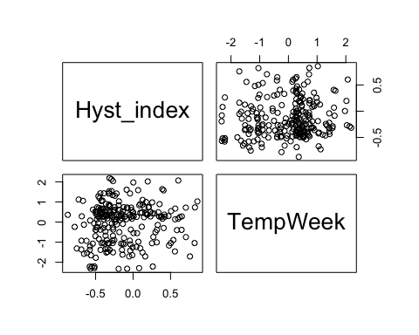

HI_FI_fDOM %>% ggplot(aes(x = TempWeek, y = Hyst_index)) +   
 geom_hline(yintercept = 0, linetype = "dotted", size = 1) +  
 geom_errorbar(aes(ymin=HI_ymin, ymax=HI_ymax), colour="black", alpha=0.5, size=.5, width = 0.1)+   
 geom_point(aes(color = site.ID), size = 2) +  
 scale_color_manual(values = c("orange red", viridis::viridis(6)), "Catchment")+theme_bw() +  
 geom_smooth(method = "lm", na.rm = TRUE, fullrange = TRUE, aes(group = 1)) +   
 stat_poly_eq(formula = y~x,  
 label.y = "top", label.x = "right",  
 aes(label = paste(..eq.label.., ..rr.label.., sep = "~~~")),   
 parse = TRUE) +   
 ylab("Hysteresis Index") +  
 ggtitle("HI vs. TempWeek")

## `geom_smooth()` using formula 'y ~ x'

## Warning: Removed 3 rows containing non-finite values (stat_poly_eq).

## Warning: Removed 3 rows containing missing values (geom_point).

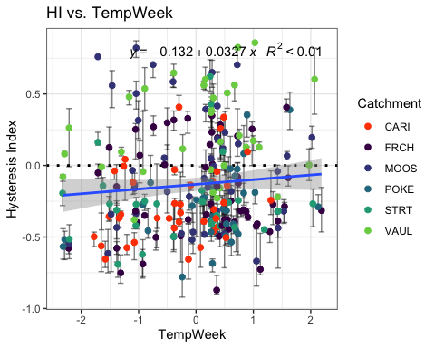

fDOM_data.8 <- HI_FI_fDOM[,c("Hyst_index","TimeSinceChena")]  
  
pairs(fDOM_data.8)

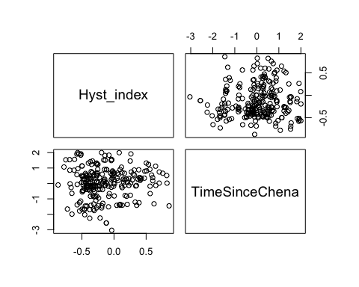

HI_FI_fDOM %>% ggplot(aes(x = TimeSinceChena, y = Hyst_index)) +   
 geom_hline(yintercept = 0, linetype = "dotted", size = 1) +  
 geom_errorbar(aes(ymin=HI_ymin, ymax=HI_ymax), colour="black", alpha=0.5, size=.5, width = 0.1)+   
 geom_point(aes(color = site.ID), size = 2) +  
 scale_color_manual(values = c("orange red", viridis::viridis(6)), "Catchment")+theme_bw() +  
 geom_smooth(method = "lm", na.rm = TRUE, fullrange = TRUE, aes(group = 1)) +   
 stat_poly_eq(formula = y~x,  
 label.y = "top", label.x = "right",  
 aes(label = paste(..eq.label.., ..rr.label.., sep = "~~~")),   
 parse = TRUE) +   
 ylab("Hysteresis Index") +  
 ggtitle("HI vs. TimeSinceChena")

## `geom_smooth()` using formula 'y ~ x'

## Warning: Removed 1 rows containing non-finite values (stat_poly_eq).

## Warning: Removed 1 rows containing missing values (geom_point).

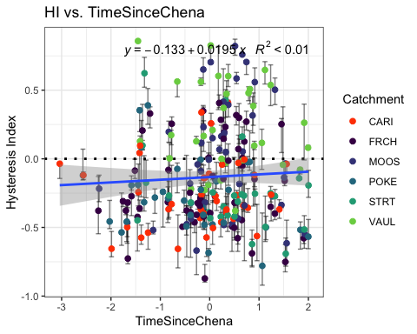 It appears that fDOM has slightly more site variation. It seems like there is a clearer distinction between sites and fDOM responses. Lets see if that shows in the model…

fDOM_data <- HI_FI_fDOM[,c("Hyst_index", "site.ID", "StormPrecip", "StormTemp", "PrecipWeek", "PrecipMonth", "ThreeMonth", "TempWeek", "Intensity", "TimeSinceChena", "burn", "pf")]  
  
fDOM_data <- na.omit(fDOM_data) # 241 to 237  
cor(fDOM_data[, c(1,3:10)])

## Hyst_index StormPrecip StormTemp PrecipWeek PrecipMonth  
## Hyst_index 1.000000000 -0.006092357 -0.003204005 0.19064484 0.28172957  
## StormPrecip -0.006092357 1.000000000 0.105595116 0.10624319 0.06391839  
## StormTemp -0.003204005 0.105595116 1.000000000 0.02498455 0.08794510  
## PrecipWeek 0.190644844 0.106243187 0.024984552 1.00000000 0.54650808  
## PrecipMonth 0.281729566 0.063918393 0.087945104 0.54650808 1.00000000  
## ThreeMonth 0.224083175 -0.066626545 -0.239248629 0.23027666 0.62781148  
## TempWeek 0.089224879 0.165788071 0.798185045 0.07103093 0.11902006  
## Intensity 0.014900148 0.331984241 0.082866547 0.02461959 0.04281811  
## TimeSinceChena 0.060383708 -0.122772037 -0.726784905 -0.03832246 0.15138401  
## ThreeMonth TempWeek Intensity TimeSinceChena  
## Hyst_index 0.2240831747 0.08922488 0.0149001478 0.06038371  
## StormPrecip -0.0666265447 0.16578807 0.3319842414 -0.12277204  
## StormTemp -0.2392486293 0.79818504 0.0828665473 -0.72678491  
## PrecipWeek 0.2302766571 0.07103093 0.0246195873 -0.03832246  
## PrecipMonth 0.6278114766 0.11902006 0.0428181126 0.15138401  
## ThreeMonth 1.0000000000 -0.14131171 0.0008017555 0.56708271  
## TempWeek -0.1413117077 1.00000000 0.0976169639 -0.58646572  
## Intensity 0.0008017555 0.09761696 1.0000000000 -0.05686662  
## TimeSinceChena 0.5670827085 -0.58646572 -0.0568666201 1.00000000

1. Storm temperature is heavily correlated with temp week (0.798) but temp week is more correlated with HI (0.0892 vs. -0.0032)
2. Precip week is correlated with precip month (0.546) but precip month is more correlated with HI (0.281 vs. 0.190)
3. Precip month is correlated with three month (0.627) but precip month is more correlated with HI (0.281 vs. 0.224)
4. Three month is correlated with Time since Chena (0.567) but three month is more correlated with HI ( 0.224 vs. 0.0603)

* this makes me want to drop time since chena and three month

## Linear mixed model fit by REML ['lmerMod']  
## Formula: Hyst_index ~ StormPrecip + PrecipWeek + PrecipMonth + ThreeMonth +   
## Intensity + StormTemp + TempWeek + TimeSinceChena + (1 | site.ID)  
## Data: fDOM_data  
##   
## REML criterion at convergence: 173.4  
##   
## Scaled residuals:   
## Min 1Q Median 3Q Max   
## -2.2444 -0.6317 -0.1089 0.6189 2.9987   
##   
## Random effects:  
## Groups Name Variance Std.Dev.  
## site.ID (Intercept) 0.03507 0.1873   
## Residual 0.09693 0.3113   
## Number of obs: 237, groups: site.ID, 6  
##   
## Fixed effects:  
## Estimate Std. Error t value  
## (Intercept) -0.128280 0.079257 -1.619  
## StormPrecip -0.027510 0.022728 -1.210  
## PrecipWeek 0.020920 0.025912 0.807  
## PrecipMonth 0.066500 0.033922 1.960  
## ThreeMonth 0.007539 0.037441 0.201  
## Intensity 0.033841 0.022202 1.524  
## StormTemp -0.054905 0.042419 -1.294  
## TempWeek 0.053744 0.035972 1.494  
## TimeSinceChena -0.025921 0.040362 -0.642  
##   
## Correlation of Fixed Effects:  
## (Intr) StrmPr PrcpWk PrcpMn ThrMnt Intnst StrmTm TempWk  
## StormPrecip 0.005   
## PrecipWeek -0.004 -0.054   
## PrecipMonth 0.007 -0.016 -0.489   
## ThreeMonth -0.003 0.015 0.048 -0.602   
## Intensity -0.017 -0.338 0.035 -0.054 0.021   
## StormTemp -0.012 0.114 0.181 -0.117 -0.130 -0.040   
## TempWeek 0.004 -0.160 -0.053 -0.031 0.022 -0.012 -0.655   
## TimeSincChn -0.021 0.053 0.183 0.063 -0.535 -0.018 0.530 0.007

1. Scaled residuals look appropriate
2. The site accounts for slightly more variation

3)Precip month is the most significant

vif(M0.fDOM)

## StormPrecip PrecipWeek PrecipMonth ThreeMonth Intensity   
## 1.196187 1.529224 2.643834 2.901320 1.157859   
## StormTemp TempWeek TimeSinceChena   
## 4.226736 2.983576 3.406072

Any values over 2 indicate heavy correlation…lets remove ThreeMonth and StormTemp as this is what we did for NO3-

## Linear mixed model fit by REML ['lmerMod']  
## Formula: Hyst_index ~ StormPrecip + PrecipWeek + PrecipMonth + Intensity +   
## TempWeek + TimeSinceChena + (1 | site.ID)  
## Data: fDOM_data  
##   
## REML criterion at convergence: 165.9  
##   
## Scaled residuals:   
## Min 1Q Median 3Q Max   
## -2.3028 -0.6299 -0.1402 0.6084 2.9984   
##   
## Random effects:  
## Groups Name Variance Std.Dev.  
## site.ID (Intercept) 0.03568 0.1889   
## Residual 0.09676 0.3111   
## Number of obs: 237, groups: site.ID, 6  
##   
## Fixed effects:  
## Estimate Std. Error t value  
## (Intercept) -0.129493 0.079885 -1.621  
## StormPrecip -0.024190 0.022549 -1.073  
## PrecipWeek 0.026932 0.025391 1.061  
## PrecipMonth 0.062046 0.026219 2.366  
## Intensity 0.032732 0.022163 1.477  
## TempWeek 0.023280 0.027053 0.861  
## TimeSinceChena 0.002368 0.028461 0.083  
##   
## Correlation of Fixed Effects:  
## (Intr) StrmPr PrcpWk PrcpMn Intnst TempWk  
## StormPrecip 0.006   
## PrecipWeek -0.002 -0.079   
## PrecipMonth 0.004 0.020 -0.556   
## Intensity -0.017 -0.337 0.042 -0.063   
## TempWeek -0.006 -0.111 0.095 -0.253 -0.050   
## TimeSincChn -0.023 0.009 0.175 -0.307 0.015 0.611

vif(M1.fDOM)

## StormPrecip PrecipWeek PrecipMonth Intensity TempWeek   
## 1.179507 1.471028 1.582154 1.155750 1.690413   
## TimeSinceChena   
## 1.696548

None of our VIFs are over 2 which is good! however as was true with NO3 PrecipWeek and PrecipMonth are correlated (0.54) and TimeSinceChena and TempWeek are correlated (-0.58)

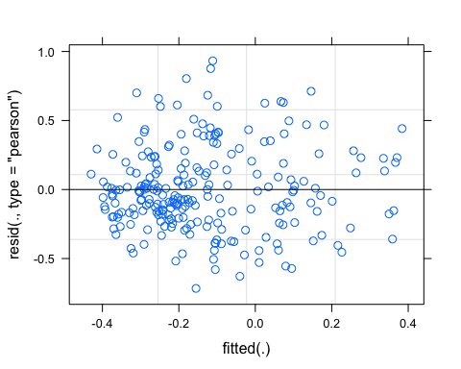 Potentially some funneling of the residuals from left to right

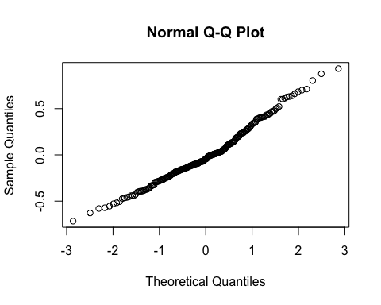

pr <- ggpredict(M1.fDOM, terms = c("PrecipMonth"))  
plot(pr, add.data = TRUE)

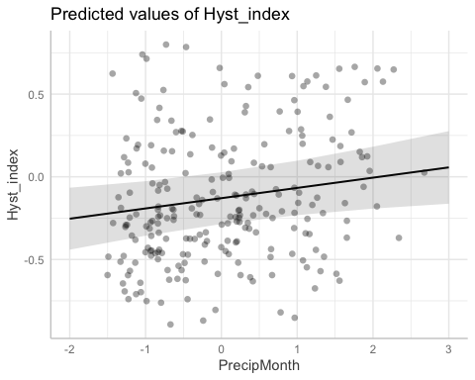

### Altnerative slopes

## boundary (singular) fit: see ?isSingular

## Linear mixed model fit by REML ['lmerMod']  
## Formula: Hyst_index ~ StormPrecip + PrecipWeek + PrecipMonth + Intensity +   
## TempWeek + TimeSinceChena + (PrecipMonth | site.ID)  
## Data: fDOM_data  
##   
## REML criterion at convergence: 165.9  
##   
## Scaled residuals:   
## Min 1Q Median 3Q Max   
## -2.3023 -0.6289 -0.1412 0.6056 2.9972   
##   
## Random effects:  
## Groups Name Variance Std.Dev. Corr   
## site.ID (Intercept) 3.569e-02 0.1889311   
## PrecipMonth 3.729e-07 0.0006107 -1.00  
## Residual 9.676e-02 0.3110613   
## Number of obs: 237, groups: site.ID, 6  
##   
## Fixed effects:  
## Estimate Std. Error t value  
## (Intercept) -0.12939 0.07991 -1.619  
## StormPrecip -0.02416 0.02255 -1.071  
## PrecipWeek 0.02692 0.02539 1.060  
## PrecipMonth 0.06222 0.02621 2.373  
## Intensity 0.03270 0.02216 1.476  
## TempWeek 0.02320 0.02706 0.858  
## TimeSinceChena 0.00225 0.02846 0.079  
##   
## Correlation of Fixed Effects:  
## (Intr) StrmPr PrcpWk PrcpMn Intnst TempWk  
## StormPrecip 0.006   
## PrecipWeek -0.002 -0.079   
## PrecipMonth -0.005 0.020 -0.556   
## Intensity -0.017 -0.337 0.041 -0.063   
## TempWeek -0.006 -0.111 0.095 -0.253 -0.050   
## TimeSincChn -0.023 0.009 0.175 -0.307 0.015 0.611  
## optimizer (nloptwrap) convergence code: 0 (OK)  
## boundary (singular) fit: see ?isSingular

aictab(list(M0.fDOM, M1.fDOM, M2.fDOM))

## Warning in aictab.AIClmerMod(list(M0.fDOM, M1.fDOM, M2.fDOM)):   
## Model names have been supplied automatically in the table

## Warning in aictab.AIClmerMod(list(M0.fDOM, M1.fDOM, M2.fDOM)):   
## Model selection for fixed effects is only appropriate with ML estimation:  
## REML (default) should only be used to select random effects for a constant set of fixed effects

##   
## Model selection based on AICc:  
##   
## K AICc Delta_AICc AICcWt Cum.Wt Res.LL  
## Mod2 9 184.66 0.00 0.9 0.9 -82.93  
## Mod3 11 189.04 4.38 0.1 1.0 -82.93  
## Mod1 11 196.60 11.94 0.0 1.0 -86.71

Mod2: Reduced model (no StormTemp or ThreeMonth precip) and random intercept structure Mod3: Reduced model (’’) with random slopes structure Mod1: Full model with random intercept structure

Mod2 with random intercept structure is the better model.

dwplot(list(M1.fDOM),  
 vline = geom_vline(xintercept = 0,  
 colour = "grey60",  
 linetype = 2)) +  
 ggtitle("Antecedent Conditions, fDOM")

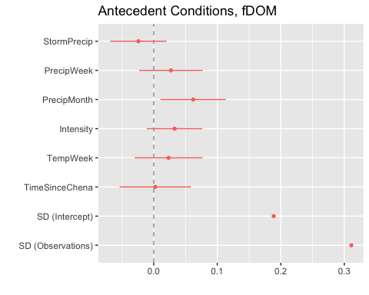 CI overlapping 0 are nonsignificant…This shows us that the only predictor that is significant is PrecipMonth precip

plot(M1.fDOM, site.ID ~ resid(.), abline = 0 ) # generate diagnostic plots

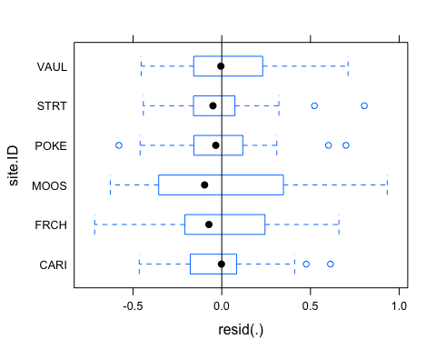 This plot shows us that there are some outliers in POKE, STRT, and CARI and that the variability within MOOS is greater than in other sites we therefore examine the sites in isolation standardized residuals versus fitted values

plot(M1.fDOM, resid(., type = "pearson") ~ fitted(.) | site.ID, id = 0.05,   
 adj = -0.3, pch = 20, col = "gray40")

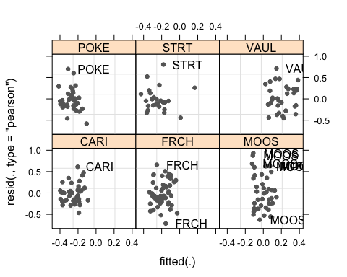 The plot shows the standardized residuals (or Pearson’s residuals) versus fitted values and suggests that there are outliers in the data (the names elements in the plots). To check if these outliers are a cause for concern, we will now use a Levene’s test to check if the variance is distributed homogeneously (homoscedasticity) or whether the assumption of variance homogeneity is violated (due to the outliers).

### Mixed effect model is a pseudo r^2

sjPlot::tab_model(M1.fDOM)

## Argument 'df_method' is deprecated. Please use 'ci_method' instead.

Hyst_index

Predictors

Estimates

CI

p

(Intercept)

-0.13

-0.29 – 0.03

0.106

StormPrecip

-0.02

-0.07 – 0.02

0.285

PrecipWeek

0.03

-0.02 – 0.08

0.290

PrecipMonth

0.06

0.01 – 0.11

0.019

Intensity

0.03

-0.01 – 0.08

0.141

TempWeek

0.02

-0.03 – 0.08

0.390

TimeSinceChena

0.00

-0.05 – 0.06

0.934

Random Effects

σ2

0.10

τ00 site.ID

0.04

ICC

0.27

N site.ID

6

Observations

237

Marginal R2 / Conditional R2

0.059 / 0.312

The R2 values of the summary table are correct as Marginal and conditional are both there. The more appropriate conditional and marginal coefficient of determination for generalized mixed-effect models can be extracted using the r.squaredGLMM function from the MuMIn package

The marginal R2 (marginal coefficient of determination) represents the variance explained by the fixed effects while the conditional R2 is interpreted as a variance explained by the entire model, including both fixed and random effects

r.squaredGLMM(M1.fDOM)

## R2m R2c  
## [1,] 0.05851956 0.3121382

This tells us that 31% of the variance can be explained…when I did the Levens test and added weights to the model it was closer to 42% but we talked about how that is a bad test and any transformation of the data would be more appropriate so let me quickly log transform this model and see if that helps with anything

## Linear mixed model fit by REML ['lmerMod']  
## Formula: log(Hyst_index + 1) ~ StormPrecip + PrecipWeek + PrecipMonth +   
## Intensity + TempWeek + TimeSinceChena + (1 | site.ID)  
## Data: fDOM_data  
##   
## REML criterion at convergence: 262.5  
##   
## Scaled residuals:   
## Min 1Q Median 3Q Max   
## -4.5926 -0.5978 0.0233 0.6113 2.1687   
##   
## Random effects:  
## Groups Name Variance Std.Dev.  
## site.ID (Intercept) 0.04054 0.2014   
## Residual 0.14816 0.3849   
## Number of obs: 237, groups: site.ID, 6  
##   
## Fixed effects:  
## Estimate Std. Error t value  
## (Intercept) -0.226249 0.086159 -2.626  
## StormPrecip -0.023788 0.027884 -0.853  
## PrecipWeek 0.013701 0.031415 0.436  
## PrecipMonth 0.087710 0.032435 2.704  
## Intensity 0.035027 0.027368 1.280  
## TempWeek 0.040380 0.033455 1.207  
## TimeSinceChena 0.001834 0.035194 0.052  
##   
## Correlation of Fixed Effects:  
## (Intr) StrmPr PrcpWk PrcpMn Intnst TempWk  
## StormPrecip 0.007   
## PrecipWeek -0.002 -0.079   
## PrecipMonth 0.004 0.020 -0.557   
## Intensity -0.019 -0.336 0.041 -0.062   
## TempWeek -0.007 -0.111 0.095 -0.254 -0.050   
## TimeSincChn -0.026 0.010 0.175 -0.308 0.015 0.611

1. The scaled residuals look worse

plot(Mlog.fDOM)

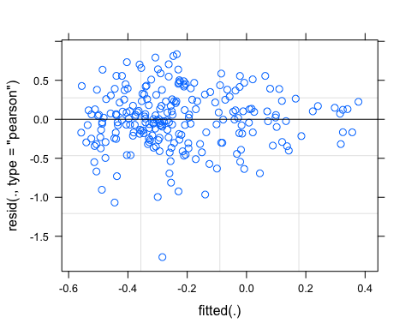

qqnorm(resid(Mlog.fDOM))

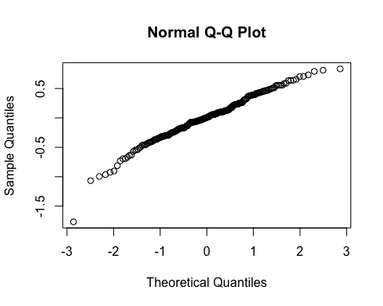

r.squaredGLMM(Mlog.fDOM)

## R2m R2c  
## [1,] 0.06313583 0.2644285

Worse so lets stick with the original model

sjPlot::plot_model(M1.fDOM, type = "pred", terms = c("PrecipMonth")) +  
 # show uncentered date rather than centered date  
 scale_x_continuous(name = "PrecipMonth",   
 breaks = seq(-500, 300, 100),   
 labels = seq(1150, 1950, 100))

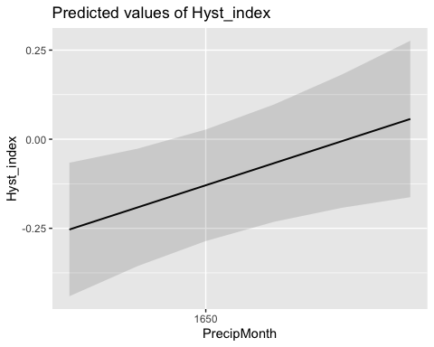

### Permafrost

f4.fDOM <- formula(Hyst_index ~ StormPrecip*pf + PrecipWeek*pf + PrecipMonth*pf + Intensity*pf + TempWeek*pf + TimeSinceChena*pf + (1|site.ID))  
  
M4.fDOM <- lmer(f4.fDOM, data = fDOM_data)  
summary(M4.fDOM)

## Linear mixed model fit by REML ['lmerMod']  
## Formula: Hyst_index ~ StormPrecip * pf + PrecipWeek * pf + PrecipMonth *   
## pf + Intensity * pf + TempWeek * pf + TimeSinceChena * pf +   
## (1 | site.ID)  
## Data: fDOM_data  
##   
## REML criterion at convergence: 186.9  
##   
## Scaled residuals:   
## Min 1Q Median 3Q Max   
## -2.20472 -0.68344 -0.09961 0.53186 2.95407   
##   
## Random effects:  
## Groups Name Variance Std.Dev.  
## site.ID (Intercept) 0.03599 0.1897   
## Residual 0.09780 0.3127   
## Number of obs: 237, groups: site.ID, 6  
##   
## Fixed effects:  
## Estimate Std. Error t value  
## (Intercept) -0.001248 0.142618 -0.009  
## StormPrecip -0.013373 0.038394 -0.348  
## pfmedium -0.175114 0.172975 -1.012  
## PrecipWeek 0.054462 0.056959 0.956  
## PrecipMonth 0.060478 0.055701 1.086  
## Intensity 0.017043 0.027173 0.627  
## TempWeek -0.022790 0.066943 -0.340  
## TimeSinceChena -0.067022 0.086686 -0.773  
## StormPrecip:pfmedium -0.033831 0.050148 -0.675  
## pfmedium:PrecipWeek -0.044856 0.064193 -0.699  
## pfmedium:PrecipMonth 0.007939 0.063687 0.125  
## pfmedium:Intensity 0.051911 0.051169 1.014  
## pfmedium:TempWeek 0.053305 0.073925 0.721  
## pfmedium:TimeSinceChena 0.082706 0.092096 0.898

##   
## Correlation matrix not shown by default, as p = 14 > 12.  
## Use print(x, correlation=TRUE) or  
## vcov(x) if you need it

This does not show us that pf has really an effect on on predictors

### burn

f5.fDOM <- formula(Hyst_index ~ StormPrecip*burn + PrecipWeek*burn + PrecipMonth*burn + Intensity*burn + TempWeek*burn + TimeSinceChena*burn + (1|site.ID))  
  
M5.fDOM <- lmer(f5.fDOM, data = fDOM_data)  
summary(M5.fDOM)

## Linear mixed model fit by REML ['lmerMod']  
## Formula: Hyst_index ~ StormPrecip * burn + PrecipWeek * burn + PrecipMonth *   
## burn + Intensity * burn + TempWeek * burn + TimeSinceChena *   
## burn + (1 | site.ID)  
## Data: fDOM_data  
##   
## REML criterion at convergence: 186.1  
##   
## Scaled residuals:   
## Min 1Q Median 3Q Max   
## -2.4597 -0.6492 -0.1412 0.5042 3.0149   
##   
## Random effects:  
## Groups Name Variance Std.Dev.  
## site.ID (Intercept) 0.03181 0.1783   
## Residual 0.09757 0.3124   
## Number of obs: 237, groups: site.ID, 6  
##   
## Fixed effects:  
## Estimate Std. Error t value  
## (Intercept) -0.197109 0.093141 -2.116  
## StormPrecip -0.038611 0.028827 -1.339  
## burnunburned 0.204849 0.161603 1.268  
## PrecipWeek 0.019112 0.030730 0.622  
## PrecipMonth 0.044069 0.036525 1.207  
## Intensity 0.029429 0.023250 1.266  
## TempWeek 0.030781 0.034345 0.896  
## TimeSinceChena -0.005513 0.033971 -0.162  
## StormPrecip:burnunburned 0.015169 0.052835 0.287  
## burnunburned:PrecipWeek 0.039660 0.055581 0.714  
## burnunburned:PrecipMonth 0.021479 0.053991 0.398  
## burnunburned:Intensity 0.083146 0.085550 0.972  
## burnunburned:TempWeek 0.011053 0.060263 0.183  
## burnunburned:TimeSinceChena 0.053869 0.066322 0.812

##   
## Correlation matrix not shown by default, as p = 14 > 12.  
## Use print(x, correlation=TRUE) or  
## vcov(x) if you need it

Burn also doesnt have any significance here

SPC

#### Scatter plot matrix

HI_FI_SPC_CARI <- filter(HI_FI_SPC, site.ID == "CARI")  
HI_FI_SPC_FRCH <- filter(HI_FI_SPC, site.ID == "FRCH")  
HI_FI_SPC_MOOS <- filter(HI_FI_SPC, site.ID == "MOOS")  
HI_FI_SPC_POKE <- filter(HI_FI_SPC, site.ID == "POKE")  
HI_FI_SPC_VAUL <- filter(HI_FI_SPC, site.ID == "VAUL")  
HI_FI_SPC_STRT <- filter(HI_FI_SPC, site.ID == "STRT")  
  
  
SPC_data.1 <- HI_FI_SPC[,c("Hyst_index","StormPrecip")]  
  
pairs(SPC_data.1)

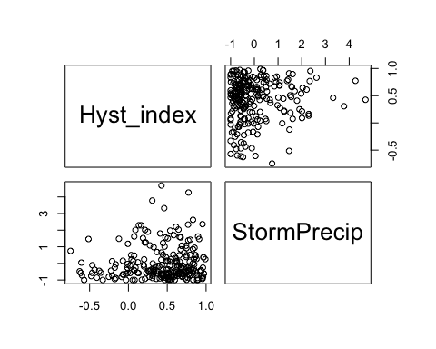

HI_FI_SPC %>% ggplot(aes(x = StormPrecip, y = Hyst_index)) +   
 geom_hline(yintercept = 0, linetype = "dotted", size = 1) +  
 geom_errorbar(aes(ymin=HI_ymin, ymax=HI_ymax), colour="black", alpha=0.5, size=.5, width = 0.1)+   
 geom_point(aes(color = site.ID), size = 2) +  
 scale_color_manual(values = c("orange red", viridis::viridis(6)), "Catchment")+theme_bw() +  
 geom_smooth(method = "lm", na.rm = TRUE, fullrange = TRUE, aes(group = 1)) +   
 stat_poly_eq(formula = y~x,  
 label.y = "top", label.x = "right",  
 aes(label = paste(..eq.label.., ..rr.label.., sep = "~~~")),   
 parse = TRUE) +   
 ylab("Hysteresis Index") +  
 ggtitle("HI vs. StormPrecip")

## `geom_smooth()` using formula 'y ~ x'

## Warning: Removed 1 rows containing non-finite values (stat_poly_eq).

## Warning: Removed 1 rows containing missing values (geom_point).

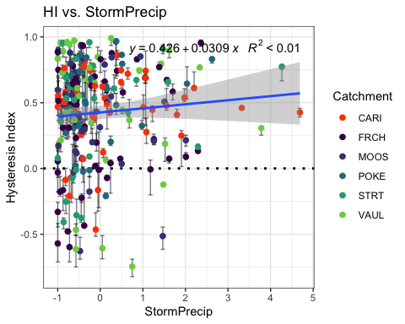

SPC_data.2 <- HI_FI_SPC[,c("Hyst_index","PrecipWeek")]  
  
pairs(SPC_data.2)

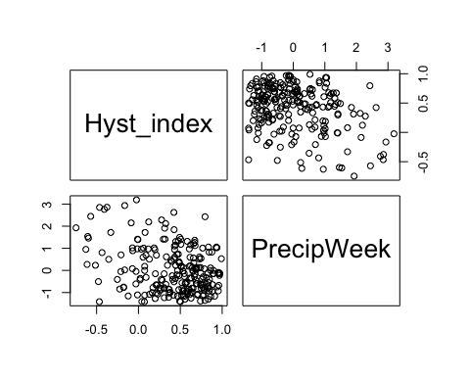

HI_FI_SPC %>% ggplot(aes(x = PrecipWeek, y = Hyst_index)) +   
 geom_hline(yintercept = 0, linetype = "dotted", size = 1) +  
 geom_errorbar(aes(ymin=HI_ymin, ymax=HI_ymax), colour="black", alpha=0.5, size=.5, width = 0.1)+   
 geom_point(aes(color = site.ID), size = 2) +  
 scale_color_manual(values = c("orange red", viridis::viridis(6)), "Catchment")+theme_bw() +  
 geom_smooth(method = "lm", na.rm = TRUE, fullrange = TRUE, aes(group = 1)) +   
 stat_poly_eq(formula = y~x,  
 label.y = "top", label.x = "right",  
 aes(label = paste(..eq.label.., ..rr.label.., sep = "~~~")),   
 parse = TRUE) +   
 ylab("Hysteresis Index") +  
 ggtitle("HI vs. PrecipWeek")

## `geom_smooth()` using formula 'y ~ x'

## Warning: Removed 1 rows containing non-finite values (stat_poly_eq).

## Warning: Removed 1 rows containing missing values (geom_point).

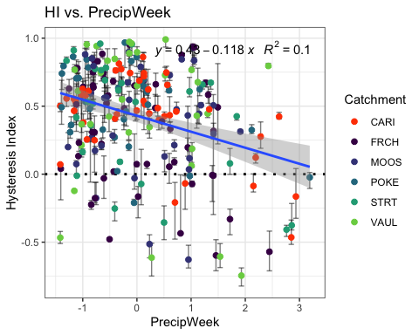

SPC_data.3 <- HI_FI_SPC[,c("Hyst_index","PrecipMonth")]  
  
pairs(SPC_data.3)

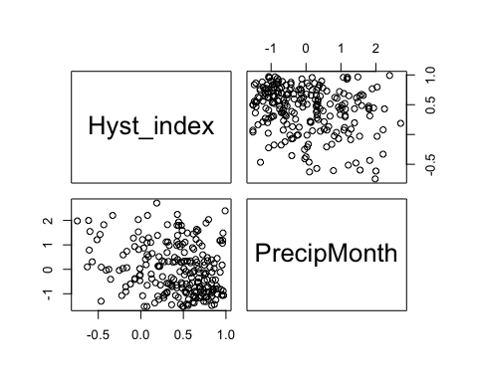

HI_FI_SPC %>% ggplot(aes(x = PrecipMonth, y = Hyst_index)) +   
 geom_hline(yintercept = 0, linetype = "dotted", size = 1) +  
 geom_errorbar(aes(ymin=HI_ymin, ymax=HI_ymax), colour="black", alpha=0.5, size=.5, width = 0.1)+   
 geom_point(aes(color = site.ID), size = 2) +  
 scale_color_manual(values = c("orange red", viridis::viridis(6)), "Catchment")+theme_bw() +  
 geom_smooth(method = "lm", na.rm = TRUE, fullrange = TRUE, aes(group = 1)) +   
 stat_poly_eq(formula = y~x,  
 label.y = "top", label.x = "right",  
 aes(label = paste(..eq.label.., ..rr.label.., sep = "~~~")),   
 parse = TRUE) +   
 ylab("Hysteresis Index") +  
 ggtitle("HI vs. PrecipMonth")

## `geom_smooth()` using formula 'y ~ x'

## Warning: Removed 1 rows containing non-finite values (stat_poly_eq).

## Warning: Removed 1 rows containing missing values (geom_point).

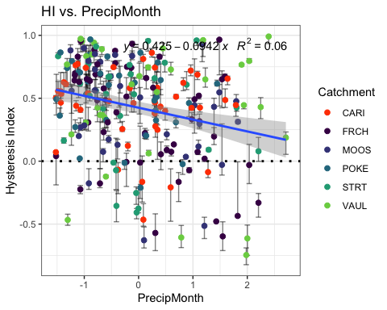

SPC_data.4 <- HI_FI_SPC[,c("Hyst_index","ThreeMonth")]  
  
pairs(SPC_data.4)

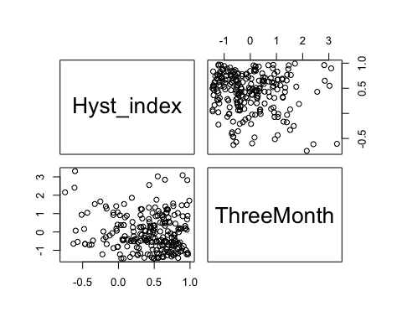

HI_FI_SPC %>% ggplot(aes(x = ThreeMonth, y = Hyst_index)) +   
 geom_hline(yintercept = 0, linetype = "dotted", size = 1) +  
 geom_errorbar(aes(ymin=HI_ymin, ymax=HI_ymax), colour="black", alpha=0.5, size=.5, width = 0.1)+   
 geom_point(aes(color = site.ID), size = 2) +  
 scale_color_manual(values = c("orange red", viridis::viridis(6)), "Catchment")+theme_bw() +  
 geom_smooth(method = "lm", na.rm = TRUE, fullrange = TRUE, aes(group = 1)) +   
 stat_poly_eq(formula = y~x,  
 label.y = "top", label.x = "right",  
 aes(label = paste(..eq.label.., ..rr.label.., sep = "~~~")),   
 parse = TRUE) +   
 ylab("Hysteresis Index") +  
 ggtitle("HI vs. ThreeMonth")

## `geom_smooth()` using formula 'y ~ x'

## Warning: Removed 1 rows containing non-finite values (stat_poly_eq).

## Warning: Removed 1 rows containing missing values (geom_point).

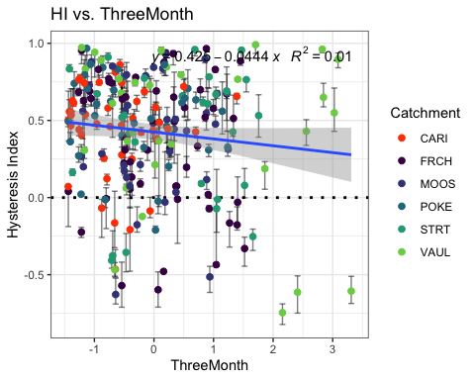

SPC_data.5 <- HI_FI_SPC[,c("Hyst_index","Intensity")]  
  
pairs(SPC_data.5)

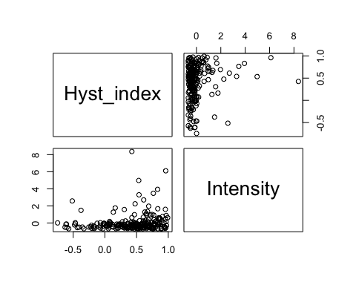

HI_FI_SPC %>% ggplot(aes(x = Intensity, y = Hyst_index)) +   
 geom_hline(yintercept = 0, linetype = "dotted", size = 1) +  
 geom_errorbar(aes(ymin=HI_ymin, ymax=HI_ymax), colour="black", alpha=0.5, size=.5, width = 0.1)+   
 geom_point(aes(color = site.ID), size = 2) +  
 scale_color_manual(values = c("orange red", viridis::viridis(6)), "Catchment")+theme_bw() +  
 geom_smooth(method = "lm", na.rm = TRUE, fullrange = TRUE, aes(group = 1)) +   
 stat_poly_eq(formula = y~x,  
 label.y = "top", label.x = "right",  
 aes(label = paste(..eq.label.., ..rr.label.., sep = "~~~")),   
 parse = TRUE) +   
 ylab("Hysteresis Index") +  
 ggtitle("HI vs. Intensity")

## `geom_smooth()` using formula 'y ~ x'

## Warning: Removed 2 rows containing non-finite values (stat_poly_eq).

## Warning: Removed 2 rows containing missing values (geom_point).

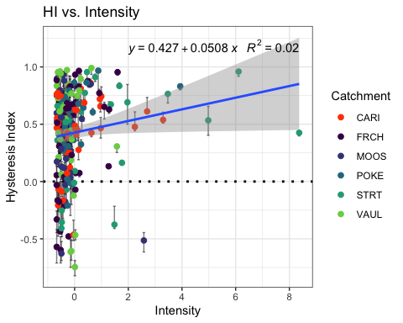

SPC_data.6 <- HI_FI_SPC[,c("Hyst_index","StormTemp")]  
  
pairs(SPC_data.6)

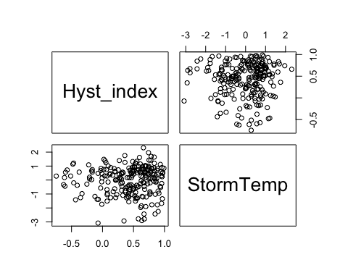

HI_FI_SPC %>% ggplot(aes(x = StormTemp, y = Hyst_index)) +   
 geom_hline(yintercept = 0, linetype = "dotted", size = 1) +  
 geom_errorbar(aes(ymin=HI_ymin, ymax=HI_ymax), colour="black", alpha=0.5, size=.5, width = 0.1)+   
 geom_point(aes(color = site.ID), size = 2) +  
 scale_color_manual(values = c("orange red", viridis::viridis(6)), "Catchment")+theme_bw() +  
 geom_smooth(method = "lm", na.rm = TRUE, fullrange = TRUE, aes(group = 1)) +   
 stat_poly_eq(formula = y~x,  
 label.y = "top", label.x = "right",  
 aes(label = paste(..eq.label.., ..rr.label.., sep = "~~~")),   
 parse = TRUE) +   
 ylab("Hysteresis Index") +  
 ggtitle("HI vs. StormTemp")

## `geom_smooth()` using formula 'y ~ x'

## Warning: Removed 1 rows containing non-finite values (stat_poly_eq).

## Warning: Removed 1 rows containing missing values (geom_point).

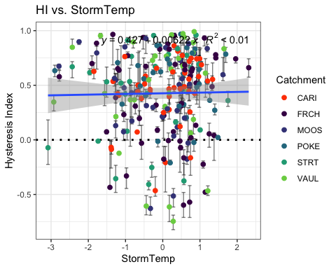

SPC_data.7 <- HI_FI_SPC[,c("Hyst_index","TempWeek")]  
  
pairs(SPC_data.7)

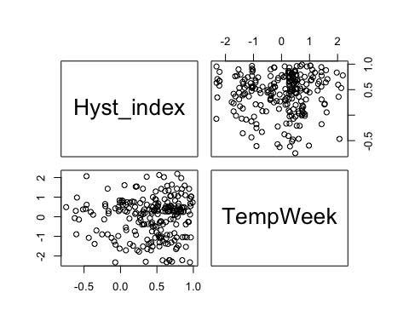

HI_FI_SPC %>% ggplot(aes(x = TempWeek, y = Hyst_index)) +   
 geom_hline(yintercept = 0, linetype = "dotted", size = 1) +  
 geom_errorbar(aes(ymin=HI_ymin, ymax=HI_ymax), colour="black", alpha=0.5, size=.5, width = 0.1)+   
 geom_point(aes(color = site.ID), size = 2) +  
 scale_color_manual(values = c("orange red", viridis::viridis(6)), "Catchment")+theme_bw() +  
 geom_smooth(method = "lm", na.rm = TRUE, fullrange = TRUE, aes(group = 1)) +   
 stat_poly_eq(formula = y~x,  
 label.y = "top", label.x = "right",  
 aes(label = paste(..eq.label.., ..rr.label.., sep = "~~~")),   
 parse = TRUE) +   
 ylab("Hysteresis Index") +  
 ggtitle("HI vs. TempWeek")

## `geom_smooth()` using formula 'y ~ x'

## Warning: Removed 3 rows containing non-finite values (stat_poly_eq).

## Warning: Removed 3 rows containing missing values (geom_point).

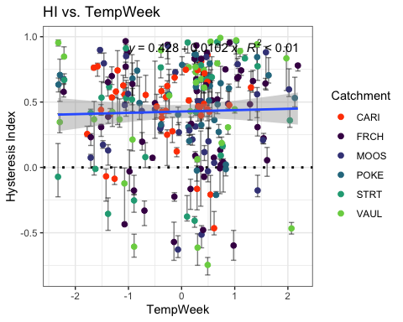

SPC_data.8 <- HI_FI_SPC[,c("Hyst_index","TimeSinceChena")]  
  
pairs(SPC_data.8)

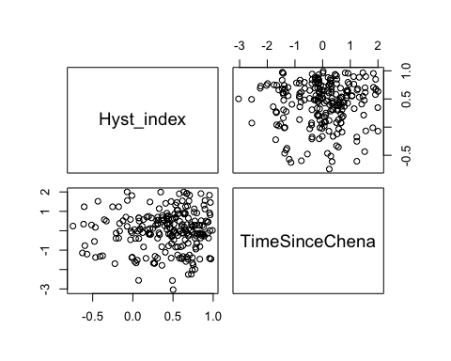

HI_FI_SPC %>% ggplot(aes(x = TimeSinceChena, y = Hyst_index)) +   
 geom_hline(yintercept = 0, linetype = "dotted", size = 1) +  
 geom_errorbar(aes(ymin=HI_ymin, ymax=HI_ymax), colour="black", alpha=0.5, size=.5, width = 0.1)+   
 geom_point(aes(color = site.ID), size = 2) +  
 scale_color_manual(values = c("orange red", viridis::viridis(6)), "Catchment")+theme_bw() +  
 geom_smooth(method = "lm", na.rm = TRUE, fullrange = TRUE, aes(group = 1)) +   
 stat_poly_eq(formula = y~x,  
 label.y = "top", label.x = "right",  
 aes(label = paste(..eq.label.., ..rr.label.., sep = "~~~")),   
 parse = TRUE) +   
 ylab("Hysteresis Index") +  
 ggtitle("HI vs. TimeSinceChena")

## `geom_smooth()` using formula 'y ~ x'

## Warning: Removed 1 rows containing non-finite values (stat_poly_eq).

## Warning: Removed 1 rows containing missing values (geom_point).

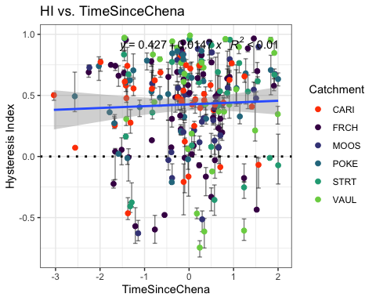

SPC_data <- HI_FI_SPC[,c("Hyst_index", "site.ID", "StormPrecip", "StormTemp", "PrecipWeek", "PrecipMonth", "ThreeMonth", "TempWeek", "Intensity", "TimeSinceChena", "burn", "pf")]  
  
SPC_data <- na.omit(SPC_data) # 232-228  
cor(SPC_data[,c(1,3:10)])

## Hyst_index StormPrecip StormTemp PrecipWeek PrecipMonth  
## Hyst_index 1.00000000 0.07615513 0.01026969 -0.314632580 -0.24679265  
## StormPrecip 0.07615513 1.00000000 0.11497752 0.096062860 0.06062205  
## StormTemp 0.01026969 0.11497752 1.00000000 0.029484778 0.08882232  
## PrecipWeek -0.31463258 0.09606286 0.02948478 1.000000000 0.55214489  
## PrecipMonth -0.24679265 0.06062205 0.08882232 0.552144890 1.00000000  
## ThreeMonth -0.11432914 -0.06324691 -0.24518194 0.241898486 0.63150939  
## TempWeek 0.02390792 0.17640383 0.79484387 0.085404462 0.11434524  
## Intensity 0.13710984 0.35214397 0.08707696 0.009149697 0.03280435  
## TimeSinceChena 0.03357222 -0.13182035 -0.72243611 -0.053746289 0.14682218  
## ThreeMonth TempWeek Intensity TimeSinceChena  
## Hyst_index -0.1143291422 0.02390792 0.1371098425 0.03357222  
## StormPrecip -0.0632469075 0.17640383 0.3521439698 -0.13182035  
## StormTemp -0.2451819386 0.79484387 0.0870769599 -0.72243611  
## PrecipWeek 0.2418984858 0.08540446 0.0091496971 -0.05374629  
## PrecipMonth 0.6315093858 0.11434524 0.0328043518 0.14682218  
## ThreeMonth 1.0000000000 -0.15704799 0.0002109709 0.56326363  
## TempWeek -0.1570479909 1.00000000 0.1085609340 -0.59264662  
## Intensity 0.0002109709 0.10856093 1.0000000000 -0.06252823  
## TimeSinceChena 0.5632636347 -0.59264662 -0.0625282284 1.00000000

1. StormTemp is heavily correlated with TempWeek (0.794) but TempWeek is more correlated with HI (0.024 vs. 0.01)
2. StormTemp is also correlated with TimeSinceChena (-0.722) but TimeSinceChena is more correlated with HI (0.033 vs. -0.01)
3. PrecipWeek is correlated with PrecipMonth (0.552) but PrecipWeek is more correlated with HI (-0.314 vs. -0.246)
4. PrecipMonth is correlated with ThreeMonth (0.631) but PrecipMonth is more correlated with HI (-0.246 vs. -0.114)
5. ThreeMonth is correlated with TimeSinceChena (0.563) but ThreeMonth is more correlated with HI ( -0.114 vs. 0.033)

* this makes me want to drop time since chena and three month

## boundary (singular) fit: see ?isSingular

## Linear mixed model fit by REML ['lmerMod']  
## Formula: Hyst_index ~ StormPrecip + PrecipWeek + PrecipMonth + ThreeMonth +   
## Intensity + StormTemp + TempWeek + TimeSinceChena + (1 | site.ID)  
## Data: SPC_data  
##   
## REML criterion at convergence: 227.4  
##   
## Scaled residuals:   
## Min 1Q Median 3Q Max   
## -3.2685 -0.5824 0.2009 0.7174 1.8859   
##   
## Random effects:  
## Groups Name Variance Std.Dev.  
## site.ID (Intercept) 0.0000 0.0000   
## Residual 0.1344 0.3666   
## Number of obs: 228, groups: site.ID, 6  
##   
## Fixed effects:  
## Estimate Std. Error t value  
## (Intercept) 0.429150 0.024373 17.607  
## StormPrecip 0.024978 0.026251 0.952  
## PrecipWeek -0.089543 0.030053 -2.979  
## PrecipMonth -0.058232 0.039490 -1.475  
## ThreeMonth -0.009995 0.040914 -0.244  
## Intensity 0.043338 0.024761 1.750  
## StormTemp 0.023304 0.048449 0.481  
## TempWeek 0.032157 0.040649 0.791  
## TimeSinceChena 0.066335 0.045897 1.445  
##   
## Correlation of Fixed Effects:  
## (Intr) StrmPr PrcpWk PrcpMn ThrMnt Intnst StrmTm TempWk  
## StormPrecip -0.013   
## PrecipWeek -0.056 -0.053   
## PrecipMonth 0.016 -0.054 -0.513   
## ThreeMonth 0.043 0.071 0.057 -0.579   
## Intensity -0.023 -0.343 0.032 0.003 -0.032   
## StormTemp -0.038 0.068 0.201 -0.183 -0.039 -0.020   
## TempWeek 0.022 -0.120 -0.056 0.017 -0.079 -0.018 -0.625   
## TimeSincChn -0.053 0.023 0.199 0.008 -0.502 0.002 0.504 0.076  
## optimizer (nloptwrap) convergence code: 0 (OK)  
## boundary (singular) fit: see ?isSingular

1. Scaled residuals do not look as normal as they should
2. The site accounts for none of the variation
3. Precip week is the most significant

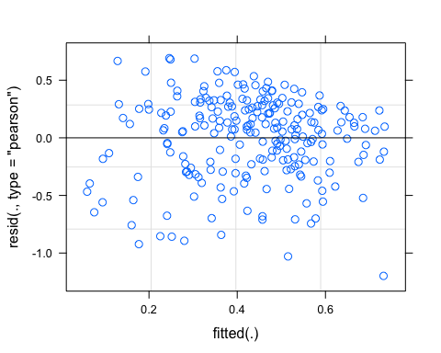 Looks good

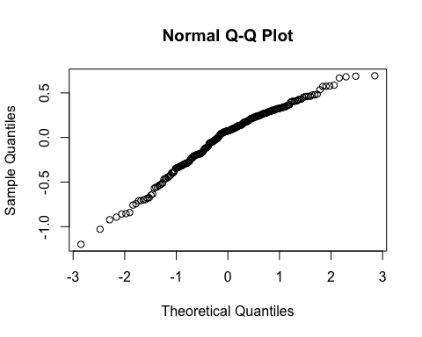 A little bent

vif(M0.SPC)

## StormPrecip PrecipWeek PrecipMonth ThreeMonth Intensity   
## 1.190012 1.570296 2.597943 2.749300 1.148115   
## StormTemp TempWeek TimeSinceChena   
## 3.991877 2.818197 3.357583

Any VIF>2 indicates high correlation….StormTemp and TimeSinceChena are above three…lets remove StormTemp and ThreeMonth

## boundary (singular) fit: see ?isSingular

## StormPrecip PrecipWeek PrecipMonth Intensity TempWeek   
## 1.178024 1.500282 1.617935 1.146452 1.686224   
## TimeSinceChena   
## 1.723253

1. all VIFs are below 2 which is good!
2. PrecipWeek and PrecipMonth (0.55)
3. TimeSinceChena and TempWeek (-0.59)

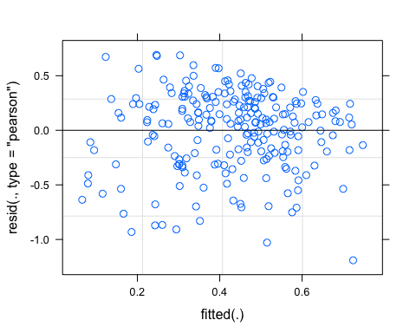

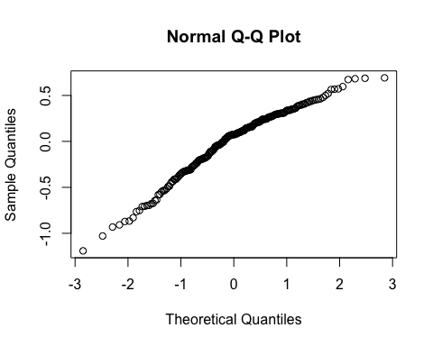

pr <- ggpredict(M1.SPC, terms = c("PrecipWeek"))  
plot(pr, add.data = TRUE)

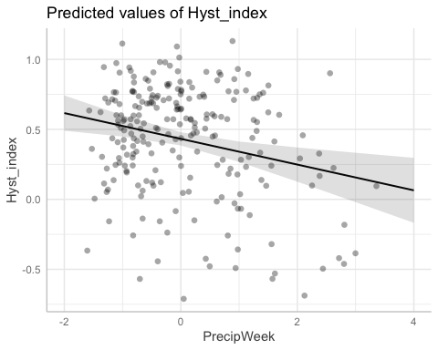

### alternative slope

## boundary (singular) fit: see ?isSingular

aictab(list(M0.SPC, M1.SPC, M2.SPC))

## Warning in aictab.AIClmerMod(list(M0.SPC, M1.SPC, M2.SPC)):   
## Model names have been supplied automatically in the table

## Warning in aictab.AIClmerMod(list(M0.SPC, M1.SPC, M2.SPC)):   
## Model selection for fixed effects is only appropriate with ML estimation:  
## REML (default) should only be used to select random effects for a constant set of fixed effects

##   
## Model selection based on AICc:  
##   
## K AICc Delta_AICc AICcWt Cum.Wt Res.LL  
## Mod2 9 237.75 0.00 0.9 0.9 -109.46  
## Mod3 11 242.15 4.40 0.1 1.0 -109.46  
## Mod1 11 250.65 12.89 0.0 1.0 -113.71

Mod2: Reduced model (no StormTemp or ThreeMonth Precip) with random intercept structure Mod3: Reduced model (’’) with random slope structure Mod1: Full model with random intercept structure

dwplot(list(M1.SPC),  
 vline = geom_vline(xintercept = 0,  
 colour = "grey60",  
 linetype = 2)) +  
 ggtitle("Antecedent conditions, SPC")

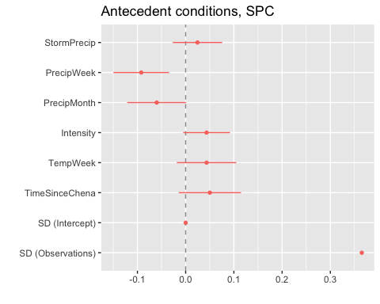 CI overlapping 0 are nonsignificant. PrecipWeek and maybe PrecipMonth are significant

plot(M1.SPC, site.ID ~ resid(.), abline = 0 ) # generate diagnostic plots

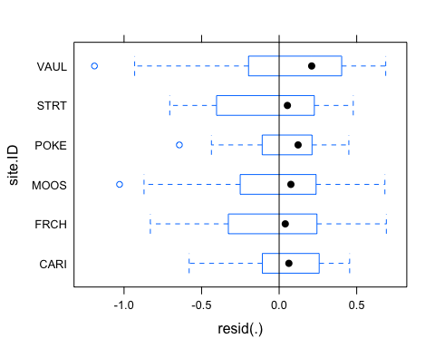 This plot shows us that there are some outliers in VAUL, POKE, and MOOS and that the variability within VAUL is greater than in other sites we therefore examine the sites in isolation standardized residuals versus fitted values

plot(M1.SPC, resid(., type = "pearson") ~ fitted(.) | site.ID, id = 0.05,   
 adj = -0.3, pch = 20, col = "gray40")

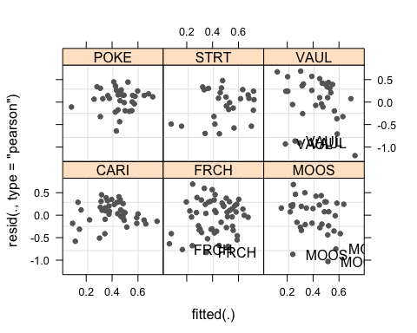 The plot shows the standardized residuals (or Pearson’s residuals) versus fitted values and suggests that there are outliers in the data (the names elements in the plots). To check if these outliers are a cause for concern, we will now use a Levene’s test to check if the variance is distributed homogeneously (homoscedasticity) or whether the assumption of variance homogeneity is violated (due to the outliers).

### Mixed effect model is a pseudo r^2

sjPlot::tab_model(M1.SPC)

## Argument 'df_method' is deprecated. Please use 'ci_method' instead.

Hyst_index

Predictors

Estimates

CI

p

(Intercept)

0.43

0.38 – 0.48

<0.001

StormPrecip

0.02

-0.03 – 0.08

0.346

PrecipWeek

-0.09

-0.15 – -0.03

0.002

PrecipMonth

-0.06

-0.12 – 0.00

0.055

Intensity

0.04

-0.01 – 0.09

0.080

TempWeek

0.04

-0.02 – 0.11

0.167

TimeSinceChena

0.05

-0.01 – 0.11

0.127

Random Effects

σ2

0.13

τ00 site.ID

0.00

N site.ID

6

Observations

228

Marginal R2 / Conditional R2

0.138 / NA

The R2 values of the summary table are correct as Marginal and conditional are bothe there. The more appropriate conditional and marginal coefficient of determination for generalized mixed-effect models can be extracted using the r.squaredGLMM function from the MuMIn package

The marginal R2 (marginal coefficient of determination) represents the variance explained by the fixed effects while the conditional R2 is interpreted as a variance explained by the entire model, including both fixed and random effects

r.squaredGLMM(M1.SPC)

## R2m R2c  
## [1,] 0.1380048 0.1380048

Only ~14% of the variance is explained in this model…ouch

sjPlot::plot_model(M1.SPC, type = "pred", terms = c("PrecipWeek")) +  
 # show uncentered date rather than centered date  
 scale_x_continuous(name = "PrecipWeek",   
 breaks = seq(-500, 300, 100),   
 labels = seq(1150, 1950, 100))

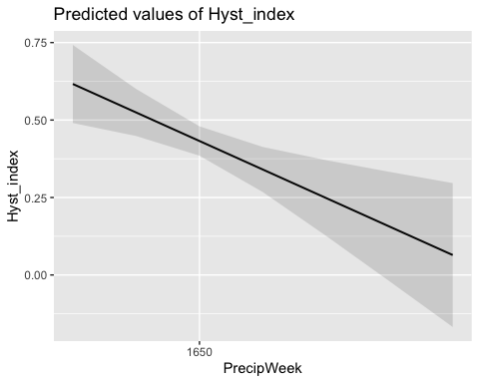

### Permafrost

f4.SPC <- formula(Hyst_index ~ StormPrecip*pf + PrecipWeek*pf + PrecipMonth*pf + Intensity*pf + TempWeek*pf + TimeSinceChena*pf + (1|site.ID))  
  
M4.SPC <- lmer(f4.SPC, data = SPC_data)

## boundary (singular) fit: see ?isSingular

summary(M4.SPC)

## Linear mixed model fit by REML ['lmerMod']  
## Formula: Hyst_index ~ StormPrecip * pf + PrecipWeek * pf + PrecipMonth *   
## pf + Intensity * pf + TempWeek * pf + TimeSinceChena * pf +   
## (1 | site.ID)  
## Data: SPC_data  
##   
## REML criterion at convergence: 239.1  
##   
## Scaled residuals:   
## Min 1Q Median 3Q Max   
## -3.3013 -0.6390 0.1828 0.6936 1.9284   
##   
## Random effects:  
## Groups Name Variance Std.Dev.  
## site.ID (Intercept) 0.000 0.0000   
## Residual 0.134 0.3661   
## Number of obs: 228, groups: site.ID, 6  
##   
## Fixed effects:  
## Estimate Std. Error t value  
## (Intercept) 0.437017 0.055535 7.869  
## StormPrecip 0.009367 0.044098 0.212  
## pfmedium -0.002077 0.062607 -0.033  
## PrecipWeek -0.158653 0.066463 -2.387  
## PrecipMonth 0.029462 0.064762 0.455  
## Intensity 0.028430 0.029646 0.959  
## TempWeek 0.059366 0.077262 0.768  
## TimeSinceChena 0.003591 0.098632 0.036  
## StormPrecip:pfmedium 0.012455 0.058068 0.214  
## pfmedium:PrecipWeek 0.084585 0.074529 1.135  
## pfmedium:PrecipMonth -0.124077 0.074547 -1.664  
## pfmedium:Intensity 0.037941 0.059807 0.634  
## pfmedium:TempWeek -0.038586 0.085288 -0.452  
## pfmedium:TimeSinceChena 0.057545 0.105162 0.547

##   
## Correlation matrix not shown by default, as p = 14 > 12.  
## Use print(x, correlation=TRUE) or  
## vcov(x) if you need it

## optimizer (nloptwrap) convergence code: 0 (OK)  
## boundary (singular) fit: see ?isSingular

Nothing sticking out here

### burn

f5.SPC <- formula(Hyst_index ~ StormPrecip*burn + PrecipWeek*burn + PrecipMonth*burn + Intensity*burn + TempWeek*burn + TimeSinceChena*burn + (1|site.ID))  
  
M5.SPC <- lmer(f5.SPC, data = SPC_data)

## boundary (singular) fit: see ?isSingular

summary(M5.SPC)

## Linear mixed model fit by REML ['lmerMod']  
## Formula: Hyst_index ~ StormPrecip * burn + PrecipWeek * burn + PrecipMonth *   
## burn + Intensity * burn + TempWeek * burn + TimeSinceChena *   
## burn + (1 | site.ID)  
## Data: SPC_data  
##   
## REML criterion at convergence: 241.9  
##   
## Scaled residuals:   
## Min 1Q Median 3Q Max   
## -3.4381 -0.5855 0.1828 0.6959 1.8994   
##   
## Random effects:  
## Groups Name Variance Std.Dev.  
## site.ID (Intercept) 0.0000 0.0000   
## Residual 0.1358 0.3685   
## Number of obs: 228, groups: site.ID, 6  
##   
## Fixed effects:  
## Estimate Std. Error t value  
## (Intercept) 0.44599 0.03251 13.717  
## StormPrecip 0.02957 0.03307 0.894  
## burnunburned -0.01714 0.05556 -0.309  
## PrecipWeek -0.11680 0.03562 -3.279  
## PrecipMonth -0.02527 0.04445 -0.568  
## Intensity 0.03454 0.02614 1.321  
## TempWeek 0.02819 0.03989 0.707  
## TimeSinceChena 0.03880 0.03950 0.982  
## StormPrecip:burnunburned -0.03386 0.06279 -0.539  
## burnunburned:PrecipWeek 0.08075 0.06523 1.238  
## burnunburned:PrecipMonth -0.07505 0.06474 -1.159  
## burnunburned:Intensity 0.10175 0.11153 0.912  
## burnunburned:TempWeek 0.05288 0.07014 0.754  
## burnunburned:TimeSinceChena 0.05088 0.07620 0.668

##   
## Correlation matrix not shown by default, as p = 14 > 12.  
## Use print(x, correlation=TRUE) or  
## vcov(x) if you need it

## optimizer (nloptwrap) convergence code: 0 (OK)  
## boundary (singular) fit: see ?isSingular

Nothing sticking out here

TURB

#### Scatter plot matrix

HI_FI_turb_CARI <- filter(HI_FI_turb, site.ID == "CARI")  
HI_FI_turb_FRCH <- filter(HI_FI_turb, site.ID == "FRCH")  
HI_FI_turb_MOOS <- filter(HI_FI_turb, site.ID == "MOOS")  
HI_FI_turb_POKE <- filter(HI_FI_turb, site.ID == "POKE")  
HI_FI_turb_VAUL <- filter(HI_FI_turb, site.ID == "VAUL")  
HI_FI_turb_STRT <- filter(HI_FI_turb, site.ID == "STRT")  
  
turb_data.1 <- HI_FI_turb[,c("Hyst_index","StormPrecip")]  
  
pairs(turb_data.1)

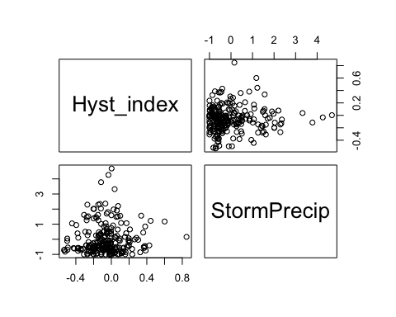

HI_FI_turb %>% ggplot(aes(x = StormPrecip, y = Hyst_index)) +   
 geom_hline(yintercept = 0, linetype = "dotted", size = 1) +  
 geom_errorbar(aes(ymin=HI_ymin, ymax=HI_ymax), colour="black", alpha=0.5, size=.5, width = 0.1)+   
 geom_point(aes(color = site.ID), size = 2) +  
 scale_color_manual(values = c("orange red", viridis::viridis(6)), "Catchment")+theme_bw() +  
 geom_smooth(method = "lm", na.rm = TRUE, fullrange = TRUE, aes(group = 1)) +   
 stat_poly_eq(formula = y~x,  
 label.y = "top", label.x = "right",  
 aes(label = paste(..eq.label.., ..rr.label.., sep = "~~~")),   
 parse = TRUE) +   
 ylab("Hysteresis Index") +  
 ggtitle("HI vs. StormPrecip")

## `geom_smooth()` using formula 'y ~ x'

## Warning: Removed 1 rows containing non-finite values (stat_poly_eq).

## Warning: Removed 1 rows containing missing values (geom_point).

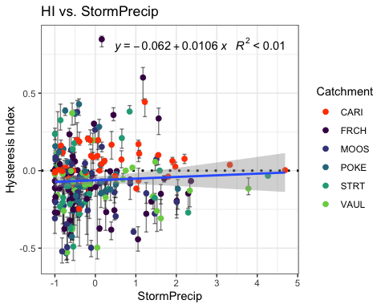

turb_data.2 <- HI_FI_turb[,c("Hyst_index","PrecipWeek")]  
  
pairs(turb_data.2)

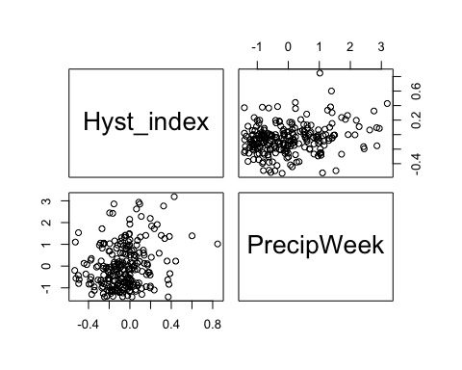

HI_FI_turb %>% ggplot(aes(x = PrecipWeek, y = Hyst_index)) +   
 geom_hline(yintercept = 0, linetype = "dotted", size = 1) +  
 geom_errorbar(aes(ymin=HI_ymin, ymax=HI_ymax), colour="black", alpha=0.5, size=.5, width = 0.1)+   
 geom_point(aes(color = site.ID), size = 2) +  
 scale_color_manual(values = c("orange red", viridis::viridis(6)), "Catchment")+theme_bw() +  
 geom_smooth(method = "lm", na.rm = TRUE, fullrange = TRUE, aes(group = 1)) +   
 stat_poly_eq(formula = y~x,  
 label.y = "top", label.x = "right",  
 aes(label = paste(..eq.label.., ..rr.label.., sep = "~~~")),   
 parse = TRUE) +   
 ylab("Hysteresis Index") +  
 ggtitle("HI vs. PrecipWeek")

## `geom_smooth()` using formula 'y ~ x'

## Warning: Removed 1 rows containing non-finite values (stat_poly_eq).

## Warning: Removed 1 rows containing missing values (geom_point).

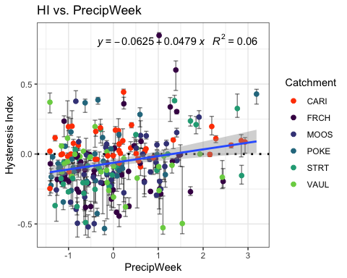

turb_data.3 <- HI_FI_turb[,c("Hyst_index","PrecipMonth")]  
  
pairs(turb_data.3)

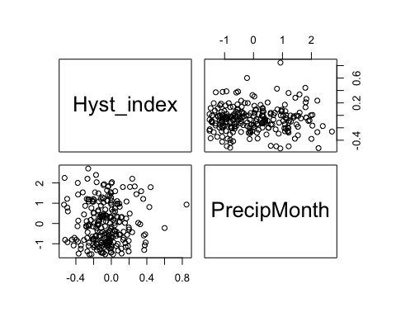

HI_FI_turb %>% ggplot(aes(x = PrecipMonth, y = Hyst_index)) +   
 geom_hline(yintercept = 0, linetype = "dotted", size = 1) +  
 geom_errorbar(aes(ymin=HI_ymin, ymax=HI_ymax), colour="black", alpha=0.5, size=.5, width = 0.1)+   
 geom_point(aes(color = site.ID), size = 2) +  
 scale_color_manual(values = c("orange red", viridis::viridis(6)), "Catchment")+theme_bw() +  
 geom_smooth(method = "lm", na.rm = TRUE, fullrange = TRUE, aes(group = 1)) +   
 stat_poly_eq(formula = y~x,  
 label.y = "top", label.x = "right",  
 aes(label = paste(..eq.label.., ..rr.label.., sep = "~~~")),   
 parse = TRUE) +   
 ylab("Hysteresis Index") +  
 ggtitle("HI vs. PrecipMonth")

## `geom_smooth()` using formula 'y ~ x'

## Warning: Removed 1 rows containing non-finite values (stat_poly_eq).

## Warning: Removed 1 rows containing missing values (geom_point).

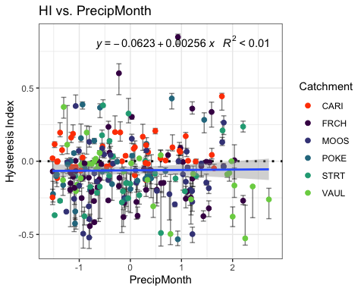

turb_data.4 <- HI_FI_turb[,c("Hyst_index","ThreeMonth")]  
  
pairs(SPC_data.4)



HI_FI_turb %>% ggplot(aes(x = ThreeMonth, y = Hyst_index)) +   
 geom_hline(yintercept = 0, linetype = "dotted", size = 1) +  
 geom_errorbar(aes(ymin=HI_ymin, ymax=HI_ymax), colour="black", alpha=0.5, size=.5, width = 0.1)+   
 geom_point(aes(color = site.ID), size = 2) +  
 scale_color_manual(values = c("orange red", viridis::viridis(6)), "Catchment")+theme_bw() +  
 geom_smooth(method = "lm", na.rm = TRUE, fullrange = TRUE, aes(group = 1)) +   
 stat_poly_eq(formula = y~x,  
 label.y = "top", label.x = "right",  
 aes(label = paste(..eq.label.., ..rr.label.., sep = "~~~")),   
 parse = TRUE) +   
 ylab("Hysteresis Index") +  
 ggtitle("HI vs. ThreeMonth")

## `geom_smooth()` using formula 'y ~ x'

## Warning: Removed 1 rows containing non-finite values (stat_poly_eq).

## Warning: Removed 1 rows containing missing values (geom_point).

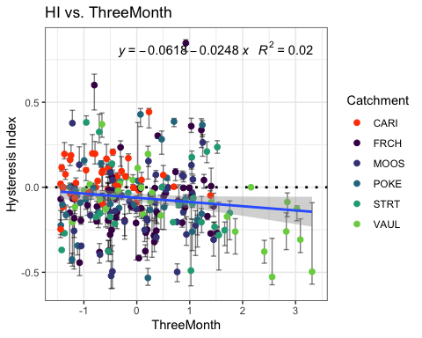

turb_data.5 <- HI_FI_turb[,c("Hyst_index","Intensity")]  
  
pairs(turb_data.5)

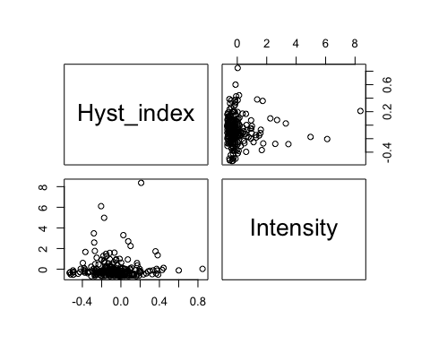

HI_FI_turb %>% ggplot(aes(x = Intensity, y = Hyst_index)) +   
 geom_hline(yintercept = 0, linetype = "dotted", size = 1) +  
 geom_errorbar(aes(ymin=HI_ymin, ymax=HI_ymax), colour="black", alpha=0.5, size=.5, width = 0.1)+   
 geom_point(aes(color = site.ID), size = 2) +  
 scale_color_manual(values = c("orange red", viridis::viridis(6)), "Catchment")+theme_bw() +  
 geom_smooth(method = "lm", na.rm = TRUE, fullrange = TRUE, aes(group = 1)) +   
 stat_poly_eq(formula = y~x,  
 label.y = "top", label.x = "right",  
 aes(label = paste(..eq.label.., ..rr.label.., sep = "~~~")),   
 parse = TRUE) +   
 ylab("Hysteresis Index") +  
 ggtitle("HI vs. Intensity")

## `geom_smooth()` using formula 'y ~ x'

## Warning: Removed 3 rows containing non-finite values (stat_poly_eq).

## Warning: Removed 3 rows containing missing values (geom_point).

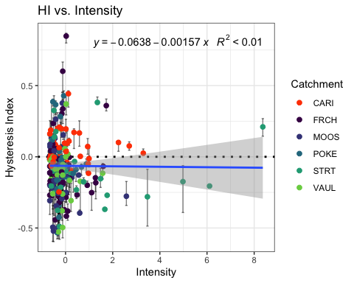

turb_data.6 <- HI_FI_turb[,c("Hyst_index","StormTemp")]  
  
pairs(turb_data.6)

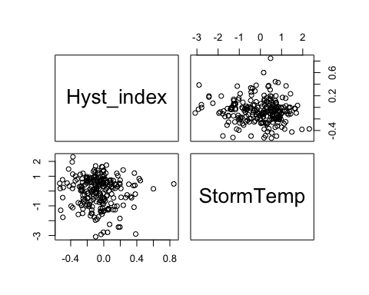

HI_FI_turb %>% ggplot(aes(x = StormTemp, y = Hyst_index)) +   
 geom_hline(yintercept = 0, linetype = "dotted", size = 1) +  
 geom_errorbar(aes(ymin=HI_ymin, ymax=HI_ymax), colour="black", alpha=0.5, size=.5, width = 0.1)+   
 geom_point(aes(color = site.ID), size = 2) +  
 scale_color_manual(values = c("orange red", viridis::viridis(6)), "Catchment")+theme_bw() +  
 geom_smooth(method = "lm", na.rm = TRUE, fullrange = TRUE, aes(group = 1)) +   
 stat_poly_eq(formula = y~x,  
 label.y = "top", label.x = "right",  
 aes(label = paste(..eq.label.., ..rr.label.., sep = "~~~")),   
 parse = TRUE) +   
 ylab("Hysteresis Index") +  
 ggtitle("HI vs. StormTemp")

## `geom_smooth()` using formula 'y ~ x'

## Warning: Removed 1 rows containing non-finite values (stat_poly_eq).

## Warning: Removed 1 rows containing missing values (geom_point).

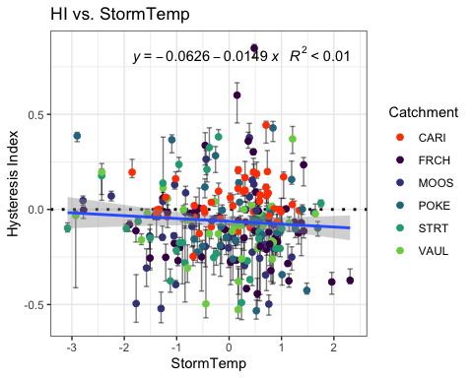

turb_data.7 <- HI_FI_turb[,c("Hyst_index","TempWeek")]  
  
pairs(turb_data.7)

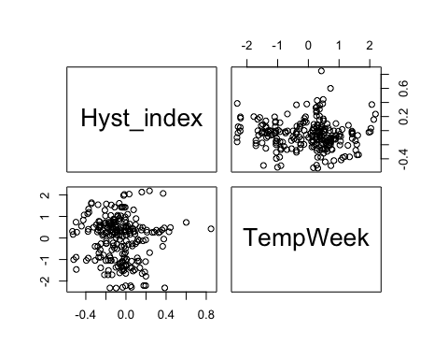

HI_FI_turb %>% ggplot(aes(x = TempWeek, y = Hyst_index)) +   
 geom_hline(yintercept = 0, linetype = "dotted", size = 1) +  
 geom_errorbar(aes(ymin=HI_ymin, ymax=HI_ymax), colour="black", alpha=0.5, size=.5, width = 0.1)+   
 geom_point(aes(color = site.ID), size = 2) +  
 scale_color_manual(values = c("orange red", viridis::viridis(6)), "Catchment")+theme_bw() +  
 geom_smooth(method = "lm", na.rm = TRUE, fullrange = TRUE, aes(group = 1)) +   
 stat_poly_eq(formula = y~x,  
 label.y = "top", label.x = "right",  
 aes(label = paste(..eq.label.., ..rr.label.., sep = "~~~")),   
 parse = TRUE) +   
 ylab("Hysteresis Index") +  
 ggtitle("HI vs. TempWeek")

## `geom_smooth()` using formula 'y ~ x'

## Warning: Removed 3 rows containing non-finite values (stat_poly_eq).

## Warning: Removed 3 rows containing missing values (geom_point).

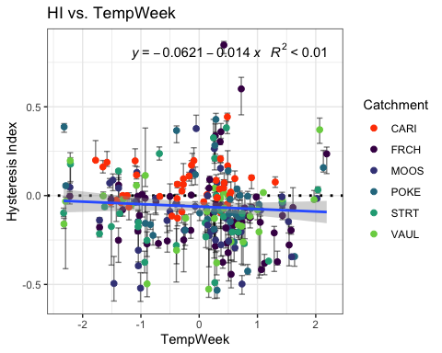

turb_data.8 <- HI_FI_turb[,c("Hyst_index","TimeSinceChena")]  
  
pairs(turb_data.8)

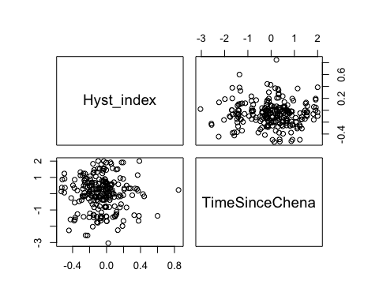

HI_FI_turb %>% ggplot(aes(x = TimeSinceChena, y = Hyst_index)) +   
 geom_hline(yintercept = 0, linetype = "dotted", size = 1) +  
 geom_errorbar(aes(ymin=HI_ymin, ymax=HI_ymax), colour="black", alpha=0.5, size=.5, width = 0.1)+   
 geom_point(aes(color = site.ID), size = 2) +  
 scale_color_manual(values = c("orange red", viridis::viridis(6)), "Catchment")+theme_bw() +  
 geom_smooth(method = "lm", na.rm = TRUE, fullrange = TRUE, aes(group = 1)) +   
 stat_poly_eq(formula = y~x,  
 label.y = "top", label.x = "right",  
 aes(label = paste(..eq.label.., ..rr.label.., sep = "~~~")),   
 parse = TRUE) +   
 ylab("Hysteresis Index") +  
 ggtitle("HI vs. TimeSinceChena")

## `geom_smooth()` using formula 'y ~ x'

## Warning: Removed 1 rows containing non-finite values (stat_poly_eq).

## Warning: Removed 1 rows containing missing values (geom_point).

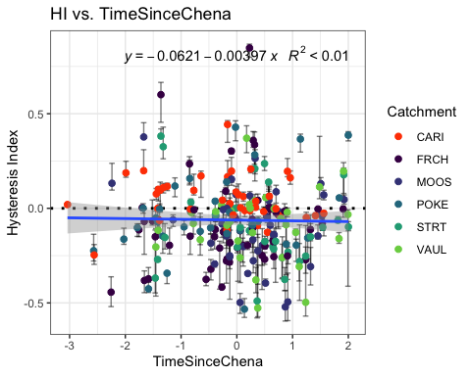

turb_data <- HI_FI_turb[,c("Hyst_index", "site.ID", "StormPrecip", "StormTemp", "PrecipWeek", "PrecipMonth", "ThreeMonth", "TempWeek", "Intensity", "TimeSinceChena", "burn", "pf")]  
  
turb_data <- na.omit(turb_data) # 240 to 235  
cor(turb_data[,c(1,3:10)])

## Hyst_index StormPrecip StormTemp PrecipWeek PrecipMonth  
## Hyst_index 1.000000000 0.05706302 -0.07135094 0.22889521 -0.004277163  
## StormPrecip 0.057063023 1.00000000 0.09718838 0.08534058 0.057525047  
## StormTemp -0.071350942 0.09718838 1.00000000 0.01432988 0.087603791  
## PrecipWeek 0.228895214 0.08534058 0.01432988 1.00000000 0.542657468  
## PrecipMonth -0.004277163 0.05752505 0.08760379 0.54265747 1.000000000  
## ThreeMonth -0.139292765 -0.07626630 -0.24026619 0.22552886 0.628517931  
## TempWeek -0.065572152 0.17018332 0.79717681 0.07145948 0.114853090  
## Intensity -0.007844651 0.35081081 0.07104716 0.02506764 0.042780943  
## TimeSinceChena -0.028366915 -0.14025822 -0.72271484 -0.05747850 0.154526266  
## ThreeMonth TempWeek Intensity TimeSinceChena  
## Hyst_index -0.13929276 -0.06557215 -0.007844651 -0.02836692  
## StormPrecip -0.07626630 0.17018332 0.350810812 -0.14025822  
## StormTemp -0.24026619 0.79717681 0.071047157 -0.72271484  
## PrecipWeek 0.22552886 0.07145948 0.025067640 -0.05747850  
## PrecipMonth 0.62851793 0.11485309 0.042780943 0.15452627  
## ThreeMonth 1.00000000 -0.14863192 -0.011755414 0.57178796  
## TempWeek -0.14863192 1.00000000 0.103943681 -0.58848520  
## Intensity -0.01175541 0.10394368 1.000000000 -0.07546714  
## TimeSinceChena 0.57178796 -0.58848520 -0.075467140 1.00000000

1. StormTemp is heavily correlated with TempWeek (0.797) but StormTemp is more correlated with HI (-0.07 vs. -0.06)
2. StormTemp is also correlated with TimeSinceChena (-0.722) but StormTemp is more correlated with HI (-0.07 vs. -0.02)
3. PrecipWeek is correlated with PrecipMonth (0.542) but PrecipWeek is more correlated with HI (0.228 vs. -0.004)
4. PrecipMonth is correlated with ThreeMonth (0.628) but ThreeMonth is more correlated with HI (-0.139 vs. -0.004)
5. ThreeMonth is correlated with TimeSinceChena (0.571) but ThreeMonth is more correlated with HI ( -0.139 vs. -0.028)

* this makes me want to drop time since chena and three month

## Linear mixed model fit by REML ['lmerMod']  
## Formula: Hyst_index ~ StormPrecip + PrecipWeek + PrecipMonth + ThreeMonth +   
## Intensity + StormTemp + TempWeek + TimeSinceChena + (1 | site.ID)  
## Data: turb_data  
##   
## REML criterion at convergence: -58.8  
##   
## Scaled residuals:   
## Min 1Q Median 3Q Max   
## -2.3883 -0.4934 -0.0960 0.4921 4.7931   
##   
## Random effects:  
## Groups Name Variance Std.Dev.  
## site.ID (Intercept) 0.00157 0.03962   
## Residual 0.03619 0.19023   
## Number of obs: 235, groups: site.ID, 6  
##   
## Fixed effects:  
## Estimate Std. Error t value  
## (Intercept) -0.063353 0.020556 -3.082  
## StormPrecip 0.004487 0.014037 0.320  
## PrecipWeek 0.057888 0.015823 3.658  
## PrecipMonth -0.003098 0.020336 -0.152  
## ThreeMonth -0.043281 0.022134 -1.955  
## Intensity -0.003337 0.013823 -0.241  
## StormTemp -0.020366 0.025859 -0.788  
## TempWeek 0.002215 0.021678 0.102  
## TimeSinceChena 0.014484 0.024419 0.593  
##   
## Correlation of Fixed Effects:  
## (Intr) StrmPr PrcpWk PrcpMn ThrMnt Intnst StrmTm TempWk  
## StormPrecip 0.013   
## PrecipWeek -0.001 -0.012   
## PrecipMonth 0.007 -0.044 -0.491   
## ThreeMonth -0.007 0.032 0.022 -0.583   
## Intensity -0.022 -0.342 0.028 -0.042 0.003   
## StormTemp 0.001 0.125 0.239 -0.162 -0.104 -0.002   
## TempWeek -0.005 -0.158 -0.080 -0.003 -0.012 -0.029 -0.647   
## TimeSincChn -0.019 0.067 0.239 0.019 -0.525 0.012 0.529 0.024

1. Scaled residuals dont look ideal
2. The site accounts for slightly more variation

3)Precip week is the most significant

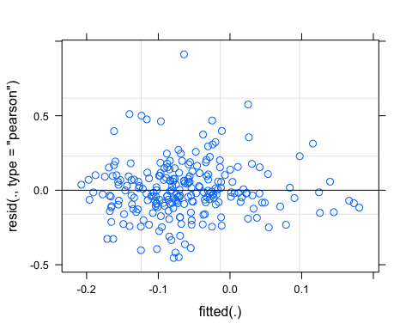 perhaps some funnelling

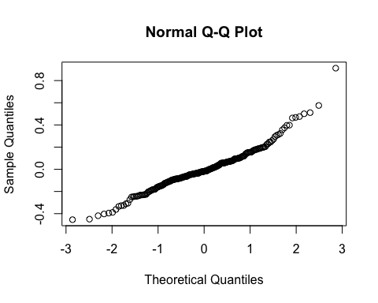

vif(M0.turb)

## StormPrecip PrecipWeek PrecipMonth ThreeMonth Intensity   
## 1.204506 1.566374 2.614484 2.864025 1.159961   
## StormTemp TempWeek TimeSinceChena   
## 4.228724 2.959376 3.493013

Any VIF > 2 indicates high correlation….lets remove StormTemp and ThreeMonth

## StormPrecip PrecipWeek PrecipMonth Intensity TempWeek   
## 1.184798 1.472399 1.594259 1.162529 1.701838   
## TimeSinceChena   
## 1.735921

## Linear mixed model fit by REML ['lmerMod']  
## Formula: Hyst_index ~ StormPrecip + PrecipWeek + PrecipMonth + Intensity +   
## TempWeek + TimeSinceChena + (1 | site.ID)  
## Data: turb_data  
##   
## REML criterion at convergence: -65.3  
##   
## Scaled residuals:   
## Min 1Q Median 3Q Max   
## -2.6290 -0.5199 -0.0624 0.4810 4.6794   
##   
## Random effects:  
## Groups Name Variance Std.Dev.  
## site.ID (Intercept) 0.002124 0.04609   
## Residual 0.036469 0.19097   
## Number of obs: 235, groups: site.ID, 6  
##   
## Fixed effects:  
## Estimate Std. Error t value  
## (Intercept) -0.063776 0.022736 -2.805  
## StormPrecip 0.006631 0.013994 0.474  
## PrecipWeek 0.062179 0.015418 4.033  
## PrecipMonth -0.030636 0.015966 -1.919  
## Intensity -0.003038 0.013962 -0.218  
## TempWeek -0.011593 0.016524 -0.702  
## TimeSinceChena 0.002012 0.017319 0.116  
##   
## Correlation of Fixed Effects:  
## (Intr) StrmPr PrcpWk PrcpMn Intnst TempWk  
## StormPrecip 0.014   
## PrecipWeek -0.001 -0.045   
## PrecipMonth 0.004 0.005 -0.560   
## Intensity -0.023 -0.346 0.030 -0.055   
## TempWeek -0.007 -0.099 0.104 -0.261 -0.041   
## TimeSincChn -0.030 0.030 0.196 -0.326 0.023 0.616

1. VIFs are all below 2…woot
2. PrecipWeek and PrecipMonth (0.54)
3. TimeSinceChena (-0.588) 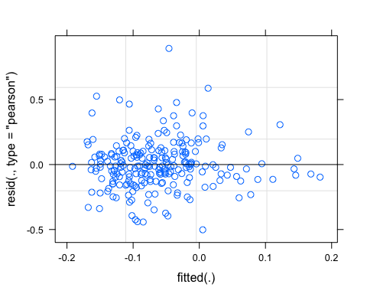

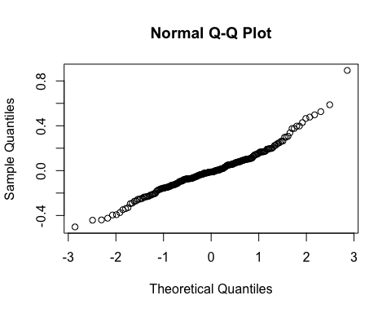

pr <- ggpredict(M1.turb, terms = c("PrecipWeek"))  
plot(pr, add.data = TRUE)

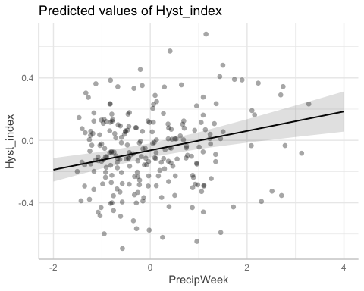

### Alternative slopes

## Linear mixed model fit by REML ['lmerMod']  
## Formula: Hyst_index ~ StormPrecip + PrecipWeek + PrecipMonth + Intensity +   
## TempWeek + TimeSinceChena + (PrecipWeek | site.ID)  
## Data: turb_data  
##   
## REML criterion at convergence: -72.7  
##   
## Scaled residuals:   
## Min 1Q Median 3Q Max   
## -2.4359 -0.5650 -0.0091 0.4909 4.7346   
##   
## Random effects:  
## Groups Name Variance Std.Dev. Corr   
## site.ID (Intercept) 0.002648 0.05146   
## PrecipWeek 0.003106 0.05573 -0.26  
## Residual 0.034097 0.18465   
## Number of obs: 235, groups: site.ID, 6  
##   
## Fixed effects:  
## Estimate Std. Error t value  
## (Intercept) -0.060954 0.024455 -2.493  
## StormPrecip 0.007840 0.013601 0.576  
## PrecipWeek 0.059420 0.027581 2.154  
## PrecipMonth -0.023784 0.016013 -1.485  
## Intensity -0.004520 0.013624 -0.332  
## TempWeek -0.008114 0.016248 -0.499  
## TimeSinceChena 0.003273 0.017127 0.191  
##   
## Correlation of Fixed Effects:  
## (Intr) StrmPr PrcpWk PrcpMn Intnst TempWk  
## StormPrecip 0.014   
## PrecipWeek -0.183 -0.027   
## PrecipMonth 0.006 0.016 -0.329   
## Intensity -0.025 -0.351 0.013 -0.059   
## TempWeek -0.004 -0.098 0.076 -0.281 -0.043   
## TimeSincChn -0.027 0.033 0.126 -0.345 0.016 0.625

aictab(list(M0.turb, M1.turb, M2.turb))

## Warning in aictab.AIClmerMod(list(M0.turb, M1.turb, M2.turb)):   
## Model names have been supplied automatically in the table

## Warning in aictab.AIClmerMod(list(M0.turb, M1.turb, M2.turb)):   
## Model selection for fixed effects is only appropriate with ML estimation:  
## REML (default) should only be used to select random effects for a constant set of fixed effects

##   
## Model selection based on AICc:  
##   
## K AICc Delta_AICc AICcWt Cum.Wt Res.LL  
## Mod3 11 -49.49 0.00 0.81 0.81 36.34  
## Mod2 9 -46.54 2.96 0.19 1.00 32.67  
## Mod1 11 -35.59 13.90 0.00 1.00 29.39

Mod3: Reduced model (no StormTemp, ThreeMonth Precip) with random slope intercept structure Mod2: Reduced model (’’) with random intercept structure Mod1: Full model with random intercept structure

dwplot(list(M1.turb),  
 vline = geom_vline(xintercept = 0,  
 colour = "grey60",  
 linetype = 2)) +  
 ggtitle("Antecedent Conditions, Turb")

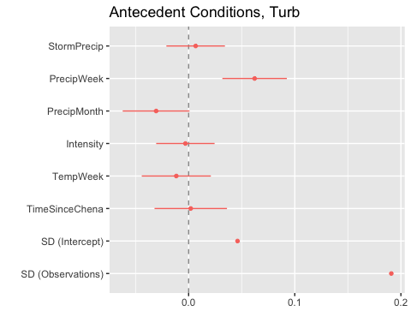 CI overlapping 0 are nonsignificant which is almost everything besides PrecipMonth and PrecipWeek for our reduced model

plot(M1.turb, site.ID ~ resid(.), abline = 0 ) # generate diagnostic plots

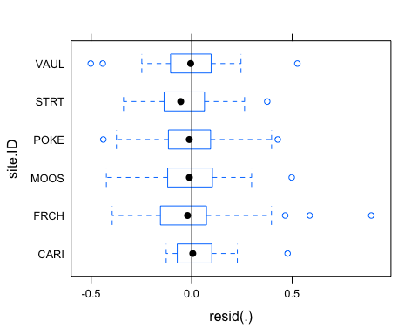 This plot shows us that there are some outliers in all of our sites and that the variability within FRCH is greater than in other sites we therefore examine the sites in isolation standardized residuals versus fitted values

plot(M1.turb, resid(., type = "pearson") ~ fitted(.) | site.ID, id = 0.05,   
 adj = -0.3, pch = 20, col = "gray40")

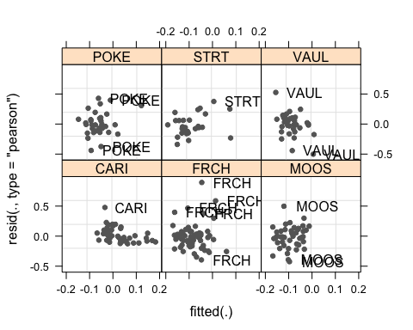 The plot shows the standardized residuals (or Pearson’s residuals) versus fitted values and suggests that there are outliers in the data (the names elements in the plots). To check if these outliers are a cause for concern, we will now use a Levene’s test to check if the variance is distributed homogeneously (homoscedasticity) or whether the assumption of variance homogeneity is violated (due to the outliers).

### Mixed effect model is a pseudo r^2

sjPlot::tab_model(M1.turb)

## Argument 'df_method' is deprecated. Please use 'ci_method' instead.

Hyst_index

Predictors

Estimates

CI

p

(Intercept)

-0.06

-0.11 – -0.02

0.005

StormPrecip

0.01

-0.02 – 0.03

0.636

PrecipWeek

0.06

0.03 – 0.09

<0.001

PrecipMonth

-0.03

-0.06 – 0.00

0.056

Intensity

-0.00

-0.03 – 0.02

0.828

TempWeek

-0.01

-0.04 – 0.02

0.484

TimeSinceChena

0.00

-0.03 – 0.04

0.908

Random Effects

σ2

0.04

τ00 site.ID

0.00

ICC

0.06

N site.ID

6

Observations

235

Marginal R2 / Conditional R2

0.069 / 0.120

The R2 values of the summary table are correct as Marginal and conditional are bothe there. The more appropriate conditional and marginal coefficient of determination for generalized mixed-effect models can be extracted using the r.squaredGLMM function from the MuMIn package

The marginal R2 (marginal coefficient of determination) represents the variance explained by the fixed effects while the conditional R2 is interpreted as a variance explained by the entire model, including both fixed and random effects

r.squaredGLMM(M1.turb)

## R2m R2c  
## [1,] 0.06923219 0.1204548

only 12%…ouch

sjPlot::plot_model(M1.turb, type = "pred", terms = c("PrecipWeek")) +  
 # show uncentered date rather than centered date  
 scale_x_continuous(name = "PrecipWeek",   
 breaks = seq(-500, 300, 100),   
 labels = seq(1150, 1950, 100))

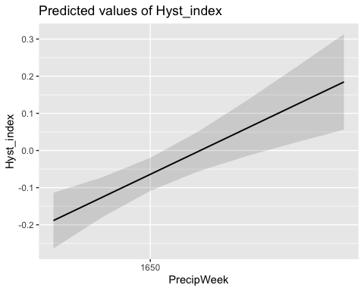

### Permafrost

f4.turb <- formula(Hyst_index ~ StormPrecip*pf + PrecipWeek*pf + PrecipMonth*pf + Intensity*pf + TempWeek*pf + TimeSinceChena*pf + (1|site.ID))  
  
M4.turb <- lmer(f4.turb, data = turb_data)  
summary(M4.turb)

## Linear mixed model fit by REML ['lmerMod']  
## Formula: Hyst_index ~ StormPrecip * pf + PrecipWeek * pf + PrecipMonth *   
## pf + Intensity * pf + TempWeek * pf + TimeSinceChena * pf +   
## (1 | site.ID)  
## Data: turb_data  
##   
## REML criterion at convergence: -42.6  
##   
## Scaled residuals:   
## Min 1Q Median 3Q Max   
## -2.5655 -0.4896 -0.0606 0.5249 4.6534   
##   
## Random effects:  
## Groups Name Variance Std.Dev.  
## site.ID (Intercept) 0.002608 0.05107   
## Residual 0.035685 0.18890   
## Number of obs: 235, groups: site.ID, 6  
##   
## Fixed effects:  
## Estimate Std. Error t value  
## (Intercept) -0.107102 0.046138 -2.321  
## StormPrecip -0.001728 0.023387 -0.074  
## pfmedium 0.057531 0.054774 1.050  
## PrecipWeek 0.094074 0.034947 2.692  
## PrecipMonth -0.113891 0.033812 -3.368  
## Intensity 0.011155 0.016490 0.676  
## TempWeek 0.047356 0.040377 1.173  
## TimeSinceChena 0.054220 0.051432 1.054  
## StormPrecip:pfmedium 0.012504 0.030420 0.411  
## pfmedium:PrecipWeek -0.035746 0.039078 -0.915  
## pfmedium:PrecipMonth 0.109239 0.038525 2.836  
## pfmedium:Intensity -0.019472 0.032921 -0.591  
## pfmedium:TempWeek -0.069949 0.044574 -1.569  
## pfmedium:TimeSinceChena -0.058288 0.054733 -1.065

##   
## Correlation matrix not shown by default, as p = 14 > 12.  
## Use print(x, correlation=TRUE) or  
## vcov(x) if you need it

Permafrost does have a significant effect with PrecipMonth

### burn

f5.turb <- formula(Hyst_index ~ StormPrecip*burn + PrecipWeek*burn + PrecipMonth*burn + Intensity*burn + TempWeek*burn + TimeSinceChena*burn + (1|site.ID))  
  
M5.turb <- lmer(f5.turb, data = turb_data)  
summary(M5.turb)

## Linear mixed model fit by REML ['lmerMod']  
## Formula: Hyst_index ~ StormPrecip * burn + PrecipWeek * burn + PrecipMonth *   
## burn + Intensity * burn + TempWeek * burn + TimeSinceChena *   
## burn + (1 | site.ID)  
## Data: turb_data  
##   
## REML criterion at convergence: -40.3  
##   
## Scaled residuals:   
## Min 1Q Median 3Q Max   
## -2.4678 -0.5524 -0.0475 0.5035 4.7375   
##   
## Random effects:  
## Groups Name Variance Std.Dev.  
## site.ID (Intercept) 0.002154 0.04641   
## Residual 0.036101 0.19000   
## Number of obs: 235, groups: site.ID, 6  
##   
## Fixed effects:  
## Estimate Std. Error t value  
## (Intercept) -0.051391 0.028356 -1.812  
## StormPrecip 0.008267 0.017806 0.464  
## burnunburned -0.043791 0.049380 -0.887  
## PrecipWeek 0.069622 0.018317 3.801  
## PrecipMonth -0.006264 0.021889 -0.286  
## Intensity -0.005810 0.014623 -0.397  
## TempWeek -0.033376 0.020720 -1.611  
## TimeSinceChena -0.022876 0.020430 -1.120  
## StormPrecip:burnunburned 0.010365 0.032214 0.322  
## burnunburned:PrecipWeek -0.025583 0.033808 -0.757  
## burnunburned:PrecipMonth -0.040691 0.032695 -1.245  
## burnunburned:Intensity -0.009369 0.052156 -0.180  
## burnunburned:TempWeek 0.070632 0.036489 1.936  
## burnunburned:TimeSinceChena 0.084680 0.039988 2.118

##   
## Correlation matrix not shown by default, as p = 14 > 12.  
## Use print(x, correlation=TRUE) or  
## vcov(x) if you need it

Fire has significant interaction with TimeSinceChena

beta ##################################################

beta.pl <- antecedent_HI_FI_1_0 %>%  
 ggplot(aes(x = doy, y = beta)) +   
 geom_hline(yintercept = 0, linetype = "dotted", size = 1) +  
 geom_point(aes(color = site.ID)) +  
 scale_color_manual(values = c("orange red", viridis::viridis(6)), "Catchment")+theme_bw() +  
 geom_smooth(method = "lm", na.rm = TRUE, fullrange = TRUE, aes(group = 1)) +   
 stat_poly_eq(formula = y~x,  
 label.y = "top", label.x = "right",  
 aes(label = paste(..eq.label.., ..rr.label.., sep = "~~~")),   
 parse = TRUE) +   
 ylim(c(-1.5, 1.5)) +  
 ylab("Beta") +  
 ggtitle("Beta") +  
 facet_grid(rows=vars(year), cols = vars(response_var))   
   
beta.pl

## `geom_smooth()` using formula 'y ~ x'

## Warning: Removed 116 rows containing non-finite values (stat_poly_eq).

## Warning: Removed 116 rows containing missing values (geom_point).

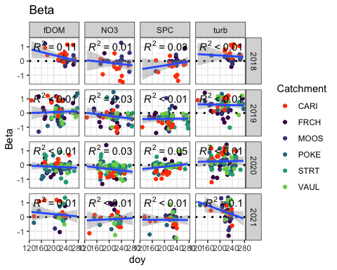

#### Scatter plot matrix

HI_FI_NO3 %>% ggplot(aes(x = StormPrecip, y = beta)) +   
 geom_hline(yintercept = 0, linetype = "dotted", size = 1) +  
 geom_point(aes(color = site.ID), size = 2) +  
 scale_color_manual(values = c("orange red", viridis::viridis(6)), "Catchment")+theme_bw() +  
 geom_smooth(method = "lm", na.rm = TRUE, fullrange = TRUE, aes(group = 1)) +   
 stat_poly_eq(formula = y~x,  
 label.y = "top", label.x = "right",  
 aes(label = paste(..eq.label.., ..rr.label.., sep = "~~~")),   
 parse = TRUE) +   
 ylim(c(-1.5, 1.5)) +  
 ylab("beta") +  
 ggtitle("Beta vs. StormPrecip")

## `geom_smooth()` using formula 'y ~ x'

## Warning: Removed 31 rows containing non-finite values (stat_poly_eq).

## Warning: Removed 31 rows containing missing values (geom_point).

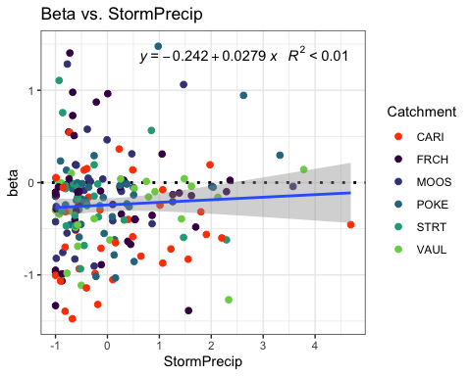

HI_FI_NO3 %>% ggplot(aes(x = PrecipWeek, y = beta)) +   
 geom_hline(yintercept = 0, linetype = "dotted", size = 1) +  
 geom_point(aes(color = site.ID), size = 2) +  
 scale_color_manual(values = c("orange red", viridis::viridis(6)), "Catchment")+theme_bw() +  
 geom_smooth(method = "lm", na.rm = TRUE, fullrange = TRUE, aes(group = 1)) +   
 stat_poly_eq(formula = y~x,  
 label.y = "top", label.x = "right",  
 aes(label = paste(..eq.label.., ..rr.label.., sep = "~~~")),   
 parse = TRUE) +   
 ylim(c(-1.5, 1.5)) +  
 ylab("beta") +  
 ggtitle("Beta vs. PrecipWeek")

## `geom_smooth()` using formula 'y ~ x'

## Warning: Removed 31 rows containing non-finite values (stat_poly_eq).

## Warning: Removed 31 rows containing missing values (geom_point).

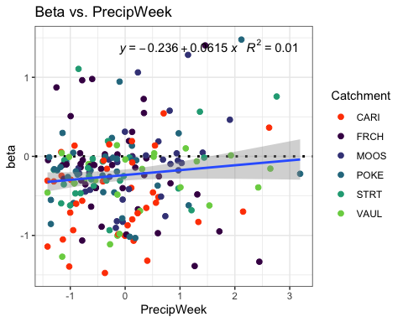 any value over 1.5 is an outlier

NO3_data.1 <- HI_FI_NO3[,c("beta","PrecipMonth")]  
  
pairs(NO3_data.1)

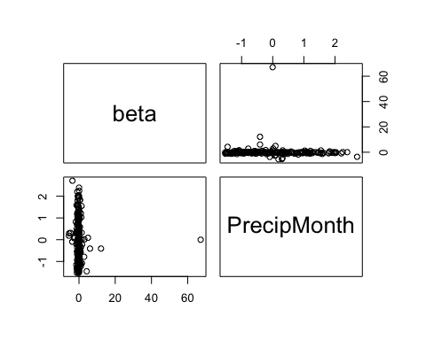

HI_FI_NO3 %>% ggplot(aes(x = PrecipMonth, y = beta)) +   
 geom_hline(yintercept = 0, linetype = "dotted", size = 1) +  
 geom_point(aes(color = site.ID), size = 2) +  
 scale_color_manual(values = c("orange red", viridis::viridis(6)), "Catchment")+theme_bw() +  
 geom_smooth(method = "lm", na.rm = TRUE, fullrange = TRUE, aes(group = 1)) +   
 stat_poly_eq(formula = y~x,  
 label.y = "top", label.x = "right",  
 aes(label = paste(..eq.label.., ..rr.label.., sep = "~~~")),   
 parse = TRUE) +   
 ylim(c(-1.5, 1.5)) +  
 ylab("beta") +  
 ggtitle("Beta vs. PrecipMonth")

## `geom_smooth()` using formula 'y ~ x'

## Warning: Removed 31 rows containing non-finite values (stat_poly_eq).

## Warning: Removed 31 rows containing missing values (geom_point).

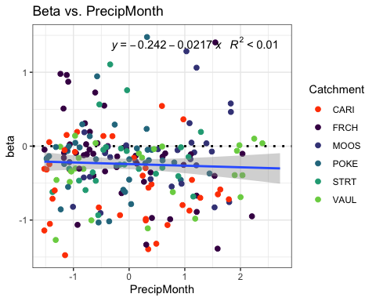

NO3_data.1 <- HI_FI_NO3[,c("beta","ThreeMonth")]  
  
pairs(NO3_data.1)

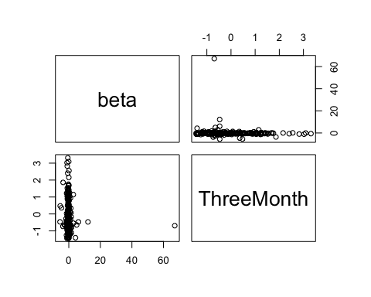

HI_FI_NO3 %>% ggplot(aes(x = ThreeMonth, y = beta)) +   
 geom_hline(yintercept = 0, linetype = "dotted", size = 1) +  
 geom_point(aes(color = site.ID), size = 2) +  
 scale_color_manual(values = c("orange red", viridis::viridis(6)), "Catchment")+theme_bw() +  
 geom_smooth(method = "lm", na.rm = TRUE, fullrange = TRUE, aes(group = 1)) +   
 stat_poly_eq(formula = y~x,  
 label.y = "top", label.x = "right",  
 aes(label = paste(..eq.label.., ..rr.label.., sep = "~~~")),   
 parse = TRUE) +   
 ylim(c(-1.5, 1.5)) +  
 ylab("beta") +  
 ggtitle("Beta vs. ThreeMonth")

## `geom_smooth()` using formula 'y ~ x'

## Warning: Removed 31 rows containing non-finite values (stat_poly_eq).

## Warning: Removed 31 rows containing missing values (geom_point).

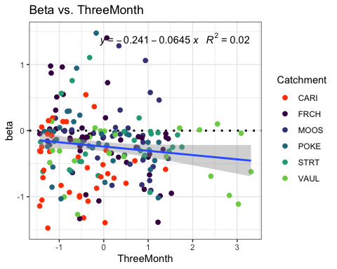

HI_FI_NO3 %>% ggplot(aes(x = StormTemp, y = beta)) +   
 geom_hline(yintercept = 0, linetype = "dotted", size = 1) +  
 geom_point(aes(color = site.ID), size = 2) +  
 scale_color_manual(values = c("orange red", viridis::viridis(6)), "Catchment")+theme_bw() +  
 geom_smooth(method = "lm", na.rm = TRUE, fullrange = TRUE, aes(group = 1)) +   
 stat_poly_eq(formula = y~x,  
 label.y = "top", label.x = "right",  
 aes(label = paste(..eq.label.., ..rr.label.., sep = "~~~")),   
 parse = TRUE) +   
 ylim(c(-1.5, 1.5)) +  
 ylab("beta") +  
 ggtitle("Beta vs. StormTemp")

## `geom_smooth()` using formula 'y ~ x'

## Warning: Removed 31 rows containing non-finite values (stat_poly_eq).

## Warning: Removed 31 rows containing missing values (geom_point).

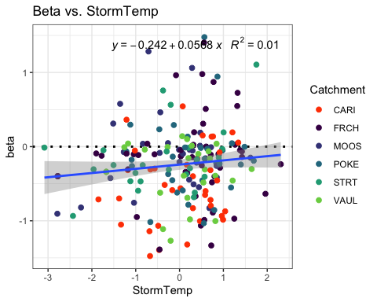

HI_FI_NO3 %>% ggplot(aes(x = TempWeek, y = beta)) +   
 geom_hline(yintercept = 0, linetype = "dotted", size = 1) +  
 geom_point(aes(color = site.ID), size = 2) +  
 scale_color_manual(values = c("orange red", viridis::viridis(6)), "Catchment")+theme_bw() +  
 geom_smooth(method = "lm", na.rm = TRUE, fullrange = TRUE, aes(group = 1)) +   
 stat_poly_eq(formula = y~x,  
 label.y = "top", label.x = "right",  
 aes(label = paste(..eq.label.., ..rr.label.., sep = "~~~")),   
 parse = TRUE) +   
 ylim(c(-1.5, 1.5)) +  
 ylab("beta") +  
 ggtitle("Beta vs.TempWeek")

## `geom_smooth()` using formula 'y ~ x'

## Warning: Removed 33 rows containing non-finite values (stat_poly_eq).

## Warning: Removed 33 rows containing missing values (geom_point).

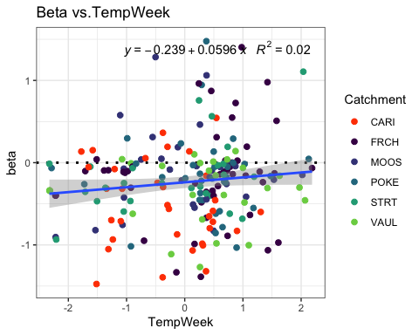

HI_FI_NO3 %>% ggplot(aes(x = Intensity, y = beta)) +   
 geom_hline(yintercept = 0, linetype = "dotted", size = 1) +  
 geom_point(aes(color = site.ID), size = 2) +  
 scale_color_manual(values = c("orange red", viridis::viridis(6)), "Catchment")+theme_bw() +  
 geom_smooth(method = "lm", na.rm = TRUE, fullrange = TRUE, aes(group = 1)) +   
 stat_poly_eq(formula = y~x,  
 label.y = "top", label.x = "right",  
 aes(label = paste(..eq.label.., ..rr.label.., sep = "~~~")),   
 parse = TRUE) +   
 ylim(c(-1.5, 1.5)) +  
 ylab("beta") +  
 ggtitle("Beta vs. Intensity")

## `geom_smooth()` using formula 'y ~ x'

## Warning: Removed 37 rows containing non-finite values (stat_poly_eq).

## Warning: Removed 37 rows containing missing values (geom_point).

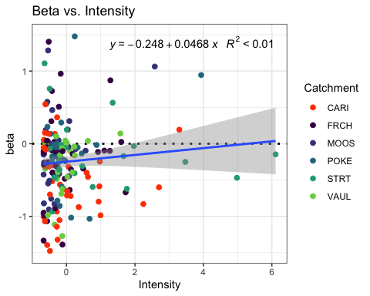

HI_FI_NO3 %>% ggplot(aes(x = TimeSinceChena, y = beta)) +   
 geom_hline(yintercept = 0, linetype = "dotted", size = 1) +  
 geom_point(aes(color = site.ID), size = 2) +  
 scale_color_manual(values = c("orange red", viridis::viridis(6)), "Catchment")+theme_bw() +  
 geom_smooth(method = "lm", na.rm = TRUE, fullrange = TRUE, aes(group = 1)) +   
 stat_poly_eq(formula = y~x,  
 label.y = "top", label.x = "right",  
 aes(label = paste(..eq.label.., ..rr.label.., sep = "~~~")),   
 parse = TRUE) +   
 ylim(c(-1.5, 1.5)) +  
 ylab("Flushing Index") +  
 ggtitle("Beta vs. TimeSinceChena")

## `geom_smooth()` using formula 'y ~ x'

## Warning: Removed 31 rows containing non-finite values (stat_poly_eq).

## Warning: Removed 31 rows containing missing values (geom_point).

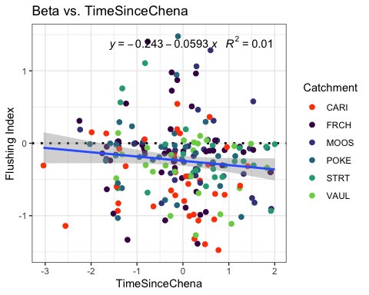

NO3_data_beta <- HI_FI_NO3[,c("beta", "site.ID", "StormPrecip", "StormTemp", "PrecipWeek", "PrecipMonth", "ThreeMonth", "TempWeek", "Intensity", "TimeSinceChena", "burn", "pf")]  
  
NO3_data_beta <- na.omit(NO3_data_beta) #236 to 216  
which(NO3_data_beta$beta > 1.5)

## [1] 5 63 80 102 125 144 151 180 192 201

NO3_data_beta <- NO3_data_beta[-c(5,63,80,102,125,144,151,180,192,201), ] # remove outliers  
which(NO3_data_beta$beta < -1.5)

## [1] 56 78 90 91 113 129 163 173 204

NO3_data_beta <- NO3_data_beta[-c(56,78,90,91,113,129,163,173,204), ] # remove outliers  
  
cor(NO3_data_beta[,c(1,3:10)])

## beta StormPrecip StormTemp PrecipWeek PrecipMonth  
## beta 1.00000000 0.044248180 0.11662314 0.12175530 -0.037130921  
## StormPrecip 0.04424818 1.000000000 0.08950966 0.07793537 -0.007282534  
## StormTemp 0.11662314 0.089509664 1.00000000 0.05809098 0.116524302  
## PrecipWeek 0.12175530 0.077935369 0.05809098 1.00000000 0.574154740  
## PrecipMonth -0.03713092 -0.007282534 0.11652430 0.57415474 1.000000000  
## ThreeMonth -0.13380242 -0.143249569 -0.31814965 0.21784104 0.589080187  
## TempWeek 0.12387914 0.159050239 0.79991413 0.14534001 0.153792292  
## Intensity 0.08556143 0.408483178 0.11468428 -0.07205609 -0.039248327  
## TimeSinceChena -0.16215262 -0.169169174 -0.75913932 -0.12006361 0.106900803  
## ThreeMonth TempWeek Intensity TimeSinceChena  
## beta -0.13380242 0.1238791 0.08556143 -0.16215262  
## StormPrecip -0.14324957 0.1590502 0.40848318 -0.16916917  
## StormTemp -0.31814965 0.7999141 0.11468428 -0.75913932  
## PrecipWeek 0.21784104 0.1453400 -0.07205609 -0.12006361  
## PrecipMonth 0.58908019 0.1537923 -0.03924833 0.10690080  
## ThreeMonth 1.00000000 -0.2140399 -0.07701158 0.61369522  
## TempWeek -0.21403986 1.0000000 0.11294162 -0.63682706  
## Intensity -0.07701158 0.1129416 1.00000000 -0.07413098  
## TimeSinceChena 0.61369522 -0.6368271 -0.07413098 1.00000000

1. StormTemp is correlated with TempWeek (0.799) but TempWeek is more correlated with beta (0.12 vs. 0.11)
2. StormTemp is correlated with TimeSinceChena (-0.759) but TimeSinceChena is more correlated with beta (-0.16 vs. 0.11)
3. PrecipWeek is correlated with PrecipMonth (0.574) but PrecipWeek is more correlated with beta (0.12 vs. -0.03)
4. PrecipMonth is correlated with ThreeMonth (0.589) but ThreeMonth is more correlated with beta (-0.13 vs. -0.03)
5. ThreeMonth is correlated with TimeSinceChena (0.613) but TimeSinceChena is more correlated with beta (-0.16 vs. -0.13)

## Linear mixed model fit by REML ['lmerMod']  
## Formula: beta ~ StormPrecip + PrecipWeek + PrecipMonth + ThreeMonth +   
## Intensity + StormTemp + TempWeek + TimeSinceChena + (1 | site.ID)  
## Data: NO3_data_beta  
##   
## REML criterion at convergence: 307.7  
##   
## Scaled residuals:   
## Min 1Q Median 3Q Max   
## -3.12758 -0.46522 0.01455 0.51916 3.11380   
##   
## Random effects:  
## Groups Name Variance Std.Dev.  
## site.ID (Intercept) 0.03114 0.1765   
## Residual 0.22894 0.4785   
## Number of obs: 197, groups: site.ID, 6  
##   
## Fixed effects:  
## Estimate Std. Error t value  
## (Intercept) -0.228662 0.080152 -2.853  
## StormPrecip 0.007177 0.039064 0.184  
## PrecipWeek 0.117563 0.049197 2.390  
## PrecipMonth -0.025425 0.058864 -0.432  
## ThreeMonth -0.115412 0.063427 -1.820  
## Intensity 0.041068 0.042374 0.969  
## StormTemp 0.087812 0.073482 1.195  
## TempWeek -0.039946 0.058999 -0.677  
## TimeSinceChena 0.044090 0.071614 0.616  
##   
## Correlation of Fixed Effects:  
## (Intr) StrmPr PrcpWk PrcpMn ThrMnt Intnst StrmTm TempWk  
## StormPrecip 0.001   
## PrecipWeek 0.024 -0.051   
## PrecipMonth 0.009 0.001 -0.513   
## ThreeMonth -0.034 0.012 0.003 -0.571   
## Intensity -0.021 -0.448 0.068 -0.017 0.034   
## StormTemp 0.008 0.178 0.283 -0.197 -0.108 -0.114   
## TempWeek -0.016 -0.149 -0.094 -0.041 0.027 0.002 -0.614   
## TimeSincChn 0.006 0.116 0.292 0.002 -0.545 -0.086 0.555 0.032

1. Our scaled residuals look good
2. site slightly explains variance
3. PrecipWeek seems to be the most important 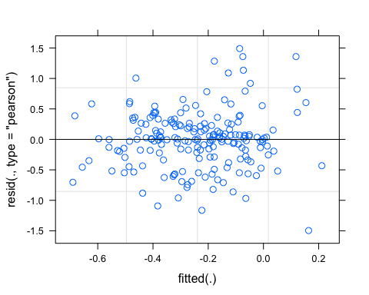

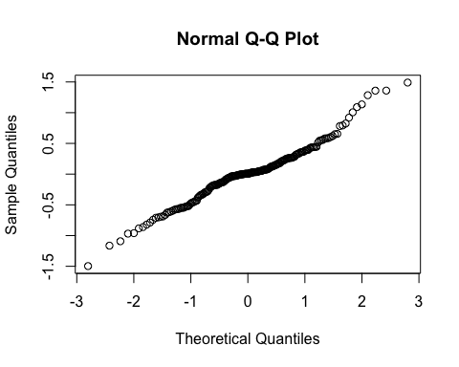

## StormPrecip PrecipWeek PrecipMonth ThreeMonth Intensity   
## 1.334339 1.720121 2.774272 3.159641 1.293923   
## StormTemp TempWeek TimeSinceChena   
## 4.712639 3.104196 4.320977

Any VIFs > 2 indicated correlation

## StormPrecip PrecipWeek PrecipMonth Intensity TempWeek   
## 1.283082 1.584788 1.686335 1.267012 1.923306   
## TimeSinceChena   
## 1.954865

1. No VIFs over 2!
2. PrecipWeek and PrecipMonth (0.57)
3. TimeSinceChena and TempWeek (-0.63) 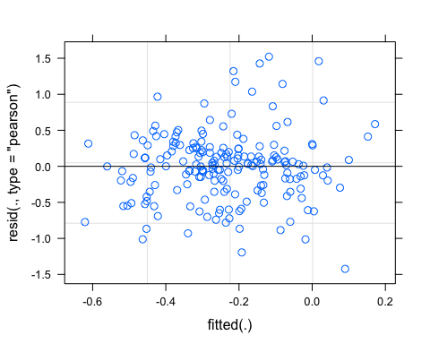

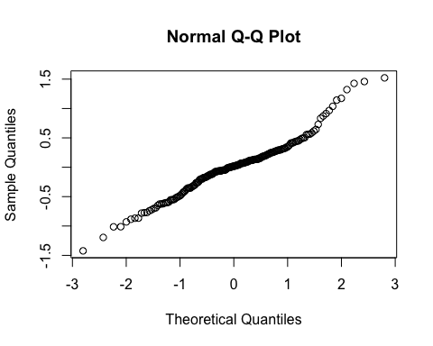

pr <- ggpredict(M1.NO3.beta, terms = c("PrecipWeek"))  
plot(pr, add.data = TRUE)

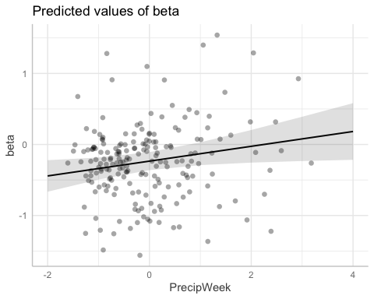

f2.NO3_beta <- formula(beta ~ StormPrecip + PrecipWeek + PrecipMonth + Intensity + TempWeek + TimeSinceChena + (PrecipWeek|site.ID))  
  
M2.NO3.beta <- lmer(f2.NO3_beta, data = NO3_data_beta)

aictab(list(M0.NO3_beta, M1.NO3.beta, M2.NO3.beta))

## Warning in aictab.AIClmerMod(list(M0.NO3_beta, M1.NO3.beta, M2.NO3.beta)):   
## Model names have been supplied automatically in the table

## Warning in aictab.AIClmerMod(list(M0.NO3_beta, M1.NO3.beta, M2.NO3.beta)):   
## Model selection for fixed effects is only appropriate with ML estimation:  
## REML (default) should only be used to select random effects for a constant set of fixed effects

##   
## Model selection based on AICc:  
##   
## K AICc Delta_AICc AICcWt Cum.Wt Res.LL  
## Mod3 11 322.37 0.00 0.63 0.63 -149.47  
## Mod2 9 323.52 1.15 0.36 0.99 -152.28  
## Mod1 11 331.16 8.79 0.01 1.00 -153.87

Mod3: Reduced model (No StormTemp or ThreeMonth) with random slopes structure Mod2: Reduced model (’’) with random intercept structure Mod1: Full model with random intercept structure

dwplot(list(M1.NO3.beta),  
 vline = geom_vline(xintercept = 0,  
 colour = "grey60",  
 linetype = 2)) +  
 ggtitle("Antecedent Conditions, NO3")

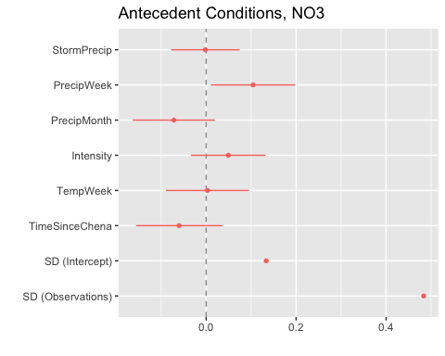 CI overlapping with 0 implies nonsignificace PrecipWeek is the only significant predictor

sjPlot::tab_model(M1.NO3.beta)

## Argument 'df_method' is deprecated. Please use 'ci_method' instead.

beta

Predictors

Estimates

CI

p

(Intercept)

-0.23

-0.36 – -0.11

<0.001

StormPrecip

-0.00

-0.08 – 0.07

0.967

PrecipWeek

0.10

0.01 – 0.20

0.030

PrecipMonth

-0.07

-0.16 – 0.02

0.123

Intensity

0.05

-0.03 – 0.13

0.245

TempWeek

0.00

-0.09 – 0.10

0.950

TimeSinceChena

-0.06

-0.16 – 0.04

0.217

Random Effects

σ2

0.23

τ00 site.ID

0.02

ICC

0.07

N site.ID

6

Observations

197

Marginal R2 / Conditional R2

0.056 / 0.123

r.squaredGLMM(M1.NO3.beta)

## R2m R2c  
## [1,] 0.0561014 0.1229671

Only 12.3% explained

### Permafrost

## Linear mixed model fit by REML ['lmerMod']  
## Formula: beta ~ StormPrecip * pf + PrecipWeek * pf + PrecipMonth * pf +   
## ThreeMonth * pf + Intensity * pf + StormTemp * pf + TempWeek *   
## pf + TimeSinceChena * pf + (1 | site.ID)  
## Data: NO3_data_beta  
##   
## REML criterion at convergence: 323.2  
##   
## Scaled residuals:   
## Min 1Q Median 3Q Max   
## -3.0342 -0.5148 0.0029 0.5002 3.2665   
##   
## Random effects:  
## Groups Name Variance Std.Dev.  
## site.ID (Intercept) 0.05971 0.2444   
## Residual 0.22902 0.4786   
## Number of obs: 197, groups: site.ID, 6  
##   
## Fixed effects:  
## Estimate Std. Error t value  
## (Intercept) -0.19080 0.19305 -0.988  
## StormPrecip -0.03866 0.07391 -0.523  
## pfmedium -0.06087 0.23230 -0.262  
## PrecipWeek 0.08715 0.10806 0.806  
## PrecipMonth 0.07552 0.12999 0.581  
## ThreeMonth -0.09333 0.11366 -0.821  
## Intensity -0.00705 0.05861 -0.120  
## StormTemp -0.05358 0.21063 -0.254  
## TempWeek 0.05118 0.18844 0.272  
## TimeSinceChena -0.03060 0.19462 -0.157  
## StormPrecip:pfmedium 0.04440 0.08977 0.495  
## pfmedium:PrecipWeek 0.01442 0.12229 0.118  
## pfmedium:PrecipMonth -0.08732 0.14766 -0.591  
## pfmedium:ThreeMonth -0.12350 0.14622 -0.845  
## pfmedium:Intensity 0.09615 0.08994 1.069  
## pfmedium:StormTemp 0.16619 0.22598 0.735  
## pfmedium:TempWeek -0.11747 0.20000 -0.587  
## pfmedium:TimeSinceChena 0.13659 0.21246 0.643

##   
## Correlation matrix not shown by default, as p = 18 > 12.  
## Use print(x, correlation=TRUE) or  
## vcov(x) if you need it

### Wildfire

## Linear mixed model fit by REML ['lmerMod']  
## Formula: beta ~ StormPrecip * burn + PrecipWeek * burn + PrecipMonth *   
## burn + ThreeMonth * burn + Intensity * burn + StormTemp *   
## burn + TempWeek * burn + TimeSinceChena * burn + (1 | site.ID)  
## Data: NO3_data_beta  
##   
## REML criterion at convergence: 320.5  
##   
## Scaled residuals:   
## Min 1Q Median 3Q Max   
## -2.4076 -0.4222 -0.0337 0.5254 3.4081   
##   
## Random effects:  
## Groups Name Variance Std.Dev.  
## site.ID (Intercept) 0.03432 0.1852   
## Residual 0.22636 0.4758   
## Number of obs: 197, groups: site.ID, 6  
##   
## Fixed effects:  
## Estimate Std. Error t value  
## (Intercept) -0.22554 0.10300 -2.190  
## StormPrecip 0.02336 0.04998 0.467  
## burnunburned 0.03519 0.17890 0.197  
## PrecipWeek 0.20134 0.06162 3.267  
## PrecipMonth -0.05308 0.08017 -0.662  
## ThreeMonth -0.02145 0.09751 -0.220  
## Intensity 0.02417 0.04498 0.537  
## StormTemp 0.12458 0.08964 1.390  
## TempWeek -0.06995 0.07422 -0.943  
## TimeSinceChena -0.02709 0.09235 -0.293  
## StormPrecip:burnunburned -0.08306 0.08998 -0.923  
## burnunburned:PrecipWeek -0.20369 0.10417 -1.955  
## burnunburned:PrecipMonth 0.07020 0.12011 0.584  
## burnunburned:ThreeMonth -0.11976 0.13505 -0.887  
## burnunburned:Intensity 0.16426 0.13795 1.191  
## burnunburned:StormTemp -0.12402 0.16146 -0.768  
## burnunburned:TempWeek 0.07433 0.13005 0.572  
## burnunburned:TimeSinceChena 0.06328 0.16815 0.376

##   
## Correlation matrix not shown by default, as p = 18 > 12.  
## Use print(x, correlation=TRUE) or  
## vcov(x) if you need it

fDOM

#### Scatter plot matrix

HI_FI_fDOM %>% ggplot(aes(x = StormPrecip, y = beta)) +   
 geom_hline(yintercept = 0, linetype = "dotted", size = 1) +  
 geom_point(aes(color = site.ID), size = 2) +  
 scale_color_manual(values = c("orange red", viridis::viridis(6)), "Catchment")+theme_bw() +  
 geom_smooth(method = "lm", na.rm = TRUE, fullrange = TRUE, aes(group = 1)) +   
 stat_poly_eq(formula = y~x,  
 label.y = "top", label.x = "right",  
 aes(label = paste(..eq.label.., ..rr.label.., sep = "~~~")),   
 parse = TRUE) +   
 ylim(c(-1.5, 1.5)) +  
 ylab("beta") +  
 ggtitle("Beta vs. StormPrecip")

## `geom_smooth()` using formula 'y ~ x'

## Warning: Removed 35 rows containing non-finite values (stat_poly_eq).

## Warning: Removed 35 rows containing missing values (geom_point).

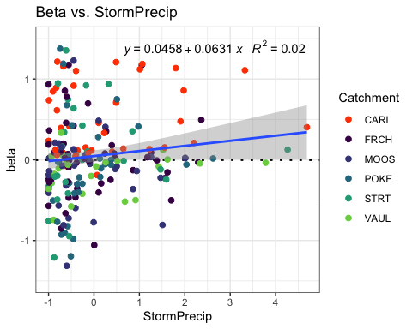

HI_FI_fDOM %>% ggplot(aes(x = PrecipWeek, y = beta)) +   
 geom_hline(yintercept = 0, linetype = "dotted", size = 1) +  
 geom_point(aes(color = site.ID), size = 2) +  
 scale_color_manual(values = c("orange red", viridis::viridis(6)), "Catchment")+theme_bw() +  
 geom_smooth(method = "lm", na.rm = TRUE, fullrange = TRUE, aes(group = 1)) +   
 stat_poly_eq(formula = y~x,  
 label.y = "top", label.x = "right",  
 aes(label = paste(..eq.label.., ..rr.label.., sep = "~~~")),   
 parse = TRUE) +   
 ylim(c(-1.5, 1.5)) +  
 ylab("beta") +  
 ggtitle("Beta vs.PrecipWeek")

## `geom_smooth()` using formula 'y ~ x'

## Warning: Removed 35 rows containing non-finite values (stat_poly_eq).

## Warning: Removed 35 rows containing missing values (geom_point).

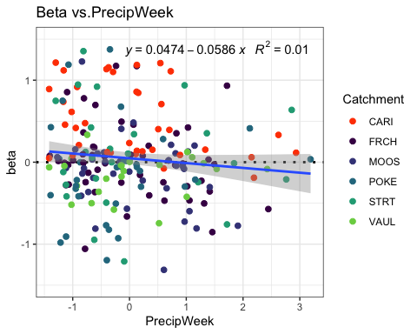

HI_FI_fDOM %>% ggplot(aes(x = PrecipMonth, y = beta)) +   
 geom_hline(yintercept = 0, linetype = "dotted", size = 1) +  
 geom_point(aes(color = site.ID), size = 2) +  
 scale_color_manual(values = c("orange red", viridis::viridis(6)), "Catchment")+theme_bw() +  
 geom_smooth(method = "lm", na.rm = TRUE, fullrange = TRUE, aes(group = 1)) +   
 stat_poly_eq(formula = y~x,  
 label.y = "top", label.x = "right",  
 aes(label = paste(..eq.label.., ..rr.label.., sep = "~~~")),   
 parse = TRUE) +   
 ylim(c(-1.5, 1.5)) +  
 ylab("beta") +  
 ggtitle("Beta vs. PrecipMonth")

## `geom_smooth()` using formula 'y ~ x'

## Warning: Removed 35 rows containing non-finite values (stat_poly_eq).

## Warning: Removed 35 rows containing missing values (geom_point).

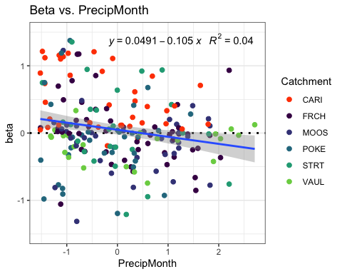

HI_FI_fDOM %>% ggplot(aes(x = ThreeMonth, y = beta)) +   
 geom_hline(yintercept = 0, linetype = "dotted", size = 1) +  
 geom_point(aes(color = site.ID), size = 2) +  
 scale_color_manual(values = c("orange red", viridis::viridis(6)), "Catchment")+theme_bw() +  
 geom_smooth(method = "lm", na.rm = TRUE, fullrange = TRUE, aes(group = 1)) +   
 stat_poly_eq(formula = y~x,  
 label.y = "top", label.x = "right",  
 aes(label = paste(..eq.label.., ..rr.label.., sep = "~~~")),   
 parse = TRUE) +   
 ylim(c(-1.5, 1.5)) +  
 ylab("beta") +  
 ggtitle("Beta vs.ThreeMonth")

## `geom_smooth()` using formula 'y ~ x'

## Warning: Removed 35 rows containing non-finite values (stat_poly_eq).

## Warning: Removed 35 rows containing missing values (geom_point).

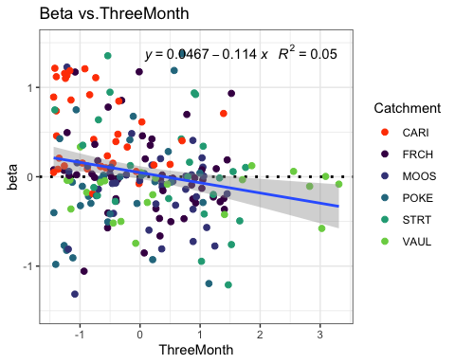

HI_FI_fDOM %>% ggplot(aes(x = StormTemp, y = beta)) +   
 geom_hline(yintercept = 0, linetype = "dotted", size = 1) +  
 geom_point(aes(color = site.ID), size = 2) +  
 scale_color_manual(values = c("orange red", viridis::viridis(6)), "Catchment")+theme_bw() +  
 geom_smooth(method = "lm", na.rm = TRUE, fullrange = TRUE, aes(group = 1)) +   
 stat_poly_eq(formula = y~x,  
 label.y = "top", label.x = "right",  
 aes(label = paste(..eq.label.., ..rr.label.., sep = "~~~")),   
 parse = TRUE) +   
 ylim(c(-1.5, 1.5)) +  
 ylab("beta") +  
 ggtitle("Beta vs. StormTemp")

## `geom_smooth()` using formula 'y ~ x'

## Warning: Removed 35 rows containing non-finite values (stat_poly_eq).

## Warning: Removed 35 rows containing missing values (geom_point).

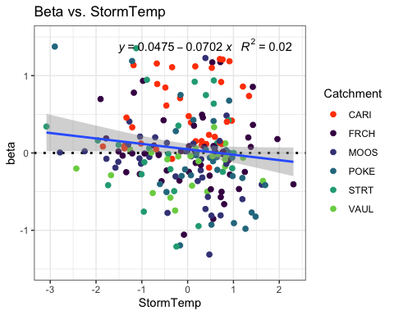

HI_FI_fDOM %>% ggplot(aes(x = TempWeek, y = beta)) +   
 geom_hline(yintercept = 0, linetype = "dotted", size = 1) +  
 geom_point(aes(color = site.ID), size = 2) +  
 scale_color_manual(values = c("orange red", viridis::viridis(6)), "Catchment")+theme_bw() +  
 geom_smooth(method = "lm", na.rm = TRUE, fullrange = TRUE, aes(group = 1)) +   
 stat_poly_eq(formula = y~x,  
 label.y = "top", label.x = "right",  
 aes(label = paste(..eq.label.., ..rr.label.., sep = "~~~")),   
 parse = TRUE) +   
 ylim(c(-1.5, 1.5)) +  
 ylab("beta") +  
 ggtitle("Beta vs. TempWeek")

## `geom_smooth()` using formula 'y ~ x'

## Warning: Removed 37 rows containing non-finite values (stat_poly_eq).

## Warning: Removed 37 rows containing missing values (geom_point).

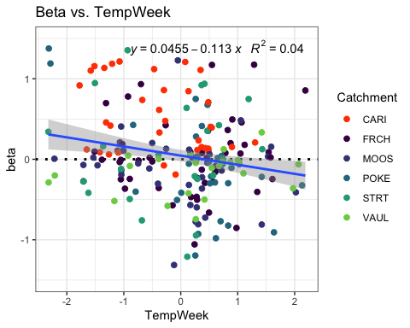

HI_FI_fDOM %>% ggplot(aes(x = Intensity, y = beta)) +   
 geom_hline(yintercept = 0, linetype = "dotted", size = 1) +  
 geom_point(aes(color = site.ID), size = 2) +  
 scale_color_manual(values = c("orange red", viridis::viridis(6)), "Catchment")+theme_bw() +  
 geom_smooth(method = "lm", na.rm = TRUE, fullrange = TRUE, aes(group = 1)) +   
 stat_poly_eq(formula = y~x,  
 label.y = "top", label.x = "right",  
 aes(label = paste(..eq.label.., ..rr.label.., sep = "~~~")),   
 parse = TRUE) +   
 ylim(c(-1.5, 1.5)) +  
 ylab("beta") +  
 ggtitle("Beta vs. Intensity")

## `geom_smooth()` using formula 'y ~ x'

## Warning: Removed 36 rows containing non-finite values (stat_poly_eq).

## Warning: Removed 36 rows containing missing values (geom_point).

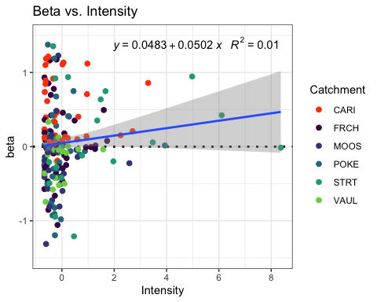

HI_FI_fDOM %>% ggplot(aes(x = TimeSinceChena, y = beta)) +   
 geom_hline(yintercept = 0, linetype = "dotted", size = 1) +  
 geom_point(aes(color = site.ID), size = 2) +  
 scale_color_manual(values = c("orange red", viridis::viridis(6)), "Catchment")+theme_bw() +  
 geom_smooth(method = "lm", na.rm = TRUE, fullrange = TRUE, aes(group = 1)) +   
 stat_poly_eq(formula = y~x,  
 label.y = "top", label.x = "right",  
 aes(label = paste(..eq.label.., ..rr.label.., sep = "~~~")),   
 parse = TRUE) +   
 ylim(c(-1.5, 1.5)) +  
 ylab("beta") +  
 ggtitle("Beta vs. TimeSinceChena")

## `geom_smooth()` using formula 'y ~ x'

## Warning: Removed 35 rows containing non-finite values (stat_poly_eq).

## Warning: Removed 35 rows containing missing values (geom_point).

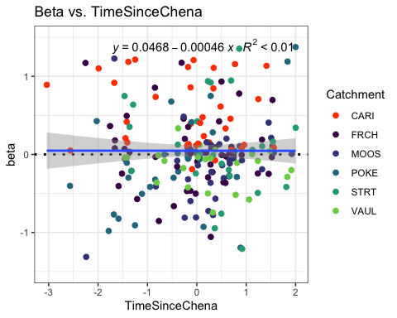

fDOM_data_beta <- HI_FI_fDOM[,c("beta", "site.ID", "StormPrecip", "StormTemp", "PrecipWeek", "PrecipMonth", "ThreeMonth", "TempWeek", "Intensity", "TimeSinceChena", "burn", "pf")]  
  
fDOM_data_beta <- na.omit(fDOM_data_beta) #241 to 232  
  
which(fDOM_data_beta$beta > 1.5)

## [1] 29 40 46 54 57 79 85 105 125 152 153 154 177 185 186 195 205 207 212  
## [20] 215 221

fDOM_data_beta <- fDOM_data_beta[-c(29,40,46, 54,57,79,85,105,125,152,153,154,177,185,186,195,205,207,212, 215, 221), ] # remove outliers  
which(fDOM_data_beta$beta < -1.5)

## [1] 56 83 84 90 117 164 201 203

fDOM_data_beta <- fDOM_data_beta[-c(56,83,84,90,117,164,201,203), ] # remove outliers  
  
cor(fDOM_data_beta[,c(1,3:10)])

## beta StormPrecip StormTemp PrecipWeek PrecipMonth  
## beta 1.00000000 0.12525598 -0.13308419 -0.09055210 -0.18276811  
## StormPrecip 0.12525598 1.00000000 0.11611209 0.09769537 0.05859089  
## StormTemp -0.13308419 0.11611209 1.00000000 0.02494171 0.03969422  
## PrecipWeek -0.09055210 0.09769537 0.02494171 1.00000000 0.56304160  
## PrecipMonth -0.18276811 0.05859089 0.03969422 0.56304160 1.00000000  
## ThreeMonth -0.19941690 -0.07423905 -0.24488004 0.23964558 0.64803298  
## TempWeek -0.21693105 0.18185299 0.77689286 0.07396639 0.09106880  
## Intensity 0.11080662 0.32206239 0.06826553 0.01318085 0.02958474  
## TimeSinceChena 0.02805425 -0.12774498 -0.71389091 -0.03076852 0.19868918  
## ThreeMonth TempWeek Intensity TimeSinceChena  
## beta -0.199416901 -0.21693105 0.110806618 0.02805425  
## StormPrecip -0.074239048 0.18185299 0.322062389 -0.12774498  
## StormTemp -0.244880037 0.77689286 0.068265533 -0.71389091  
## PrecipWeek 0.239645578 0.07396639 0.013180850 -0.03076852  
## PrecipMonth 0.648032979 0.09106880 0.029584735 0.19868918  
## ThreeMonth 1.000000000 -0.15197016 0.004034566 0.57676881  
## TempWeek -0.151970156 1.00000000 0.087285670 -0.56520460  
## Intensity 0.004034566 0.08728567 1.000000000 -0.04685659  
## TimeSinceChena 0.576768808 -0.56520460 -0.046856587 1.00000000

1. StormTemp is correlated with TempWeek (0.776) but TempWeek is more correlated with beta (-0.21 vs. 0.12)
2. StormTemp is correlated with TimeSinceChena (-0.713) but StormTemp is more correlated with beta (0.12 vs. 0.02)
3. PrecipWeek is correlated with PrecipMonth (0.56) but PrecipMonth is more correlated with beta (-0.18 vs. 0.09)
4. PreciMonth is correlated with ThreeMonth (0.648) but ThreeMonth is more correlated with beta (-0.19 vs. -0.18)
5. ThreeMonth is correlated with TimeSinceChena (0.576) but ThreeMonth is is more correlated with beta (-0.19 vs. 0.02)

## Linear mixed model fit by REML ['lmerMod']  
## Formula: beta ~ StormPrecip + PrecipWeek + PrecipMonth + ThreeMonth +   
## Intensity + StormTemp + TempWeek + TimeSinceChena + (1 | site.ID)  
## Data: fDOM_data_beta  
##   
## REML criterion at convergence: 311.5  
##   
## Scaled residuals:   
## Min 1Q Median 3Q Max   
## -2.6571 -0.6066 -0.0808 0.5367 2.6543   
##   
## Random effects:  
## Groups Name Variance Std.Dev.  
## site.ID (Intercept) 0.03851 0.1962   
## Residual 0.22149 0.4706   
## Number of obs: 203, groups: site.ID, 6  
##   
## Fixed effects:  
## Estimate Std. Error t value  
## (Intercept) 0.041672 0.087182 0.478  
## StormPrecip 0.047043 0.035151 1.338  
## PrecipWeek -0.026391 0.042172 -0.626  
## PrecipMonth -0.032812 0.055115 -0.595  
## ThreeMonth -0.046981 0.061636 -0.762  
## Intensity 0.034830 0.033848 1.029  
## StormTemp -0.033396 0.067934 -0.492  
## TempWeek -0.080007 0.057410 -1.394  
## TimeSinceChena -0.009281 0.064088 -0.145  
##   
## Correlation of Fixed Effects:  
## (Intr) StrmPr PrcpWk PrcpMn ThrMnt Intnst StrmTm TempWk  
## StormPrecip -0.001   
## PrecipWeek -0.010 -0.041   
## PrecipMonth 0.011 -0.033 -0.510   
## ThreeMonth -0.004 0.027 0.052 -0.598   
## Intensity -0.034 -0.326 0.040 -0.049 0.023   
## StormTemp -0.010 0.098 0.166 -0.078 -0.165 -0.034   
## TempWeek -0.009 -0.160 -0.050 -0.062 0.067 -0.013 -0.636   
## TimeSincChn -0.025 0.047 0.187 0.049 -0.530 -0.016 0.539 -0.004

1. scaled residuals look good
2. Site is explaining a little of the variance 3)Apparently nothing is significant 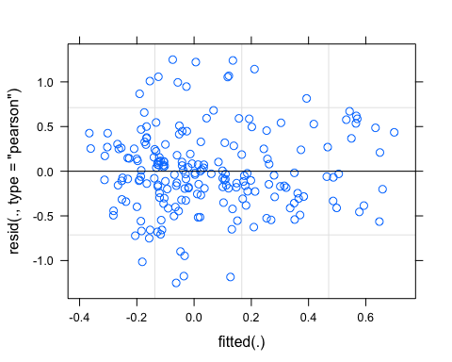

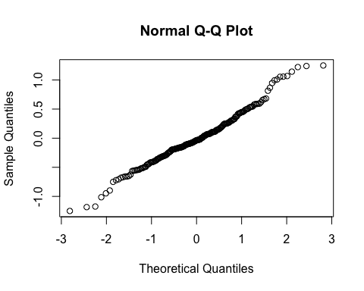

## StormPrecip PrecipWeek PrecipMonth ThreeMonth Intensity   
## 1.190632 1.591708 2.720081 2.931989 1.143489   
## StormTemp TempWeek TimeSinceChena   
## 3.779871 2.713295 3.266754

VIFs > 2 indicate correlation

## Linear mixed model fit by REML ['lmerMod']  
## Formula:   
## beta ~ StormPrecip + PrecipWeek + PrecipMonth + Intensity + TempWeek +   
## TimeSinceChena + (1 | site.ID)  
## Data: fDOM_data_beta  
##   
## REML criterion at convergence: 305.1  
##   
## Scaled residuals:   
## Min 1Q Median 3Q Max   
## -2.69935 -0.59667 -0.06323 0.53559 2.66618   
##   
## Random effects:  
## Groups Name Variance Std.Dev.  
## site.ID (Intercept) 0.04086 0.2021   
## Residual 0.22001 0.4690   
## Number of obs: 203, groups: site.ID, 6  
##   
## Fixed effects:  
## Estimate Std. Error t value  
## (Intercept) 0.04075 0.08936 0.456  
## StormPrecip 0.04983 0.03484 1.430  
## PrecipWeek -0.02028 0.04132 -0.491  
## PrecipMonth -0.06392 0.04294 -1.489  
## Intensity 0.03465 0.03374 1.027  
## TempWeek -0.09928 0.04410 -2.251  
## TimeSinceChena -0.01655 0.04559 -0.363  
##   
## Correlation of Fixed Effects:  
## (Intr) StrmPr PrcpWk PrcpMn Intnst TempWk  
## StormPrecip 0.000   
## PrecipWeek -0.007 -0.062   
## PrecipMonth 0.008 0.003 -0.583   
## Intensity -0.034 -0.326 0.045 -0.052   
## TempWeek -0.020 -0.126 0.076 -0.224 -0.044   
## TimeSincChn -0.030 0.020 0.190 -0.333 0.015 0.585

TempWeek is the most important

## StormPrecip PrecipWeek PrecipMonth Intensity TempWeek   
## 1.177217 1.537827 1.661303 1.142226 1.611190   
## TimeSinceChena   
## 1.663104

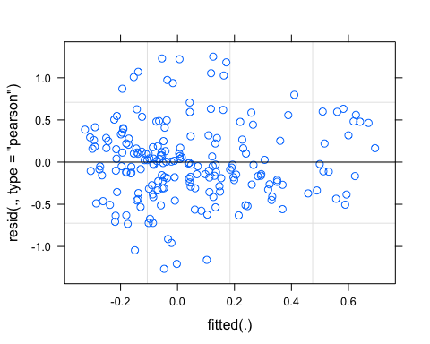

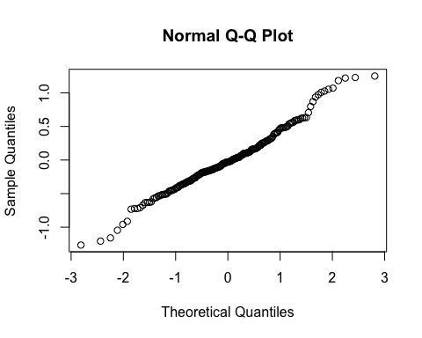

pr <- ggpredict(M1.turb, terms = c("TempWeek"))  
plot(pr, add.data = TRUE)

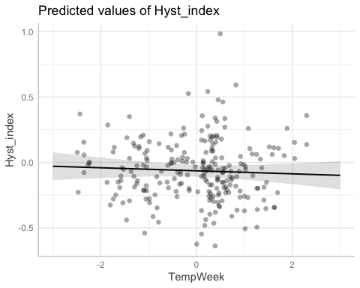

## Linear mixed model fit by REML ['lmerMod']  
## Formula: beta ~ StormPrecip + PrecipWeek + PrecipMonth + ThreeMonth +   
## Intensity + StormTemp + TempWeek + TimeSinceChena + (TempWeek |   
## site.ID)  
## Data: fDOM_data_beta  
##   
## REML criterion at convergence: 304.2  
##   
## Scaled residuals:   
## Min 1Q Median 3Q Max   
## -2.63874 -0.52254 -0.05946 0.51324 2.80838   
##   
## Random effects:  
## Groups Name Variance Std.Dev. Corr   
## site.ID (Intercept) 0.03308 0.1819   
## TempWeek 0.02306 0.1519 -0.41  
## Residual 0.20655 0.4545   
## Number of obs: 203, groups: site.ID, 6  
##   
## Fixed effects:  
## Estimate Std. Error t value  
## (Intercept) 0.039517 0.081778 0.483  
## StormPrecip 0.049020 0.034122 1.437  
## PrecipWeek -0.023099 0.040747 -0.567  
## PrecipMonth -0.030685 0.053790 -0.570  
## ThreeMonth -0.042267 0.060452 -0.699  
## Intensity 0.042075 0.032731 1.285  
## StormTemp -0.053987 0.067099 -0.805  
## TempWeek -0.069882 0.083818 -0.834  
## TimeSinceChena 0.008062 0.062170 0.130  
##   
## Correlation of Fixed Effects:  
## (Intr) StrmPr PrcpWk PrcpMn ThrMnt Intnst StrmTm TempWk  
## StormPrecip -0.011   
## PrecipWeek -0.012 -0.037   
## PrecipMonth 0.014 -0.040 -0.509   
## ThreeMonth -0.018 0.046 0.058 -0.600   
## Intensity -0.041 -0.317 0.040 -0.044 0.031   
## StormTemp -0.002 0.088 0.161 -0.079 -0.178 -0.052   
## TempWeek -0.287 -0.103 -0.032 -0.048 0.059 0.001 -0.432   
## TimeSincChn -0.024 0.040 0.184 0.052 -0.525 -0.014 0.528 -0.004

aictab(list(M0.fDOM_beta, M1.fDOM_beta, M2.fDOM_beta))

## Warning in aictab.AIClmerMod(list(M0.fDOM_beta, M1.fDOM_beta, M2.fDOM_beta)):   
## Model names have been supplied automatically in the table

## Warning in aictab.AIClmerMod(list(M0.fDOM_beta, M1.fDOM_beta, M2.fDOM_beta)):   
## Model selection for fixed effects is only appropriate with ML estimation:  
## REML (default) should only be used to select random effects for a constant set of fixed effects

##   
## Model selection based on AICc:  
##   
## K AICc Delta_AICc AICcWt Cum.Wt Res.LL  
## Mod2 9 324.08 0.00 0.98 0.98 -152.57  
## Mod3 13 332.08 8.00 0.02 1.00 -152.08  
## Mod1 11 334.87 10.79 0.00 1.00 -155.74

Mod2: Reduced model (No StormTemp or ThreeMonth Precip) with random intercept structure Mod3: Reduced model (’’) with random slope structure Mod1: Full model with random intercept structure

dwplot(list(M1.fDOM_beta),  
 vline = geom_vline(xintercept = 0,  
 colour = "grey60",  
 linetype = 2)) +  
 ggtitle("Antecedent Conditions, fDOM")

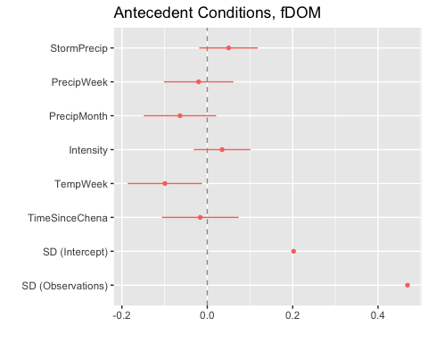 CI overlapping 0 indicate nonsignificance and it seems like only TempWeek is significant

sjPlot::tab_model(M1.fDOM_beta)

## Argument 'df_method' is deprecated. Please use 'ci_method' instead.

beta

Predictors

Estimates

CI

p

(Intercept)

0.04

-0.14 – 0.22

0.649

StormPrecip

0.05

-0.02 – 0.12

0.154

PrecipWeek

-0.02

-0.10 – 0.06

0.624

PrecipMonth

-0.06

-0.15 – 0.02

0.138

Intensity

0.03

-0.03 – 0.10

0.306

TempWeek

-0.10

-0.19 – -0.01

0.026

TimeSinceChena

-0.02

-0.11 – 0.07

0.717

Random Effects

σ2

0.22

τ00 site.ID

0.04

ICC

0.16

N site.ID

6

Observations

203

Marginal R2 / Conditional R2

0.065 / 0.212

r.squaredGLMM(M1.fDOM_beta)

## R2m R2c  
## [1,] 0.06539408 0.2117945

21% explained

### Permafrost

## Linear mixed model fit by REML ['lmerMod']  
## Formula: beta ~ StormPrecip * pf + PrecipWeek * pf + PrecipMonth * pf +   
## ThreeMonth * pf + Intensity * pf + StormTemp * pf + TempWeek *   
## pf + TimeSinceChena * pf + (1 | site.ID)  
## Data: fDOM_data_beta  
##   
## REML criterion at convergence: 324.3  
##   
## Scaled residuals:   
## Min 1Q Median 3Q Max   
## -2.65283 -0.58830 -0.07918 0.52401 2.72423   
##   
## Random effects:  
## Groups Name Variance Std.Dev.  
## site.ID (Intercept) 0.04751 0.2180   
## Residual 0.21959 0.4686   
## Number of obs: 203, groups: site.ID, 6  
##   
## Fixed effects:  
## Estimate Std. Error t value  
## (Intercept) 0.0015139 0.1765591 0.009  
## StormPrecip 0.0001292 0.0612360 0.002  
## pfmedium 0.0672487 0.2114695 0.318  
## PrecipWeek -0.0166851 0.1050079 -0.159  
## PrecipMonth 0.0072049 0.1202272 0.060  
## ThreeMonth -0.0301857 0.1113262 -0.271  
## Intensity 0.0485679 0.0417632 1.163  
## StormTemp -0.0947509 0.1852794 -0.511  
## TempWeek -0.0006228 0.1805270 -0.003  
## TimeSinceChena -0.1411076 0.2009843 -0.702  
## StormPrecip:pfmedium 0.1021821 0.0791261 1.291  
## pfmedium:PrecipWeek -0.0301108 0.1153970 -0.261  
## pfmedium:PrecipMonth -0.0910705 0.1373831 -0.663  
## pfmedium:ThreeMonth 0.0209520 0.1414097 0.148  
## pfmedium:Intensity -0.0979103 0.0787851 -1.243  
## pfmedium:StormTemp 0.0781343 0.1997819 0.391  
## pfmedium:TempWeek -0.1084710 0.1911427 -0.567  
## pfmedium:TimeSinceChena 0.1692002 0.2137326 0.792

##   
## Correlation matrix not shown by default, as p = 18 > 12.  
## Use print(x, correlation=TRUE) or  
## vcov(x) if you need it

PF doesnt appear to have an effect

### Wildfire

## Linear mixed model fit by REML ['lmerMod']  
## Formula: beta ~ StormPrecip * burn + PrecipWeek * burn + PrecipMonth *   
## burn + ThreeMonth * burn + Intensity * burn + StormTemp *   
## burn + TempWeek * burn + TimeSinceChena * burn + (1 | site.ID)  
## Data: fDOM_data_beta  
##   
## REML criterion at convergence: 309.8  
##   
## Scaled residuals:   
## Min 1Q Median 3Q Max   
## -2.44310 -0.48935 -0.00832 0.50447 2.83518   
##   
## Random effects:  
## Groups Name Variance Std.Dev.  
## site.ID (Intercept) 0.02292 0.1514   
## Residual 0.20402 0.4517   
## Number of obs: 203, groups: site.ID, 6  
##   
## Fixed effects:  
## Estimate Std. Error t value  
## (Intercept) 0.047889 0.086608 0.553  
## StormPrecip 0.085583 0.042184 2.029  
## burnunburned -0.116227 0.151945 -0.765  
## PrecipWeek -0.036408 0.048365 -0.753  
## PrecipMonth 0.063307 0.075698 0.836  
## ThreeMonth -0.244771 0.089409 -2.738  
## Intensity 0.043415 0.033757 1.286  
## StormTemp 0.072922 0.076719 0.951  
## TempWeek -0.219339 0.065804 -3.333  
## TimeSinceChena 0.134529 0.075222 1.788  
## StormPrecip:burnunburned -0.130322 0.082140 -1.587  
## burnunburned:PrecipWeek -0.010235 0.092035 -0.111  
## burnunburned:PrecipMonth -0.157339 0.107538 -1.463  
## burnunburned:ThreeMonth 0.393681 0.121494 3.240  
## burnunburned:Intensity 0.004009 0.127866 0.031  
## burnunburned:StormTemp -0.443021 0.149767 -2.958  
## burnunburned:TempWeek 0.430219 0.127693 3.369  
## burnunburned:TimeSinceChena -0.407681 0.147241 -2.769

##   
## Correlation matrix not shown by default, as p = 18 > 12.  
## Use print(x, correlation=TRUE) or  
## vcov(x) if you need it

Wildfire seems to have a more substantial effect

SPC

#### Scatter plot matrix

HI_FI_SPC %>% ggplot(aes(x = StormPrecip, y = beta)) +   
 geom_hline(yintercept = 0, linetype = "dotted", size = 1) +  
 geom_point(aes(color = site.ID), size = 2) +  
 scale_color_manual(values = c("orange red", viridis::viridis(6)), "Catchment")+theme_bw() +  
 geom_smooth(method = "lm", na.rm = TRUE, fullrange = TRUE, aes(group = 1)) +   
 stat_poly_eq(formula = y~x,  
 label.y = "top", label.x = "right",  
 aes(label = paste(..eq.label.., ..rr.label.., sep = "~~~")),   
 parse = TRUE) +   
 ylim(c(-1.5, 1.5)) +  
 ylab("beta") +  
 ggtitle("Beta vs. StormPrecip")

## `geom_smooth()` using formula 'y ~ x'

## Warning: Removed 20 rows containing non-finite values (stat_poly_eq).

## Warning: Removed 20 rows containing missing values (geom_point).

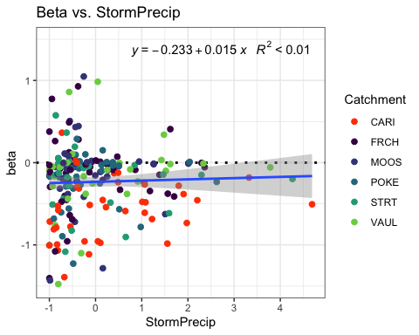

HI_FI_SPC %>% ggplot(aes(x = PrecipWeek, y = beta)) +   
 geom_hline(yintercept = 0, linetype = "dotted", size = 1) +  
 geom_point(aes(color = site.ID), size = 2) +  
 scale_color_manual(values = c("orange red", viridis::viridis(6)), "Catchment")+theme_bw() +  
 geom_smooth(method = "lm", na.rm = TRUE, fullrange = TRUE, aes(group = 1)) +   
 stat_poly_eq(formula = y~x,  
 label.y = "top", label.x = "right",  
 aes(label = paste(..eq.label.., ..rr.label.., sep = "~~~")),   
 parse = TRUE) +   
 ylim(c(-1.5, 1.5)) +  
 ylab("beta") +  
 ggtitle("Beta vs. PrecipWeek")

## `geom_smooth()` using formula 'y ~ x'

## Warning: Removed 20 rows containing non-finite values (stat_poly_eq).

## Warning: Removed 20 rows containing missing values (geom_point).

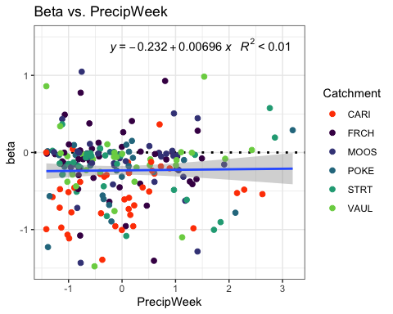

HI_FI_SPC %>% ggplot(aes(x = PrecipMonth, y = beta)) +   
 geom_hline(yintercept = 0, linetype = "dotted", size = 1) +  
 geom_point(aes(color = site.ID), size = 2) +  
 scale_color_manual(values = c("orange red", viridis::viridis(6)), "Catchment")+theme_bw() +  
 geom_smooth(method = "lm", na.rm = TRUE, fullrange = TRUE, aes(group = 1)) +   
 stat_poly_eq(formula = y~x,  
 label.y = "top", label.x = "right",  
 aes(label = paste(..eq.label.., ..rr.label.., sep = "~~~")),   
 parse = TRUE) +   
 ylim(c(-1.5, 1.5)) +  
 ylab("beta") +  
 ggtitle("beta vs. PrecipMonth")

## `geom_smooth()` using formula 'y ~ x'

## Warning: Removed 20 rows containing non-finite values (stat_poly_eq).

## Warning: Removed 20 rows containing missing values (geom_point).

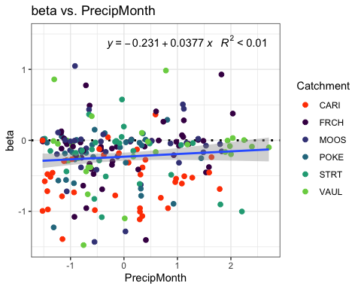

HI_FI_SPC %>% ggplot(aes(x = ThreeMonth, y = beta)) +   
 geom_hline(yintercept = 0, linetype = "dotted", size = 1) +  
 geom_point(aes(color = site.ID), size = 2) +  
 scale_color_manual(values = c("orange red", viridis::viridis(6)), "Catchment")+theme_bw() +  
 geom_smooth(method = "lm", na.rm = TRUE, fullrange = TRUE, aes(group = 1)) +   
 stat_poly_eq(formula = y~x,  
 label.y = "top", label.x = "right",  
 aes(label = paste(..eq.label.., ..rr.label.., sep = "~~~")),   
 parse = TRUE) +   
 ylim(c(-1.5, 1.5)) +  
 ylab("beta") +  
 ggtitle("Beta vs. ThreeMonth")

## `geom_smooth()` using formula 'y ~ x'

## Warning: Removed 20 rows containing non-finite values (stat_poly_eq).

## Warning: Removed 20 rows containing missing values (geom_point).

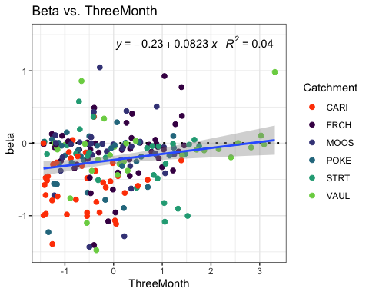

HI_FI_SPC %>% ggplot(aes(x = StormTemp, y = beta)) +   
 geom_hline(yintercept = 0, linetype = "dotted", size = 1) +  
 geom_point(aes(color = site.ID), size = 2) +  
 scale_color_manual(values = c("orange red", viridis::viridis(6)), "Catchment")+theme_bw() +  
 geom_smooth(method = "lm", na.rm = TRUE, fullrange = TRUE, aes(group = 1)) +   
 stat_poly_eq(formula = y~x,  
 label.y = "top", label.x = "right",  
 aes(label = paste(..eq.label.., ..rr.label.., sep = "~~~")),   
 parse = TRUE) +   
 ylim(c(-1.5, 1.5)) +  
 ylab("beta") +  
 ggtitle("Beta vs. StormTemp")

## `geom_smooth()` using formula 'y ~ x'

## Warning: Removed 20 rows containing non-finite values (stat_poly_eq).

## Warning: Removed 20 rows containing missing values (geom_point).

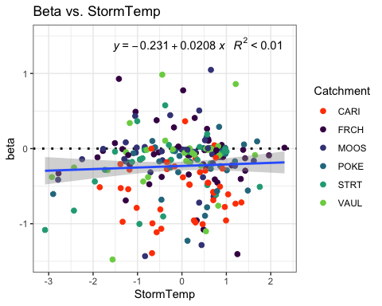

HI_FI_SPC %>% ggplot(aes(x = TempWeek, y = beta)) +   
 geom_hline(yintercept = 0, linetype = "dotted", size = 1) +  
 geom_point(aes(color = site.ID), size = 2) +  
 scale_color_manual(values = c("orange red", viridis::viridis(6)), "Catchment")+theme_bw() +  
 geom_smooth(method = "lm", na.rm = TRUE, fullrange = TRUE, aes(group = 1)) +   
 stat_poly_eq(formula = y~x,  
 label.y = "top", label.x = "right",  
 aes(label = paste(..eq.label.., ..rr.label.., sep = "~~~")),   
 parse = TRUE) +   
 ylim(c(-1.5, 1.5)) +  
 ylab("Beta") +  
 ggtitle("Beta vs. TempWeek")

## `geom_smooth()` using formula 'y ~ x'

## Warning: Removed 22 rows containing non-finite values (stat_poly_eq).

## Warning: Removed 22 rows containing missing values (geom_point).

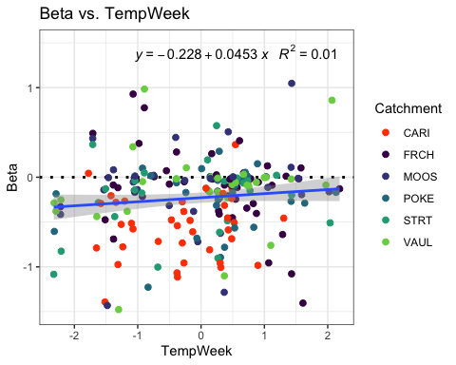

HI_FI_SPC %>% ggplot(aes(x = Intensity, y = beta)) +   
 geom_hline(yintercept = 0, linetype = "dotted", size = 1) +  
 geom_point(aes(color = site.ID), size = 2) +  
 scale_color_manual(values = c("orange red", viridis::viridis(6)), "Catchment")+theme_bw() +  
 geom_smooth(method = "lm", na.rm = TRUE, fullrange = TRUE, aes(group = 1)) +   
 stat_poly_eq(formula = y~x,  
 label.y = "top", label.x = "right",  
 aes(label = paste(..eq.label.., ..rr.label.., sep = "~~~")),   
 parse = TRUE) +   
 ylim(c(-1.5, 1.5)) +  
 ylab("Beta") +  
 ggtitle("Beta vs. Intensity")

## `geom_smooth()` using formula 'y ~ x'

## Warning: Removed 21 rows containing non-finite values (stat_poly_eq).

## Warning: Removed 21 rows containing missing values (geom_point).

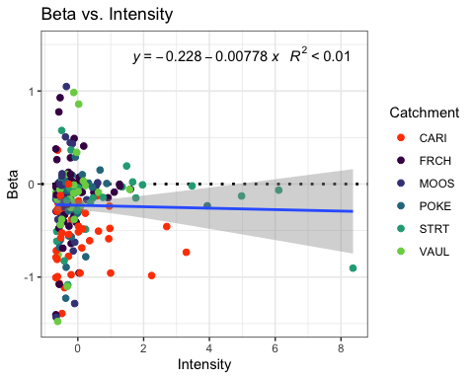

HI_FI_SPC %>% ggplot(aes(x = TimeSinceChena, y = beta)) +   
 geom_hline(yintercept = 0, linetype = "dotted", size = 1) +  
 geom_point(aes(color = site.ID), size = 2) +  
 scale_color_manual(values = c("orange red", viridis::viridis(6)), "Catchment")+theme_bw() +  
 geom_smooth(method = "lm", na.rm = TRUE, fullrange = TRUE, aes(group = 1)) +   
 stat_poly_eq(formula = y~x,  
 label.y = "top", label.x = "right",  
 aes(label = paste(..eq.label.., ..rr.label.., sep = "~~~")),   
 parse = TRUE) +   
 ylim(c(-1.5, 1.5)) +  
 ylab("beta") +  
 ggtitle("Beta vs. TimeSinceChena")

## `geom_smooth()` using formula 'y ~ x'

## Warning: Removed 20 rows containing non-finite values (stat_poly_eq).

## Warning: Removed 20 rows containing missing values (geom_point).

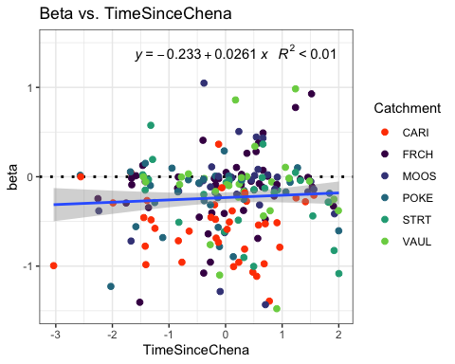

SPC_data_beta <- HI_FI_SPC[,c("beta", "site.ID", "StormPrecip", "StormTemp", "PrecipWeek", "PrecipMonth", "ThreeMonth", "TempWeek", "Intensity", "TimeSinceChena", "burn", "pf")]  
  
SPC_data_beta <- na.omit(SPC_data_beta) #232 to 223  
which(SPC_data_beta$beta > 1.5)

## [1] 48 61 88 109 111 130 173 206

SPC_data_beta <- SPC_data_beta[-c(48,61,88,109,111,130,173,206), ]  
which(SPC_data_beta$beta < -1.5)

## [1] 44 96 97 100 117 120

SPC_data_beta <- SPC_data_beta[-c(44,96,97,100,117,120), ]  
cor(SPC_data_beta[,c(1,3:10)])

## beta StormPrecip StormTemp PrecipWeek PrecipMonth  
## beta 1.00000000 0.02209225 0.03888117 0.02351738 0.10332069  
## StormPrecip 0.02209225 1.00000000 0.12885360 0.12731361 0.07613733  
## StormTemp 0.03888117 0.12885360 1.00000000 0.03618071 0.09779458  
## PrecipWeek 0.02351738 0.12731361 0.03618071 1.00000000 0.59168690  
## PrecipMonth 0.10332069 0.07613733 0.09779458 0.59168690 1.00000000  
## ThreeMonth 0.20178540 -0.07473611 -0.24347418 0.29578551 0.62741976  
## TempWeek 0.10521733 0.18179604 0.80165726 0.08495651 0.11352756  
## Intensity -0.02438390 0.33387464 0.09741093 0.03567409 0.03553170  
## TimeSinceChena 0.04884393 -0.16065031 -0.73797771 -0.02887017 0.13652746  
## ThreeMonth TempWeek Intensity TimeSinceChena  
## beta 0.20178540 0.10521733 -0.02438390 0.04884393  
## StormPrecip -0.07473611 0.18179604 0.33387464 -0.16065031  
## StormTemp -0.24347418 0.80165726 0.09741093 -0.73797771  
## PrecipWeek 0.29578551 0.08495651 0.03567409 -0.02887017  
## PrecipMonth 0.62741976 0.11352756 0.03553170 0.13652746  
## ThreeMonth 1.00000000 -0.16098693 -0.01151781 0.55619642  
## TempWeek -0.16098693 1.00000000 0.11021786 -0.60193835  
## Intensity -0.01151781 0.11021786 1.00000000 -0.08065635  
## TimeSinceChena 0.55619642 -0.60193835 -0.08065635 1.00000000

1. StormTemp is correlated with TempWeek (0.80) but TempWeek is more correlated with beta (0.10 vs. 0.03)
2. StormTemp is correlated with TimeSinceChena (-0.737) but TSC is more correlated with beta (-0.04 vs. 0.03)
3. PrecipWeek is correlated with PrecipMonth (0.591) but PrecipMonth is more correlated with beta (0.10 vs. 0.02)
4. PrecipMonth is correlated with ThreeMonth (0.627) but ThreeMonth is more correlated with beta (0.20 vs. 0.20)
5. ThreeMonth is correlated with TimeSinceChena (0.556) but ThreeMonth is more correlated with FI (0.20 vs. 0.04)

## Linear mixed model fit by REML ['lmerMod']  
## Formula: beta ~ StormPrecip + PrecipWeek + PrecipMonth + ThreeMonth +   
## Intensity + StormTemp + TempWeek + TimeSinceChena + (1 | site.ID)  
## Data: SPC_data_beta  
##   
## REML criterion at convergence: 253.7  
##   
## Scaled residuals:   
## Min 1Q Median 3Q Max   
## -3.1214 -0.4161 0.1176 0.4402 2.8659   
##   
## Random effects:  
## Groups Name Variance Std.Dev.  
## site.ID (Intercept) 0.01872 0.1368   
## Residual 0.16040 0.4005   
## Number of obs: 209, groups: site.ID, 6  
##   
## Fixed effects:  
## Estimate Std. Error t value  
## (Intercept) -0.22490 0.06271 -3.587  
## StormPrecip 0.03155 0.02966 1.064  
## PrecipWeek -0.01414 0.03751 -0.377  
## PrecipMonth -0.00211 0.04662 -0.045  
## ThreeMonth 0.06943 0.05075 1.368  
## Intensity -0.01332 0.02937 -0.454  
## StormTemp 0.02642 0.05755 0.459  
## TempWeek 0.02063 0.04756 0.434  
## TimeSinceChena 0.01003 0.05407 0.186  
##   
## Correlation of Fixed Effects:  
## (Intr) StrmPr PrcpWk PrcpMn ThrMnt Intnst StrmTm TempWk  
## StormPrecip -0.014   
## PrecipWeek -0.007 -0.073   
## PrecipMonth 0.022 -0.024 -0.502   
## ThreeMonth 0.002 0.027 -0.002 -0.580   
## Intensity -0.035 -0.329 0.019 -0.037 0.023   
## StormTemp -0.006 0.106 0.187 -0.132 -0.130 -0.042   
## TempWeek 0.002 -0.144 -0.060 -0.026 0.037 -0.014 -0.652   
## TimeSincChn -0.027 0.067 0.198 0.038 -0.517 -0.022 0.538 0.009

1. Scaled residuals look okay
2. Site slight explanation for variation
3. Nothing really significant 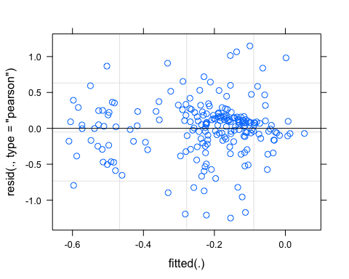 This looks less good 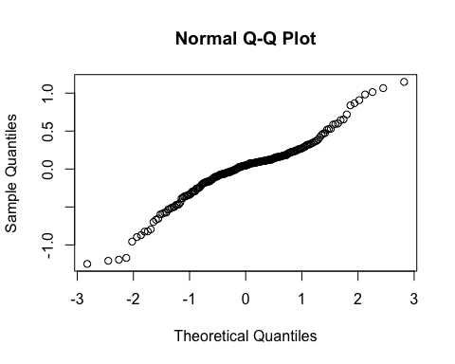 Do we need to log transform this?

## Linear mixed model fit by REML ['lmerMod']  
## Formula:   
## beta ~ StormPrecip + PrecipWeek + PrecipMonth + Intensity + TempWeek +   
## TimeSinceChena + (1 | site.ID)  
## Data: SPC_data_beta  
##   
## REML criterion at convergence: 247.9  
##   
## Scaled residuals:   
## Min 1Q Median 3Q Max   
## -3.1542 -0.3908 0.1171 0.4298 2.9344   
##   
## Random effects:  
## Groups Name Variance Std.Dev.  
## site.ID (Intercept) 0.02208 0.1486   
## Residual 0.16006 0.4001   
## Number of obs: 209, groups: site.ID, 6  
##   
## Fixed effects:  
## Estimate Std. Error t value  
## (Intercept) -0.22477 0.06702 -3.354  
## StormPrecip 0.02893 0.02946 0.982  
## PrecipWeek -0.01865 0.03680 -0.507  
## PrecipMonth 0.04135 0.03668 1.127  
## Intensity -0.01343 0.02939 -0.457  
## TempWeek 0.03695 0.03599 1.027  
## TimeSinceChena 0.03063 0.03852 0.795  
##   
## Correlation of Fixed Effects:  
## (Intr) StrmPr PrcpWk PrcpMn Intnst TempWk  
## StormPrecip -0.012   
## PrecipWeek -0.005 -0.096   
## PrecipMonth 0.027 0.020 -0.599   
## Intensity -0.034 -0.328 0.027 -0.042   
## TempWeek -0.002 -0.098 0.084 -0.238 -0.054   
## TimeSincChn -0.030 0.040 0.153 -0.288 0.013 0.627

## StormPrecip PrecipWeek PrecipMonth Intensity TempWeek   
## 1.187311 1.595487 1.692534 1.149064 1.750336   
## TimeSinceChena   
## 1.755465

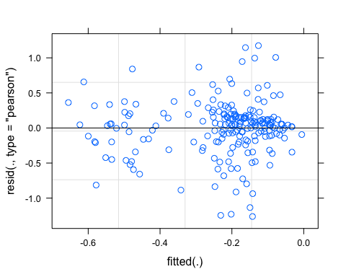

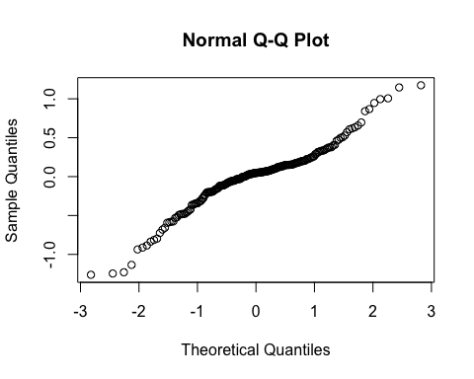

pr <- ggpredict(M1.turb, terms = c("PrecipMonth"))  
plot(pr, add.data = TRUE)

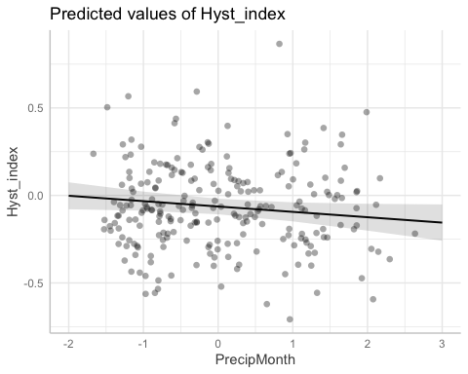

## boundary (singular) fit: see ?isSingular

## Linear mixed model fit by REML ['lmerMod']  
## Formula:   
## beta ~ StormPrecip + PrecipWeek + PrecipMonth + Intensity + TempWeek +   
## TimeSinceChena + (PrecipMonth | site.ID)  
## Data: SPC_data_beta  
##   
## REML criterion at convergence: 247.6  
##   
## Scaled residuals:   
## Min 1Q Median 3Q Max   
## -3.1787 -0.3617 0.1053 0.4379 2.9508   
##   
## Random effects:  
## Groups Name Variance Std.Dev. Corr  
## site.ID (Intercept) 0.0219245 0.14807   
## PrecipMonth 0.0003244 0.01801 1.00  
## Residual 0.1598340 0.39979   
## Number of obs: 209, groups: site.ID, 6  
##   
## Fixed effects:  
## Estimate Std. Error t value  
## (Intercept) -0.22587 0.06684 -3.380  
## StormPrecip 0.02860 0.02949 0.970  
## PrecipWeek -0.01826 0.03681 -0.496  
## PrecipMonth 0.03974 0.03764 1.056  
## Intensity -0.01306 0.02968 -0.440  
## TempWeek 0.04088 0.03576 1.143  
## TimeSinceChena 0.03391 0.03831 0.885  
##   
## Correlation of Fixed Effects:  
## (Intr) StrmPr PrcpWk PrcpMn Intnst TempWk  
## StormPrecip -0.010   
## PrecipWeek -0.007 -0.098   
## PrecipMonth 0.207 0.026 -0.587   
## Intensity -0.038 -0.335 0.030 -0.056   
## TempWeek -0.002 -0.097 0.085 -0.232 -0.049   
## TimeSincChn -0.029 0.038 0.154 -0.281 0.019 0.624  
## optimizer (nloptwrap) convergence code: 0 (OK)  
## boundary (singular) fit: see ?isSingular

aictab(list(M0.SPC_beta, M1.SPC_beta, M2.SPC_beta))

## Warning in aictab.AIClmerMod(list(M0.SPC_beta, M1.SPC_beta, M2.SPC_beta)):   
## Model names have been supplied automatically in the table

## Warning in aictab.AIClmerMod(list(M0.SPC_beta, M1.SPC_beta, M2.SPC_beta)):   
## Model selection for fixed effects is only appropriate with ML estimation:  
## REML (default) should only be used to select random effects for a constant set of fixed effects

##   
## Model selection based on AICc:  
##   
## K AICc Delta_AICc AICcWt Cum.Wt Res.LL  
## Mod2 9 266.80 0.00 0.88 0.88 -123.95  
## Mod3 11 270.90 4.10 0.11 0.99 -123.78  
## Mod1 11 277.01 10.21 0.01 1.00 -126.83

Mod2: Reduced model (No StormTemp or ThreeMonth Precip) with random intercept structure Mod3: Reduced model (’’) with random slope structure Mod1: Full model with random intercept structure

dwplot(list(M1.SPC_beta),  
 vline = geom_vline(xintercept = 0,  
 colour = "grey60",  
 linetype = 2)) +  
 ggtitle("Antecedent Conditions, SPC")

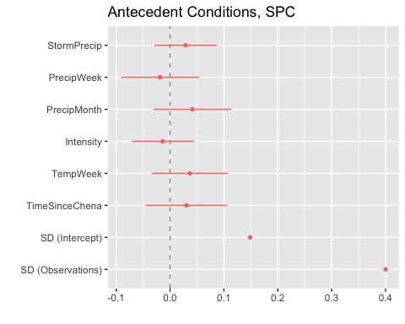

sjPlot::tab_model(M1.SPC_beta)

## Argument 'df_method' is deprecated. Please use 'ci_method' instead.

beta

Predictors

Estimates

CI

p

(Intercept)

-0.22

-0.36 – -0.09

0.001

StormPrecip

0.03

-0.03 – 0.09

0.327

PrecipWeek

-0.02

-0.09 – 0.05

0.613

PrecipMonth

0.04

-0.03 – 0.11

0.261

Intensity

-0.01

-0.07 – 0.04

0.648

TempWeek

0.04

-0.03 – 0.11

0.306

TimeSinceChena

0.03

-0.05 – 0.11

0.427

Random Effects

σ2

0.16

τ00 site.ID

0.02

ICC

0.12

N site.ID

6

Observations

209

Marginal R2 / Conditional R2

0.020 / 0.139

r.squaredGLMM(M1.SPC_beta)

## R2m R2c  
## [1,] 0.01973786 0.1385708

13.8% explained

### Permafrost

## Linear mixed model fit by REML ['lmerMod']  
## Formula: beta ~ StormPrecip * pf + PrecipWeek * pf + PrecipMonth * pf +   
## ThreeMonth * pf + Intensity * pf + StormTemp * pf + TempWeek *   
## pf + TimeSinceChena * pf + (1 | site.ID)  
## Data: SPC_data_beta  
##   
## REML criterion at convergence: 269.4  
##   
## Scaled residuals:   
## Min 1Q Median 3Q Max   
## -3.1893 -0.4047 0.0939 0.4545 3.0556   
##   
## Random effects:  
## Groups Name Variance Std.Dev.  
## site.ID (Intercept) 0.02862 0.1692   
## Residual 0.15754 0.3969   
## Number of obs: 209, groups: site.ID, 6  
##   
## Fixed effects:  
## Estimate Std. Error t value  
## (Intercept) -0.153436 0.136522 -1.124  
## StormPrecip -0.006353 0.049389 -0.129  
## pfmedium -0.093252 0.164515 -0.567  
## PrecipWeek -0.023919 0.078212 -0.306  
## PrecipMonth -0.177020 0.099253 -1.784  
## ThreeMonth 0.238922 0.087875 2.719  
## Intensity -0.005050 0.035372 -0.143  
## StormTemp 0.149904 0.143722 1.043  
## TempWeek -0.139938 0.136933 -1.022  
## TimeSinceChena -0.275756 0.148450 -1.858  
## StormPrecip:pfmedium 0.050677 0.065249 0.777  
## pfmedium:PrecipWeek -0.005186 0.089859 -0.058  
## pfmedium:PrecipMonth 0.214344 0.113581 1.887  
## pfmedium:ThreeMonth -0.210174 0.114622 -1.834  
## pfmedium:Intensity -0.013843 0.070013 -0.198  
## pfmedium:StormTemp -0.119081 0.157363 -0.757  
## pfmedium:TempWeek 0.136831 0.146559 0.934  
## pfmedium:TimeSinceChena 0.325817 0.160716 2.027

##   
## Correlation matrix not shown by default, as p = 18 > 12.  
## Use print(x, correlation=TRUE) or  
## vcov(x) if you need it

Permafors on TimeSinceChena

### Wildfire

## Linear mixed model fit by REML ['lmerMod']  
## Formula: beta ~ StormPrecip * burn + PrecipWeek * burn + PrecipMonth *   
## burn + ThreeMonth * burn + Intensity * burn + StormTemp *   
## burn + TempWeek * burn + TimeSinceChena * burn + (1 | site.ID)  
## Data: SPC_data_beta  
##   
## REML criterion at convergence: 267.5  
##   
## Scaled residuals:   
## Min 1Q Median 3Q Max   
## -3.0725 -0.5142 0.1169 0.5255 2.7500   
##   
## Random effects:  
## Groups Name Variance Std.Dev.  
## site.ID (Intercept) 0.01989 0.1410   
## Residual 0.15654 0.3957   
## Number of obs: 209, groups: site.ID, 6  
##   
## Fixed effects:  
## Estimate Std. Error t value  
## (Intercept) -0.264709 0.079869 -3.314  
## StormPrecip -0.001414 0.036930 -0.038  
## burnunburned 0.102110 0.138613 0.737  
## PrecipWeek 0.032901 0.044781 0.735  
## PrecipMonth -0.035671 0.065446 -0.545  
## ThreeMonth 0.032716 0.078751 0.415  
## Intensity -0.018491 0.030240 -0.611  
## StormTemp 0.003655 0.068300 0.054  
## TempWeek 0.069950 0.056415 1.240  
## TimeSinceChena -0.006287 0.065377 -0.096  
## StormPrecip:burnunburned 0.075557 0.072908 1.036  
## burnunburned:PrecipWeek -0.130167 0.081381 -1.599  
## burnunburned:PrecipMonth 0.089108 0.093847 0.949  
## burnunburned:ThreeMonth 0.027658 0.104684 0.264  
## burnunburned:Intensity 0.098321 0.123273 0.798  
## burnunburned:StormTemp 0.140318 0.128551 1.092  
## burnunburned:TempWeek -0.116537 0.108109 -1.078  
## burnunburned:TimeSinceChena 0.153193 0.127363 1.203

##   
## Correlation matrix not shown by default, as p = 18 > 12.  
## Use print(x, correlation=TRUE) or  
## vcov(x) if you need it

Wildfire doesnt seem to have much of an effect

turb

#### Scatter plot matrix

HI_FI_turb %>% ggplot(aes(x = StormPrecip, y = beta)) +   
 geom_hline(yintercept = 0, linetype = "dotted", size = 1) +  
 geom_point(aes(color = site.ID), size = 2) +  
 scale_color_manual(values = c("orange red", viridis::viridis(6)), "Catchment")+theme_bw() +  
 geom_smooth(method = "lm", na.rm = TRUE, fullrange = TRUE, aes(group = 1)) +   
 stat_poly_eq(formula = y~x,  
 label.y = "top", label.x = "right",  
 aes(label = paste(..eq.label.., ..rr.label.., sep = "~~~")),   
 parse = TRUE) +   
 ylim(c(-1.5, 1.5)) +  
 ylab("beta") +  
 ggtitle("beta vs. StormPrecip")

## `geom_smooth()` using formula 'y ~ x'

## Warning: Removed 30 rows containing non-finite values (stat_poly_eq).

## Warning: Removed 30 rows containing missing values (geom_point).

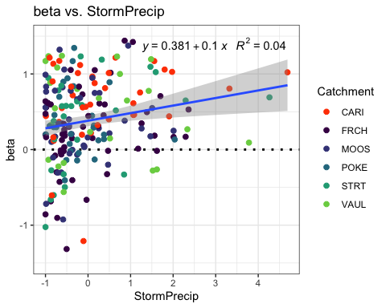

HI_FI_turb %>% ggplot(aes(x = PrecipWeek, y = beta)) +   
 geom_hline(yintercept = 0, linetype = "dotted", size = 1) +  
 geom_point(aes(color = site.ID), size = 2) +  
 scale_color_manual(values = c("orange red", viridis::viridis(6)), "Catchment")+theme_bw() +  
 geom_smooth(method = "lm", na.rm = TRUE, fullrange = TRUE, aes(group = 1)) +   
 stat_poly_eq(formula = y~x,  
 label.y = "top", label.x = "right",  
 aes(label = paste(..eq.label.., ..rr.label.., sep = "~~~")),   
 parse = TRUE) +   
 ylim(c(-1.5, 1.5)) +  
 ylab("Beta") +  
 ggtitle("Beta vs. PrecipWeek")

## `geom_smooth()` using formula 'y ~ x'

## Warning: Removed 30 rows containing non-finite values (stat_poly_eq).

## Warning: Removed 30 rows containing missing values (geom_point).

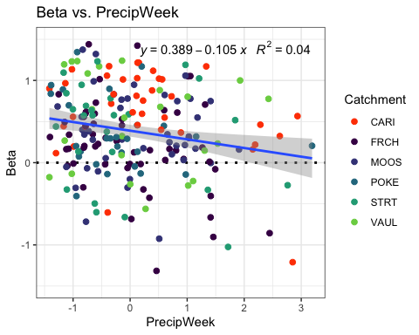

HI_FI_turb %>% ggplot(aes(x = PrecipMonth, y = beta)) +   
 geom_hline(yintercept = 0, linetype = "dotted", size = 1) +  
 geom_point(aes(color = site.ID), size = 2) +  
 scale_color_manual(values = c("orange red", viridis::viridis(6)), "Catchment")+theme_bw() +  
 geom_smooth(method = "lm", na.rm = TRUE, fullrange = TRUE, aes(group = 1)) +   
 stat_poly_eq(formula = y~x,  
 label.y = "top", label.x = "right",  
 aes(label = paste(..eq.label.., ..rr.label.., sep = "~~~")),   
 parse = TRUE) +   
 ylim(c(-1.5, 1.5)) +  
 ylab("Beta") +  
 ggtitle("Beta vs. PrecipMonth")

## `geom_smooth()` using formula 'y ~ x'

## Warning: Removed 30 rows containing non-finite values (stat_poly_eq).

## Warning: Removed 30 rows containing missing values (geom_point).

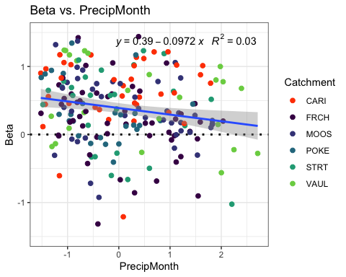

HI_FI_turb %>% ggplot(aes(x = ThreeMonth, y = beta)) +   
 geom_hline(yintercept = 0, linetype = "dotted", size = 1) +  
 geom_point(aes(color = site.ID), size = 2) +  
 scale_color_manual(values = c("orange red", viridis::viridis(6)), "Catchment")+theme_bw() +  
 geom_smooth(method = "lm", na.rm = TRUE, fullrange = TRUE, aes(group = 1)) +   
 stat_poly_eq(formula = y~x,  
 label.y = "top", label.x = "right",  
 aes(label = paste(..eq.label.., ..rr.label.., sep = "~~~")),   
 parse = TRUE) +   
 ylim(c(-1.5, 1.5)) +  
 ylab("Beta") +  
 ggtitle("Beta vs. ThreeMonth")

## `geom_smooth()` using formula 'y ~ x'

## Warning: Removed 30 rows containing non-finite values (stat_poly_eq).

## Warning: Removed 30 rows containing missing values (geom_point).

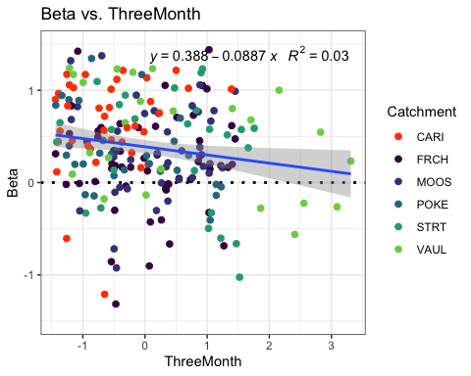

HI_FI_turb %>% ggplot(aes(x = StormTemp, y = beta)) +   
 geom_hline(yintercept = 0, linetype = "dotted", size = 1) +  
 geom_point(aes(color = site.ID), size = 2) +  
 scale_color_manual(values = c("orange red", viridis::viridis(6)), "Catchment")+theme_bw() +  
 geom_smooth(method = "lm", na.rm = TRUE, fullrange = TRUE, aes(group = 1)) +   
 stat_poly_eq(formula = y~x,  
 label.y = "top", label.x = "right",  
 aes(label = paste(..eq.label.., ..rr.label.., sep = "~~~")),   
 parse = TRUE) +   
 ylim(c(-1.5, 1.5)) +  
 ylab("Beta") +  
 ggtitle("Beta vs. StormTemp")

## `geom_smooth()` using formula 'y ~ x'

## Warning: Removed 30 rows containing non-finite values (stat_poly_eq).

## Warning: Removed 30 rows containing missing values (geom_point).

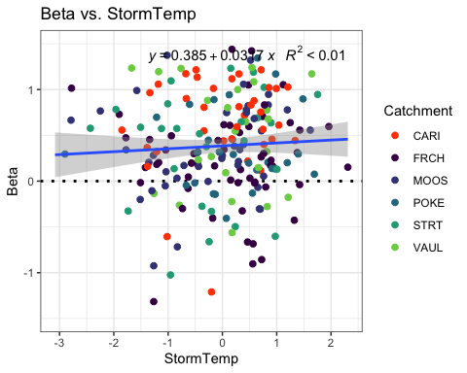

HI_FI_turb %>% ggplot(aes(x = TempWeek, y = beta)) +   
 geom_hline(yintercept = 0, linetype = "dotted", size = 1) +  
 geom_point(aes(color = site.ID), size = 2) +  
 scale_color_manual(values = c("orange red", viridis::viridis(6)), "Catchment")+theme_bw() +  
 geom_smooth(method = "lm", na.rm = TRUE, fullrange = TRUE, aes(group = 1)) +   
 stat_poly_eq(formula = y~x,  
 label.y = "top", label.x = "right",  
 aes(label = paste(..eq.label.., ..rr.label.., sep = "~~~")),   
 parse = TRUE) +   
 ylim(c(-1.5, 1.5)) +  
 ylab("Beta") +  
 ggtitle("Beta vs. TempWeek")

## `geom_smooth()` using formula 'y ~ x'

## Warning: Removed 31 rows containing non-finite values (stat_poly_eq).

## Warning: Removed 31 rows containing missing values (geom_point).

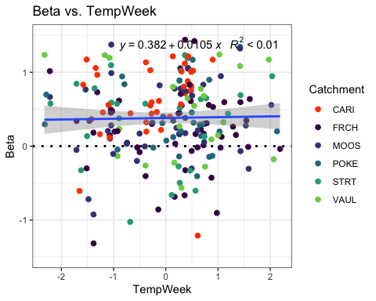

HI_FI_turb %>% ggplot(aes(x = Intensity, y = beta)) +   
 geom_hline(yintercept = 0, linetype = "dotted", size = 1) +  
 geom_point(aes(color = site.ID), size = 2) +  
 scale_color_manual(values = c("orange red", viridis::viridis(6)), "Catchment")+theme_bw() +  
 geom_smooth(method = "lm", na.rm = TRUE, fullrange = TRUE, aes(group = 1)) +   
 stat_poly_eq(formula = y~x,  
 label.y = "top", label.x = "right",  
 aes(label = paste(..eq.label.., ..rr.label.., sep = "~~~")),   
 parse = TRUE) +   
 ylim(c(-1.5, 1.5)) +  
 ylab("beta") +  
 ggtitle("Beta vs. Intensity")

## `geom_smooth()` using formula 'y ~ x'

## Warning: Removed 32 rows containing non-finite values (stat_poly_eq).

## Warning: Removed 32 rows containing missing values (geom_point).

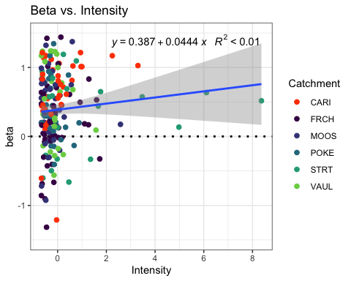

HI_FI_turb %>% ggplot(aes(x = TimeSinceChena, y = beta)) +   
 geom_hline(yintercept = 0, linetype = "dotted", size = 1) +  
 geom_point(aes(color = site.ID), size = 2) +  
 scale_color_manual(values = c("orange red", viridis::viridis(6)), "Catchment")+theme_bw() +  
 geom_smooth(method = "lm", na.rm = TRUE, fullrange = TRUE, aes(group = 1)) +   
 stat_poly_eq(formula = y~x,  
 label.y = "top", label.x = "right",  
 aes(label = paste(..eq.label.., ..rr.label.., sep = "~~~")),   
 parse = TRUE) +   
 ylim(c(-1.5, 1.5)) +  
 ylab("beta ") +  
 ggtitle("Beta vs. TimeSinceChena")

## `geom_smooth()` using formula 'y ~ x'

## Warning: Removed 30 rows containing non-finite values (stat_poly_eq).

## Warning: Removed 30 rows containing missing values (geom_point).

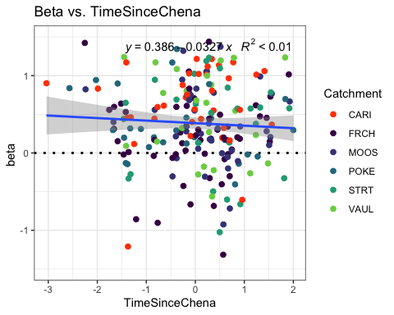

turb_data_beta <- HI_FI_turb[,c("beta", "site.ID", "StormPrecip", "StormTemp", "PrecipWeek", "PrecipMonth", "ThreeMonth", "TempWeek", "Intensity", "TimeSinceChena", "burn", "pf")]  
  
turb_data_beta <- na.omit(turb_data_beta) #240 to 229  
which(turb_data_beta$beta > 1.5)

## [1] 22 25 51 68 73 83 91 92 95 99 120 129 146 174 177 200 209 219 221

turb_data_beta <- turb_data_beta[-c(22,25,51,68,73,83,91,92,95,99,120,129,146,174,177,200,209,219,221),]  
which(turb_data_beta$beta < -1.5)

## [1] 21 139 195

turb_data_beta <- turb_data_beta[-c(21,139,195),]  
  
cor(turb_data_beta[,c(1,3:10)])

## beta StormPrecip StormTemp PrecipWeek PrecipMonth  
## beta 1.000000000 0.17663051 0.04420590 -0.18067411 -0.15769271  
## StormPrecip 0.176630510 1.00000000 0.09510971 0.10485766 0.08925169  
## StormTemp 0.044205900 0.09510971 1.00000000 0.05454895 0.09214566  
## PrecipWeek -0.180674107 0.10485766 0.05454895 1.00000000 0.54648916  
## PrecipMonth -0.157692712 0.08925169 0.09214566 0.54648916 1.00000000  
## ThreeMonth -0.141235160 -0.06286306 -0.21008350 0.22537257 0.63329791  
## TempWeek 0.008608851 0.15555604 0.80615886 0.08263248 0.11197449  
## Intensity 0.089727440 0.31978366 0.05453119 0.01743402 0.06830090  
## TimeSinceChena -0.039469663 -0.14319451 -0.70434355 -0.08563994 0.15216150  
## ThreeMonth TempWeek Intensity TimeSinceChena  
## beta -0.14123516 0.008608851 0.08972744 -0.03946966  
## StormPrecip -0.06286306 0.155556043 0.31978366 -0.14319451  
## StormTemp -0.21008350 0.806158865 0.05453119 -0.70434355  
## PrecipWeek 0.22537257 0.082632481 0.01743402 -0.08563994  
## PrecipMonth 0.63329791 0.111974489 0.06830090 0.15216150  
## ThreeMonth 1.00000000 -0.143101398 0.01824563 0.55892198  
## TempWeek -0.14310140 1.000000000 0.07938916 -0.60399159  
## Intensity 0.01824563 0.079389160 1.00000000 -0.04653162  
## TimeSinceChena 0.55892198 -0.603991594 -0.04653162 1.00000000

1. StormTemp is correlated with TempWeek (0.806) but StormTemp is more correlated with beta (0.04 vs. 0.008)
2. StormTemp is correlated with TimeSinceChena (-0.704) but StormTemp is more correlated with beta (-0.03 vs. 0.04)
3. PrecipWeek is correlated with PrecipMonth (0.546) but PrecipWeek is more correlated with beta (-0.18 vs. -0.157)
4. PrecipMonth is correlated with ThreeMonth (0.633) but PrecipMonth is more correlated with beta (-0.15 vs. -0.14)
5. ThreeMonth is correlated with TimeSinceChena (0.558) but ThreeMonth is more correlated with beta (-0.14 vs. -0.03)

## Linear mixed model fit by REML ['lmerMod']  
## Formula: beta ~ StormPrecip + PrecipWeek + PrecipMonth + ThreeMonth +   
## Intensity + StormTemp + TempWeek + TimeSinceChena + (1 | site.ID)  
## Data: turb_data_beta  
##   
## REML criterion at convergence: 341.4  
##   
## Scaled residuals:   
## Min 1Q Median 3Q Max   
## -2.92784 -0.59715 0.03411 0.67602 2.10572   
##   
## Random effects:  
## Groups Name Variance Std.Dev.  
## site.ID (Intercept) 0.01469 0.1212   
## Residual 0.25615 0.5061   
## Number of obs: 207, groups: site.ID, 6  
##   
## Fixed effects:  
## Estimate Std. Error t value  
## (Intercept) 0.40059 0.06150 6.513  
## StormPrecip 0.08603 0.03827 2.248  
## PrecipWeek -0.09005 0.04504 -1.999  
## PrecipMonth -0.04703 0.05716 -0.823  
## ThreeMonth -0.01039 0.06495 -0.160  
## Intensity 0.02180 0.03775 0.577  
## StormTemp 0.05461 0.07346 0.743  
## TempWeek -0.01898 0.06346 -0.299  
## TimeSinceChena 0.02111 0.06999 0.302  
##   
## Correlation of Fixed Effects:  
## (Intr) StrmPr PrcpWk PrcpMn ThrMnt Intnst StrmTm TempWk  
## StormPrecip -0.011   
## PrecipWeek -0.011 -0.016   
## PrecipMonth 0.006 -0.063 -0.472   
## ThreeMonth -0.008 0.032 -0.013 -0.580   
## Intensity -0.026 -0.315 0.034 -0.067 0.018   
## StormTemp 0.010 0.119 0.186 -0.115 -0.129 -0.010   
## TempWeek -0.036 -0.133 -0.038 -0.030 -0.001 -0.014 -0.650   
## TimeSincChn -0.030 0.078 0.244 0.039 -0.544 -0.003 0.484 0.074

1)Scaled residuals look eh

1. Slight site variation
2. StormPrecip is most important

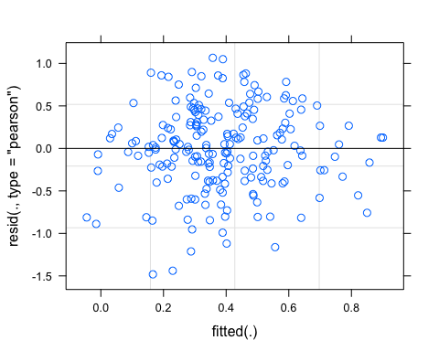

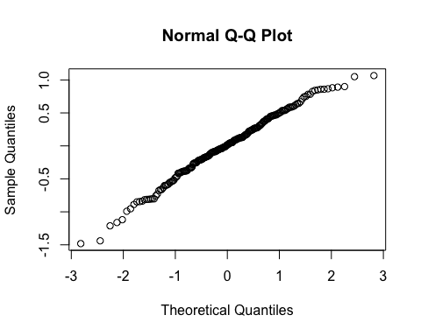

## Linear mixed model fit by REML ['lmerMod']  
## Formula:   
## beta ~ StormPrecip + PrecipWeek + PrecipMonth + Intensity + TempWeek +   
## TimeSinceChena + (1 | site.ID)  
## Data: turb_data_beta  
##   
## REML criterion at convergence: 334.9  
##   
## Scaled residuals:   
## Min 1Q Median 3Q Max   
## -2.97657 -0.61025 0.02597 0.68026 2.07673   
##   
## Random effects:  
## Groups Name Variance Std.Dev.  
## site.ID (Intercept) 0.01615 0.1271   
## Residual 0.25386 0.5038   
## Number of obs: 207, groups: site.ID, 6  
##   
## Fixed effects:  
## Estimate Std. Error t value  
## (Intercept) 0.400393 0.063379 6.317  
## StormPrecip 0.082152 0.037808 2.173  
## PrecipWeek -0.096722 0.044066 -2.195  
## PrecipMonth -0.044326 0.045056 -0.984  
## Intensity 0.022334 0.037655 0.593  
## TempWeek 0.011889 0.047727 0.249  
## TimeSinceChena -0.006149 0.050745 -0.121  
##   
## Correlation of Fixed Effects:  
## (Intr) StrmPr PrcpWk PrcpMn Intnst TempWk  
## StormPrecip -0.011   
## PrecipWeek -0.012 -0.039   
## PrecipMonth 0.004 -0.025 -0.571   
## Intensity -0.026 -0.317 0.036 -0.074   
## TempWeek -0.039 -0.068 0.112 -0.261 -0.025   
## TimeSincChn -0.051 0.061 0.223 -0.341 0.014 0.632

## StormPrecip PrecipWeek PrecipMonth Intensity TempWeek   
## 1.157874 1.507397 1.631465 1.133475 1.739400   
## TimeSinceChena   
## 1.817155

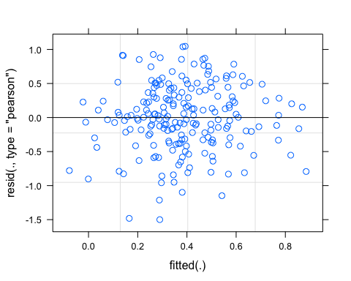

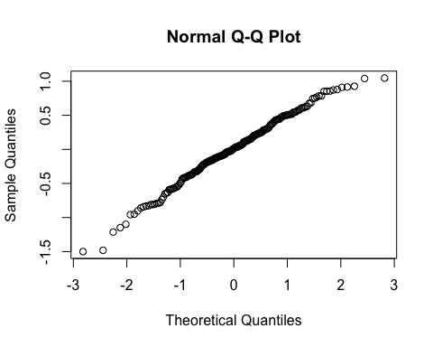

pr <- ggpredict(M1.turb_beta, terms = c("StormPrecip"))  
plot(pr, add.data = TRUE)

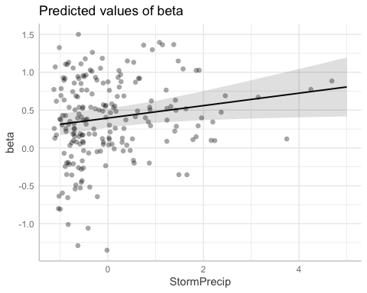

## Linear mixed model fit by REML ['lmerMod']  
## Formula:   
## beta ~ StormPrecip + PrecipWeek + PrecipMonth + Intensity + TempWeek +   
## TimeSinceChena + (StormPrecip | site.ID)  
## Data: turb_data_beta  
##   
## REML criterion at convergence: 334.6  
##   
## Scaled residuals:   
## Min 1Q Median 3Q Max   
## -2.98217 -0.59521 0.04937 0.67903 2.03967   
##   
## Random effects:  
## Groups Name Variance Std.Dev. Corr   
## site.ID (Intercept) 0.016820 0.12969   
## StormPrecip 0.001509 0.03885 -0.57  
## Residual 0.252403 0.50240   
## Number of obs: 207, groups: site.ID, 6  
##   
## Fixed effects:  
## Estimate Std. Error t value  
## (Intercept) 0.404300 0.064270 6.291  
## StormPrecip 0.082343 0.041050 2.006  
## PrecipWeek -0.095670 0.043922 -2.178  
## PrecipMonth -0.044581 0.044917 -0.993  
## Intensity 0.022969 0.037606 0.611  
## TempWeek 0.009275 0.047794 0.194  
## TimeSinceChena -0.007015 0.050764 -0.138  
##   
## Correlation of Fixed Effects:  
## (Intr) StrmPr PrcpWk PrcpMn Intnst TempWk  
## StormPrecip -0.191   
## PrecipWeek -0.013 -0.039   
## PrecipMonth 0.003 -0.026 -0.571   
## Intensity -0.026 -0.292 0.037 -0.071   
## TempWeek -0.038 -0.059 0.111 -0.258 -0.028   
## TimeSincChn -0.051 0.054 0.222 -0.338 0.015 0.634

aictab(list(M0.turb_beta, M1.turb_beta, M2.turb_beta))

## Warning in aictab.AIClmerMod(list(M0.turb_beta, M1.turb_beta, M2.turb_beta)):   
## Model names have been supplied automatically in the table

## Warning in aictab.AIClmerMod(list(M0.turb_beta, M1.turb_beta, M2.turb_beta)):   
## Model selection for fixed effects is only appropriate with ML estimation:  
## REML (default) should only be used to select random effects for a constant set of fixed effects

##   
## Model selection based on AICc:  
##   
## K AICc Delta_AICc AICcWt Cum.Wt Res.LL  
## Mod2 9 353.84 0.00 0.88 0.88 -167.47  
## Mod3 11 357.96 4.12 0.11 1.00 -167.31  
## Mod1 11 364.78 10.93 0.00 1.00 -170.71

Mod2: Reduced Model (no StormPrcip or ThreeMonth) with random intercept structure Mod3: Reduced model (’’) with random slope structure Mod1: Full model with random intercept structure

dwplot(list(M1.turb_beta),  
 vline = geom_vline(xintercept = 0,  
 colour = "grey60",  
 linetype = 2)) +  
 ggtitle("Antecedent Conditions, Turb")

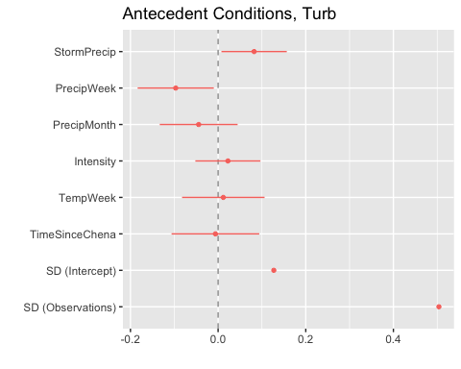

sjPlot::tab_model(M1.turb_beta)

## Argument 'df_method' is deprecated. Please use 'ci_method' instead.

beta

Predictors

Estimates

CI

p

(Intercept)

0.40

0.28 – 0.53

<0.001

StormPrecip

0.08

0.01 – 0.16

0.031

PrecipWeek

-0.10

-0.18 – -0.01

0.029

PrecipMonth

-0.04

-0.13 – 0.04

0.326

Intensity

0.02

-0.05 – 0.10

0.554

TempWeek

0.01

-0.08 – 0.11

0.804

TimeSinceChena

-0.01

-0.11 – 0.09

0.904

Random Effects

σ2

0.25

τ00 site.ID

0.02

ICC

0.06

N site.ID

6

Observations

207

Marginal R2 / Conditional R2

0.077 / 0.132

r.squaredGLMM(M1.turb_beta)

## R2m R2c  
## [1,] 0.07683608 0.1320507

13% explained

### Permafrost

## Linear mixed model fit by REML ['lmerMod']  
## Formula: beta ~ StormPrecip * pf + PrecipWeek * pf + PrecipMonth * pf +   
## ThreeMonth * pf + Intensity * pf + StormTemp * pf + TempWeek *   
## pf + TimeSinceChena * pf + (1 | site.ID)  
## Data: turb_data_beta  
##   
## REML criterion at convergence: 352  
##   
## Scaled residuals:   
## Min 1Q Median 3Q Max   
## -3.02304 -0.60691 0.08498 0.65809 2.11733   
##   
## Random effects:  
## Groups Name Variance Std.Dev.  
## site.ID (Intercept) 0.03253 0.1804   
## Residual 0.25023 0.5002   
## Number of obs: 207, groups: site.ID, 6  
##   
## Fixed effects:  
## Estimate Std. Error t value  
## (Intercept) 0.550950 0.158332 3.480  
## StormPrecip 0.033535 0.065917 0.509  
## pfmedium -0.134437 0.187285 -0.718  
## PrecipWeek -0.022660 0.122545 -0.185  
## PrecipMonth 0.086138 0.142755 0.603  
## ThreeMonth -0.237042 0.129542 -1.830  
## Intensity -0.002348 0.045408 -0.052  
## StormTemp 0.161306 0.243574 0.662  
## TempWeek -0.190837 0.213995 -0.892  
## TimeSinceChena 0.093207 0.209176 0.446  
## StormPrecip:pfmedium 0.069723 0.084608 0.824  
## pfmedium:PrecipWeek -0.082995 0.131975 -0.629  
## pfmedium:PrecipMonth -0.207638 0.157164 -1.321  
## pfmedium:ThreeMonth 0.385773 0.156848 2.460  
## pfmedium:Intensity 0.055769 0.091761 0.608  
## pfmedium:StormTemp -0.139288 0.256182 -0.544  
## pfmedium:TempWeek 0.209912 0.224964 0.933  
## pfmedium:TimeSinceChena -0.133749 0.223451 -0.599

##   
## Correlation matrix not shown by default, as p = 18 > 12.  
## Use print(x, correlation=TRUE) or  
## vcov(x) if you need it

### Wildfire

## Linear mixed model fit by REML ['lmerMod']  
## Formula: beta ~ StormPrecip * burn + PrecipWeek * burn + PrecipMonth *   
## burn + Intensity * burn + TempWeek * burn + TimeSinceChena *   
## burn + (1 | site.ID)  
## Data: turb_data_beta  
##   
## REML criterion at convergence: 352.2  
##   
## Scaled residuals:   
## Min 1Q Median 3Q Max   
## -3.05026 -0.60467 0.02403 0.69244 2.14952   
##   
## Random effects:  
## Groups Name Variance Std.Dev.  
## site.ID (Intercept) 0.02074 0.144   
## Residual 0.25907 0.509   
## Number of obs: 207, groups: site.ID, 6  
##   
## Fixed effects:  
## Estimate Std. Error t value  
## (Intercept) 0.429461 0.085757 5.008  
## StormPrecip 0.088109 0.049243 1.789  
## burnunburned -0.072733 0.150647 -0.483  
## PrecipWeek -0.093499 0.053389 -1.751  
## PrecipMonth -0.029478 0.062829 -0.469  
## Intensity 0.026449 0.040300 0.656  
## TempWeek 0.034875 0.061078 0.571  
## TimeSinceChena 0.004126 0.061057 0.068  
## StormPrecip:burnunburned 0.001146 0.088147 0.013  
## burnunburned:PrecipWeek -0.032348 0.097861 -0.331  
## burnunburned:PrecipMonth -0.021090 0.094024 -0.224  
## burnunburned:Intensity -0.104376 0.141076 -0.740  
## burnunburned:TempWeek -0.090206 0.108372 -0.832  
## burnunburned:TimeSinceChena -0.073057 0.119116 -0.613

##   
## Correlation matrix not shown by default, as p = 14 > 12.  
## Use print(x, correlation=TRUE) or  
## vcov(x) if you need it

FI

FI.pl <- antecedent_HI_FI_1_0 %>%  
 ggplot(aes(x = doy, y = Flush_index)) +   
 geom_hline(yintercept = 0, linetype = "dotted", size = 1) +  
 geom_errorbar(aes(ymin=FI_ymin, ymax=FI_ymax), colour="black", alpha=0.5, size=.5, width = 0.1)+   
 geom_point(aes(color = site.ID)) +  
 scale_color_manual(values = c("orange red", viridis::viridis(6)),  
 labels = c("French", "Moose", "Poker", "Vault", "Stuart", "Caribou")) +  
 ylab("Flushing Index") +  
 ggtitle("FI") +  
 facet_grid(rows=vars(year), cols = vars(response_var))   
   
FI.pl

## Warning: Removed 343 rows containing missing values (geom_point).

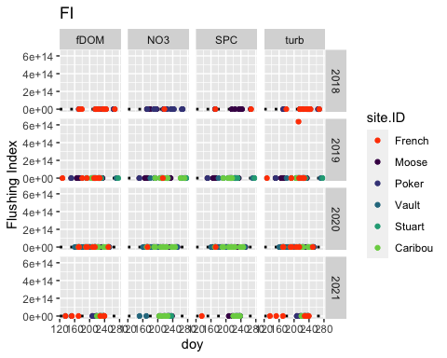 fDOM: Potentially an out outlier in 2019 POKE NO3-: Potentially some outliers in 2021 VAUL SPC: potentially some outliers in 2020 CARI Turb: Potentially some outliuers in VAUL 2020 Lets check it out:

FI_fDOM.2019.pl <- HI_FI_fDOM %>% filter(year == "2019") %>%  
 ggplot(aes(x = doy, y = Flush_index)) +   
 geom_hline(yintercept = 0, linetype = "dotted", size = 1) +  
 geom_errorbar(aes(ymin=FI_ymin, ymax=FI_ymax), colour="black", alpha=0.5, size=.5, width = 0.1)+   
 geom_point(aes(color = site.ID), size = 2) +  
 scale_color_manual(values = c("orange red", viridis::viridis(6)),  
 labels = c("French", "Moose", "Poker", "Vault", "Stuart", "Caribou")) +  
 ylab("Flushing Index") +  
 ggtitle("2019 fDOM")  
   
FI_fDOM.2019.pl

## Warning: Removed 22 rows containing missing values (geom_point).

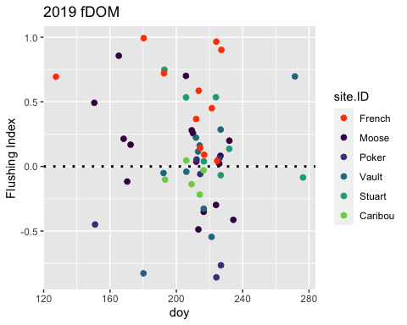 First storm of VAUL and last storm of POKE seem a little sus.

FI_NO3.2021.pl <- HI_FI_NO3 %>% filter(year == "2021") %>%  
 ggplot(aes(x = doy, y = Flush_index)) +   
 geom_hline(yintercept = 0, linetype = "dotted", size = 1) +  
 geom_errorbar(aes(ymin=FI_ymin, ymax=FI_ymax), colour="black", alpha=0.5, size=.5, width = 0.1)+   
 geom_point(aes(color = site.ID), size = 2) +  
 scale_color_manual(values = c("orange red", viridis::viridis(6)),  
 labels = c("French", "Moose", "Poker", "Vault", "Stuart", "Caribou")) +  
 ylab("Flushing Index") +  
 ggtitle("2021 NO3")  
   
FI_NO3.2021.pl

## Warning: Removed 16 rows containing missing values (geom_point).

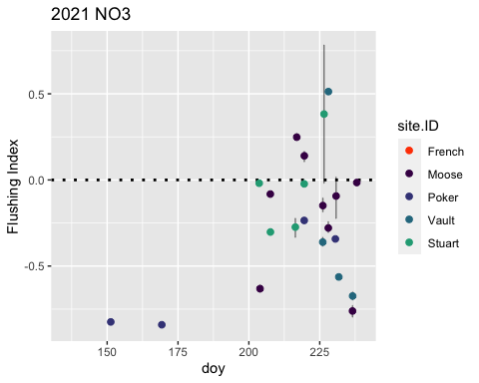 First two storms of poker seem a little suspicious

FI_SPC.2020.pl <- HI_FI_SPC %>% filter(year == "2020") %>%  
 ggplot(aes(x = doy, y = Flush_index)) +   
 geom_hline(yintercept = 0, linetype = "dotted", size = 1) +  
 geom_errorbar(aes(ymin=FI_ymin, ymax=FI_ymax), colour="black", alpha=0.5, size=.5, width = 0.1)+   
 geom_point(aes(color = site.ID), size = 2) +  
 scale_color_manual(values = c("orange red", viridis::viridis(6)),  
 labels = c("French", "Moose", "Poker", "Vault", "Stuart", "Caribou")) +  
 ylab("Flushing Index") +  
 ggtitle("2020 SPC")  
   
FI_SPC.2020.pl

## Warning: Removed 37 rows containing missing values (geom_point).

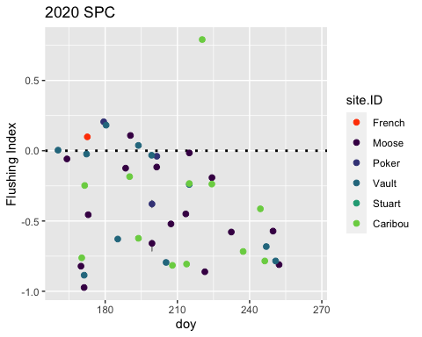 Highest Caribou point doesnt look normal

FI_turb.2020.pl <- HI_FI_turb %>% filter(year == "2020") %>%  
 ggplot(aes(x = doy, y = Flush_index)) +   
 geom_hline(yintercept = 0, linetype = "dotted", size = 1) +  
 geom_errorbar(aes(ymin=FI_ymin, ymax=FI_ymax), colour="black", alpha=0.5, size=.5, width = 0.1)+   
 geom_point(aes(color = site.ID), size = 2) +  
 scale_color_manual(values = c("orange red", viridis::viridis(6)),  
 labels = c("French", "Moose", "Poker", "Vault", "Stuart", "Caribou")) +  
 ylab("Flushing Index") +  
 ggtitle("2020 turb")  
   
FI_turb.2020.pl

## Warning: Removed 30 rows containing missing values (geom_point).

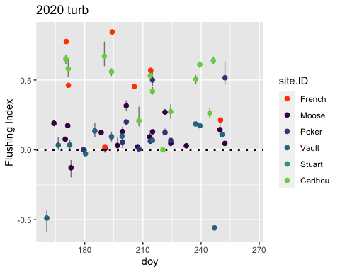 Both negative points for VAUL seem erroneous

#### Scatter plot matrix

NO3_data.1 <- HI_FI_NO3[,c("Flush_index","StormPrecip")]  
  
pairs(NO3_data.1)

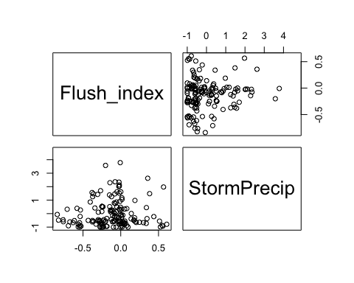

HI_FI_NO3 %>% ggplot(aes(x = StormPrecip, y = Flush_index)) +   
 geom_hline(yintercept = 0, linetype = "dotted", size = 1) +  
 geom_errorbar(aes(ymin=FI_ymin, ymax=FI_ymax), colour="black", alpha=0.5, size=.5, width = 0.1)+   
 geom_point(aes(color = site.ID), size = 2) +  
 scale_color_manual(values = c("orange red", viridis::viridis(6)),  
 labels = c("French", "Moose", "Poker", "Vault", "Stuart", "Caribou")) +  
 ylab("Flushing Index") +  
 ggtitle("HI vs. StormPrecip")

## Warning: Removed 86 rows containing missing values (geom_point).

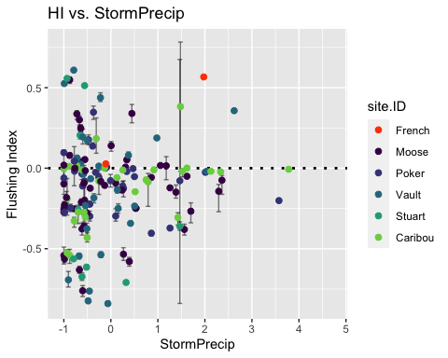

NO3_data.2 <- HI_FI_NO3[,c("Flush_index","PrecipWeek")]  
  
pairs(NO3_data.2)

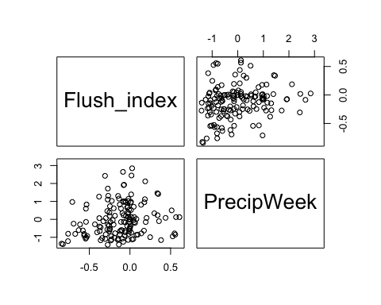

HI_FI_NO3 %>% ggplot(aes(x = PrecipWeek, y = Flush_index)) +   
 geom_hline(yintercept = 0, linetype = "dotted", size = 1) +  
 geom_errorbar(aes(ymin=FI_ymin, ymax=FI_ymax), colour="black", alpha=0.5, size=.5, width = 0.1)+   
 geom_point(aes(color = site.ID), size = 2) +  
 scale_color_manual(values = c("orange red", viridis::viridis(6)),  
 labels = c("French", "Moose", "Poker", "Vault", "Stuart", "Caribou")) +  
 ylab("Flushing Index") +  
 ggtitle("HI vs. PrecipWeek")

## Warning: Removed 86 rows containing missing values (geom_point).

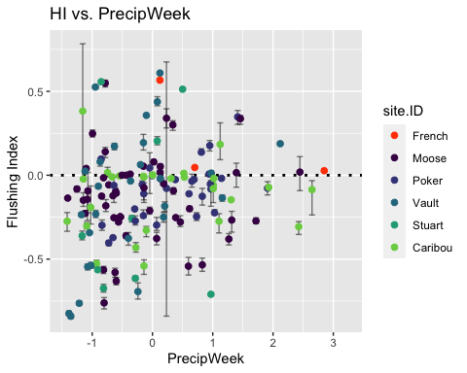

NO3_data.3 <- HI_FI_NO3[,c("Flush_index","PrecipMonth")]  
  
pairs(NO3_data.3)

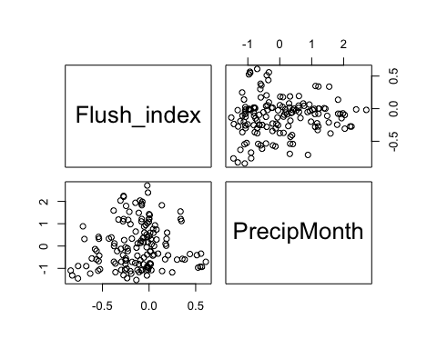

HI_FI_NO3 %>% ggplot(aes(x = PrecipMonth, y = Flush_index)) +   
 geom_hline(yintercept = 0, linetype = "dotted", size = 1) +  
 geom_errorbar(aes(ymin=FI_ymin, ymax=FI_ymax), colour="black", alpha=0.5, size=.5, width = 0.1)+   
 geom_point(aes(color = site.ID), size = 2) +  
 scale_color_manual(values = c("orange red", viridis::viridis(6)),  
 labels = c("French", "Moose", "Poker", "Vault", "Stuart", "Caribou")) +  
 ylab("Flushing Index") +  
 ggtitle("HI vs. PrecipMonth")

## Warning: Removed 86 rows containing missing values (geom_point).

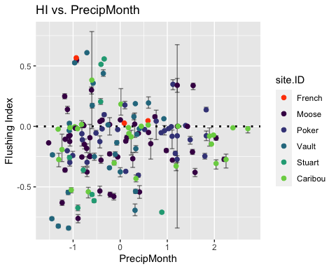

NO3_data.4 <- HI_FI_NO3[,c("Flush_index","ThreeMonth")]  
  
pairs(NO3_data.4)

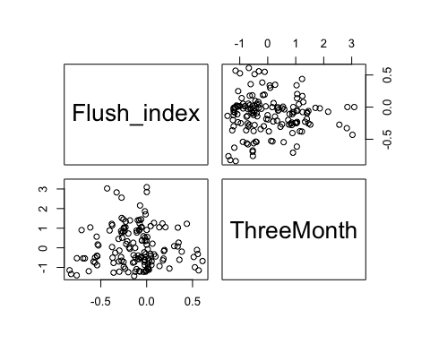

HI_FI_NO3 %>% ggplot(aes(x = ThreeMonth, y = Flush_index)) +   
 geom_hline(yintercept = 0, linetype = "dotted", size = 1) +  
 geom_errorbar(aes(ymin=FI_ymin, ymax=FI_ymax), colour="black", alpha=0.5, size=.5, width = 0.1)+   
 geom_point(aes(color = site.ID), size = 2) +  
 scale_color_manual(values = c("orange red", viridis::viridis(6)),  
 labels = c("French", "Moose", "Poker", "Vault", "Stuart", "Caribou")) +  
 ylab("Flushing Index") +  
 ggtitle("HI vs. ThreeMonth")

## Warning: Removed 86 rows containing missing values (geom_point).

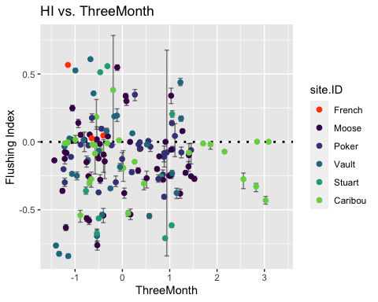

NO3_data.5 <- HI_FI_NO3[,c("Flush_index","StormTemp")]  
  
pairs(NO3_data.5)

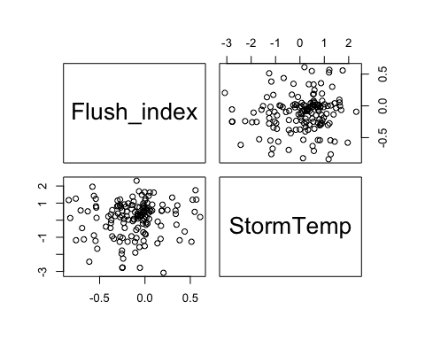

HI_FI_NO3 %>% ggplot(aes(x = StormTemp, y = Flush_index)) +   
 geom_hline(yintercept = 0, linetype = "dotted", size = 1) +  
 geom_errorbar(aes(ymin=FI_ymin, ymax=FI_ymax), colour="black", alpha=0.5, size=.5, width = 0.1)+   
 geom_point(aes(color = site.ID), size = 2) +  
 scale_color_manual(values = c("orange red", viridis::viridis(6)),  
 labels = c("French", "Moose", "Poker", "Vault", "Stuart", "Caribou")) +  
 ylab("Flushing Index") +  
 ggtitle("HI vs. StormTemp")

## Warning: Removed 86 rows containing missing values (geom_point).

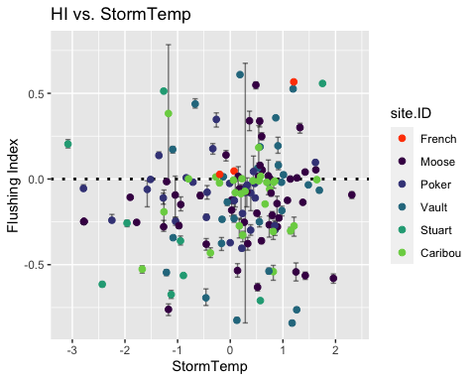

NO3_data.6 <- HI_FI_NO3[,c("Flush_index","TempWeek")]  
  
pairs(NO3_data.6)

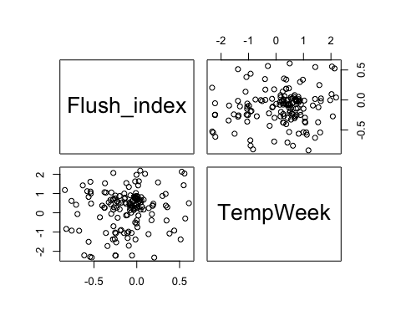

HI_FI_NO3 %>% ggplot(aes(x = TempWeek, y = Flush_index)) +   
 geom_hline(yintercept = 0, linetype = "dotted", size = 1) +  
 geom_errorbar(aes(ymin=FI_ymin, ymax=FI_ymax), colour="black", alpha=0.5, size=.5, width = 0.1)+   
 geom_point(aes(color = site.ID), size = 2) +  
 scale_color_manual(values = c("orange red", viridis::viridis(6)),  
 labels = c("French", "Moose", "Poker", "Vault", "Stuart", "Caribou")) +  
 ylab("Flushing Index") +  
 ggtitle("HI vs. TempWeek")

## Warning: Removed 86 rows containing missing values (geom_point).

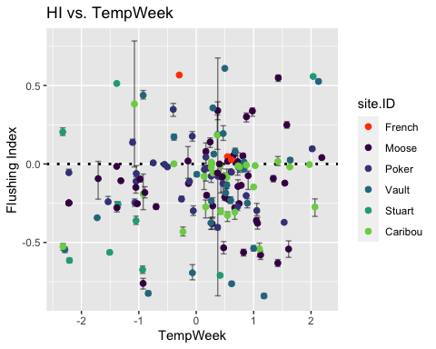

NO3_data.7 <- HI_FI_NO3[,c("Flush_index","Intensity")]  
  
pairs(NO3_data.7)

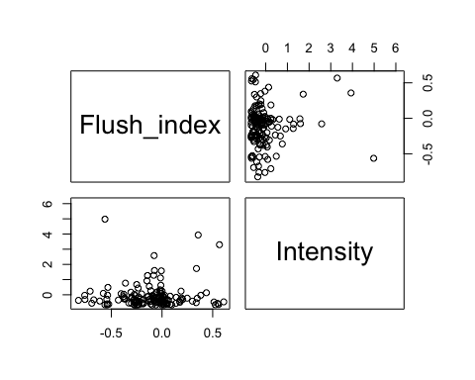

HI_FI_NO3 %>% ggplot(aes(x = Intensity, y = Flush_index)) +   
 geom_hline(yintercept = 0, linetype = "dotted", size = 1) +  
 geom_errorbar(aes(ymin=FI_ymin, ymax=FI_ymax), colour="black", alpha=0.5, size=.5, width = 0.1)+   
 geom_point(aes(color = site.ID), size = 2) +  
 scale_color_manual(values = c("orange red", viridis::viridis(6)),  
 labels = c("French", "Moose", "Poker", "Vault", "Stuart", "Caribou")) +  
 ylab("Flushing Index") +  
 ggtitle("HI vs. Intensity")

## Warning: Removed 89 rows containing missing values (geom_point).

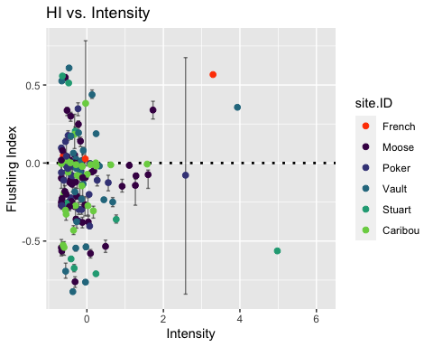

NO3_data.8 <- HI_FI_NO3[,c("Flush_index","TimeSinceChena")]  
  
pairs(NO3_data.8)

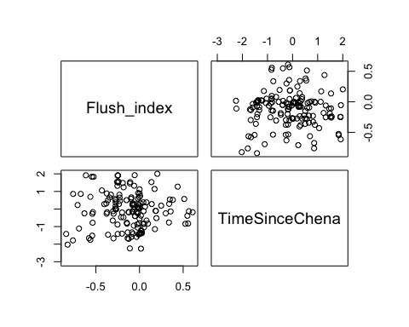

HI_FI_NO3 %>% ggplot(aes(x = StormPrecip, y = TimeSinceChena)) +   
 geom_hline(yintercept = 0, linetype = "dotted", size = 1) +  
 geom_errorbar(aes(ymin=FI_ymin, ymax=FI_ymax), colour="black", alpha=0.5, size=.5, width = 0.1)+   
 geom_point(aes(color = site.ID), size = 2) +  
 scale_color_manual(values = c("orange red", viridis::viridis(6)),  
 labels = c("French", "Moose", "Poker", "Vault", "Stuart", "Caribou")) +  
 ylab("Flushing Index") +  
 ggtitle("HI vs. TimeSinceChena")

## Warning: Removed 6 rows containing missing values (geom_point).

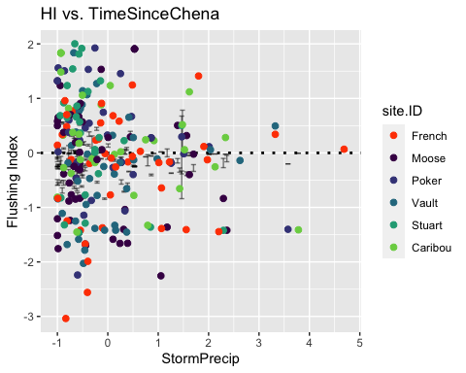

NO3_data_FI <- HI_FI_NO3[,c("Flush_index","StormPrecip", "StormTemp", "PrecipWeek", "PrecipMonth", "ThreeMonth", "TempWeek", "Intensity", "TimeSinceChena")]  
  
NO3_data_FI <- na.omit(NO3_data_FI)  
cor(NO3_data_FI)

## Flush_index StormPrecip StormTemp PrecipWeek PrecipMonth  
## Flush_index 1.00000000 0.087163627 0.13623127 0.16741493 0.055586722  
## StormPrecip 0.08716363 1.000000000 0.03452761 0.09899583 -0.003753911  
## StormTemp 0.13623127 0.034527610 1.00000000 0.02527546 0.095679399  
## PrecipWeek 0.16741493 0.098995826 0.02527546 1.00000000 0.570065052  
## PrecipMonth 0.05558672 -0.003753911 0.09567940 0.57006505 1.000000000  
## ThreeMonth -0.05260553 -0.102791920 -0.37487633 0.20526000 0.589116452  
## TempWeek 0.18073996 0.101004334 0.86198042 0.06898846 0.069187221  
## Intensity 0.06154452 0.492661209 0.06338699 -0.06305101 -0.076109716  
## TimeSinceChena -0.03501673 -0.119241811 -0.76183375 -0.12115802 0.108228460  
## ThreeMonth TempWeek Intensity TimeSinceChena  
## Flush_index -0.05260553 0.18073996 0.06154452 -0.03501673  
## StormPrecip -0.10279192 0.10100433 0.49266121 -0.11924181  
## StormTemp -0.37487633 0.86198042 0.06338699 -0.76183375  
## PrecipWeek 0.20526000 0.06898846 -0.06305101 -0.12115802  
## PrecipMonth 0.58911645 0.06918722 -0.07610972 0.10822846  
## ThreeMonth 1.00000000 -0.34664815 -0.14246871 0.66088257  
## TempWeek -0.34664815 1.00000000 -0.02231106 -0.70902843  
## Intensity -0.14246871 -0.02231106 1.00000000 -0.02571044  
## TimeSinceChena 0.66088257 -0.70902843 -0.02571044 1.00000000

1. Storm temperature is correlated with temp week (0.870) but temp week is more correlated with FI (0.191 vs. 0.122)
2. Storm temperature is correlated with TimeSinceChena (-0.771) but storm temp is more correlated with FI (0.122 vs. -0.03)
3. Precip week is correlated with precip month (0.592) but precip week is more correlated with FI (0.163 vs. 0.073)
4. Precip month is correlated with three month (0.587) but precip month is more correlated with FI (0.07 vs. -0.03)
5. Three month is correlated with TimeSinceChena (0.662) but ThreeMonth is more correlated with FI (-0.0305 vs. -0.0301)

## boundary (singular) fit: see ?isSingular

## Linear mixed model fit by REML ['lmerMod']  
## Formula: Flush_index ~ StormPrecip + PrecipWeek + PrecipMonth + ThreeMonth +   
## Intensity + StormTemp + TempWeek + TimeSinceChena + (1 | site.ID)  
## Data: HI_FI_NO3  
##   
## REML criterion at convergence: 67.9  
##   
## Scaled residuals:   
## Min 1Q Median 3Q Max   
## -2.64799 -0.51836 0.03306 0.55830 2.40864   
##   
## Random effects:  
## Groups Name Variance Std.Dev.  
## site.ID (Intercept) 0.00000 0.0000   
## Residual 0.07172 0.2678   
## Number of obs: 147, groups: site.ID, 6  
##   
## Fixed effects:  
## Estimate Std. Error t value  
## (Intercept) -0.107582 0.022930 -4.692  
## StormPrecip 0.014119 0.026913 0.525  
## PrecipWeek 0.086104 0.032309 2.665  
## PrecipMonth -0.015546 0.037225 -0.418  
## ThreeMonth -0.066605 0.041497 -1.605  
## Intensity 0.007632 0.033823 0.226  
## StormTemp 0.052110 0.049535 1.052  
## TempWeek 0.071656 0.044575 1.608  
## TimeSinceChena 0.140268 0.047924 2.927  
##   
## Correlation of Fixed Effects:  
## (Intr) StrmPr PrcpWk PrcpMn ThrMnt Intnst StrmTm TempWk  
## StormPrecip -0.034   
## PrecipWeek 0.056 -0.067   
## PrecipMonth 0.041 -0.002 -0.540   
## ThreeMonth -0.143 -0.043 0.017 -0.568   
## Intensity 0.066 -0.535 0.026 -0.022 0.162   
## StormTemp 0.114 0.245 0.275 -0.245 -0.059 -0.271   
## TempWeek -0.162 -0.222 -0.060 0.062 -0.035 0.233 -0.698   
## TimeSincChn 0.090 0.135 0.294 0.035 -0.590 -0.180 0.458 0.081  
## optimizer (nloptwrap) convergence code: 0 (OK)  
## boundary (singular) fit: see ?isSingular

1. Scaled residuals look appropriate
2. Site explains 0 of the variance
3. Precip week and TimeSinceChena are the most significant

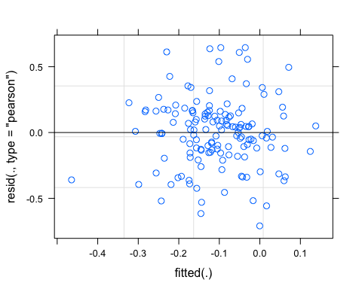

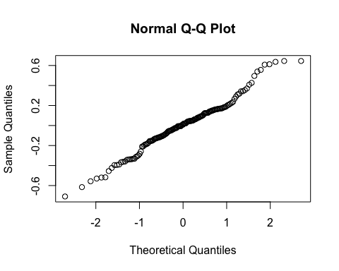

## boundary (singular) fit: see ?isSingular

## Linear mixed model fit by REML ['lmerMod']  
## Formula: Flush_index ~ StormPrecip + PrecipWeek + PrecipMonth + Intensity +   
## TempWeek + TimeSinceChena + (1 | site.ID)  
## Data: HI_FI_NO3  
##   
## REML criterion at convergence: 62.7  
##   
## Scaled residuals:   
## Min 1Q Median 3Q Max   
## -2.60560 -0.51335 0.07213 0.53366 2.53332   
##   
## Random effects:  
## Groups Name Variance Std.Dev.  
## site.ID (Intercept) 0.00000 0.0000   
## Residual 0.07249 0.2692   
## Number of obs: 147, groups: site.ID, 6  
##   
## Fixed effects:  
## Estimate Std. Error t value  
## (Intercept) -0.115179 0.022684 -5.078  
## StormPrecip 0.005965 0.026216 0.228  
## PrecipWeek 0.078406 0.031207 2.512  
## PrecipMonth -0.039525 0.028988 -1.363  
## Intensity 0.024921 0.032352 0.770  
## TempWeek 0.099116 0.031918 3.105  
## TimeSinceChena 0.075367 0.033082 2.278  
##   
## Correlation of Fixed Effects:  
## (Intr) StrmPr PrcpWk PrcpMn Intnst TempWk  
## StormPrecip -0.069   
## PrecipWeek 0.031 -0.143   
## PrecipMonth -0.015 0.055 -0.609   
## Intensity 0.124 -0.504 0.104 -0.004   
## TempWeek -0.132 -0.077 0.197 -0.277 0.081   
## TimeSincChn -0.058 0.009 0.283 -0.341 0.040 0.731  
## optimizer (nloptwrap) convergence code: 0 (OK)  
## boundary (singular) fit: see ?isSingular

aictab(list(M0.NO3.FI, M1.NO3.FI))

## Warning in aictab.AIClmerMod(list(M0.NO3.FI, M1.NO3.FI)):   
## Model names have been supplied automatically in the table

## Warning in aictab.AIClmerMod(list(M0.NO3.FI, M1.NO3.FI)):   
## Model selection for fixed effects is only appropriate with ML estimation:  
## REML (default) should only be used to select random effects for a constant set of fixed effects

##   
## Model selection based on AICc:  
##   
## K AICc Delta_AICc AICcWt Cum.Wt Res.LL  
## Mod2 9 82.04 0.00 0.99 0.99 -31.36  
## Mod1 11 91.89 9.86 0.01 1.00 -33.97

fDOM

#### Scatter plot matrix

fDOM_data.1 <- HI_FI_fDOM[,c("Flush_index","StormPrecip")]  
  
pairs(fDOM_data.1)

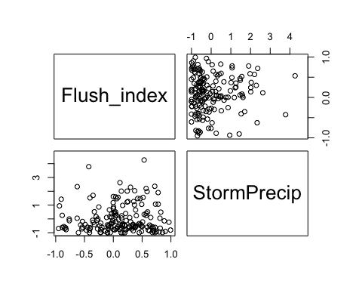

HI_FI_fDOM %>% ggplot(aes(x = StormPrecip, y = Flush_index)) +   
 geom_hline(yintercept = 0, linetype = "dotted", size = 1) +  
 geom_errorbar(aes(ymin=FI_ymin, ymax=FI_ymax), colour="black", alpha=0.5, size=.5, width = 0.1)+   
 geom_point(aes(color = site.ID), size = 2) +  
 scale_color_manual(values = c("orange red", viridis::viridis(6)),  
 labels = c("French", "Moose", "Poker", "Vault", "Stuart", "Caribou")) +  
 ylab("Flushing Index") +  
 ggtitle("HI vs. StormPrecip")

## Warning: Removed 69 rows containing missing values (geom_point).

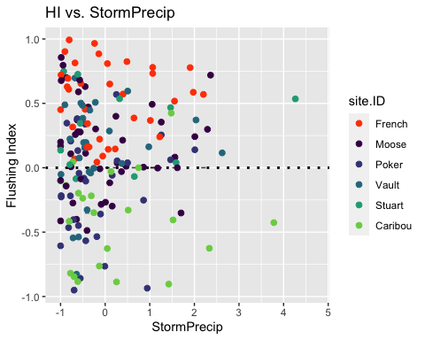

fDOM_data.2 <- HI_FI_fDOM[,c("Flush_index","PrecipWeek")]  
  
pairs(fDOM_data.1)



HI_FI_fDOM %>% ggplot(aes(x = PrecipWeek, y = Flush_index)) +   
 geom_hline(yintercept = 0, linetype = "dotted", size = 1) +  
 geom_errorbar(aes(ymin=FI_ymin, ymax=FI_ymax), colour="black", alpha=0.5, size=.5, width = 0.1)+   
 geom_point(aes(color = site.ID), size = 2) +  
 scale_color_manual(values = c("orange red", viridis::viridis(6)),  
 labels = c("French", "Moose", "Poker", "Vault", "Stuart", "Caribou")) +  
 ylab("Flushing Index") +  
 ggtitle("HI vs. PrecipWeek")

## Warning: Removed 69 rows containing missing values (geom_point).

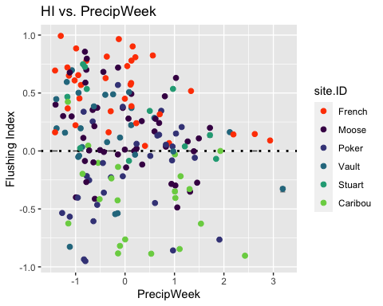

fDOM_data.1 <- HI_FI_fDOM[,c("Flush_index","PrecipMonth")]  
  
pairs(fDOM_data.1)

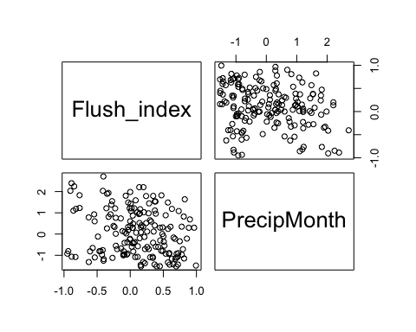

HI_FI_fDOM %>% ggplot(aes(x = PrecipMonth, y = Flush_index)) +   
 geom_hline(yintercept = 0, linetype = "dotted", size = 1) +  
 geom_errorbar(aes(ymin=FI_ymin, ymax=FI_ymax), colour="black", alpha=0.5, size=.5, width = 0.1)+   
 geom_point(aes(color = site.ID), size = 2) +  
 scale_color_manual(values = c("orange red", viridis::viridis(6)),  
 labels = c("French", "Moose", "Poker", "Vault", "Stuart", "Caribou")) +  
 ylab("Flushing Index") +  
 ggtitle("HI vs. PrecipMonth")

## Warning: Removed 69 rows containing missing values (geom_point).

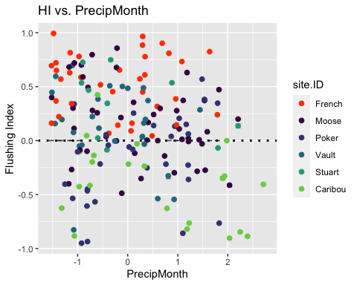

fDOM_data.1 <- HI_FI_fDOM[,c("Flush_index","ThreeMonth")]  
  
pairs(fDOM_data.1)

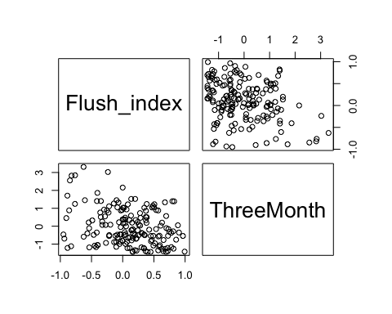

HI_FI_fDOM %>% ggplot(aes(x = ThreeMonth, y = Flush_index)) +   
 geom_hline(yintercept = 0, linetype = "dotted", size = 1) +  
 geom_errorbar(aes(ymin=FI_ymin, ymax=FI_ymax), colour="black", alpha=0.5, size=.5, width = 0.1)+   
 geom_point(aes(color = site.ID), size = 2) +  
 scale_color_manual(values = c("orange red", viridis::viridis(6)),  
 labels = c("French", "Moose", "Poker", "Vault", "Stuart", "Caribou")) +  
 ylab("Flushing Index") +  
 ggtitle("HI vs. ThreeMonth")

## Warning: Removed 69 rows containing missing values (geom_point).

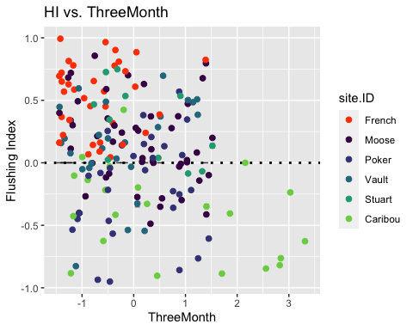

fDOM_data.1 <- HI_FI_fDOM[,c("Flush_index","StormTemp")]  
  
pairs(fDOM_data.1)

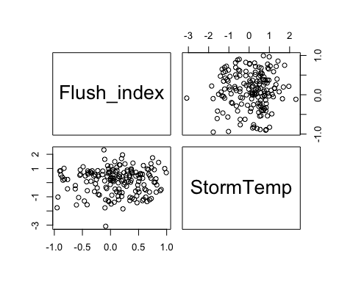

HI_FI_fDOM %>% ggplot(aes(x = StormTemp, y = Flush_index)) +   
 geom_hline(yintercept = 0, linetype = "dotted", size = 1) +  
 geom_errorbar(aes(ymin=FI_ymin, ymax=FI_ymax), colour="black", alpha=0.5, size=.5, width = 0.1)+   
 geom_point(aes(color = site.ID), size = 2) +  
 scale_color_manual(values = c("orange red", viridis::viridis(6)),  
 labels = c("French", "Moose", "Poker", "Vault", "Stuart", "Caribou")) +  
 ylab("Flushing Index") +  
 ggtitle("HI vs. StormTemp")

## Warning: Removed 69 rows containing missing values (geom_point).

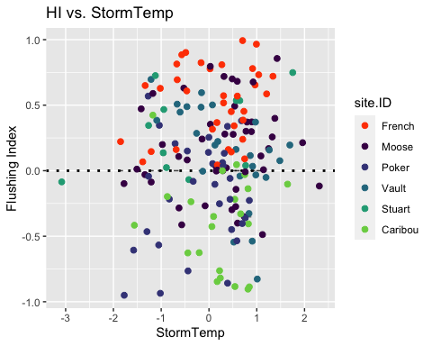

fDOM_data.1 <- HI_FI_fDOM[,c("Flush_index","TempWeek")]  
  
pairs(fDOM_data.1)

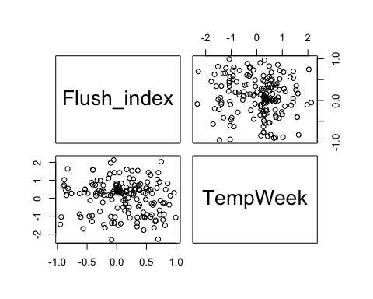

HI_FI_fDOM %>% ggplot(aes(x = TempWeek, y = Flush_index)) +   
 geom_hline(yintercept = 0, linetype = "dotted", size = 1) +  
 geom_errorbar(aes(ymin=FI_ymin, ymax=FI_ymax), colour="black", alpha=0.5, size=.5, width = 0.1)+   
 geom_point(aes(color = site.ID), size = 2) +  
 scale_color_manual(values = c("orange red", viridis::viridis(6)),  
 labels = c("French", "Moose", "Poker", "Vault", "Stuart", "Caribou")) +  
 ylab("Flushing Index") +  
 ggtitle("HI vs. TempWeek")

## Warning: Removed 71 rows containing missing values (geom_point).

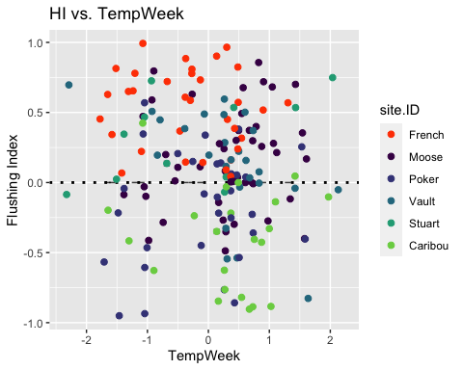

fDOM_data.1 <- HI_FI_fDOM[,c("Flush_index","Intensity")]  
  
pairs(fDOM_data.1)

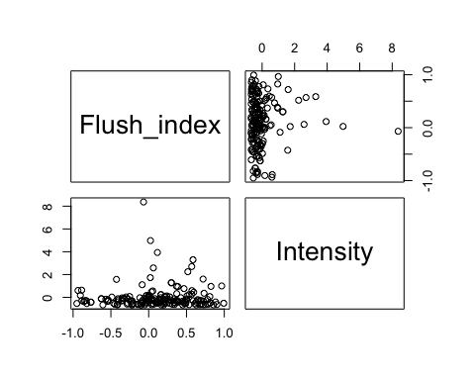

HI_FI_fDOM %>% ggplot(aes(x = Intensity, y = Flush_index)) +   
 geom_hline(yintercept = 0, linetype = "dotted", size = 1) +  
 geom_errorbar(aes(ymin=FI_ymin, ymax=FI_ymax), colour="black", alpha=0.5, size=.5, width = 0.1)+   
 geom_point(aes(color = site.ID), size = 2) +  
 scale_color_manual(values = c("orange red", viridis::viridis(6)),  
 labels = c("French", "Moose", "Poker", "Vault", "Stuart", "Caribou")) +  
 ylab("Flushing Index") +  
 ggtitle("HI vs. Intensity")

## Warning: Removed 70 rows containing missing values (geom_point).

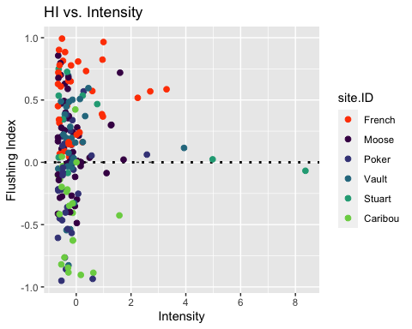

fDOM_data.1 <- HI_FI_fDOM[,c("Flush_index","TimeSinceChena")]  
  
pairs(fDOM_data.1)

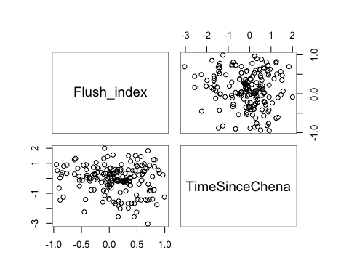

HI_FI_fDOM %>% ggplot(aes(x = StormPrecip, y = TimeSinceChena)) +   
 geom_hline(yintercept = 0, linetype = "dotted", size = 1) +  
 geom_errorbar(aes(ymin=FI_ymin, ymax=FI_ymax), colour="black", alpha=0.5, size=.5, width = 0.1)+   
 geom_point(aes(color = site.ID), size = 2) +  
 scale_color_manual(values = c("orange red", viridis::viridis(6)),  
 labels = c("French", "Moose", "Poker", "Vault", "Stuart", "Caribou")) +  
 ylab("Flushing Index") +  
 ggtitle("HI vs. TimeSinceChena")

## Warning: Removed 1 rows containing missing values (geom_point).

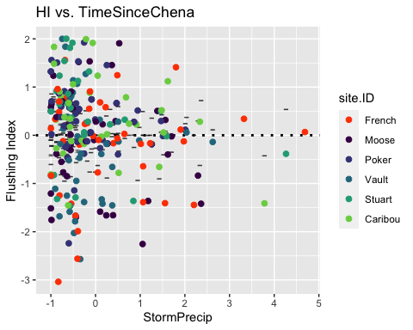

fDOM_data_FI <- HI_FI_fDOM[,c("Flush_index","StormPrecip", "StormTemp", "PrecipWeek", "PrecipMonth", "ThreeMonth", "TempWeek", "Intensity", "TimeSinceChena")]  
  
fDOM_data_FI <- na.omit(fDOM_data_FI)  
cor(fDOM_data_FI)

## Flush_index StormPrecip StormTemp PrecipWeek PrecipMonth  
## Flush_index 1.00000000 0.05414150 0.034227322 -0.228718654 -0.20444588  
## StormPrecip 0.05414150 1.00000000 0.115169640 0.111844092 0.04136386  
## StormTemp 0.03422732 0.11516964 1.000000000 0.009684106 0.02863792  
## PrecipWeek -0.22871865 0.11184409 0.009684106 1.000000000 0.58295995  
## PrecipMonth -0.20444588 0.04136386 0.028637918 0.582959955 1.00000000  
## ThreeMonth -0.28970511 -0.05891232 -0.183077992 0.350921307 0.70768888  
## TempWeek -0.11120861 0.20904164 0.716843195 0.102292479 0.11509976  
## Intensity 0.04757437 0.41003712 0.023700299 0.061211760 0.02660726  
## TimeSinceChena -0.09991649 -0.14289558 -0.673008494 0.088569794 0.25432522  
## ThreeMonth TempWeek Intensity TimeSinceChena  
## Flush_index -0.28970511 -0.11120861 0.047574373 -0.099916488  
## StormPrecip -0.05891232 0.20904164 0.410037123 -0.142895581  
## StormTemp -0.18307799 0.71684319 0.023700299 -0.673008494  
## PrecipWeek 0.35092131 0.10229248 0.061211760 0.088569794  
## PrecipMonth 0.70768888 0.11509976 0.026607255 0.254325216  
## ThreeMonth 1.00000000 -0.05512690 -0.019927848 0.552705676  
## TempWeek -0.05512690 1.00000000 0.045788513 -0.459824565  
## Intensity -0.01992785 0.04578851 1.000000000 -0.007162529  
## TimeSinceChena 0.55270568 -0.45982456 -0.007162529 1.000000000

1. Storm temperature is correlated with temp week (0.728) but temp week is more correlated with FI (0.02 vs. -0.09)
2. Storm temperature is correlated with TimeSinceChena (-0.679) but TSC is more correlated with FI (-0.123 vs. 0.02)
3. Precip week is correlated with precip month (0.609) but precip week is more correlated with FI (-0.218 vs. -0.2009)
4. Precip month is correlated with three month (0.698) but ThreeMonth is more correlated with FI (-0.264 vs. -0.200)
5. Three month is correlated with TimeSinceChena (0.579) but ThreeMonth is more correlated with FI (-0.264 vs. -0.123)

## Linear mixed model fit by REML ['lmerMod']  
## Formula: Flush_index ~ StormPrecip + PrecipWeek + PrecipMonth + ThreeMonth +   
## Intensity + StormTemp + TempWeek + TimeSinceChena + (1 | site.ID)  
## Data: HI_FI_fDOM  
##   
## REML criterion at convergence: 174.9  
##   
## Scaled residuals:   
## Min 1Q Median 3Q Max   
## -2.89725 -0.62932 0.02474 0.73897 2.01640   
##   
## Random effects:  
## Groups Name Variance Std.Dev.  
## site.ID (Intercept) 0.1008 0.3174   
## Residual 0.1222 0.3496   
## Number of obs: 169, groups: site.ID, 6  
##   
## Fixed effects:  
## Estimate Std. Error t value  
## (Intercept) 0.096557 0.133070 0.726  
## StormPrecip 0.036639 0.031097 1.178  
## PrecipWeek -0.087945 0.035035 -2.510  
## PrecipMonth 0.020724 0.044919 0.461  
## ThreeMonth -0.020338 0.051384 -0.396  
## Intensity -0.029501 0.029472 -1.001  
## StormTemp 0.010411 0.056129 0.185  
## TempWeek -0.023501 0.046658 -0.504  
## TimeSinceChena -0.009028 0.051844 -0.174  
##   
## Correlation of Fixed Effects:  
## (Intr) StrmPr PrcpWk PrcpMn ThrMnt Intnst StrmTm TempWk  
## StormPrecip -0.008   
## PrecipWeek 0.003 -0.055   
## PrecipMonth -0.015 -0.013 -0.469   
## ThreeMonth 0.012 0.021 0.046 -0.630   
## Intensity -0.016 -0.389 -0.011 -0.026 0.013   
## StormTemp -0.018 0.110 0.105 -0.038 -0.181 -0.035   
## TempWeek 0.009 -0.185 -0.074 -0.083 0.106 0.014 -0.617   
## TimeSincChn -0.011 0.095 0.071 0.095 -0.526 -0.043 0.562 -0.075

1)Scaled residuals look ok

1. Site explains slightly more variation
2. Precip week is most significant 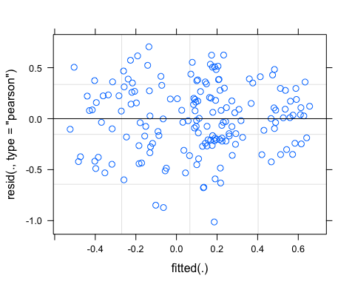

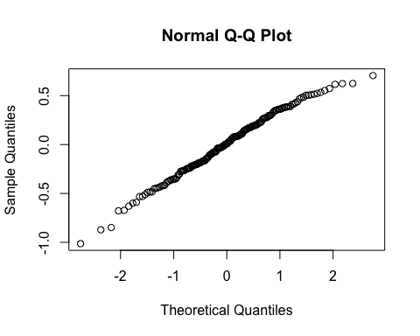

## Linear mixed model fit by REML ['lmerMod']  
## Formula: Flush_index ~ StormPrecip + PrecipWeek + ThreeMonth + Intensity +   
## TempWeek + TimeSinceChena + (1 | site.ID)  
## Data: HI_FI_fDOM  
##   
## REML criterion at convergence: 166.8  
##   
## Scaled residuals:   
## Min 1Q Median 3Q Max   
## -2.93389 -0.64810 0.02603 0.68816 2.08832   
##   
## Random effects:  
## Groups Name Variance Std.Dev.  
## site.ID (Intercept) 0.1026 0.3203   
## Residual 0.1208 0.3476   
## Number of obs: 169, groups: site.ID, 6  
##   
## Fixed effects:  
## Estimate Std. Error t value  
## (Intercept) 0.098017 0.134145 0.731  
## StormPrecip 0.036146 0.030727 1.176  
## PrecipWeek -0.081002 0.030603 -2.647  
## ThreeMonth -0.003081 0.038273 -0.081  
## Intensity -0.029034 0.029274 -0.992  
## TempWeek -0.015739 0.036171 -0.435  
## TimeSinceChena -0.017308 0.042213 -0.410  
##   
## Correlation of Fixed Effects:  
## (Intr) StrmPr PrcpWk ThrMnt Intnst TempWk  
## StormPrecip -0.006   
## PrecipWeek -0.002 -0.081   
## ThreeMonth -0.002 0.047 -0.353   
## Intensity -0.017 -0.389 -0.023 -0.015   
## TempWeek -0.004 -0.153 -0.087 -0.127 -0.013   
## TimeSincChn 0.001 0.042 0.092 -0.570 -0.024 0.444

aictab(list(M0.fDOM_FI, M1.fDOM_FI))

## Warning in aictab.AIClmerMod(list(M0.fDOM_FI, M1.fDOM_FI)):   
## Model names have been supplied automatically in the table

## Warning in aictab.AIClmerMod(list(M0.fDOM_FI, M1.fDOM_FI)):   
## Model selection for fixed effects is only appropriate with ML estimation:  
## REML (default) should only be used to select random effects for a constant set of fixed effects

##   
## Model selection based on AICc:  
##   
## K AICc Delta_AICc AICcWt Cum.Wt Res.LL  
## Mod2 9 185.97 0.0 1 1 -83.42  
## Mod1 11 198.57 12.6 0 1 -87.45

SPC

#### Scatter plot matrix

SPC_data.1 <- HI_FI_SPC[,c("Flush_index","StormPrecip")]  
  
pairs(SPC_data.1)

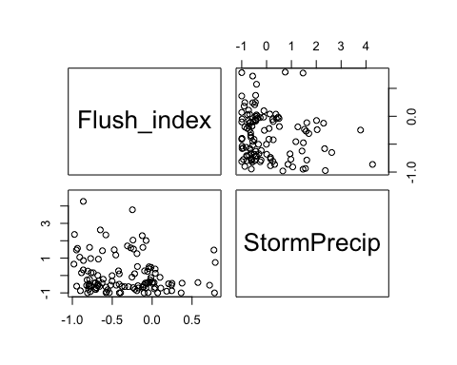

HI_FI_SPC %>% ggplot(aes(x = StormPrecip, y = Flush_index)) +   
 geom_hline(yintercept = 0, linetype = "dotted", size = 1) +  
 geom_errorbar(aes(ymin=FI_ymin, ymax=FI_ymax), colour="black", alpha=0.5, size=.5, width = 0.1)+   
 geom_point(aes(color = site.ID), size = 2) +  
 scale_color_manual(values = c("orange red", viridis::viridis(6)),  
 labels = c("French", "Moose", "Poker", "Vault", "Stuart", "Caribou")) +  
 ylab("Flushing Index") +  
 ggtitle("HI vs. StormPrecip")

## Warning: Removed 114 rows containing missing values (geom_point).

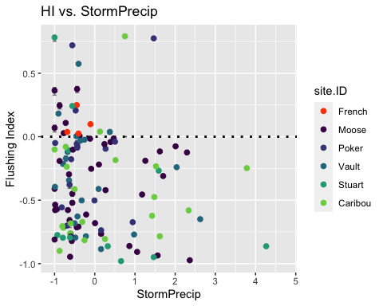

SPC_data.2 <- HI_FI_SPC[,c("Flush_index","PrecipWeek")]  
  
pairs(SPC_data.1)



HI_FI_SPC %>% ggplot(aes(x = PrecipWeek, y = Flush_index)) +   
 geom_hline(yintercept = 0, linetype = "dotted", size = 1) +  
 geom_errorbar(aes(ymin=FI_ymin, ymax=FI_ymax), colour="black", alpha=0.5, size=.5, width = 0.1)+   
 geom_point(aes(color = site.ID), size = 2) +  
 scale_color_manual(values = c("orange red", viridis::viridis(6)),  
 labels = c("French", "Moose", "Poker", "Vault", "Stuart", "Caribou")) +  
 ylab("Flushing Index") +  
 ggtitle("HI vs. PrecipWeek")

## Warning: Removed 114 rows containing missing values (geom_point).

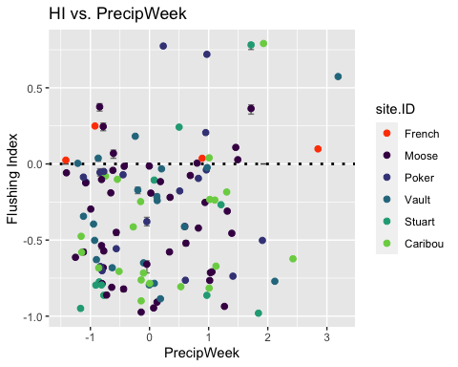

SPC_data.1 <- HI_FI_SPC[,c("Flush_index","PrecipMonth")]  
  
pairs(SPC_data.1)

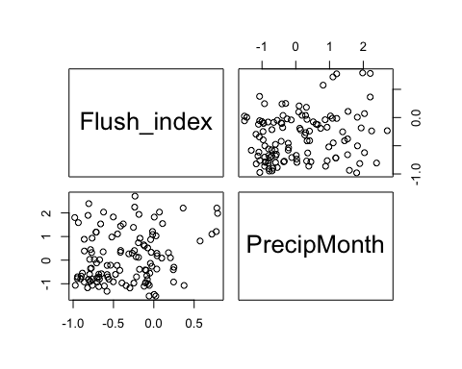

HI_FI_SPC %>% ggplot(aes(x = PrecipMonth, y = Flush_index)) +   
 geom_hline(yintercept = 0, linetype = "dotted", size = 1) +  
 geom_errorbar(aes(ymin=FI_ymin, ymax=FI_ymax), colour="black", alpha=0.5, size=.5, width = 0.1)+   
 geom_point(aes(color = site.ID), size = 2) +  
 scale_color_manual(values = c("orange red", viridis::viridis(6)),  
 labels = c("French", "Moose", "Poker", "Vault", "Stuart", "Caribou")) +  
 ylab("Flushing Index") +  
 ggtitle("HI vs. PrecipMonth")

## Warning: Removed 114 rows containing missing values (geom_point).

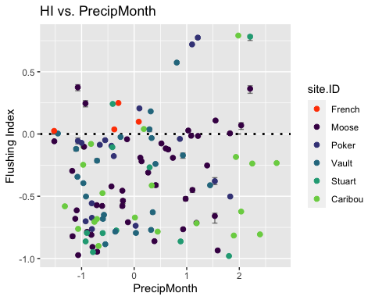

SPC_data.1 <- HI_FI_SPC[,c("Flush_index","ThreeMonth")]  
  
pairs(SPC_data.1)

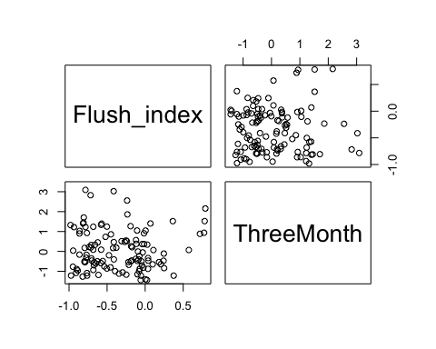

HI_FI_SPC %>% ggplot(aes(x = ThreeMonth, y = Flush_index)) +   
 geom_hline(yintercept = 0, linetype = "dotted", size = 1) +  
 geom_errorbar(aes(ymin=FI_ymin, ymax=FI_ymax), colour="black", alpha=0.5, size=.5, width = 0.1)+   
 geom_point(aes(color = site.ID), size = 2) +  
 scale_color_manual(values = c("orange red", viridis::viridis(6)),  
 labels = c("French", "Moose", "Poker", "Vault", "Stuart", "Caribou")) +  
 ylab("Flushing Index") +  
 ggtitle("HI vs. ThreeMonth")

## Warning: Removed 114 rows containing missing values (geom_point).

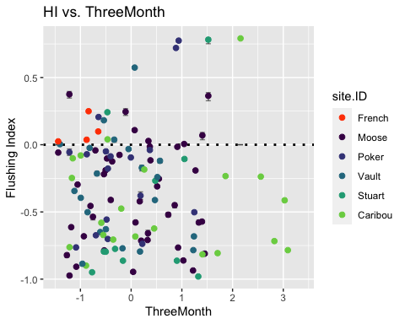

SPC_data.1 <- HI_FI_SPC[,c("Flush_index","StormTemp")]  
  
pairs(SPC_data.1)

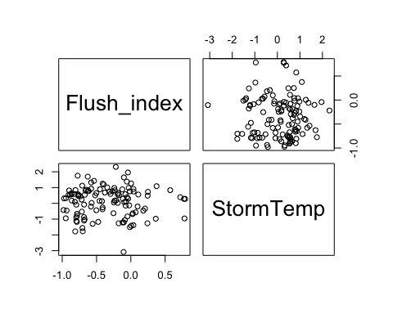

HI_FI_SPC %>% ggplot(aes(x = StormTemp, y = Flush_index)) +   
 geom_hline(yintercept = 0, linetype = "dotted", size = 1) +  
 geom_errorbar(aes(ymin=FI_ymin, ymax=FI_ymax), colour="black", alpha=0.5, size=.5, width = 0.1)+   
 geom_point(aes(color = site.ID), size = 2) +  
 scale_color_manual(values = c("orange red", viridis::viridis(6)),  
 labels = c("French", "Moose", "Poker", "Vault", "Stuart", "Caribou")) +  
 ylab("Flushing Index") +  
 ggtitle("HI vs. StormTemp")

## Warning: Removed 114 rows containing missing values (geom_point).

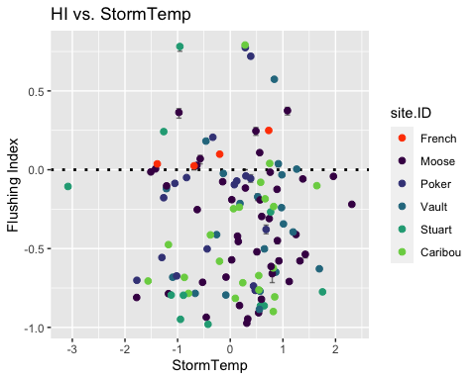

SPC_data.1 <- HI_FI_SPC[,c("Flush_index","TempWeek")]  
  
pairs(SPC_data.1)

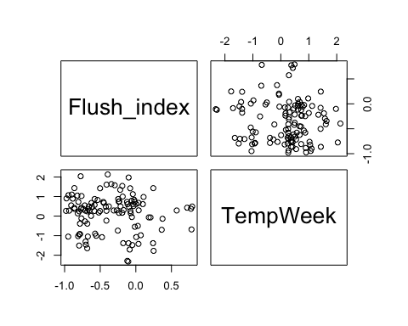

HI_FI_SPC %>% ggplot(aes(x = TempWeek, y = Flush_index)) +   
 geom_hline(yintercept = 0, linetype = "dotted", size = 1) +  
 geom_errorbar(aes(ymin=FI_ymin, ymax=FI_ymax), colour="black", alpha=0.5, size=.5, width = 0.1)+   
 geom_point(aes(color = site.ID), size = 2) +  
 scale_color_manual(values = c("orange red", viridis::viridis(6)),  
 labels = c("French", "Moose", "Poker", "Vault", "Stuart", "Caribou")) +  
 ylab("Flushing Index") +  
 ggtitle("HI vs. TempWeek")

## Warning: Removed 115 rows containing missing values (geom_point).

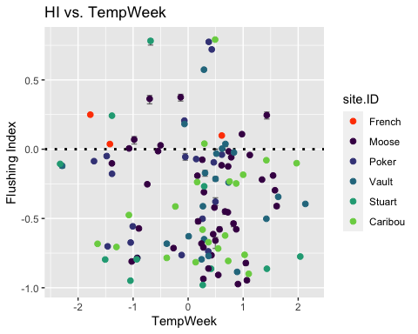

SPC_data.1 <- HI_FI_SPC[,c("Flush_index","Intensity")]  
  
pairs(SPC_data.1)

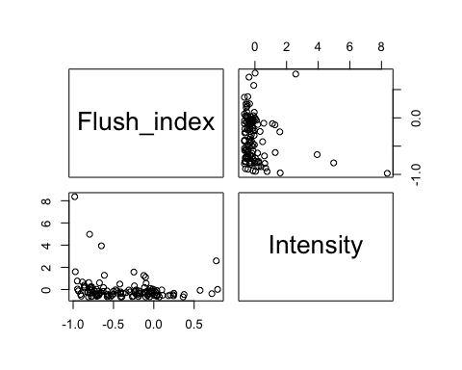

HI_FI_SPC %>% ggplot(aes(x = Intensity, y = Flush_index)) +   
 geom_hline(yintercept = 0, linetype = "dotted", size = 1) +  
 geom_errorbar(aes(ymin=FI_ymin, ymax=FI_ymax), colour="black", alpha=0.5, size=.5, width = 0.1)+   
 geom_point(aes(color = site.ID), size = 2) +  
 scale_color_manual(values = c("orange red", viridis::viridis(6)),  
 labels = c("French", "Moose", "Poker", "Vault", "Stuart", "Caribou")) +  
 ylab("Flushing Index") +  
 ggtitle("HI vs. Intensity")

## Warning: Removed 115 rows containing missing values (geom_point).

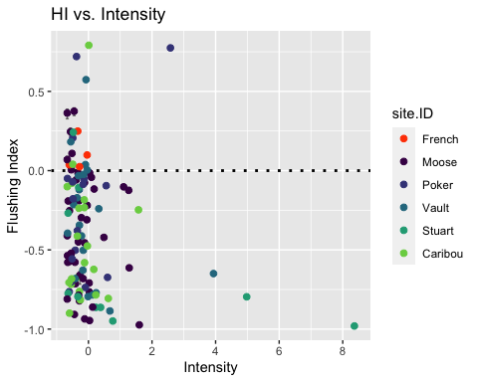

SPC_data.1 <- HI_FI_SPC[,c("Flush_index","TimeSinceChena")]  
  
pairs(SPC_data.1)

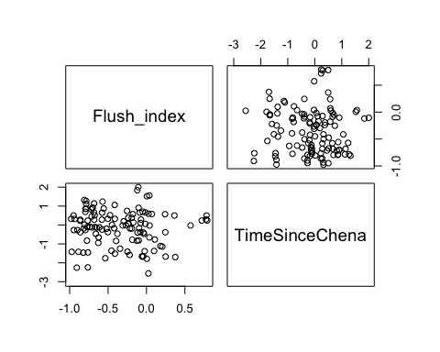

HI_FI_SPC %>% ggplot(aes(x = StormPrecip, y = TimeSinceChena)) +   
 geom_hline(yintercept = 0, linetype = "dotted", size = 1) +  
 geom_errorbar(aes(ymin=FI_ymin, ymax=FI_ymax), colour="black", alpha=0.5, size=.5, width = 0.1)+   
 geom_point(aes(color = site.ID), size = 2) +  
 scale_color_manual(values = c("orange red", viridis::viridis(6)),  
 labels = c("French", "Moose", "Poker", "Vault", "Stuart", "Caribou")) +  
 ylab("Flushing Index") +  
 ggtitle("HI vs. TimeSinceChena")

## Warning: Removed 1 rows containing missing values (geom_point).

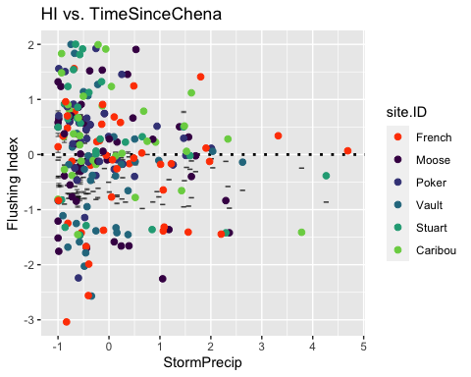

SPC_data_FI <- HI_FI_SPC[,c("Flush_index","StormPrecip", "StormTemp", "PrecipWeek", "PrecipMonth", "ThreeMonth", "TempWeek", "Intensity", "TimeSinceChena")]  
  
SPC_data_FI <- na.omit(SPC_data_FI)  
cor(SPC_data_FI)

## Flush_index StormPrecip StormTemp PrecipWeek PrecipMonth  
## Flush_index 1.00000000 -0.114623187 0.02916768 0.16526013 0.18945706  
## StormPrecip -0.11462319 1.000000000 0.09832742 0.10773657 0.06353536  
## StormTemp 0.02916768 0.098327419 1.00000000 0.01753005 0.05212081  
## PrecipWeek 0.16526013 0.107736574 0.01753005 1.00000000 0.61010205  
## PrecipMonth 0.18945706 0.063535360 0.05212081 0.61010205 1.00000000  
## ThreeMonth -0.01562111 0.000587679 -0.20355128 0.32599750 0.68476929  
## TempWeek -0.04838444 0.192067398 0.80009690 0.10048940 0.06100126  
## Intensity -0.18303208 0.362706316 -0.02735655 0.05909335 0.04937868  
## TimeSinceChena -0.05962890 -0.124762404 -0.70280488 -0.00895473 0.16527249  
## ThreeMonth TempWeek Intensity TimeSinceChena  
## Flush_index -0.015621112 -0.04838444 -0.18303208 -0.05962890  
## StormPrecip 0.000587679 0.19206740 0.36270632 -0.12476240  
## StormTemp -0.203551281 0.80009690 -0.02735655 -0.70280488  
## PrecipWeek 0.325997495 0.10048940 0.05909335 -0.00895473  
## PrecipMonth 0.684769285 0.06100126 0.04937868 0.16527249  
## ThreeMonth 1.000000000 -0.17198058 0.01162747 0.56051005  
## TempWeek -0.171980578 1.00000000 -0.01056590 -0.62517274  
## Intensity 0.011627473 -0.01056590 1.00000000 0.02120897  
## TimeSinceChena 0.560510054 -0.62517274 0.02120897 1.00000000

1. Storm temperature is correlated with temp week (0.8209) but temp week is more correlated with FI (-0.02 vs. 0.019)
2. Storm temperature is correlated with TimeSinceChena (-0.703) but TSC is more correlated with FI (-0.026 vs. 0.019)
3. Precip week is correlated with precip month (0.609) but precip month is more correlated with FI (0.195 vs. 0.167)
4. Precip month is correlated with three month (0.670) but PrecipMonth is more correlated with FI (0.19 vs. -0.002)
5. Three month is correlated with TimeSinceChena (0.563) but TSC is more correlated with FI (-0.02 vs. -0.002)

## boundary (singular) fit: see ?isSingular

## Linear mixed model fit by REML ['lmerMod']  
## Formula: Flush_index ~ StormPrecip + PrecipWeek + PrecipMonth + ThreeMonth +   
## Intensity + StormTemp + TempWeek + TimeSinceChena + (1 | site.ID)  
## Data: HI_FI_SPC  
##   
## REML criterion at convergence: 141.8  
##   
## Scaled residuals:   
## Min 1Q Median 3Q Max   
## -1.5956 -0.8563 0.0062 0.6946 3.2840   
##   
## Random effects:  
## Groups Name Variance Std.Dev.  
## site.ID (Intercept) 0.0000 0.0000   
## Residual 0.1532 0.3914   
## Number of obs: 116, groups: site.ID, 6  
##   
## Fixed effects:  
## Estimate Std. Error t value  
## (Intercept) -0.358006 0.037251 -9.611  
## StormPrecip -0.019069 0.038290 -0.498  
## PrecipWeek 0.029904 0.048364 0.618  
## PrecipMonth 0.146343 0.061239 2.390  
## ThreeMonth -0.122180 0.065989 -1.852  
## Intensity -0.066507 0.035128 -1.893  
## StormTemp 0.052552 0.076538 0.687  
## TempWeek -0.097243 0.067122 -1.449  
## TimeSinceChena -0.005181 0.074820 -0.069  
##   
## Correlation of Fixed Effects:  
## (Intr) StrmPr PrcpWk PrcpMn ThrMnt Intnst StrmTm TempWk  
## StormPrecip 0.009   
## PrecipWeek -0.043 -0.042   
## PrecipMonth 0.022 0.016 -0.529   
## ThreeMonth -0.093 -0.050 0.063 -0.628   
## Intensity -0.006 -0.370 -0.012 -0.045 0.058   
## StormTemp 0.029 0.107 0.197 -0.102 -0.131 -0.022   
## TempWeek -0.083 -0.174 -0.119 0.049 -0.050 0.052 -0.630   
## TimeSincChn 0.087 0.081 0.125 0.140 -0.577 -0.051 0.461 0.127  
## optimizer (nloptwrap) convergence code: 0 (OK)  
## boundary (singular) fit: see ?isSingular

1. Scaled resiudals aren’t great
2. Site explains 0 variance
3. Precip month is most significant

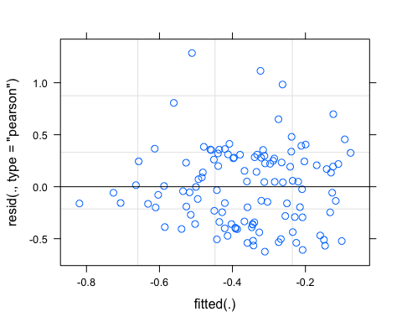

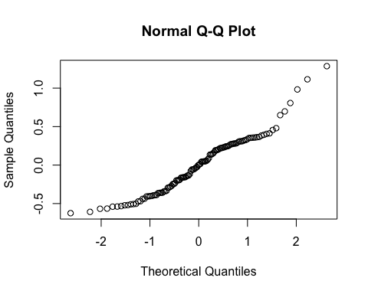 Not very good

## Linear mixed model fit by REML ['lmerMod']  
## Formula: Flush_index ~ StormPrecip + PrecipWeek + PrecipMonth + Intensity +   
## TempWeek + TimeSinceChena + (1 | site.ID)  
## Data: HI_FI_SPC  
##   
## REML criterion at convergence: 138.5  
##   
## Scaled residuals:   
## Min 1Q Median 3Q Max   
## -1.6613 -0.8709 0.0096 0.7675 3.1924   
##   
## Random effects:  
## Groups Name Variance Std.Dev.  
## site.ID (Intercept) 0.002273 0.04768   
## Residual 0.153921 0.39233   
## Number of obs: 116, groups: site.ID, 6  
##   
## Fixed effects:  
## Estimate Std. Error t value  
## (Intercept) -0.36125 0.04335 -8.333  
## StormPrecip -0.02190 0.03825 -0.573  
## PrecipWeek 0.02825 0.04752 0.595  
## PrecipMonth 0.08332 0.04661 1.787  
## Intensity -0.06262 0.03545 -1.767  
## TempWeek -0.07904 0.05195 -1.521  
## TimeSinceChena -0.09363 0.05408 -1.731  
##   
## Correlation of Fixed Effects:  
## (Intr) StrmPr PrcpWk PrcpMn Intnst TempWk  
## StormPrecip 0.001   
## PrecipWeek -0.056 -0.063   
## PrecipMonth -0.019 0.009 -0.612   
## Intensity -0.017 -0.367 -0.008 -0.024   
## TempWeek -0.064 -0.141 0.012 -0.166 0.054   
## TimeSincChn 0.035 0.022 0.112 -0.271 -0.013 0.632

aictab(list(M0.SPC_FI, M1.SPC_FI))

## Warning in aictab.AIClmerMod(list(M0.SPC_FI, M1.SPC_FI)):   
## Model names have been supplied automatically in the table

## Warning in aictab.AIClmerMod(list(M0.SPC_FI, M1.SPC_FI)):   
## Model selection for fixed effects is only appropriate with ML estimation:  
## REML (default) should only be used to select random effects for a constant set of fixed effects

##   
## Model selection based on AICc:  
##   
## K AICc Delta_AICc AICcWt Cum.Wt Res.LL  
## Mod2 9 158.15 0.00 0.98 0.98 -69.23  
## Mod1 11 166.36 8.21 0.02 1.00 -70.91

turb

#### Scatter plot matrix

turb_data.1 <- HI_FI_turb[,c("Flush_index","StormPrecip")]  
  
pairs(turb_data.1)

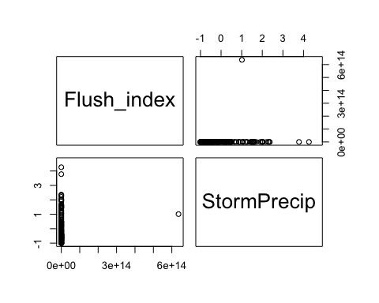

HI_FI_turb %>% ggplot(aes(x = StormPrecip, y = Flush_index)) +   
 geom_hline(yintercept = 0, linetype = "dotted", size = 1) +  
 geom_errorbar(aes(ymin=FI_ymin, ymax=FI_ymax), colour="black", alpha=0.5, size=.5, width = 0.1)+   
 geom_point(aes(color = site.ID), size = 2) +  
 scale_color_manual(values = c("orange red", viridis::viridis(6)),  
 labels = c("French", "Moose", "Poker", "Vault", "Stuart", "Caribou")) +  
 ylab("Flushing Index") +  
 ggtitle("HI vs. StormPrecip")

## Warning: Removed 74 rows containing missing values (geom_point).

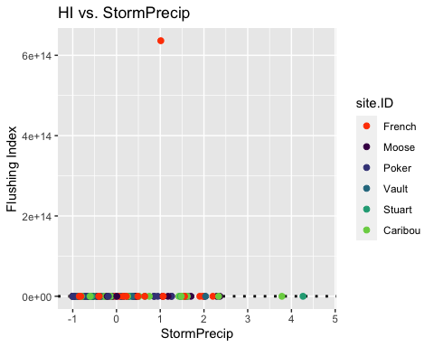

turb_data.2 <- HI_FI_turb[,c("Flush_index","PrecipWeek")]  
  
pairs(turb_data.1)



HI_FI_turb %>% ggplot(aes(x = PrecipWeek, y = Flush_index)) +   
 geom_hline(yintercept = 0, linetype = "dotted", size = 1) +  
 geom_errorbar(aes(ymin=FI_ymin, ymax=FI_ymax), colour="black", alpha=0.5, size=.5, width = 0.1)+   
 geom_point(aes(color = site.ID), size = 2) +  
 scale_color_manual(values = c("orange red", viridis::viridis(6)),  
 labels = c("French", "Moose", "Poker", "Vault", "Stuart", "Caribou")) +  
 ylab("Flushing Index") +  
 ggtitle("HI vs. PrecipWeek")

## Warning: Removed 74 rows containing missing values (geom_point).

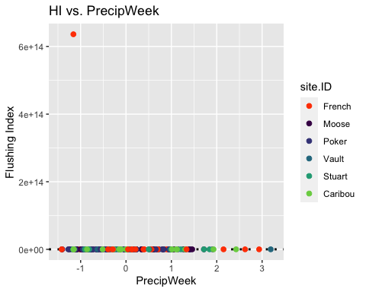

turb_data.1 <- HI_FI_turb[,c("Flush_index","PrecipMonth")]  
  
pairs(turb_data.1)

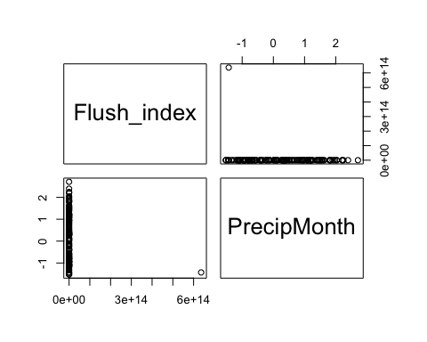

HI_FI_turb %>% ggplot(aes(x = PrecipMonth, y = Flush_index)) +   
 geom_hline(yintercept = 0, linetype = "dotted", size = 1) +  
 geom_errorbar(aes(ymin=FI_ymin, ymax=FI_ymax), colour="black", alpha=0.5, size=.5, width = 0.1)+   
 geom_point(aes(color = site.ID), size = 2) +  
 scale_color_manual(values = c("orange red", viridis::viridis(6)),  
 labels = c("French", "Moose", "Poker", "Vault", "Stuart", "Caribou")) +  
 ylab("Flushing Index") +  
 ggtitle("HI vs. PrecipMonth")

## Warning: Removed 74 rows containing missing values (geom_point).

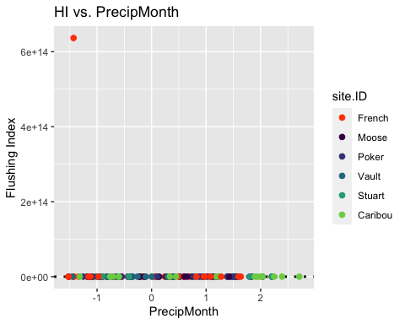

turb_data.1 <- HI_FI_turb[,c("Flush_index","ThreeMonth")]  
  
pairs(turb_data.1)

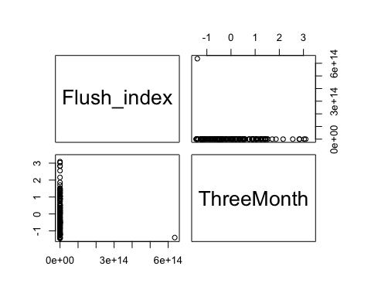

HI_FI_turb %>% ggplot(aes(x = ThreeMonth, y = Flush_index)) +   
 geom_hline(yintercept = 0, linetype = "dotted", size = 1) +  
 geom_errorbar(aes(ymin=FI_ymin, ymax=FI_ymax), colour="black", alpha=0.5, size=.5, width = 0.1)+   
 geom_point(aes(color = site.ID), size = 2) +  
 scale_color_manual(values = c("orange red", viridis::viridis(6)),  
 labels = c("French", "Moose", "Poker", "Vault", "Stuart", "Caribou")) +  
 ylab("Flushing Index") +  
 ggtitle("HI vs. ThreeMonth")

## Warning: Removed 74 rows containing missing values (geom_point).

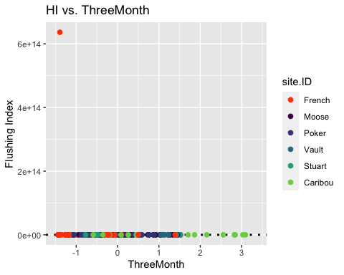

turb_data.1 <- HI_FI_turb[,c("Flush_index","StormTemp")]  
  
pairs(turb_data.1)

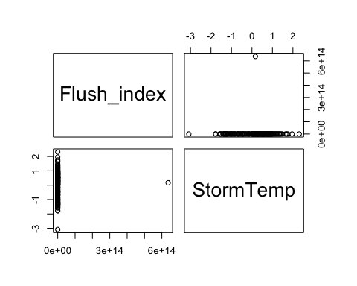

HI_FI_turb %>% ggplot(aes(x = StormTemp, y = Flush_index)) +   
 geom_hline(yintercept = 0, linetype = "dotted", size = 1) +  
 geom_errorbar(aes(ymin=FI_ymin, ymax=FI_ymax), colour="black", alpha=0.5, size=.5, width = 0.1)+   
 geom_point(aes(color = site.ID), size = 2) +  
 scale_color_manual(values = c("orange red", viridis::viridis(6)),  
 labels = c("French", "Moose", "Poker", "Vault", "Stuart", "Caribou")) +  
 ylab("Flushing Index") +  
 ggtitle("HI vs. StormTemp")

## Warning: Removed 74 rows containing missing values (geom_point).

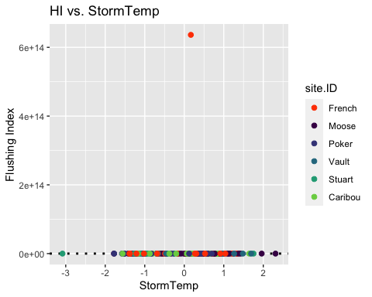

turb_data.1 <- HI_FI_turb[,c("Flush_index","TempWeek")]  
  
pairs(turb_data.1)

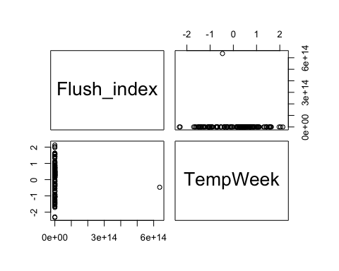

HI_FI_turb %>% ggplot(aes(x = TempWeek, y = Flush_index)) +   
 geom_hline(yintercept = 0, linetype = "dotted", size = 1) +  
 geom_errorbar(aes(ymin=FI_ymin, ymax=FI_ymax), colour="black", alpha=0.5, size=.5, width = 0.1)+   
 geom_point(aes(color = site.ID), size = 2) +  
 scale_color_manual(values = c("orange red", viridis::viridis(6)),  
 labels = c("French", "Moose", "Poker", "Vault", "Stuart", "Caribou")) +  
 ylab("Flushing Index") +  
 ggtitle("HI vs. TempWeek")

## Warning: Removed 76 rows containing missing values (geom_point).

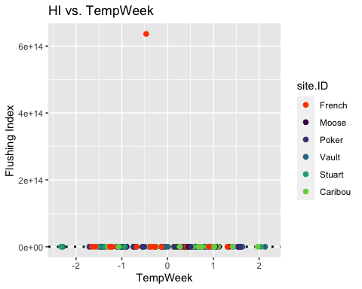

turb_data.1 <- HI_FI_NO3[,c("Flush_index","Intensity")]  
  
pairs(turb_data.1)



HI_FI_turb %>% ggplot(aes(x = Intensity, y = Flush_index)) +   
 geom_hline(yintercept = 0, linetype = "dotted", size = 1) +  
 geom_errorbar(aes(ymin=FI_ymin, ymax=FI_ymax), colour="black", alpha=0.5, size=.5, width = 0.1)+   
 geom_point(aes(color = site.ID), size = 2) +  
 scale_color_manual(values = c("orange red", viridis::viridis(6)),  
 labels = c("French", "Moose", "Poker", "Vault", "Stuart", "Caribou")) +  
 ylab("Flushing Index") +  
 ggtitle("HI vs. Intensity")

## Warning: Removed 76 rows containing missing values (geom_point).

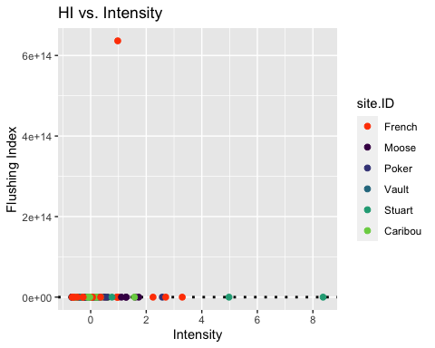

turb_data.1 <- HI_FI_turb[,c("Flush_index","TimeSinceChena")]  
  
pairs(turb_data.1)

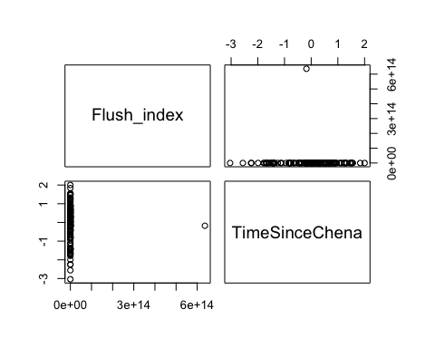

HI_FI_turb %>% ggplot(aes(x = StormPrecip, y = TimeSinceChena)) +   
 geom_hline(yintercept = 0, linetype = "dotted", size = 1) +  
 geom_errorbar(aes(ymin=FI_ymin, ymax=FI_ymax), colour="black", alpha=0.5, size=.5, width = 0.1)+   
 geom_point(aes(color = site.ID), size = 2) +  
 scale_color_manual(values = c("orange red", viridis::viridis(6)),  
 labels = c("French", "Moose", "Poker", "Vault", "Stuart", "Caribou")) +  
 ylab("Flushing Index") +  
 ggtitle("HI vs. TimeSinceChena")

## Warning: Removed 1 rows containing missing values (geom_point).

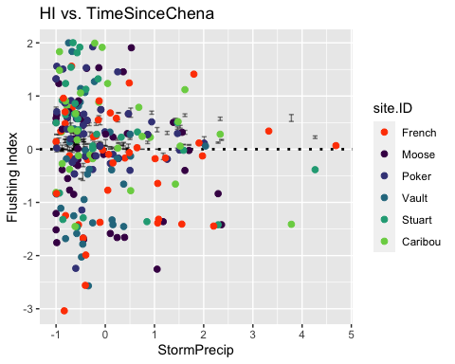

turb_data_FI <- HI_FI_turb[,c("Flush_index","StormPrecip", "StormTemp", "PrecipWeek", "PrecipMonth", "ThreeMonth", "TempWeek", "Intensity", "TimeSinceChena")]  
  
turb_data_FI <- na.omit(turb_data_FI)  
cor(turb_data_FI)

## Flush_index StormPrecip StormTemp PrecipWeek PrecipMonth  
## Flush_index 1.000000000 0.08089422 0.007953713 -0.10196545 -0.12137934  
## StormPrecip 0.080894219 1.00000000 0.092438330 0.06568314 0.02524601  
## StormTemp 0.007953713 0.09243833 1.000000000 -0.05349042 -0.03691081  
## PrecipWeek -0.101965450 0.06568314 -0.053490418 1.00000000 0.59084489  
## PrecipMonth -0.121379339 0.02524601 -0.036910810 0.59084489 1.00000000  
## ThreeMonth -0.113687274 -0.04290230 -0.223736267 0.30681917 0.68629530  
## TempWeek -0.047206069 0.19448500 0.753613525 0.03399311 0.04154596  
## Intensity 0.077178282 0.40957565 0.026085013 0.05316466 0.02044303  
## TimeSinceChena -0.015495393 -0.17328374 -0.726657786 0.04919071 0.25157880  
## ThreeMonth TempWeek Intensity TimeSinceChena  
## Flush_index -0.11368727 -0.04720607 0.07717828 -0.01549539  
## StormPrecip -0.04290230 0.19448500 0.40957565 -0.17328374  
## StormTemp -0.22373627 0.75361352 0.02608501 -0.72665779  
## PrecipWeek 0.30681917 0.03399311 0.05316466 0.04919071  
## PrecipMonth 0.68629530 0.04154596 0.02044303 0.25157880  
## ThreeMonth 1.00000000 -0.10590777 -0.01424012 0.55267371  
## TempWeek -0.10590777 1.00000000 0.05047797 -0.56960393  
## Intensity -0.01424012 0.05047797 1.00000000 -0.03556597  
## TimeSinceChena 0.55267371 -0.56960393 -0.03556597 1.00000000

1. Storm temperature is correlated with temp week (0.7605) but StormTemp is more correlated with FI (0.03 vs. -0.0089)
2. Storm temperature is correlated with TimeSinceChena (-0.74) but TSC is more correlated with FI (-0.05 vs. 0.03)
3. Precip week is correlated with precip month (0.616) but precip month is more correlated with FI (-0.07 vs. 0.01)
4. Precip month is correlated with three month (0.677) but PrecipMonth is more correlated with FI (-0.07 vs. 0.03)
5. Three month is correlated with TimeSinceChena (0.562) but TSC is more correlated with FI (-0.05 vs. -0.03)

## boundary (singular) fit: see ?isSingular

## Linear mixed model fit by REML ['lmerMod']  
## Formula: Flush_index ~ StormPrecip + PrecipWeek + PrecipMonth + ThreeMonth +   
## Intensity + StormTemp + TempWeek + TimeSinceChena + (1 | site.ID)  
## Data: HI_FI_turb  
##   
## REML criterion at convergence: 10129.8  
##   
## Scaled residuals:   
## Min 1Q Median 3Q Max   
## -0.7762 -0.1944 -0.0513 0.0647 12.0959   
##   
## Random effects:  
## Groups Name Variance Std.Dev.   
## site.ID (Intercept) 0.000e+00 0.000e+00  
## Residual 2.531e+27 5.031e+13  
## Number of obs: 162, groups: site.ID, 6  
##   
## Fixed effects:  
## Estimate Std. Error t value  
## (Intercept) 4.546e+12 4.063e+12 1.119  
## StormPrecip 4.502e+12 4.567e+12 0.986  
## PrecipWeek -2.609e+12 5.446e+12 -0.479  
## PrecipMonth -1.820e+12 6.350e+12 -0.287  
## ThreeMonth -5.430e+12 6.738e+12 -0.806  
## Intensity 2.397e+12 4.288e+12 0.559  
## StormTemp 7.405e+12 8.339e+12 0.888  
## TempWeek -6.407e+12 6.827e+12 -0.938  
## TimeSinceChena 5.881e+12 8.354e+12 0.704  
##   
## Correlation of Fixed Effects:  
## (Intr) StrmPr PrcpWk PrcpMn ThrMnt Intnst StrmTm TempWk  
## StormPrecip -0.006   
## PrecipWeek 0.063 -0.005   
## PrecipMonth -0.191 -0.016 -0.541   
## ThreeMonth 0.122 -0.033 0.081 -0.589   
## Intensity 0.024 -0.409 -0.036 0.001 0.031   
## StormTemp -0.057 0.159 0.174 -0.090 -0.119 -0.048   
## TempWeek -0.030 -0.171 -0.048 0.001 -0.092 0.032 -0.572   
## TimeSincChn -0.074 0.154 0.152 0.020 -0.506 -0.057 0.557 0.086  
## optimizer (nloptwrap) convergence code: 0 (OK)  
## boundary (singular) fit: see ?isSingular

1)Scaled residuals look ok

1. Site explains little variance

3)Storm Precip is most significant

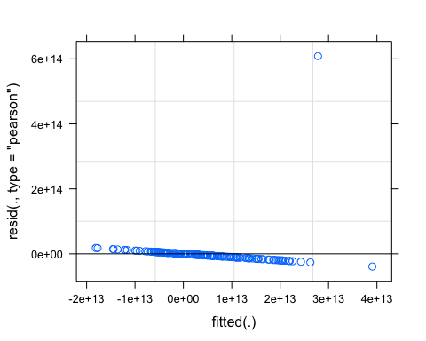 Some funnelling going on here

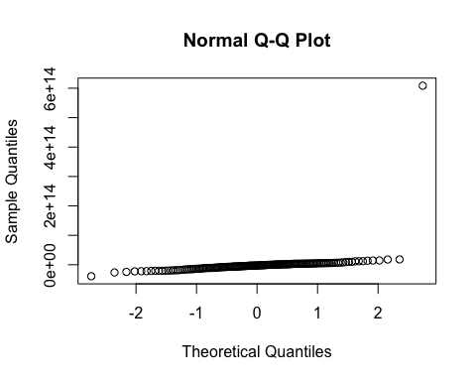

## boundary (singular) fit: see ?isSingular

## Linear mixed model fit by REML ['lmerMod']  
## Formula: Flush_index ~ StormPrecip + PrecipWeek + PrecipMonth + Intensity +   
## StormTemp + TimeSinceChena + (1 | site.ID)  
## Data: HI_FI_turb  
##   
## REML criterion at convergence: 10383.6  
##   
## Scaled residuals:   
## Min 1Q Median 3Q Max   
## -0.5594 -0.1652 -0.0859 0.0427 12.3206   
##   
## Random effects:  
## Groups Name Variance Std.Dev.   
## site.ID (Intercept) 0.000e+00 0.000e+00  
## Residual 2.494e+27 4.994e+13  
## Number of obs: 164, groups: site.ID, 6  
##   
## Fixed effects:  
## Estimate Std. Error t value  
## (Intercept) 4.823e+12 3.971e+12 1.214  
## StormPrecip 3.612e+12 4.427e+12 0.816  
## PrecipWeek -2.391e+12 5.289e+12 -0.452  
## PrecipMonth -5.234e+12 5.037e+12 -1.039  
## Intensity 2.650e+12 4.251e+12 0.623  
## StormTemp 1.903e+12 5.937e+12 0.321  
## TimeSinceChena 3.134e+12 6.078e+12 0.516  
##   
## Correlation of Fixed Effects:  
## (Intr) StrmPr PrcpWk PrcpMn Intnst StrmTm  
## StormPrecip 0.009   
## PrecipWeek 0.078 -0.033   
## PrecipMonth -0.170 -0.041 -0.608   
## Intensity 0.020 -0.411 -0.036 0.025   
## StormTemp -0.013 0.014 0.133 -0.266 -0.028   
## TimeSincChn 0.061 0.124 0.155 -0.388 -0.052 0.679  
## optimizer (nloptwrap) convergence code: 0 (OK)  
## boundary (singular) fit: see ?isSingular

aictab(list(M0.turb_FI, M1.turb_FI))

## Warning in aictab.AIClmerMod(list(M0.turb_FI, M1.turb_FI)):   
## Model names have been supplied automatically in the table

## Warning in aictab.AIClmerMod(list(M0.turb_FI, M1.turb_FI)):   
## Model selection for fixed effects is only appropriate with ML estimation:  
## REML (default) should only be used to select random effects for a constant set of fixed effects

##   
## Model selection based on AICc:  
##   
## K AICc Delta_AICc AICcWt Cum.Wt Res.LL  
## Mod1 11 10153.55 0.0 1 1 -5064.90  
## Mod2 9 10402.75 249.2 0 1 -5191.79